Annex 6 to the Tender conditions

TECHNICAL SPECIFICATION

- DEFINITIONS AND ABBREVIATIONS
  - Client – Public Institution Go Vilnius.
  - Service provider - an economic entity - a natural person, private legal person, public legal person, other organisations and their subdivisions or a group of such persons, with whom the Buyer, the Customer concludes an Agreement.
  - Agreement - the Agreement concluded between the Supplier, the Buyer and the Customer, in respect of the Procurement object.
  - Services - Creative agency services for the implementation of integrated marketing and communication projects and actions
- DESCRIPTION OF THE SCOPE OF THE PROCUREMENT OBJECT
  - The Client intends to acquire the services of a creative agency to develop marketing and communication campaigns for Vilnius tourism and business on foreign markets. The services include:
No. | Name of the service | Preliminary quantity of services* | Unit of measurement
1. | Extended concept (4 or more media channels) | 4 | pcs.
2. | Small-scale concept (2 or more media channels) | 8 | pcs.
3. | Creating a video script. | 6 | pcs.
4. | Creation and adaptation of the main visual for the advertising campaign for traditional media, such as outdoor billboards, print layouts, publications, for media channels and tools. | 4 | pcs.
5. | Creation of the main campaign banner (standard Google, Meta formats) | 6 | pcs.
6. | Creating the “Reels” video banner | 60 | pcs.
7. | Creation of a website idea, content and design for a promotional campaign. | 6 | pcs.
8. | Creating and implementing an idea for the presentation of a brand, service or product at events | 6 | pcs.
9. | Creation of a PR Stunt concept and adaptation of the campaign for media attention. | 6 | pcs.
10. | Video banner reproduction | 200 | pcs.
11. | Static banner reproduction | 200 | pcs.
12. | Animated (GIF) banner reproduction | 200 | pcs.
13. | Hourly rate for the services of a creative director | 200 | h
14. | Hourly rate for designer services | 200 | h
15. | Hourly rate for strategist services | 100 | h
16. | Hourly rate for Lithuanian creative writing services. | 200 | h
17. | Hourly rate for English creative writing services. | 200 | h
18. | Hourly rate for Lithuanian language editor services. | 50 | h
19. | Hourly rate for English language editor (Native speaker) | 200 | h
20. | Hourly rate for project management services. | 1000 | h
21. | Creation of a video clip to implement the advertising concept (without concept development) | 6 | pcs.
21.1.1 | Creating a directorial script | 6 | pcs.
21.1.2. | Creating a soundtrack  minute | 6 | pcs.
21.2
  Costs under service, labour or copyright agreements
21.2.1. |  |  | 1 project
  Director
  6
21.2.2 | Assistant to the director | 6 | 1 filming shift
21.2.3 | Sound Designer | 6 | 1 project
21.2.4 | Producer (Project Manager) | 6 | 1 project
21.2.5 | Production Manager | 6 | 1 project
21.2.6 | Cameraman | 6 | 1 filming shift
21.2.7 | Assistant to the cameraman | 6 | 1 filming shift
21.2.8 | Operator of a trolley | 6 | 1 project
21.2.9 | Sound Operator | 6 | 1 project
21.2.10 | Assistant Sound Operator | 6 | 1 project
21.2.11 | Senior Lighting designer | 6 | 1 filming shift
21.2.12 | Senior Assistant Lighting designer | 6 | 1 filming shift
21.2.13 | Costume designer | 6 | 1 filming shift
21.2.14 | Setting artist | 6 | 1 filming shift
21.2.15 | Assistant Setting artist | 6 | 1 filming shift
21.2.16 | Location Manager | 6 | 1 project
21.2.17 | Make-up artist | 6 | 1 filming shift
21.2.18 | Setting Assistant | 6 | 1 filming shift
21.3 | Average salaries of performers:
21.3.1 | Actors in leading roles | 6 | 1 filming shift
21.3.2 | Actors in supporting roles | 6 | 1 filming shift
21.3.3 | Stuntmen | 6 | 1 filming shift
21.4. | Equipment rental costs (cameras, filming, sound, lighting and special effects equipment and transport): | 6 | 1 filming shift
21.5. | Costs of finishing the film:
21.5.1. | Creating a soundtrack | 6 | 1 project
21.5.2 | Editing | 6 | 1 project
21.5.3 | 2D animation | 6 | 1 project
21.5.4 | Colour correction | 6 | 1 project
21.5.5 | Production of subtitles | 6 | 1 project
21.5.6 | VO : actor's voice recordings (foreign language, native language) | 6 | 1 project
22. | Other services not listed above**. | Amount of additional services from third parties 15% of the maximum quantity of Services  EUR 202,500 excluding VAT

  - *Quantities of services are preliminary. The Buyer intends, but does not undertake, to purchase the Services during the term of the Agreement up to a maximum of EUR 1,633,500.00 including all taxes. This value includes all Services to be procured, including row 22 of the table in point 2.1.
  - **The following additional services will be procured for the implementation of the advertising concepts: design of video and audio clips, websites, online games, apps, souvenirs, publications, exhibition stands, representation in international advertising competitions, testing of communication ideas. The supplier will be required to provide estimates from at least 3 third-party suppliers excluding VAT. The contracting authority is entitled to require the use of another supplier who has submitted a lower price for the service. The total cost of third parties and administration will be - the third party price excluding VAT + the total VAT if applicable.
2.4. There is the possibility of direct payment to sub-suppliers. Upon written request by the Sub-supplier to the Buyer, a tripartite agreement shall be concluded in accordance with the procedure laid down in the Law on Public Procurement, in a form to be drawn up by the Buyer, which shall provide for the Supplier's right to object to unjustified payments.
- REQUIREMENTS FOR THE PROCUREMENT OBJECT
  - The services of a Creative agency are procured for the development and implementation of international integrated marketing campaigns or actions aimed at increasing the awareness and attractiveness of the Vilnius brand in target foreign markets, as well as attracting tourists, talent, investors, businesses, conferences. The Creative agency, based on the resources of international credible data available to it, in cooperation with GO Vilnius partner public relations agency, should strive to develop creative or marketing solutions that will potentially attract the attention of foreign media and achieve the widest possible dissemination.
  - The Supplier's Services will be ordered by submitting the need for a marketing campaign in the form of a brief specifying the marketing objectives, target audience, budget and other relevant information. The Agency must use available international studies, wider reliable data to find insights beyond the data provided by the contracting authority.
  - The main target markets for communication: Germany, United Kingdom, Poland and Latvia. Markets can change, shrink or grow.
  - The main channels for marketing communication are: international media, digital advertising platforms, social networks. (YT, streaming TV, social networks, programmatic ads, podcasts), as well as traditional below the line and above the line advertising channels such as radio, outdoor billboards, publications, souvenirs, events and more.
  - The languages used in marketing activities and campaigns are English, German and Polish.
  - The Supplier shall indicate the unit prices for the Services in accordance with the table in clause 2.1 above:
    - Developing an extended (4 or more media channels) campaign or action concept means providing the client with at least three insight-driven concepts based on audience analysis and global trends, with communication strategies to justify the achievement of the objectives, messages in English/Lithuanian, and content ideas such as. PR event description (PR stunt), video scripts, banner or outdoor stand layouts, unique solutions for specific channels, souvenirs, events, etc.). The proposed actions/products/ideas must best meet the needs of TA and consistently develop the Vilnius communication concept and are suitable for the intended dissemination channels, such as YouTube, TikTok or other social media or traditional channels.
    - Creating a concept for a small-scale (2 or more media channels) marketing action or campaign means that the client is provided with at least two insight-based concepts with strategies for achieving the objectives, messages in English/Lithuanian, and optional content ideas (e.g. a description of a PR stunt, video scripts, banner or outdoor billboard layouts, etc.). The proposed actions/products/ideas consistently develop the communication concept of the brand and are suitable for the intended dissemination channels such as YouTube, TikTok or other social media or traditional channels.
    - Creating a video commercial means commissioning a video to showcase an existing concept or idea, and the agency will provide a script of at least 3 video ideas, with stills, text, and choose one to be fully implemented.
    - The creation of the main visual for the campaign implies the submission of at least 3 visual options with the message of the concept, with graphic elements that help to convey the idea of the concept, in line with the brand book, and one selected proposal to be executed and adapted to the media channels in a high quality and professional manner.
    - The creation of a campaign banner means that instead of the above the line campaign visual, a campaign banner solution will be created for digital advertising, reflecting the specificities of digital channel consumption.
    - The creation of a video “Reels” (mov., Mp4) means that up to 3 concepts and scripts with texts in English must be submitted, which can be filmed, edited in a short period of time and on a minimum budget, and which are specifically targeted at social networks.
    - Design and content development of the campaign website or www.govilnius.lt subpage (subject to existing website design possibilities) means the submission of the campaign website/page idea, content plan, low-fidelity and high-fidelity prototypes, text and visual content development, and programming work.
    - The development of an idea for a product presentation at events means that at least 3 concepts for the presentation of the Vilnius brand, services or products at an exhibition or conference must be submitted, consisting of: a communication strategy, a visual idea, a message, the adaptation of the message to the exhibition location (stand), communication channels, the design of the souvenir package in line with the brand book, and other event specific tools.
    - A PR stunt is an idea for an action or event, the main purpose of which is to attract media and public attention to a brand. At least 3 ideas should be submitted with scenarios to help them get across, content and tool proposals for media channels (video/audio script, banner idea, etc.).
    - Video banner reproduction according to the media plan provided.
    - Reproduction of the static banner according to the media plan provided.
    - Animated (GIF) banner reproduction according to the media plan provided.
    - Hourly rate for the services of a creative manager. It is the responsibility of the creative director to develop the campaign ideas and tools listed in points 1 to 12 and to curate their implementation until they are handed over to the media channels.
    - Hourly rate for designer services. It is the designer's responsibility to create design solutions for commissioned visual aids or products and to present them in a professional and high-quality manner to the production facility, client or media agency.
    - Hourly rate for strategist services. The strategist is responsible for developing and controlling strategies for brand communication activities (advertising campaigns), providing them in writing to the client, and monitoring compliance with the implementation of campaigns.
    - Hourly rate for creative writing services in Lithuanian. This means that the client must be provided with texts in the correct Lithuanian language for the given task.
    - Hourly rate for creative writing services in English. This means that the client must be provided with native English texts based on the brief.
    - Hourly rate for Lithuanian language editor services. This means that the agency is responsible for the quality of the texts: all the agency's texts must be edited by a professional Lithuanian language editor.
    - Hourly rate for English (Native speaker) language editor services. This means that the agency is responsible for the quality of the texts: all the agency's texts must be edited by a professional native speaker language editor.
    - Hourly rate for project management services. The project manager is responsible for campaign-project management: planning and management of time and professional resources, cost control, organisation of work, quality control of the implementation of the client's assignment, in order to achieve the best possible result of the agency's work.
    - Creation of a video clip to implement the advertising concept. This price includes all the work on the video referred to in point 21 (including copyright and GDPR rights).
    - The hourly rate for other services not mentioned in the above points implies that services enabling the implementation of the advertising concept may be purchased. Such as creating a sound clip, an interactive game, an app, a website, designing conferences or events, conducting audience surveys for campaigns and other formats not mentioned above. The Buyer may purchase other Services not listed in the table but related to the object to be procured up to a maximum of 15 per cent of the maximum quantity (volume) of the Services, i.e. for EUR 202,500.00 excluding VAT.
  - The number of hours needed to complete an order is agreed before each order. The number of hours must be justified and detailed. The number of hours quoted for the performance of the Services requested may not exceed the average time spent by professionals in the market for similar Services. If the Buyer is in doubt about the number of hours quoted, the Buyer may ask and the Supplier must clarify and, if necessary, provide calculations. Hourly rates do not include rest time.
- PLACE OF PERFORMANCE OF THE SERVICES
  - Gynėjų str.16, Vilnius (presentation and discussion remotely).
- PROCEDURES AND DEADLINES FOR THE PERFORMANCE OF SERVICES
  - The time limit for the provision of services is 36 months from the date of entry into force of the Agreement.
  - Upon receipt of an order, the Supplier must reply within 24 hours to acknowledge receipt of the request.
  - The Buyer will place the order with the Supplier by email. The estimate for the services to be ordered and the timeframe for the performance of the services shall be agreed with the Buyer prior to the execution of the order. Maximum time limits (except where the Buyer is at fault in extending the time limit):
    - Development of an expanded campaign concept - up to 20 working days.
    - Development of a small-scale campaign concept - up to 15 working days.
    - Creation of the main static banner - up to 5 working days.
    - Creation of the main animated (GIF) banner - up to 5 working days.
    - Reproduction of static banners - up to 5 working days.
    - Animated (GIF) banner reproduction - up to 5 working days.
    - Preparation and reproduction of visual files for the specified channels - up to 10 working days.
    - Creation of the campaign video - up to 30 working days;
  - The Supplier shall be responsible for the quality of the Services specified in the Buyer's order in accordance with the agreed deadlines. In unforeseen circumstances and without the fault of the Buyer, the time limits may be extended by up to 5 working days, subject to the Buyer's consent.
  - The Supplier must agree with the Buyer on all solutions for the performance of the Services and correct any defects caused by the Supplier at the Supplier's expense within 3 working days. Services carried out on the Supplier's initiative, without the agreement of the Buyer, shall not be deemed to be subject to the Agreement and shall not be paid for.
  - The Supplier will be required to submit a VAT invoice for the Services rendered and accepted by the last day of the month. Each Service must be listed on a separate line. The supplier will also have to provide supporting documents for the costs together with the invoice. Costs relating to other activities of the Supplier or to the Supplier's activities under other orders shall be borne by the Supplier.
- OBLIGATIONS OF THE BUYER
  - Provide the Supplier with all the information needed to fulfil the order;
  - Pay for the quality and conformity of the Services when due;
1.3. Fulfil all other obligations of the Buyer, which are stipulated in the Civil Code of the Republic of Lithuania and other legal acts.
- ENVIRONMENTAL PROTECTION REQUIREMENTS
  - The services are provided in accordance with sub-clause 4.4.3 of the description of the procedure for the application of environmental criteria in green procurement.
  - Electronic invoices conforming to the European Standard for Electronic Invoices shall be provided by means chosen by the Service provider. Electronic invoices that do not comply with the European Standard for Electronic Invoicing must be submitted using the SABIS tools. In the event of technical failures in the SABIS system and in the absence of the possibility to submit the accounts via SABIS, the accounts are submitted by email info@govilnius.lt.
- TENDER TASK
Task - design and implement an extended campaign concept in accordance with the requirements set out in clause 3.6.1.
We note that you provide preliminary ideas and strategies for the tasks. Preliminary strategies and ideas submitted by the winning participant (Service provider) may not be implemented in full, but may be adjusted and adapted during the implementation of the Agreement, taking into account the comments of the Evaluation commission.

GO VILNIUS BRIEF
PRODUCT BRAND | Vilnius
PRODUCT/PROJECT NAME | Vilnius awareness-raising and image-building marketing (PR stunt) or campaign in the UK (London) and Germany (Berlin, Frankfurt, Munich, Hamburg).
DATE: | July 2025
GENERAL PRODUCT/PROJECT INFORMATION
SITUATION:  (What urban and consumer problem/challenge are we addressing?) | Reaching and engaging with a huge audience of target markets is a challenge for a small city - in both the UK and Germany, the media market is very expensive and Vilnius does not have the opportunity to communicate on the most effective channels that have the greatest potential - TV or a broader mix of media.  Vilnius is not competing with cities or countries, but with much larger communication budgets.  Therefore, GO Vilnius consistent marketing strategy is to implement each year a marketing campaign that stands out from the noise of the communication and attracts media attention, which is a prerequisite for the success of campaigns. It is important to have a unique insight, a message and a value proposition based on it, which addresses a particular audience expectation and is consistent with the tone of voice of Vilnius BOLD.  Vilnius’ tone of voice BOLD means:  manifested through insight,  openness,  boldness of statement or form  is self-ironic and genuinely open,  is anti-clichéd in tourism communication,  speaks in a language that the audience understands, responds to the needs of the audience  does not ridicule or demean issues of gender, race, status, religion,  does not compare with other cities.
CONTEXT:  (What is the context of the situation/problem? Reinforcing factors or challenges?) | According to 2023 data, Vilnius visibility in target markets is growing, but slowly.  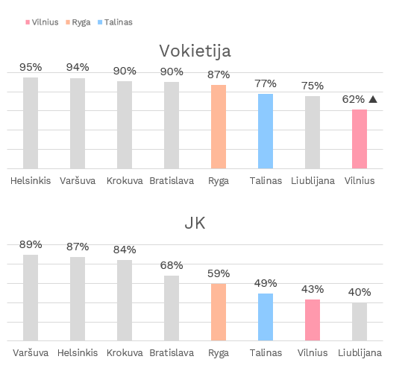  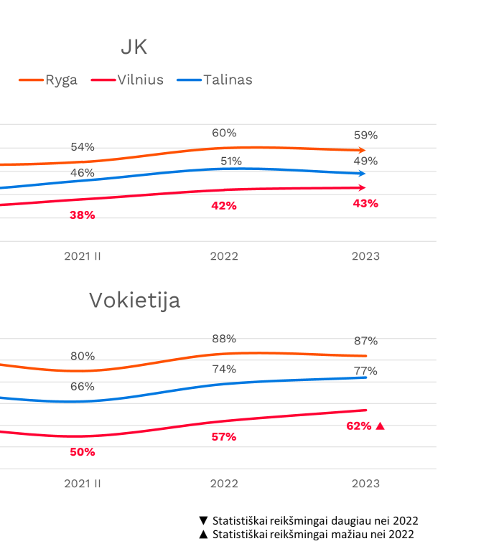  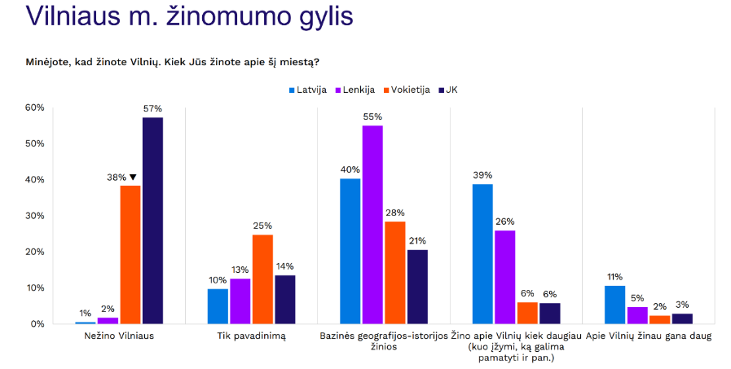  Global context: climate change, over tourism issues, the growing issue of sustainability, which is difficult to implement in the tourism sector (more flights are desired, but flights are the most polluting).  Obstacles  The UA war is very close to Lithuania, so Vilnius is seen as an unsafe location.  Vilnius has no internationally renowned attractions or works of art.  The small size of the buildings in Vilnius prevents large sporting events and concerts. The nearest neighbours are Riga and Tallinn, on the coast.  Vilnius has limited flight access and sustainable train travel is inconvenient.  Lithuania is the only one of the Baltic countries lagging behind on LGBTQ rights.  However, Vilnius is well received by visiting tourists, with low expectations being significantly exceeded and the intention to come again. The city impresses with its atmosphere, cosiness, beauty, greenery, humane size, ambience, excellent cuisine, which is still cheap for foreigners, and friendly inhabitants.
OPPORTUNITY:  (What is the end result of solving the problem? The problem the product will solve) | Draw the attention of potential travelling audiences to Vilnius.  Encourage TA to take an interest in Vilnius.  Create an image of Vilnius as an ARTISTC, BOLD, NEXT and COMFY city.  Communicate that Vilnius is easy to get to ( UK - flights, DE - cars, flights).
PROJECT IDEA: | Vilnius is a city that will meet TA expectations by revealing itself as unexpectedly amazing.
PRODUCT/PROJECT VALUE PROPOSAL:  (How will the product meet the user's needs? What value do we create/what is the uniqueness of the product/project?) | Vilnius is an undiscovered Baltic city with the spirit of a Western European city. As many as 98% of the inhabitants are happy. It's a city that combines modernity and cosiness and is easy to explore on foot. Ranked in the top five European capitals for the shortest commute to work (23 minutes on average), Vilnius offers a convenient daily routine, while 61% of its greenery gives you the chance to breathe in the nature surroundings.  The city is charmingly convenient - the airport is just 15 minutes from the city centre, while the lakes and forests can be enjoyed within 20 minutes. Vilnius also has a strong technology and business infrastructure. There is an ecosystem of as many as 740 start-ups, many of Lithuania’s unicorns are based here, and Fintech, IT, biotechnology and laser companies are creating high added value for Lithuania. The city has been recognised as having the best strategy in the European Cities and Regions of the Future ranking and as the fastest growing city in the CEE Business Services Summit & Awards 2023.  Vilnius also offers an exciting GASTRO scene and Michelin-starred restaurants, a wealth of events and leisure activities and an active nightlife. The city is distinguished by its unique historic UNESCO architecture, its Baroque buildings, its brutalist style, and unique experiences such as the conversion of Lukiskės Prison, art and pop festivals, wake parks, a TV tower and a hot-air balloon ride over the city. Vilnius has many places worthy of IG shots. Vilnius is safe. It’s 3rd in the world for online security.
PRODUCT FEATURES/ATTRIBUTES:  (What are the main design attributes (artistic, comfy, next, bold)? What are the main features?) | Vilnius is positioned through 4 features:  Comfy - cosy, green, safe, walkable. It’s a city for short breaks or for the working traveller, with a great work-life balance. A wide range of cultural events and products, and a UNESCO Old Town. Quality services: hotels, transport, gastro scene, events. Friendly, English-speaking residents.  Artistic - plenty of cultural events, artistic environment.  Next - technologically advanced (internet, transport, prominent businesses, start-up community)  Bold - open, bold. BOLD tone of voice, which refers to Vilnius’ comfy and artistic qualities.
COMPETITION: (Who are we competing with?) | Vilnius competes with Riga and Tallinn.
PROJECT OBJECTIVE:  (What do we want to achieve? How will we measure the success of the product/project) | - Increase the visibility of Vilnius and consistently shape the image of Vilnius, through Tone of Voice increase the recognition of Vilnius communication.  - Attract media attention in target markets; (e.g. at least 4 Tier1 media channels with publications inspired by the campaign, reaching at least 200M foreign audience).  - Inform about the availability of flights.
TARGET AUDIENCE:  (Who are we talking to? Country, age, interests, occupation, etc.) | People aged 25-44 who travel abroad at least 2 times a year, have never been to Vilnius before and like 2-3 night City breaks.  London (UK)  Berlin, Munich, Frankfurt, Hamburg (Germany).  Information about TA in Germany (2024 Travel Lithuania study)  Travellers aged 24-44, more female, with secondary education, middle and higher income, without children, travelling alone or with a partner, without beach holidays, like to visit small unique cities, interested in the food scene, culture and history, like to spend time in nature, looking for beautiful places to take photos, interested in active leisure.  They also enjoy taking part in cultural festivals and events. The most important information channels are family and friends, IG and Youtube, Google, Bing.  When it comes to travel, they choose to travel by car, ferry, train and bus, with air travel only in 6th place. Most buy their own flight tickets and *** and **** hotels, apartments, hostels on platforms.  Information about TA in the UK (2024 Travel Lithuania survey) - Traveller's interests are similar to those of a German traveller, only 25-44 year olds, more female, with higher education, middle and upper income, more childless, travelling with a couple, in addition to beach holidays, like to go to festivals and cultural events. Of particular interest is the topic of GASTRO and especially Fine dining. Loves being outdoors, interested in history and culture, likes to visit small towns. The most important information channels are TripAdvisor-like platforms, IG, Google and friends.  For travel, choose to travel by plane, train, car, ferry. Most buy their own flight tickets and apartments or houses on platforms, *** or ****hotels.
PROBLEMS, CHALLENGES AND POTENTIAL RISKS:  (What are the potential risks from the product, communication, PR, etc. sides?) | - The insight will not be relevant to foreign audiences, the message will not stand out in the noise of advertising, and it will not engage audiences and media  - The message will be attributed to other trademarks  - Political and economic news from the world, target markets will overwhelm the audience.
MARKETING AND COMMUNICATION INFORMATION
CONCEPT: | VILNIUS: UNEXPECTEDLY AMAZING
WHAT SHOULD THE TARGET AUDIENCE THINK ABOUT? | The message should surprise and interest. The TA should think they want to know more about Vilnius.
WHAT SHOULD THE TARGET AUDIENCE DO? | Click on the advertisement and visit the GoVilnius website or search for Vilnius on a search platform.  Watch the video for as long as possible.
THE TONE OF THE COMMUNICATION: | Bold (brave)
BRAND STYLE: | The GO Vilnius brandbook must be followed.  https://www.dropbox.com/scl/fi/75g6yaw7p3jwxbooyt30h/Vilnius-Brandbook-GoVilnius-Addition-2023.pdf?rlkey=v9fxkd7x2h3b6yfajqycgg24p&st=qppeib3p&dl=0
RECENT CAMPAIGNS IN VILNIUS: | Expectations vs Reality https://www.youtube.com/watch?v=ymffRgbzLhs&t=19s  Sorry, neighbors https://www.youtube.com/watch?v=jiHqQLla_BI  Christmas in Vilnius: https://www.youtube.com/watch?v=1OYbDuM4Y3s
PLANNING MEDIA CHANNELS AND ACTIONS ON THEM:  (SOMe, PR, banner advertising, outdoor advertising, event, etc. - list roughly to give an idea of scope) | - Public relations, updating the message of the campaign (cooperation with local PR agencies, press trips by journalists, events in the target cities, press releases)  - Vilnius GoV web and other own channels  - Paid advertising channels
PLANNED START OF COMMUNICATION: | July 2025
TASK
TASK:  (Specific task(s) for the Agency) | Development and implementation of two PR stunt marketing actions 3.6.9 or Advanced concepts in accordance with the requirements of 3.6.1. A creative agency should use professional data analysing international trends to generate insights into the concept, going beyond the client's audience research.  - Insight and strategy.  - Idea  - Message in EN, DE, LT.  - Reasoning for public relations (UK, DE, LT)  - An idea for advertising tools adapted to the specific channels recommended. For example, if banners are proposed, examples of typical formats should be given, if video is proposed, how it will be adapted to the psychology of digital channel consumption, where it has to catch the audience's attention from the first seconds.  - Idea for the content of a dedicated subpage on the Go Vilnius website (no new website being created).  - Idea for one of the traditional media.  - Preliminary timeline for implementation
AVAILABLE BUDGET: | Budget for creation and production of creative tools - 80K including VAT.
ADDITIONAL IMPORTANT INFORMATION:  (Research, open interviews and GoV insights.) | Travel Lithuania's research database contains research on Lithuania. Vilnius is the capital of Lithuania, so these studies can be partly used, but it is worth assuming that travellers have different expectations for cities than for outdoor holidays.  It is also important that the campaign objective AWARENESS.  https://lithuania.travel/other_files/data/2024/Vokietijos%20rinkos%20tyrimo%20ataskaita_Lituania%20Destination%20Report%20-%20German%20Market_Travellyze.pdf  https://lithuania.travel/other_files/data/2024/Jungtin%C4%97s%20Karalyst%C4%97s%20rinkos%20tyrimo%20ataskaita_Lituania%20Destination%20Report%20-%20UK_Travellyze.pdf  Exemplary communication campaigns in cities, countries:  Sweden: https://www.contagious.com/news-and-views/swedish-tourism-board-targets-myth-seekers-with-audio-tales  Oslo: https://www.google.com/search?q=oslo+ad+campaign&rlz=1C1GCEA_enLT1020LT1020&oq=oslo++ad&gs_lcrp=EgZjaHJvbWUqDAgCEAAYFBiHAhiABDIGCAAQRRg5MgcIARAAGIAEMgwIAhAAGBQYhwIYgAQyDQgDEC4YrwEYxwEYgAQyDQgEEC4YrwEYxwEYgAQyBwgFEAAYgAQyBwgGEAAYgAQyBwgHEAAYgAQyBwgIEAAYgAQyBwgJEAAYgATSAQg4OTcxajBqNKgCCLACAQ&sourceid=chrome&ie=UTF-8#fpstate=ive&vld=cid:d070d94f,vid:8vhD59ac7nw,st:0  Iceland:  https://www.youtube.com/watch?v=kbfD_lX1Tog  and other campaigns in Iceland.  What foreigners think of Lithuanians: https://sc.bns.lt/view/item/490506  All strong urban campaigns are met with a wave of dissatisfaction and criticism in the local market.

Order of the Minister of the Environment of the Republic of Lithuania No. D1-508 of 28 June 2011 “On the Approval of the List of Products for the Public Procurement and Procurement for which Environmental Criteria are to be Applied, Environmental Criteria and the Description of the Procedures for the Application of Environmental Criteria to be Applied by Contracting Organisations and Contracting Entities in the Procurement of Goods, Services and Works”.

