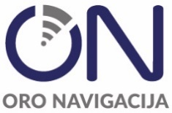

Dear all,
we would like to inform you that the term of the market consultation has been extended until the 7th of April, 2025 15.00 (Lithuania time).

Sveiki,
norime Jus informuoti, kad Rinkos konsultacijos terminas pratęstas iki 2025 m. balandžio 7 d. 15.00 val.

