REQUIREMENTS FOR PROCUREMENT OBJECT

REQUIREMENTS SPECIFICATION FOR INFORMATION SYSTEM FOR SERVICES FOR CREATING AN ESPBI IS SERVICE-ORIENTED ARCHITECTURE BASED ON THE FHIR5 STANDARD AND TESTING THE PARALLEL OPERATION OF TWO VERSIONS OF THE ESPBI IS (THE OLD FHIR0.8 AND THE NEW FHIR5) AS A PROOF OF CONCEPT (POC)

Table of Contents

1. Description & context 3
1.1. Terms and abbreviations 3
1.2. Project description and context 4
1.3. Assumptions and verification needs 4
1.4. AS-IS description 5
1.5. Technologies 5
1.6. Limitations and challenges 5
1.6.1. Centralized monolithic architecture 5
1.6.2. Proprietary data model 5
1.6.3. Data exchange mechanisms 5
1.7. General PoC objectives 6
2. Full-scale architecture 6
3. PoC requirements and objectives more in detail 8
3.1. General aspects of PoC objectives 8
3.2. Set-up for PoC 9
3.3. Medical documents to validate 9
3.4. Mapped resources to validate 9
3.5. Unmapped resources to validate 10
3.6. Validations (controls) to check 10
3.7. Performance requirements 11
3.8. Possible currently identified concerns 11
3.9. PoC objectives description 13
3.9.1. 1st priority objectives 13
3.9.1.1. Objective 1. Implement FHIR v5.0.0 13
3.9.1.2. Objective 2. Implement FHIR DSTU1 (v0.0.82) and FHIR v5.0.0 synchronization mechanism with a full mapping scenario. 16
3.9.1.3. Objective 3. Ensure that unmapped data between FHIR DSTU1 (v0.0.82) and FHIR v5.0.0 is identified and visualized for end-user in HTML or other recommended formats 20
3.9.1.4. Objective 4. Enhance ESPBIS authentication and authorization technology 28
3.9.2. 2nd priority objectives 30
3.9.2.1. Objective 5. Implement integration for regular client usage (mob. application, specialist portal, HIS) & ensure iframe or equivalent solution for data presentation 30
3.9.2.2. Objective 6. Implement integration with ULSVIS 35
4. Long-term ESPBI architecture 38
4.1. General Requirements: 38
4.2. Specific Requirements: 38
5. Requirements for service provision 40
5.1. Requirements for analysis and design 40
5.2. Project language 40
5.3. Requirements for documentation and its coordination 40
5.4. Requirements for project management 40
5.5. Requirements for change management 41
5.6. Ownership of the project results 42
5.7. General project requirements 42
6. Implementation activities & results 44
6.1. Project timeline requirements 44
6.2. Initiation & general project management stage 44
6.2.1. General stage requirements 44
6.2.2. Responsibilities 44
6.2.3. Required stage results 44
6.3. Requirements analysis stage 45
6.3.1. General stage requirements 45
6.3.2. Responsibilities 45
6.3.3. Required stage results 46
6.4. Design stage 46
6.4.1. General stage requirements 46
6.4.2. Responsibilities 47
6.4.3. Required stage results 47
6.5. Development and configuration stage 49
6.5.1. General stage requirements 49
6.5.2. Responsibilities 49
6.5.1. Required stage results 50
6.6. Deployment to test environment stage 51
6.6.1. General stage requirements 51
6.6.2. Responsibilities 51
6.6.3. Required stage results 51
6.7. UAT stage 51
6.7.1. General stage requirements 51
6.7.2. Responsibilities 52
6.7.1. Required stage results 52
6.8. Warranty stage 53
6.8.1. General stage requirements 53
6.8.2. Incident management (applicable for 6 months warranty period) 53
6.8.3. Support & maintenance (applicable for 6 months warranty period) 54
7. Licensing requirements 55

Description & context

Terms and abbreviations
Terms and abbreviations used are presented in table 1 “Terms and abbreviations used “.
Table 1. Terms and abbreviations used
Term/abbreviation | Description
API | Application programing interface
Client | State Enterprise Centre of Registers or RC
ESPBI IS | Lithuania's Electronic Health Services and Cooperation Infrastructure Information System (lit. Elektroninė sveikatos paslaugų ir bendradarbiavimo infrastruktūros informacinė sistema)
eLAB | Laboratory diagnostics subsystem of ESPBI (Laboratorinių tyrimų posistemė ESPBI)
EMR | Electronic medical record
FHIR | Fast Healthcare Interoperability Resources
HIS | Hospital information system
IS | Information system
JSON | JavaScript Object Notation
Keycloak | An open source identity and access management solution.
PoC | Proof of Concept
RC | State Enterprise Centre of Registers (lit. Registrų centras)
SAM | Ministry of Health (lit. Sveikatos apsaugos ministerija)
Service provider | The company that is providing software development services for the implementation of the project.
ULSVIS | State information systems for infectious diseases and their agents
XML | eXtensible Markup Language

Project description and context
Proof of Concept (PoC) of multiple FHIR versions maintenance in Lithuania's Electronic Health Services and Cooperation Infrastructure Information System (lit. Elektroninė sveikatos paslaugų ir bendradarbiavimo infrastruktūros informacinė sistema) (ESPBI IS) project goal is to ensure seamless transition to a newer version of FHIR.
ESPBI IS currently operates on the outdated FHIR DSTU1 (v0.0.82) standard version. Transitioning to a newer version of FHIR is a necessary step to improve interoperability, align with modern healthcare data standards and ensure scalability to meet future requirements. However, this migration presents challenges, that should be taken into consideration:
- The system's proprietary data model is heavily tied to FHIR DSTU1. Migrating to newer versions poses challenges, mainly:
  - Many data fields are not directly compatible with structures in newer FHIR versions.
  - Some resource types in DSTU1 lack direct equivalents in newer versions, increasing the risk of data loss or misrepresentation during the transition.
- Updating data exchange protocols to comply with newer FHIR standards requires:
  - Redevelopment of APIs and integration layers.
  - Investment from both internal teams and external partners who must adapt their systems to the new standards.
- Ongoing initiatives within ESPBI IS, such as patient registration component upgrades, telemedicine and disease prevention programs may influence the system’s roadmap. These interconnected projects could impact priorities, design and functionality during the migration process.
Given these challenges, conducting a PoC is crucial to identifying and mitigating potential risks and ensure a smooth transition. The primary objectives of the PoC are to:
- Validate the feasibility of migrating FHIR version while preserving data integrity.
- Assess the technical and resource implications of updating APIs and integration layers.
- Ensure interoperability with existing and future system components.
- Ensure that the migration process would be acceptable by system's clients and their end-users and would not identify major usability challenges.

Assumptions and verification needs
As this Proof of Concept (PoC) is conducted with the underlying assumption that direct data mapping between FHIR DSTU1 and FHIR v5.0.0 is currently not feasible, it is important to acknowledge that this conclusion has not yet been independently validated and it will be checked during other projects.
- Due to time and resource constraints, this PoC will operate under the stated assumption of non-interoperability without attempting direct mapping.
- It is anticipated that separate, future projects will undertake the verification of this assumption by attempting to establish whether direct mapping is feasible. Findings from these initiatives will be critical in shaping long-term strategic decisions on standard migration and interoperability solutions.
Therefore, PoC architecture does not aim to ensure full mapping of all resources, though achieving such coverage would be ideal. Instead, the focus will be on mapping key FHIR resources.

AS-IS description
ESPBI IS as is situation is described in publicly available documentation.

Technologies
Technological stack of Portals, ESPBI and related components:
- Portal API and ESPBI core– spring: 3.2.2 (Java 1.8)
- DB: oracle (ojdbc8): 19.18.0.0.
- Portal web:
- Angular.js - 1.5.11
- Angular: 16.1.8

Limitations and challenges

Centralized monolithic architecture
- ESPBI IS portals (patient, specialist, pharmacist) are directly tied to the business logic and data exchange layers.
- Update or maintenance activity risks downtime for all portals, disrupting end-user access and system operations. Update or maintenance activity risks downtime across multiple components, disrupting end-user access and system operations. Portals are connected through a load balancer, but the current architecture involves a tight integration with the Core system, which leads to changes affecting all connected components and portals.

Proprietary data model
- ESPBI IS for data management and storage currently uses a proprietary data model with unique data structure, heavily tied to FHIR DSTU1 (v0.0.82) in its centralized database.
- DSTU1 is an early beta version, designed for experimentation rather than production use.
- The data model is less expressive and structured, limiting its ability to represent complex healthcare scenarios to extract, normalize, and analyze data for insights or clinical research.
- Changes to data structures require significant development effort due to the lack of flexibility in the proprietary data model.
- The system lacks robust mechanisms for ensuring data quality and consistency, which are addressed in newer FHIR standards.

Data exchange mechanisms
- Communication between portals and the business logic layer is conducted via RESTful services based on FHIR DSTU1.
- The system lacks mechanisms to handle requests and data in different FHIR versions simultaneously. At this moment such objective was not identified as only FHIR DSTU1 was used.
- Using DSTU1 creates compatibility issues to integrate to the broader healthcare IT ecosystem and APIs, where tools, technologies, and frameworks built on open standards for example using newer FHIR versions. This requires custom integration layers and increase development and maintenance costs.

General PoC objectives
The PoC project is divided into specific objectives to define and manage its scope and goals. Each of these objectives is defined more in detail further in the document.
No. | Objective | Main tasks
 | Implement FHIR v5.0.0 core | Develop the ESPBI Core V2 stand-alone system leveraging the FHIR v5.0.0 standard. More details are provided in other section (see Objective 1. Implement FHIR v5.0.0).
 | Implement FHIR DSTU1 (v0.0.82) and FHIR v5.0.0 synchronization with a full mapping scenario | Develop FHIR DSTU1 (v0.0.82) and FHIR v5.0.0 synchronization mechanism and required components enabling both forward and backward interoperability with a full mapping scenario of resources:  1.1. Patient,  1.2. Organization,  1.3. Practitioner,  1.4. Encounter,  1.5. Condition,  1.6. Allergyintolerance,  1.7. Medication,  1.8. Substance.  More details are provided in other section (see Objective 2. Implement FHIR DSTU1 (v0.0.82) and FHIR v5.0.0 synchronization mechanism with a full mapping scenario.
 | Ensure that unmapped data between FHIR DSTU1 (v0.0.82) and FHIR v5.0.0 is identified and visualized for end-user in HTML or other recommended formats | This task involves covering and testing scenarios where data between FHIR DSTU1 (v0.0.82) and FHIR v5.0.0 is not mapped, focusing on visualizing data in other ways. The visualization will be implemented in HTML or other recommended formats to ensure the end-user can read the data even from different FHIR version information system. More details are provided in other section (see Objective 3. ).
 | Enhance ESPBIS authentication and authorization technology | Develop authentication and authorization processes to be based on Keycloak IAM solution. Service provider can propose to use alternative solution to Keycloak, however it shall be aligned with the Client and it should be fully matching all Keycloak functionalities and licencing terms. More details are provided in other section see (Objective 4. Enhance ESPBIS authentication and authorization technology).
 | Implement integration for regular client usage (mob. application, specialist portal, HIS) & ensure iframe or equivalent solution for data presentation | Develop required interfaces to enable regular clients (specialist portal, mobile application and HIS) to access ESPBI IS PoC. More details are provided in other section see (Objective 5. Implement integration for regular client usage (mob. application, specialist portal, HIS) & ensure iframe or equivalent solution for data presentation ).
 | Implement integration with ULSVIS | Develop required interfaces and components to enable integration with ULSVIS. More details are provided in other section (see Objective 6. Implement integration with ).

Full-scale architecture
- Full-scale architecture is presented and later in the document separated into smaller parts based on each of the objectives. Components and integrations marked in green presents parts that are not currently in place and should be developed during the project.
- The legacy systems test versions will be provided by the Client during the project, however the integrations or adjustments should be conducted by the Service Provider (presented more in detail on other section see Set-up for PoC).
- Service Provider is eligible to suggest alternative architectural principles to achieve project objectives, however they should be aligned with the Client and project purposes.

Figure 2: Full-scale architecture
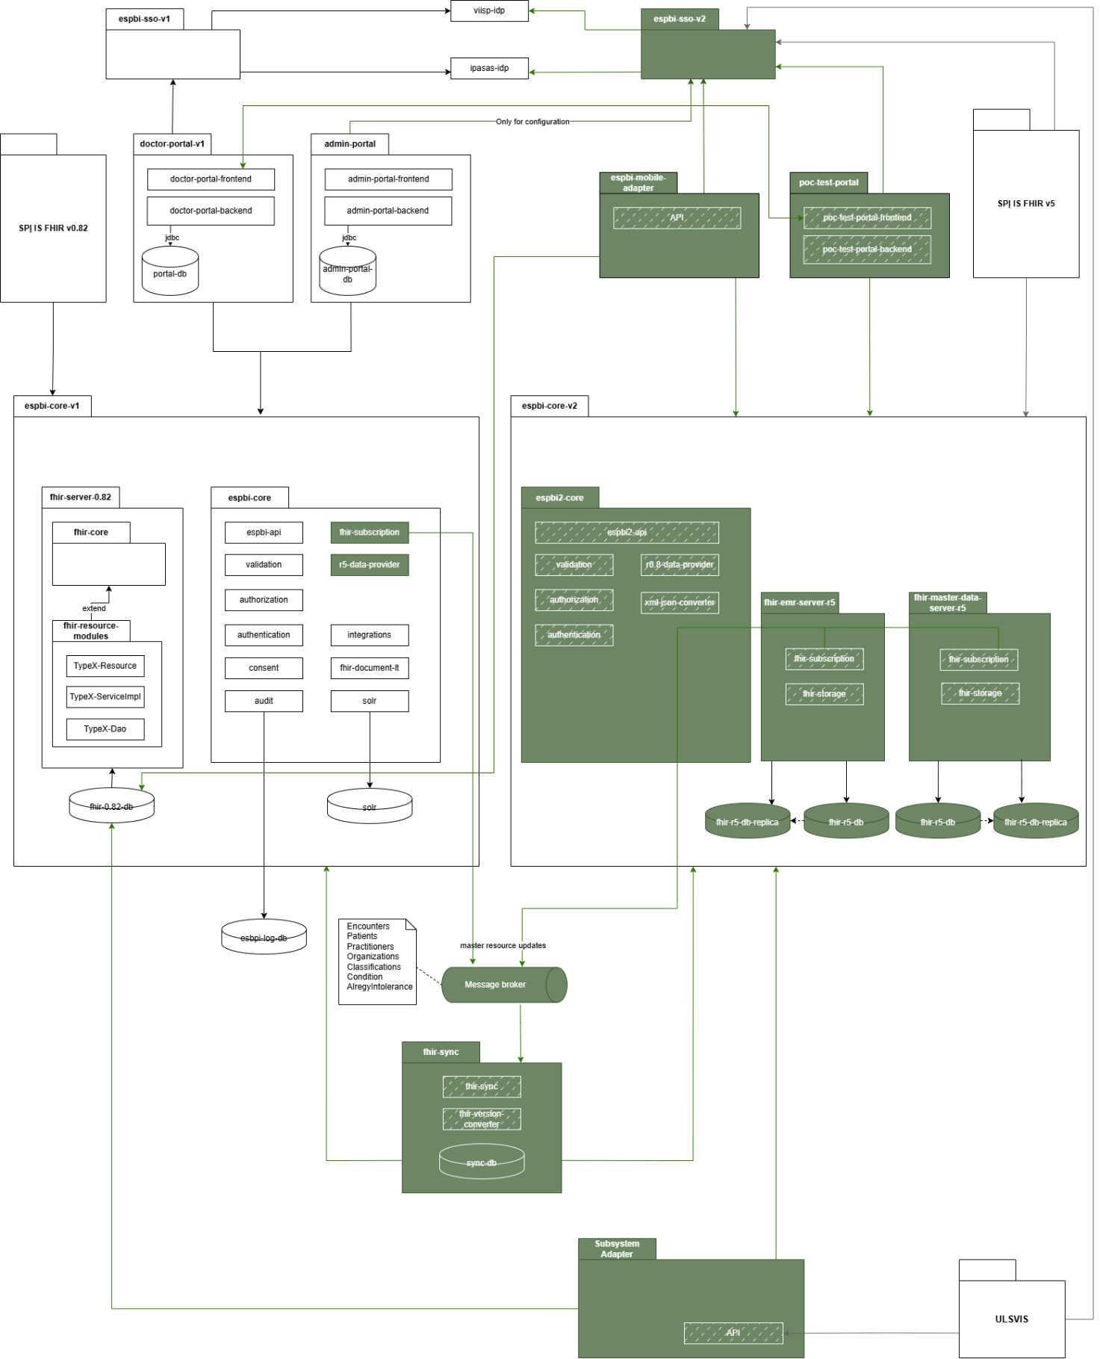

PoC requirements and objectives more in detail

General aspects of PoC objectives
- This section provides a detailed description of each project objective. For each objective, the component architecture is presented along with explanation. Where applicable, sequence diagrams are included to illustrate data flow within the objective (these diagrams serve as examples and may be adjusted based on recommendations from the Service Provider). Additionally, test scenarios or validation criteria are outlined to guide the evaluation of each objective, with insights and recommendations expected from the Service Provider. The Service Provider may propose additional or revised testing scenarios or components, provided if they are agreed with the Client.

Set-up for PoC
- Service provider is responsible to ensure all applications, data integrations or infrastructure required to perform PoC, unless it is indicated differently in the technical specification. The components that are not marked as changed in the architecture (the FHIR DSTU1 components) would be provided by the Client together with TEST environment, however these components might need modification to ensure PoC objectives are met. Service provider is responsible not only for ensuring additional components, but also for modifying existing ESPBI components in TEST environment to achieve these goals.
- The service provider must ensure that all provided components are compatible with the existing ESPBI infrastructure and can integrate with the Client's systems without significant changes.
- The service provider must ensure that all provided components are deployable onto OpenShift platform provided by the client and can integrate with the existing components without significant changes.
- The service provider must document the installation, configuration, and setup procedures for all components provided for the PoC. Documentation more in detail is provided in other sections.

Medical documents to validate
- The PoC scenarios should be conducted using selected medical documents. Each scenario (where applicable) should be tested against all mentioned documents. The following documents have been identified for testing purposes:
  - E027: Medical document summary / referral (form 027/a).
  - E027-ats: Response to referral.
  - EREC01: prescription

Mapped resources to validate
- At least these resources are projected to be mapped. Service Provider shall conduct mapping of these resources and ensure the possibility to assure interoperability of these resources (if additional resources would be identified during the project, such resources also could be mapped based on additional hours principle (change request):
  - Patient,
  - Organization,
  - Practitioner,
  - Encounter,
  - Condition,
  - Allergyintolerance,
  - Medication,
  - Substance.
- The following figures represent an approximate set of resources managed within a 7-day period:
  - Patient - 202,731
  - Practitioner - 1,110
  - Organization - 31
  - Medication - 2,092
  - Substance - 277
  - Encounter - 3,349,710
  - Condition - 2,524,094
  - AllergyIntolerance - 7
  - Number of documents (referrals) - 261,871.

Unmapped resources to validate
- For scenarios where unmapped resources need to be tested, these resources should be taken into account:
  - ImmunizationRecommendation - records of planned vaccination schedules.
  - Observation. Different type of observations:
    - risk factors
    - work capacity level
    - disability level
    - special needs.
  - Device (medical devices / implants) - (currently unavailable but expected to be introduced with other tender. Structure is already defined and the Device endpoint exists but is not yet in use).
  - Procedure - surgical procedures.
  - AdverseReaction - suspected adverse reactions.

Validations (controls) to check
- During the PoC, testing will focus on the following two validations, unless critical additional validations are identified that require testing (if additional validations would be identified during the project, such validations also could be conducted based on additional hours principle (change request). Any such additional validations will be addressed separately and agreed upon with the Client. These validations aim to determine whether 2 different FHIR standard information systems can operate together effectively and ensure data interoperability in alignment with the provided PoC objectives:
  - Validation #1 - RMPR_0024 Message Text: Medication with this ATC code level 5 has already been prescribed, and the treatment course has not yet ended.
    - The system checks if a medication with the specified ATC code level 5 is already prescribed to the patient:
    - If the prescription status is "Active," the system verifies whether [the date of the already prescribed medication] + [duration of use in days] <= the date of the newly prescribed medication.
  - Validation #2 - ERMPR_3005 message text: If the medication is an LTI, it must be prescribed with a specific active ingredient unless it is the first time it is being prescribed. Applies to both reimbursable and non-reimbursable medications.
    - If active active ingredient has no prior prescriptions in the patient’s history, no specific one is required.
    - If the active ingredient has been prescribed before, the new prescription must include a specific medication with such active ingredient.

Performance requirements
- System must be capable of synchronizing a full day’s worth of data from ESPBIv1 to ESPBIv2 within one hour, assuming all HIS systems initiate synchronization simultaneously.
- The system must process the following data volumes within this timeframe:
  - Encounter – 480,000 resources per hour (8,000 per minute, ~133 per second).
  - Condition – 360,000 resources per hour (6,000 per minute, ~100 per second).
  - Patient – 30,000 resources per hour (500 per minute, ~8 per second).
  - Total Load – 870,000 resources per hour (14,500 per minute, ~242 per second).
- Synchronization messages must be evenly distributed over each minute to ensure stable system performance and avoid peak load bursts.
- Each synchronization message must be fully processed in no more than 3 seconds from the moment it is sent from ESPBIv1 to ESPBIv2.
- System must support concurrent processing of synchronization requests from multiple HIS systems without performance degradation.
- Scalability must be ensured to handle future increases in data volume while maintaining the defined 3-second processing time.
- Error-handling mechanism must be in place to detect and recover from synchronization failures.
- Failed messages must be retried automatically within the allowed 3-second processing window, ensuring eventual consistency.
- No performance requirements are specified for synchronization from ESPBIv2 to ESPBIv1, as ESPBIv1 storage optimization is assumed to be handled by the vendor.

Possible currently identified concerns
- This section outlines the currently identified concerns for the Service Provider to consider. The Service Provider should take these concerns into account, address them, and provide insights for each one of them in the analysis documentation. These concerns are not exhaustive and may evolve or be disproven during the project:
  - Differences in specialist resource types between FHIR versions may lead to mismapped data fields during retrieval. This can cause inconsistencies in how specialist information is accessed and represented across systems.
  - When using filters to query specialists across DSTU1 and v5.0, variations in resource definitions and query parameters may result in incomplete or mismatched data retrieval outcomes.
  - If organization identifiers are generated or structured differently across databases or FHIR versions, inconsistent mapping may affect access to patient data across encounters, potentially hindering data integration.
  - Discrepancies in how active Encounters are represented or mapped between different databases could make it challenging to verify them, impacting access control and data accuracy despite full mapping efforts.
  - Without a clear, standardized approach to setting access permissions, data requests may be inconsistently applied across systems or services. This can lead to unauthorized access or denial of legitimate access due to varying interpretations of permission settings.
  - During the transition period, systems may need to handle different result delivery formats—such as AtomFeed in DSTU1 versus Bundle in v5.0—and varying ID structures. This coexistence can cause data compatibility issues for consumers interacting with both FHIR versions simultaneously.
  - Incompatibilities in handling existing diagnoses between FHIR versions—for example, differences in resource structures or coding systems—may disrupt treatment continuity. Essential diagnostic information might be misrepresented or lost, and this concern is highlighted in test scenarios involving diagnosis data migration.
  - Updating data across different FHIR versions could lead to versioning conflicts or errors due to differences in resource schemas, validation rules, or update mechanisms, potentially affecting data integrity.
  - Inconsistent structuring of XML/JSON data for signed PDFs across different FHIR versions may cause issues in storage, retrieval, and validation. This inconsistency can affect the integrity and accessibility of legally significant documents.
  - Ensuring compatibility when handling various orders and results is crucial to prevent incomplete processes and ensure continuity of care (the whole process should be finished and does not stop due to FHIR version differences).
  - Data inconsistency between old and new standards during the transition period may cause data fragmentation or loss. Implementing careful data mapping and synchronization strategies is essential to maintain data integrity throughout the transition.

PoC objectives description

1st priority objectives

Objective 1. Implement FHIR v5.0.0

- The objective will be considered achieved when the following conditions are met:
  - ESPBI Core V2 stand-alone system meets the requirements provided in the Table 3: Objective 1 Implementation requirements and component description.
  - ESPBI Core V2 stand-alone system consists of components and data integrations provided in the Figure 3: Objective 1. Components diagram.
  - Testing scenarios are checked and achieved required result listed in the table below Table 4: Objective 1. Testing scenarios
Table 3: Objective 1 Implementation requirements and component description
Nr. | Requirement | Notation in components diagram
 | ESPBI Core V2 must perform validations of process and data from FHIR servers fhir-emr-server-r5 and fhir-master-data-server-r5 and reject invalid or non-compliant inputs. | validation
 | ESPBI Core V2 should transform data between XML and JSON formats. | xml-json-converter
 | ESPBI Core V2 should contain a server to manage current data (which is equally written and read). | fhir-emr-server-r5
 | ESPBI Core V2 should contain a server to manage demographic data (which is less frequently overwritten). | fhir-master-data-server-r5
 | ESPBI Core V2 should have a database, which is required to store FHIR resources. | fhir-r5-db
 | ESPBI Core V2 should have a database replica to offload read-heavy operations from the primary database, improving system performance. | fhir-r5-db-replica
 | ESPBI Core V2 should be able to send and receive data or requests. | espbi2-api

Figure 3: Objective 1. Components diagram
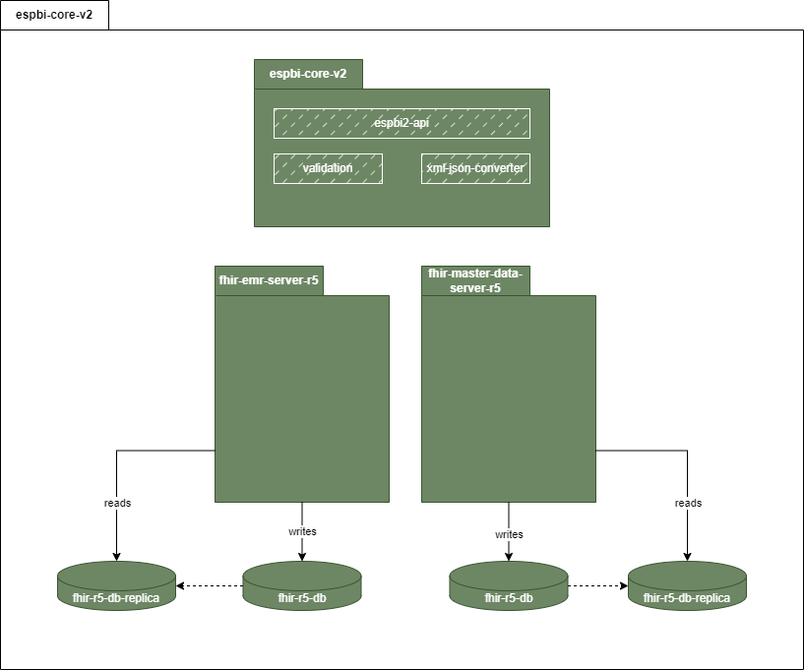
Table 4: Objective 1. Testing scenarios
Nr. | Scenario | Description | Expected result
 | New resource created | New resource (e.g. Patient resource) is created based on FHIR r5 version | New resource is created based on FHIR r5 standard.
 | New document is read consisting of newly created resource | New document out of the list (see Medical documents to validate) is viewed consisting of newly created resource. | Document is created and viewed.
 | Resource conversion | Newly created resource is converted from XML to JSON format. | Resources are converted to other format.
 | New resource created for respective FHIR server | 2 resources are created and based on their type are written to the appropriate FHIR data server. | 2 resources have been created - one for demographic data server (Patient resource) and another for non-demographic (FHIR emr data server).

Objective 2. Implement FHIR DSTU1 (v0.0.82) and FHIR v5.0.0 synchronization mechanism with a full mapping scenario.
- The objective will be considered achieved when the following conditions are met:
  - The synchronization mechanism meets the requirements provided in the Table 5: Objective 2. Implementation requirements and component description.
  - The synchronization mechanism consists of components and processes provided below.
  - The synchronization mechanism must enable forward and backward interoperability with a full mapping scenario of resources:
    - Patient,
    - Organization,
    - Practitioner,
    - Encounter,
    - Condition,
    - Allergyintolerance,
    - Medication,
    - Substance.
  - Testing scenarios are performed and achieved the required result listed in the Table 6: Objective 2. Testing scenarios.

Table 5: Objective 2. Implementation requirements and component description
Nr. | Requirement | Notation in components diagram
 | The new Core V2 architecture must support operations using the servers fhir-emr-server-r5 and fhir-master-data-server-r5 while ensuring data compatibility and synchronization with the legacy Core V1 architecture. | fhir-emr-server-r5  fhir-master-data-server-r5
 | The legacy system (ESPBI Core V1) must support operations using the fhir-server-0.82 while ensuring data compatibility and synchronization with the new Core V2 architecture. | the fhir-server-0.82
 | Synchronization mechanism must include components for event (create, delete, update) subscriptions monitoring, management and notifying about updates to resources in both ESPBI core components v1 and v2. | fhir-subscription
 | Ensure persistent storage for FHIR resources with support for versioning, validation, and efficient querying in the EPBI core V2 FHIR servers. | fhir-storage
 | Synchronization mechanism must include central message broker for publishing and distributing resource updates. | Message broker
 | Synchronization mechanism must include components dedicated to facilitating synchronization of FHIR resources between FHIR 0.82 to FHIR R5 and ensures backward and forward compatibility. | fhir-sync
 | Synchronization mechanism must include components, which converts FHIR resources between FHIR 0.82 to FHIR R5 and ensures backward and forward compatibility. | fhir-version-converter
 | Synchronization mechanism must include components, which stores metadata and logs related to synchronization operations (e.g. relations between resource representations across different systems). | sync-db

Figure 4: Objective 2. Components diagram
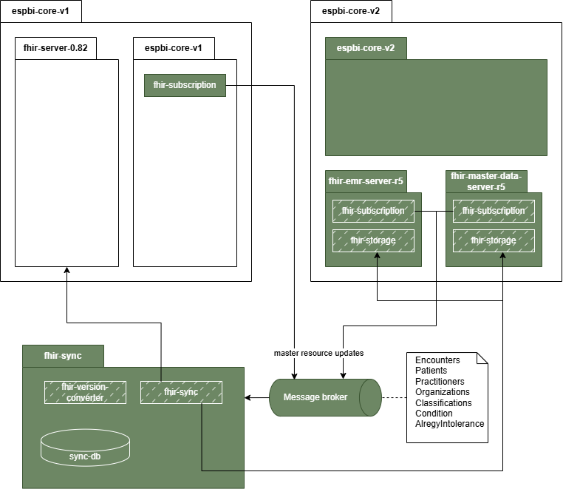

Figure 5: Objective 2. Sequence diagram
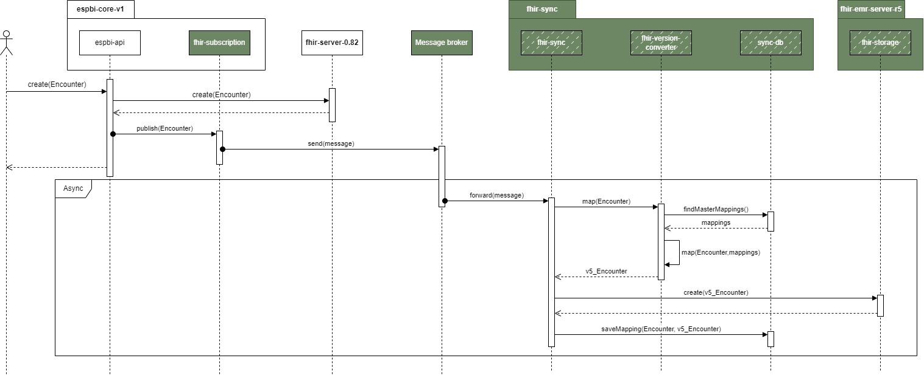

Table 6: Objective 2. Testing scenarios
Nr. | Scenario | Description | Expected result
 | Resource created, updated, deleted in new (R5) and read in old (DSTU1) version | Resource is created, updated, deleted in FHIR R5 and must be read in FHIR DSTU1, with all resources synchronized (mapped) between versions. Testing should be conducted with the mentioned mapped resources (see 34.3). | Resource is presented with all the mapped data points.
 | Resource created, updated, deleted in old (DSTU1) and read in new (R5) version | The resource is created, updated, deleted in FHIR DSTU1 and must be read in FHIR R5, with all resources synchronized (mapped) between versions. Testing should be conducted with the mentioned mapped resources (see 34.3). | Resource is presented with all the mapped data points.
 | Reference ID of resources mapped | When a new resource is created its reference ID is mapped to the reference ID of the corresponding core system in FHIR sync component. | List of resources with mapped reference IDs.
 | Encounter synchronization fail | New encounter is registered in the core v1 (FHIR DSTU1) but fails to synchronize with the new system. As a result, when attempting to access this encounter in the new system, it will not be available due to the lack of synchronization between the two systems. | It should not be possible to manage data without outstanding encounter. Service Provider shall additionally include (not only for this scenario) insights on how the risk could be managed.

Objective 3. Ensure that unmapped data between FHIR DSTU1 (v0.0.82) and FHIR v5.0.0 is identified and visualized for end-user in HTML or other recommended formats
- Service provider must develop mechanism and required components for handling data from FHIR DSTU1 (v0.0.82) and FHIR v5.0.0 without implementing any direct mapping or synchronization. Instead, the focus will be on visualizing the unmapped data in HTML or an equivalent format. This approach is based on the assumption that direct data mapping between FHIR DSTU1 and FHIR v5.0.0 is currently not feasible (please refer to Assumptions and verification needs).
- The objective will be considered achieved when the following conditions are met:
  - Data handling mechanism meets the requirements provided in the Table 7: Objective 3. Implementation requirements and component description.
  - Data handling mechanism consists of components and processes provided in other section, Figure 7: Objective 3. Sequence diagram and Figure 8: Objective 3. Sequence diagram (partial mapping scenario).
  - Testing scenarios are performed and achieved required result listed in the Table 8: Objective 3. Testing scenarios .

Table 7: Objective 3. Implementation requirements and component description
Nr. | Requirement | Notation in components diagram
 | Data handling mechanism should involve FHIR DSTU1 (v0.0.82) version r0.8-data-provider in ESBI Core V2, which by interacting with fhir-server-0.82 in ESPBI core V1 extracts data and transforms it into HTML (or similar) format, so ESBI Core V2 can read and display result. | r0.8-data-provider
 | Data handling mechanism should involve FHIR v5.0.0 version r5-data-provider in ESBI Core V1, which by interacting fhir-emr-server-r5 and fhir-master-data-server-r5 in ESPBI core V2 extracts data and transforms it into HTML (or similar) format, so ESBI Core V1 can read and display result. | r5-data-provider

Figure 6: Objective 3. Components diagram
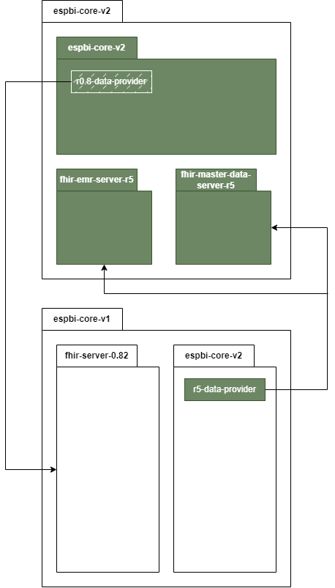

Figure 7: Objective 3. Sequence diagram
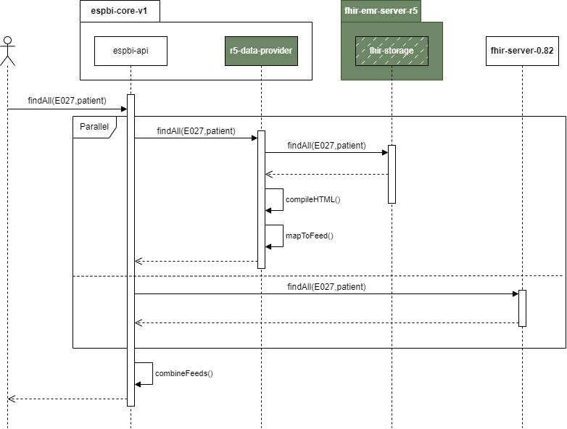

Figure 8: Objective 3. Sequence diagram (partial mapping scenario)
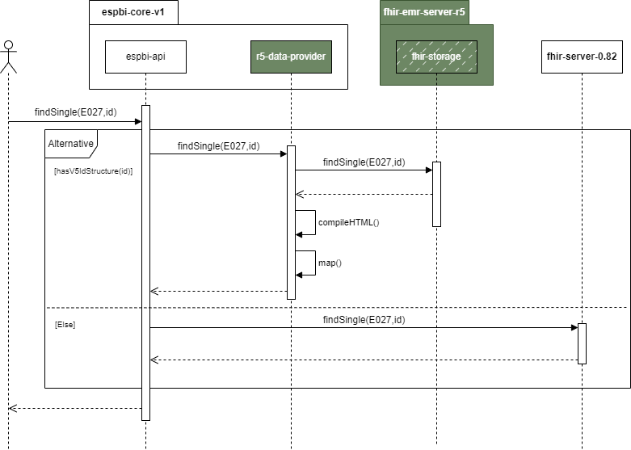

Figure 9: Objective 3. Sequence diagram (partial mapping scenario)
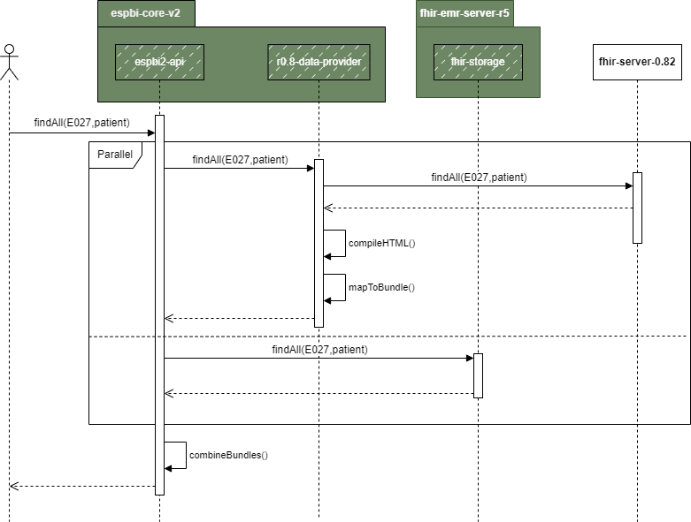

Table 8: Objective 3. Testing scenarios
Nr. | Scenario | Description | Expected result
 | Document created, updated, deleted in new (R5) and read in old (DSTU1) version | Document (list of documents is provided in other section see medical documents to validate) is created, updated, deleted in FHIR r5 and needs to be read in FHIR DSTU1. Mapped document data should be properly synchronized, while unmapped data should be displayed in HTML or an equivalent format proposed by the Service Provider. | Document is presented with all the mapped data points. If the data points are not mapped, then HTML is presented in addition. Document that should be tested with is provided in other section (see medical documents to validate).
 | Document created, updated, deleted in old (DSTU1) and read in new (R5) version | Document (list of documents is provided in other section is created, updated, deleted in FHIR DSTU1 and needs to be read in FHIR R5. Mapped document data should be properly synchronized, while unmapped data should be displayed in HTML or an equivalent format proposed by the Service Provider. | Document is presented with all the mapped data points. If the data points are not mapped, then HTML is presented in addition.
 | Resource created, updated, deleted in new (R5) and read in old (DSTU1) version | Resource is created, updated, deleted in FHIR R5 and must be read in FHIR DSTU1. However, the resource is not mapped, and it should be presented as HTML format similar. The test should be presented with at least 5 resources that should be decided during the project. | Resource is presented with all mapped data, while unmapped data should be presented as HTML or similar format.
 | Resource created, updated, deleted in old (DSTU1) and read in new (R5) version | The resource is created, updated, deleted in FHIR DSTU1 and must be read in FHIR R5. However, the resource is not mapped, and it should be presented as HTML format similar. The test should be presented with at least 5 resources that should be decided during the project. | Resource is presented with all mapped data, while unmapped data should be presented as HTML or similar format.
 | Document search | Documents of a specific type are searched across both the old and new FHIR version databases. The resulting document lists from both versions are combined and displayed together. However, documents are only presented in the structured manner if their format version matches the one that is currently in use. Documents from the other version must first be converted to HTML format before being opened. Paging risks should be managed to ensure the search results are unified, and the system should determine which results to display. It should also be possible to sort or filter results. | List of all selected type of documents from both versions.
 | Resource data list view | FHIR R5 specialist submits a request to retrieve a list of all specific resource that has not been mapped. Testing should include scenarios where there is no direct one-to-one correspondence between resource types in both versions, such as a single resource in FHIR DSTU1 being divided into separate resources in FHIR R5. | List of resources is presented.
 | Data retrieval from previous FHIR version | Specialist is creating a new document and needs to select an existing diagnosis for the patient, as it continues previously initiated treatment. The system retrieves the patient’s diagnosis history, including active Encounters, ensuring that Encounter representations are accurately mapped between FHIR versions. | The system retrieves the patient’s diagnosis history. The selected diagnosis is then linked to the new document.
 | Query branching avoidance | To avoid multiple requests (branching), the system must determine which database to query to maintain high performance. This scenario should be tested in at least 3 instances. | Query is executed only in a specific database.

Objective 4. Enhance ESPBIS authentication and authorization technology
- The objective will be considered achieved when the following conditions are met:
  - The authentication and authorization processes meet the requirements provided in the Table 9: Objective 4. Implementation requirements and component description.
  - Authentication and authorization processes consists of components and processes provided in the Figure 10: Objective 4. Components diagram.
- Testing scenarios are performed and achieved the required result listed in the Table 10: Objective 4. Testing scenarios.
Table 9: Objective 4. Implementation requirements and component description
Nr. | Requirement | Notation in components diagram
 | The developed authentication and authorization processes should provide a middleware component in Core V2 API, which handles token validation and role enforcement. The permission policy must be configured, and users with the appropriate role are created. | espbi2-api

Figure 10: Objective 4. Components diagram
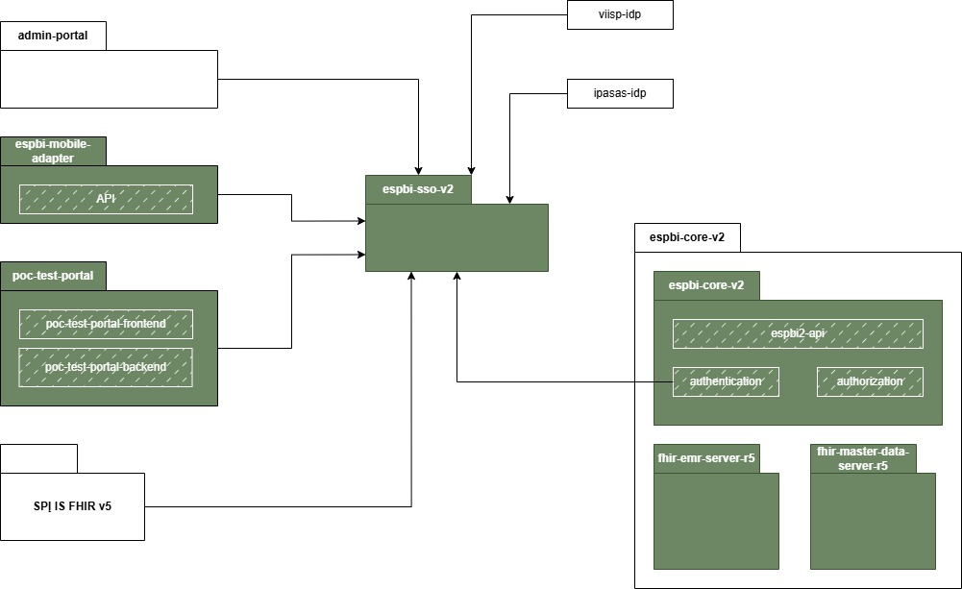

Table 10: Objective 4. Testing scenarios
Nr. | Scenario | Description | Expected result
 | User authorization | Keycloak permission policy is configured, and a new user with the appropriate role is created. The user attempts to log in and access data for which they have the necessary permissions. Subsequently, they attempt to access data for which they do not have permission, and access should be denied. | User authorization allow / disallows user to access data based on role information.
 | External system authorization (SPĮ IS FHIR v5) | SPĮ IS FHIR v5 performs authorization and requests data. Data for which SPĮ IS FHIR v5 has the necessary permissions is provided, while access to unauthorized data is denied. | Authorization mechanism allows / disallows external system to access data.

2nd priority objectives

Objective 5. Implement integration for regular client usage (mob. application, specialist portal, HIS) & ensure iframe or equivalent solution for data presentation
- The objective will be considered achieved when the following conditions are met:
  - The developed interfaces meet the requirements provided in the Table 11: Objective 5. Implementation requirements and component description.
  - The developed interfaces consist of components and processes provided in the Figure 11: Objective 5. Components diagram.
  - Testing scenarios are performed and achieved the required result listed in the Table 12: Objective 5. Testing scenarios.
Table 11: Objective 5. Implementation requirements and component description
Nr. | Requirement | Notation in components diagram
 | It is planned that the newly developed test portal should access data from the old system (v1) and enable users to view it directly within the new test portal. PoC test portal should cover Sign-In/Out via KeyCloak together with operations with various non synchronized ESPBI documents and resources mentioned in the testing scenarios under PoC Objectives. While the old system (v1) will support data viewing via an iframe, the new system may not offer this functionality due to potential challenges with token exchange. Therefore, it is not mandatory to implement iframe functionality for the new system, but the Service Provider must define how the functionality should work and describe possible scenarios and alternatives to solve it. | poc-test-portal  poc-test-portal-frontend
 | The improved specialist’s portal should access data from the new (v2) system, and it should be viewable directly on the specialist portal. In addition to converting the data to HTML format or opening the document via different portal, the data should be accessible through an iframe or a similar functionality suggested by the Service provider. | doctor-portal-v1  doctor-portal-frontend
 | The developed v2 API must provide mapped data seamlessly while unmapped data should be presented in HTML or a similar format to the SPĮ IS FHIR v5 system. | espbi2-api
 | The developed v2 API should receive data requests and parameters such as UserID, PatientID, DocumentTypeCode, EncounterOrganizationID, DateFrom, and DateTill from the ESPBI Mobile throughout the adapter. The adapter should receive and handle data from both systems (V1 and V2) unified, and returned in a single response. The response includes documents and visit details as shared in Table 12: Objective 5. Testing scenarios. | espbi-mobile-adapter  espbi2-api  espbi-api

Figure 11: Objective 5. Components diagram
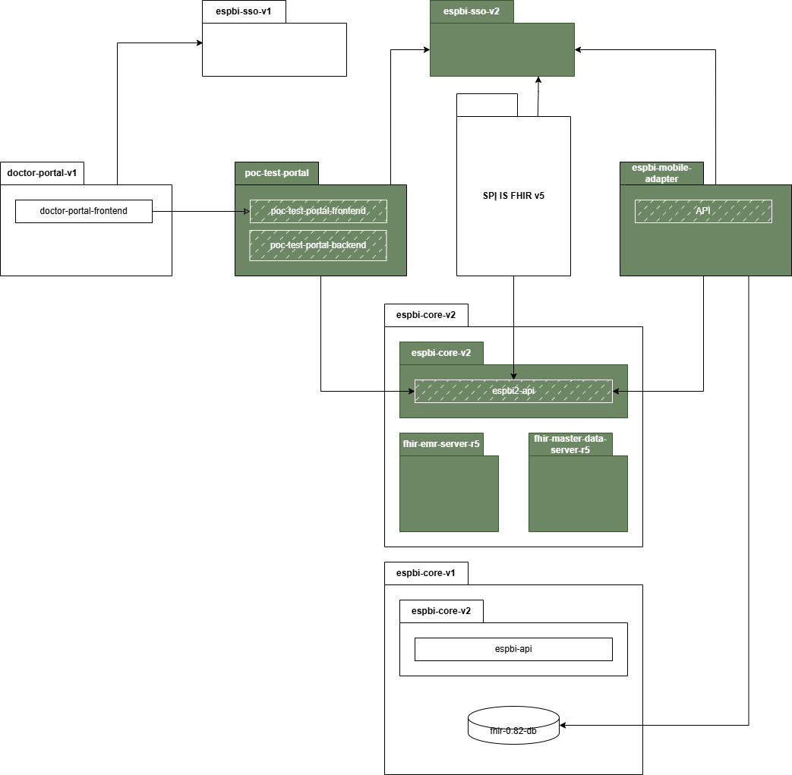
Table 12: Objective 5. Testing scenarios
Nr. | Scenario | Description | Expected result
 | Document created in new (R5) and read in old (DSTU1) version (Iframe or equivalent functionality) | Document linked to a sequence, such as a referral and its response, is managed within a single system. When a specialist opens the document in the old version of the system and seeks to review data from the new system, the data should be viewable directly within the old system. For viewing purpose, the data should be presented in HTML or similar format. For user functions, instead of converting the data to HTML format or requiring the document to be opened in the other system, the data should be accessible through an iframe or a similar functionality suggested by the Service provider. | Data is presented directly in the system using iframe or similar functionality.
 | Document created in old (DSTU1) and read in new (R5) version (SPĮ IS FHIR v5) | A document is opened in the new version portal (FHIR v5 system), and the user seeks to review data from the old Core v1 system. Data should be presented in HTML or a similar format. In another instance, the specialist closes the FHIR v5 system, accesses the Core v1 portal, and opens the same document to review it. Iframe functionality should be described (ideally provided) but it is not necessary as there might be challenges with token exchange. Service provider should define possibilities and alternatives how iframe or similar approach could be used for this purpose. | HIS specialist checks the document through HTML presentation possibility and with possibility to access old version of the (core1) portal and provide insights and recommendations regarding iframe or similar functionality.
 | Token exchange functionality | The Core v1 system provides possibility to submit data using an iframe or a similar functionality. Since Core v1 utilizes SSO v1 and the new Core v2 uses SSO v2, there should be no additional authorization requests for the user, and the token should be accepted. This scenario should be tested in one direction - opening the old system and displaying data from the new system. Vice-versa scenario should only be described identifying risks and providing possible solutions and suggestions. | Tokens are exchanged and iframe is displayed for data submission. No additional authorization is required.
 | Patient visit list view | ESPBI mobile adapter submits a request to retrieve a list of patient visits across two parallel ESPBI systems (FHIR DSTU1 and FHIR R5 cores). The application sends the request to get visit data for a specific patient, including parameters such as UserID, PatientID, DocumentTypeCode, EncounterOrganizationID, DateFrom, and DateTill. The data is received from both systems, unified, and returned in a single response. The response includes detailed visit information such as visit ID, status, class, type, associated patient and organization details, register information, and visit periods. The scenario is tested to ensure that the data is retrieved accurately from both systems, regardless of the differences in database structure or FHIR versions. | Patient list data is provided to mobile application.
 | Patient document list | ESPBI mobile adapter submits a request to retrieve a list of documents for a specific patient across the two ESPBI systems (FHIR DSTU1 and FHIR R5 cores). The request includes parameters like UserID, PatientID, DocumentTypeCode, DocumentOrganizationID, DocumentEncounterID, DateFrom, and DateTill. The system receive document data from both systems, consolidates it, and returns a unified list. The response contains document details such as document ID, type, name, associated patient and organization information, encounter ID, document creation date, author details, and additional document-specific information. The scenario is tested to verify that the unified document data is correctly received and returned, while ensuring that the system can handle large data volumes efficiently during the transitional period. | Patient document data is provided to mobile application.

Objective 6. Implement integration with ULSVIS
- The objective will be considered achieved when the following conditions are met:
  - The integration meets the requirements provided in the Table 13: Objective 6. Implementation requirements and component description.
  - The developed interfaces consist of components and processes provided in the Figure 12: Objective 6. Components diagram .
  - Testing scenarios are performed and achieved the required result listed in the Table 14: Objective 6. Testing scenarios.

Table 13: Objective 6. Implementation requirements and component description
Nr. | Requirement | Notation in components diagram
 | The integration must enable ULSVIS to request data via newly developed subsystem adapter component, where data should be aggregated and provided to ULSVIS. | subsystem-adapter
 | The integration must include authentication and authorization processes, which handles token validation and role enforcement, and the permission policy must be configured. | subsystem-adapter

Figure 12: Objective 6. Components diagram
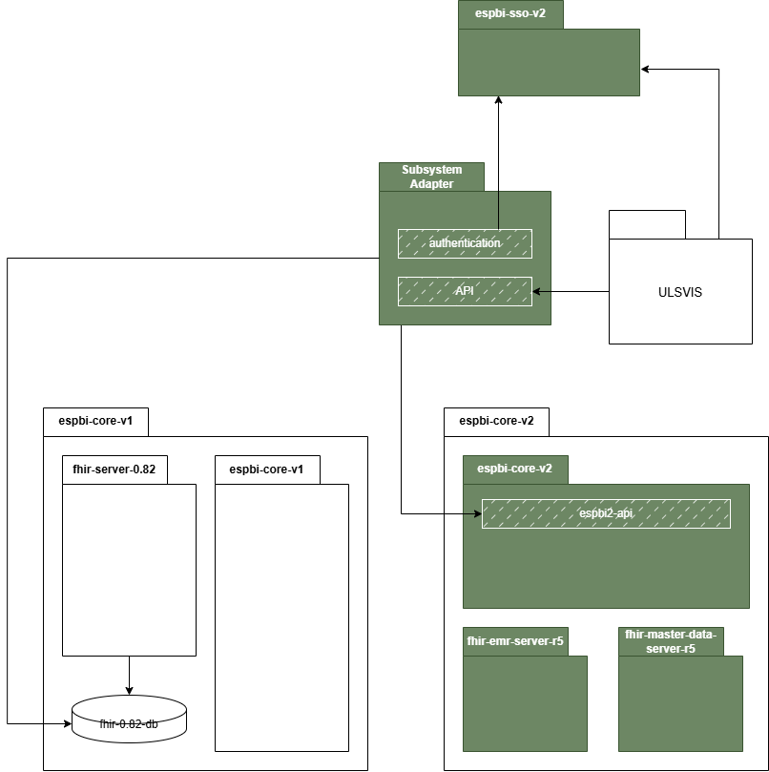

Table 14: Objective 6. Testing scenarios
Nr. | Scenario | Description | Expected result
 | External system authorization (ULSVIS) | ULSVIS authenticates via KeyCloak (espbi-sso-v2) and receives access token allowing the system to fetch E027-ats documents. The service provider must configure necessary authorization policies in KeyCloak for the generated token be valid for the use case. | Request via Subsystem Adapter using such token is authorized. Request via Subsystem Adapter using any other client's token is rejected.
 | ULSVIS data integration | ULSVIS system accesses the Subsystem Adapter component and requests for E027-ats documents. Subsystem Adapter collects the data from both espbi-core-v1 (utilizing existing integration mechanisms ULSVIS is requesting the documents today) as well as the newly introduced espbi-core-v2 (via espbi2-api), maps it into a representation that is suitable for ULSVIS and combines the results into a single collection. Performance testing should be conducted with large data volumes to identify potential risks and bottlenecks and provide recommendations for optimizing data integration processes with ULSVIS as well as other future clients of similar nature. | Combined collection of E027-ats documents is returned to ULSVIS. Performance measurements are collected and presented to the client with recommendations on how the mechanism can be improved.

Long-term ESPBI architecture

- During the project, the Service Provider may be tasked, upon a separate additional request, to develop a long-term ESPBI architecture. This architecture should cover all ESPBI components, including their internal and external integrations. It must be prepared across multiple dimensions: business, data (including integrations), security, technology and application architecture. The Service Provider will present these architectural frameworks to the client's architecture board for review and approval.

General Requirements:
- Service provider shall prepare full future (long-term) architecture documentation including architecture diagrams and detailed descriptions of it.
- Architecture document shall describe the existing ESPBI architecture and provide insights into current issues and challenges that the long-term architecture should address.
- Architecture shall include ongoing projects that are not yet in the production environment (PROD).
- Architecture shall include additional functional components that are not currently part of the ESPBI system but are recommended by Service provider for future implementation.
- Architecture diagrams shall be prepared using the Achimate (preferred) or Draw.io tool.
- Architecture shall include detailed descriptions of each component, process, and data flow.
- Where necessary, architecture shall be elaborated with additional diagrams and additional descriptions to ensure clarity.

Specific Requirements:
- Business architecture
  - Business architecture shall identify different types of system users and their interactions with ESPBI.
  - Business architecture shall detail the supported business processes and their alignment with organizational goals.
- Data architecture
  - Data architecture shall describe internal and external data flows, including interactions with organizational data warehouse solutions. All data integrations shall be described with identified changes to current data integration mechanisms.
  - Data architecture shall provide insights into data quality management practices and recommendations for improvement.
- Security architecture
  - Security architecture shall define access control mechanisms, security measures, and roles to ensure data protection and compliance.
  - Security architecture shall identify potential vulnerabilities and recommend mitigation strategies.
- Application architecture
  - Application architecture shall outline the lifecycle of existing applications, including updates, maintenance, and decommissioning plans.
  - Application architecture shall explore possibilities for integrating or adopting new applications to meet future needs.
- By adhering to these requirements, the Service Provider will ensure that the long-term ESPBI architecture is forward-looking and aligned with the client's strategic objectives and industry trends.

Requirements for service provision

Requirements for analysis and design

Project language
- Project documentation must be prepared in both Lithuanian and English languages. Interim documentation (non-final) may be prepared in a single language, however all final deliverables must be provided in both languages.
- Project communication can be held in Lithuanian or English languages.
- User training can be held in Lithuanian or English languages.

Requirements for documentation and its coordination
- Client will review documentation, and the Service Provider shall adjust it constructively, arranging meetings if any remarks are unclear. Client may align the document internally based on its content, potentially involving cybersecurity, product owners, or other relevant parties in the review process.
- All project documentation prepared by the Service provider must be prepared in accordance with the rules of the respective language grammar and formatting rules illustrated with diagrams, tables, graphs and other visual means, the presented material is arranged clearly, consistently and in detail.
- Project documentation must be updated according to project stages, activities, and all approved decisions. Final versions must reflect any changes (even previously approved documents) unless agreed otherwise.
- If a project has multiple streamlines, each must comply with all requirements, including full documentation, unless agreed otherwise.
- Project documentation must be stored and coordinated in the Client's Confluence environment, while project task management must be carried out in the Client's Jira environment. Access to these systems will be provided by the Client at the start of the project.
- The Service Provider must align all document templates with the Client. While document structure may evolve during the project, they should be submitted at the beginning each document preparation phase to align initial expectations.
- The final versions of the documents must be submitted electronically in a format suitable for editing (e.g., .doc, .docx, or another agreed format), including diagrams and other content, unless agreed otherwise. Diagrams must be prepared using the draw.io tool.
- Where applicable, the Service Provider shall apply use cases prepared in UML, BPMN, or an equivalent notation.
- Client and other relevant parties commit to reviewing the documentation and providing comments within no more than 5 business days (unless agreed otherwise).
- The Client’s GitLab repository must be used to store the system source codes (if applicable).

Requirements for project management

- Service provider must cooperate directly with the Client, Project partners, project supervision 3rd party suppliers and other interested parties involved in the Project. This includes maintaining open lines of communication and collaboration throughout the project duration.
- Service Provider must regularly update the Client on the progress of the Services by organizing status meetings and, upon the Client's request, prepare and present results at various stages of service delivery.
- Not later than within 30 (thirty) calendar days from the date of entry into force of the Contract, the Service provider shall organize a kick-off meeting . The exact agenda of the Project kick-off meeting must be agreed with the Client at the beginning of the Project;
- During the implementation of the Project, to organize working meetings/teleconferences of the Project team at least 1–2 times a week. After each meeting/teleconference, to document the decisions made using a protocol template provided by the Client or an action points register agreed at the beginning of the Project.
- To assist the Client in the preparation of the materials for the meetings of the Project Steering Committee such as:
  - To detail problems, possible solutions, alternatives. To prepare cost-benefit analyses and to make decisions on budget increases, where appropriate.
  - To provide up-to-date summary information on the Project course, progress, etc.
- To prepare all documents during the Project implementation taking into account the templates available to the Client or using the Client’s templates. To use other document templates only upon obtaining the Client’s approval.
- Sharing of data, as well as documents created/under creation during the Project, shall take place through secure channels with or without encryption (password) protection. This shall be agreed with the Client at the beginning of the Project.
- Considering that the client plans to implement not only this project but also additional projects simultaneously, the vendor must be prepared to allocate the necessary resources and participate in meetings to discuss inter-project interdependencies.
- Project must be executed in accordance with recognized project management practices as SDLC, with a likely implementation of a hybrid Agile and Waterfall approach, ensuring that systematic planning, monitoring, and delivery methodologies are applied.

Requirements for change management

- Client reserves the right (but is not obligated) to order additional services from the Service Provider based on the hourly rate specified in the proposal. The scope of additional services is defined in the tender documents.
- Service Provider must apply an hourly rate no higher than specified in the proposal. Before starting additional work, the Service Provider must provide a detailed task description, time estimates with justifications, and an implementation timeline, all of which must be agreed upon with the Client. The Client reserves the right to approve or reject the change request based on the evaluation. The preparation of the estimate must be done at the Service Provider's expense.
- Service Provider must establish and agree with the Client on a detailed procedure for providing additional services, including rules for identifying, calculating, and documenting additional service orders.
- Service provider must define and agree with the Client on a detailed procedure for providing additional services, including rules for determining, calculating, and documenting additional service orders.
- These are preliminary types of possible additional services:
  - Modifications for unforeseen areas or functionality.
  - Implementation of additional integration interfaces.
  - Additional training or consultations.
  - Issues addressed during the warranty period that were ultimately determined not to be actual issues or fell outside the warranty scope, but still required the Service Provider’s time and effort.
  - Other tasks agreed upon with the Client.
- Service Provider must account for and include in their calculations all project documentation to be prepared or updated, along with any necessary modifications, to achieve the objectives of the change request.
- Additional services are subject to the same warranty period as the System. If additional service results are delivered near the end of the warranty period, a minimum warranty of 2 months will apply to those results. However, additional services leading to significant new developments (potentially even deployment to the PROD environment) may require a different warranty period. This should be specified in the change request and assessed by the service provider.
- Service provider or Client may propose an alternative implementation method or equivalent functionality, ensuring no negative impact on tender objectives or legal compliance. Alternatives require Client approval. If substituting a requirement, the Service provider must justify the change in writing, assessing its impact, criticality, and time costs

Ownership of the project results
- All documents and/or information prepared or received during the provision of Project services must be transferred to the Client (including documents and information provided in electronic or digital format) and become the property of the Client, which may use them at its discretion. If a standard solution is proposed by the Service Provider, this requirement does not apply, and ownership rights do not transfer. In such cases, only the ownership of created custom modifications is transferred to the Client.
- Service Provider must transfer the System's source code, developed during the project.

General project requirements
- Examples, attributes, criteria, parameters, rules, and classifiers mentioned in the requirements are indicative and not exhaustive. These must be detailed and agreed upon with the Client during analysis and design phases.
- All necessary data fields for proper system functionality must be included, with character limits and integration methods agreed upon during analysis and design.
- Solution must comply with current legal regulations (the ones that are valid at the date of the proposal submission).
- Service Provider must align documentation with the Client and demonstrate system prototypes during analysis, design, and testing phases.
- According to the specifics of the procurement object, the Service Provider's specialist may be granted access to the necessary database schemas in the PROD environment for the execution of the procurement object.
- Service Provider, together with the Contract, signs a personal data processing agreement.
- Service Provider ensures that the person responsible signs the Confidentiality Commitment provided by the Client.

Implementation activities & results

Project timeline requirements
- All project services & deliverables (except for warranty and additional services) must be completed and submitted by date indicated in the contract.
- Project initiation documentation shall be submitted no later than 10 business days after the contract signing.

Initiation & general project management stage

General stage requirements
- Service provider must designate specific individuals responsible for executing the service provision contract and managing communication with the Client and the technical supervision service provider. The Client must be informed of these appointments within 2 business days from the date of signing the service provision contract.
- Service provider must, within 2 business days, assign the project team and submit a list of required logins for JIRA, Confluence, or other necessary tools for the Client to provide.
- Service provider must submit a list of open questions or required information from the Client within 10 business days of the service provision start date.
- General results acceptance criteria:
  - If no critical issues are identified and no more than 10 non-critical issues are identified UAT stage can be confirmed.

Responsibilities

Service provider’s general responsibilities | Client’s general responsibilities
- Prepares documentation. | - Provides the necessary information;  - Makes comments and recommendations.

Required stage results
Table 3. Stage results
Result no. | Result name | Result description
 | Project initiation documentation | - Prepared project initiation documentation, detailing:  - Project objectives, goals & priorities,  - results (deliveries) description (the scope and results of the stages)  - stakeholders (interested parties)  - project team & responsibilities (detailing organizational structure of decision-making process)  - work schedule (detailed with milestones and buffer time)  - risks and their management methods,  - communication principles,  - criteria for interim and results acceptance,  - change management procedures.
 | Bi-weekly briefing report | - Prepared project initiation documentation, detailing:  - Project schedule status  - Relevant project risks  - Existing open questions  - Main activities done during last 2 weeks  - Main activities planned for next 2 weeks

Requirements analysis stage

General stage requirements
- Service provider shall organize meetings with Client representatives and review all relevant Client documentation. Each meeting must have a clear agenda, and topics for discussion must be shared in advance.
- Service provider shall proactively offer insights and suggestions based on industry best practices.

Responsibilities

Service provider’s general responsibilities | Client’s general responsibilities
- Carries out an assessment of the current and desired situation;  - Prepares documentation for detailed analysis;  - Carries out other activities provided for during the analysis phase. | - Provides the necessary information;  - Makes comments and recommendations;  - Approves the presented results of the stage.

Required stage results
Table 3. Stage results
Result no. | Result name | Result description
 | Requirements analysis report | - Prepared requirements analysis report, detailing:  - Description of each functional & non-functional requirement provided in the technical specification, unless agreed otherwise (some requirements might not require additional description). The purpose of the description is to align fully between Client and Service Provider on the objective of each requirement.  - Preparation of user stories (RPO) and use cases, presented in the form of use case diagrams following UML (Unified Modeling Language) notation, with detailed descriptions of execution steps, including main course, alternative progress, and other restrictions. If necessary, descriptions of system users and their rights are also included (if applicable).  - Insights on identified required change requests.

Design stage

General stage requirements
- Service provider shall configure the following solution environments unless otherwise agreed with the Client:
  - Demonstration
  - Testing
- All environments will be prepared by the Client. The service provider shall be responsible for configuring and deploying the system to all environments.
- Service provider shall review the Client’s existing infrastructure documentation to identify infrastructure requirements needed for the solution.
- Service provider shall present the architecture to the Client’s architecture board and modify it based on the feedback received. Additional presentations may be required if needed.

Responsibilities

Service provider’s general responsibilities | Client’s general responsibilities
- Performs design and prepares design documentation;  - Draw up and align the technical specification of the infrastructure requirements;  - Analyse and prepare documentation describing the integration interfaces;  - Develop specifications for the integration interfaces and align them with the recipients and providers of the data and the Client. | - Provides the necessary information;  - Makes comments and recommendations.  - Approves the presented results of the stage.

Required stage results
Table 3. Stage results
Result no. | Result name | Result description
 | Solution design report | - Prepared solution design report, detailing:  - Implementation and software configuration:  - Descriptions of requirements implementation, including functions, screens, rules, restrictions, etc.  - Clarification on whether requirements are implemented as part of the standard system or through modifications.  - Descriptions of system parameters and configurations.  - System architecture:  - System architecture diagram and component descriptions, detailing integration with the existing ESPBI architecture.  - Technologies used, including names and versions.  - Deployment view, illustrating the distribution of software components in hardware.  - Security, high availability, and scalability solutions.  - Technical architecture document covering key system components.  - Database architecture:  - Logical and physical database structure.  - Informative view, including database structures and interface diagrams.  - Developed logical database model.  - Built-in interface specifications, including developed interface and data exchange specifications.  - Functional & UX/UI Design  - Functional image, detailing system units, their functions, interrelationships, and UI prototypes.  - UX/UI design models, including:  - User interface diagrams.  - Structure and design.  - Initial user interface prototype.  - Integration and deployment:  - Integrative image, defining interfaces between internal and external systems.  - Detailed integration data, management, and deployment areas.  - Infrastructure requirements:  - Operational picture, describing system processes, algorithms, and periodic operations.  - Prepared technical specification of infrastructure requirements, covering:  - Technical and system software requirements for proper solution functioning.  - Analysis of additional hardware and software compatibility with the Client's existing infrastructure.  - Roles and permissions:  - Complete role and permission details, including a list of roles, their definitions, and purposes.
 | Testing scenarios (for UAT) report | - Prepared testing UAT scenarios report, detailing:  - Testing scenario, it is description and expected outcome. Provided test scenarios in the document should be adjusted if needed or added new scenarios that would benefit the project objectives and outcomes.
 | Infrastructure requirements report | - Prepared infrastructure requirements report, detailing:  - Required infrastructure need for solution deployment.
 | Solution environments report | - Prepared solution environments report, detailing:  - Description of each solution environment and its purpose.  - Responsibilities of the Client and the Service provider for environment management.  - Timeline indicating when each environment will be used.  - Plan for deployment into the test and other environment.

Development and configuration stage

General stage requirements
- Service provider shall prepare all development & configuration activities to prepare solution and achieve project objectives.
- All development activities by the Service provider must be performed directly on Client servers.
- Service provider shall conduct internal testing and ensure that solution provided for the UAT shall not have any significant bugs.
- Service Provider must conduct internal testing of individual components without the participation of the Client's representatives. However, the Service provider must provide proof of such testing, including internal testing reports, automated test scripts uploaded to the Client’s GitLab version control system, and a list of identified discrepancies. Internal testing must be performed in the development environment. Automated tests must be integrated into the CI/CD processes. Internal testing activities must be conducted using test scenarios prepared by the Provider in the Client’s test management tool, XRAY.
- Service Provider must develop automated testing and deployment processes for the System and its components using the Client’s GitLab platform for Continuous Integration and Delivery (CI/CD).
- Service Provider shall conduct all necessary tests to ensure that the product meets the required quality and performance standards. The complete list of tests, which must be aligned with the Client, may include, but is not limited to:
  - Unit Testing
  - Integration Testing
  - Functional Testing
  - Performance Testing
  - Security Testing
  - Installation Testing
  - Configuration Testing

Responsibilities

Service provider’s general responsibilities | Client’s general responsibilities
- Carries out the necessary development and configuration tasks (in its own development environment), implements functional and non-functional requirements;  - Performs unit testing, internal security testing, subsystem internal testing, interface testing with other systems;  - Conducts demonstrations of the subsystem being developed, takes into account the comments made by the Client;  - Prepares an internal testing report. | - Provides the necessary information;  - Participates in demonstrations of the subsystem, provides feedback;  - Reviews and evaluates the results of internal testing;  - Makes comments and recommendations.

Required stage results
Table 3. Stage results
Result no. | Result name | Result description
 | Internal testing report | - Prepared internal testing report, detailing:  - Comprehensive internal testing report, covering:  - Scope of testing.  - Execution methodology.  - Types of testing performed.  - Testing procedures.  - Insights or comments, where additional attention should be provided during UAT.  - Testing results for each testing scenario.  - Internal security testing results, including findings from security tests performed.
 | User manual (regular users) | - Prepared user manual (regular users), detailing:  - All user functionalities should include detailed step-by-step instructions, relevant screenshots, possible alternatives, and any additional necessary information.
 | User manual (admin users) | - Prepared user manual (admin users), detailing:  - Administrator instructions, as system configurations, data integration configuration, back-ups, etc. Service provider shall include relevant screenshots, possible alternatives, and any additional necessary information.

Deployment to test environment stage

General stage requirements
- System shall be deployed to test environment.

Responsibilities

Service provider’s general responsibilities | Client’s general responsibilities
- Prepares and submits the software suitable for installation in the Client’s testing environment;  - Advises the Client on the implementation of the Client’s testing environment;  - Prepares data loading scripts into the Client’s test environment;  - Develops acceptance testing scenarios, testing methodology and plan;  - Prepares instructions for users and administrators | - Reviews and evaluates the deployment plan;  - Provides the necessary information;  - Controls the testing environment;  - Installs the submitted software into the Client’s testing environment;

Required stage results
Table 3. Stage results
Result no. | Result name | Result description
 | Deployment to test environment report | - Prepared deployment to test environment report, detailing:  - Description of how software was prepared and installed in Client’s testing environment.  - Testing scenarios, acceptance testing methodology, and plan developed and agreed with stakeholders.  - Test data prepared (SQL and/or other scripts).  - User manuals and administrator instructions developed.

UAT stage

General stage requirements
- Service provider shall participate in all UAT sessions, provide insights, consultations and recommendations.
- System shall be installed into Client’s testing environment and configured.
- Service provider is responsible to register all scenarios into Client’s internal issue management system (JIRA).
- If a bug is registered, the Service Provider shall conduct internal testing and ensure regression testing of the related functionality before making it available for UAT again.
- Service Provider must prepare sufficient test data to ensure that, during acceptance testing, the System contains enough imported test data to fully validate all newly developed or modified functionality. The import of the test data into the TEST environment will be performed by the Client’s representatives using the import tools (scripts, descriptions, or other means) provided by the Service Provider.

Responsibilities

Service provider’s general responsibilities | Client’s general responsibilities
- Actively participates in acceptance testing and provides consultations;  - Fixes recorded defects (bugs);  - Makes necessary adjustments based on Client’s penetration testing and performance testing results;  - Prepares an acceptance test report;  - Updates test scenarios as needed. | - Performs acceptance testing;  - Provides the necessary information;  - Submits additional relevant testing scenarios;  - Provides feedback and recommendations.

Required stage results
Table 3. Stage results
Result no. | Result name | Result description
 | UAT report | - Prepared UAT report, detailing:  - All incidents (bugs / questions) registered during UAT and their status  - All testing scenarios tested and their status.  - The client may conduct penetration and/or performance testing and share the results with the service provider. The service provider will address any identified issues by implementing the necessary changes and will perform re-testing to confirm that all issues have been resolved.
 | Project insights & additional recommendations | - Prepared project insights & additional recommendations report, detailing:  - Summary of activities and outcomes during PoC.  - Description of each PoC scenario and comments on how it proceeded.  - PoC architecture diagrams must be provided for all necessary aspects (data architecture, logical architecture, etc.).  - Alternatives considered and their evaluations (both high level strategic alternatives and scenario level alternatives).  - Identified risks and mitigation strategies (both technical and business organizational).  - Prepared risk list, which includes risks that could not fully be mitigated during the PoC with explanation of why these risks remain.  - An assessment of whether the proposed FHIR version deployment principle is optimal and recommend any necessary architectural changes.  - Include a section on lessons learned and best practices identified during the PoC.  - Suggest potential future enhancements or optimizations based on PoC findings (not only related to FHIR version upgrade, but all that were discussed during the project).  - Other recommendations for future implementation.

Warranty stage

General stage requirements
- Service Provider must ensure warranty for the developed solution and installed licensed software.
- Warranty does not cover changes made by Client itself.
- Warranty period is 6 months from the signing of the final delivery-acceptance act. However, Service provider shall ensure possibility for the Client to demonstrate the prepared PoC solution for months from the signing of the final delivery-acceptance act (whole PoC architecture should be available for Client during 12 month period after project closure (Client should be able to check it, present it to relevant stakeholders)).
- Service Provider must coordinate a detailed warranty maintenance procedure with the Client before the beginning of warranty period.

Incident management (applicable for 6 months warranty period)
- Critical incidents. System failures, critical function malfunctions, or issues such as security breaches or data corruption.
- Non-critical incidents. Minor disruptions, cosmetic errors, or issues with potential workarounds.
- Incidents must be recorded and monitored in the Client's issue management software, JIRA.
- Incident management must be handled according to the table below:
Aspect | Rule
Applicable period | 6 months after the signing of the final delivery-acceptance act
Relevant operating hours | Warranty service must operate from 08:00 to 18:00 (Lithuanian time zone), considering the client's working days
Critical incident response time | Must be responded to within 2 working hours
Non-critical incident response time | Must be responded to within 4 working hours
Critical incident resolution time | Must be resolved within 1 working day
Non-critical incident resolution time | Must be resolved within 10 working days

Support & maintenance (applicable for 6 months warranty period)
- Support via phone and email ("Hotline") must be available during the Client's working hours, i.e., from 08:00 to 18:00 (Lithuanian time zone), considering the Client's working days. Only Level 2 hotline support must be provided, while the Client will ensure Level 1 support.
- Updates to system source code must be provided for Client review after corrections are made.
- During the warranty period, the Service Provider must update the software if a new version becomes available.
Table 3. Stage results
Result no. | Result name | Result description
 | Warranty plan | - Prepared warranty plan, detailing:  - Roles and responsibilities of Client and Service provider.  - Procedures of communication (channels, tools, etc.).
 | Warranty report | - Prepared warranty report, detailing:  - All incidents registered during warranty and their status.  - All change requests (for all project long) and their status.

Licensing requirements
- No specific licenses are anticipated to be required for this project. However, if any licenses are necessary it will be the responsibility of the Service Provider to procure and ensure their availability for whole project time and 12 months after the project is completed. Licences of Client’s currently used systems or infrastructure would be ensured by Client.

https://www.esveikata.lt/espbi-specifikacija
Mapped resources means where FHIR DSTU1 and FHIR v5 resources are mapped between different versions.
Unmapped resources means where FHIR DSTU1 and FHIR v5 resources are not fully mapped between different versions.
Low therapeutic index (lit.: mažo terapinio indekso).
Information about patients, related persons (specialists and their groupings).

