- Orlaivio, tempiančio oro taikinį, pilotas atsako už taikinio skrydį. Taikinio tempimas atliekamas pagal orlaiviams galiojančias taisykles. Siekiant užtikrinti skrydžio saugumą, pilotas turi teisę keisti skrydžio parametrus arba nutraukti skrydį, bei apie tai nedelsiant raportuoti saugos karininkui.
(Translation, english) The pilot of an aircraft towing an aerial target is responsible for the flight of the target. The towing of the target shall be carried out in accordance with the rules applicable to aircraft. In order to ensure the safety of the flight, the pilot shall have the right to change the flight parameters or to terminate the flight and to report it immediately to the safety officer.
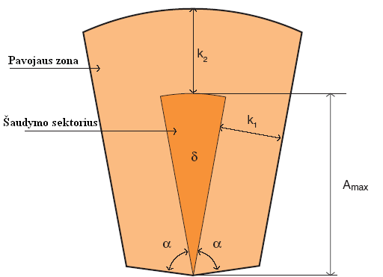
(Fire sector)
(Danger zone)
Duomenys (Data) | 90 m/s | 140 m/s | Antžeminis taikinys (Ground target)
α | 1170 tūkst. (mils) | 1170 tūkst. (mils) | 1170 tūkst. (mils)
ᵟ | 360 tūkst. (mils) | 475 tūkst. (mils) | 0
ᵟ₁ | 45 tūkst. (mils) | 50 tūkst. (mils) | 0
A_{max} (Rb70 Mk1) | 4000 | 4000 m | 4000 m
A_{max} (Rb70 Mk2, Bolide) | 6500 m | 6500 m | 6500 m
k₁ | 1500 m | 1500 m | 1500 m
k ₂ | 2000 m | 2000 m | 2000 m
Y | 8000 m | 8000 m | 8000 m
Taikinio aukštis (Target altitude) | 250-500 m | 250-500 m | -
Lyno ilgis (Towing line) | 3200 m | 4300 m | -
Šaudymo nuotolis (Firing distance) | 2650 m | 3500 m | 2500-3500 m
Taikinio greitis (velocity) | 90 m/s | 140 m/s | -
Taikinio kursas (direction) | 370 tūkst. | 370 tūkst. | -
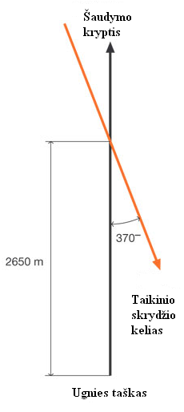
(Target flight path)
(Firing position)
(Fire direction)
δ kampo nustatymas (Determination of the δ angle).
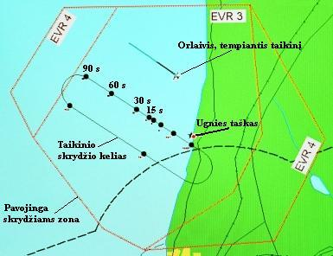
(Danger flight zone)
(Target flight path)
(Fire position)
(Target towing aircraft)
GNS žemėlapis su pažymėtu taikinio skrydžio keliu ir atskaitos taškais (GPS map with target flight path and reference points)

