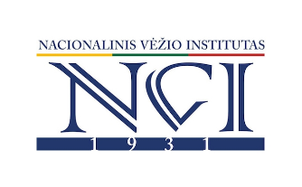

NETWORKING EVENT
HORIZON EUROPE: POSSIBILITIES FOR PARTNERSHIP IN BEATING CANCER

13-06-2025

Prof. Kazimieras Pelčaras Hall of The National Cancer Institute, Santariškių st. 1, Vilnius

PRELIMINARY PROGRAM

11.30-12.00 Registration & Welcome coffee

12.00-12.15 Welcome words: Chairman of RCL, Director of NCI, Director of LSC VU

12.15-13.00 Horizon Europe calls 2025 (Cancer, Health, Digital) – possibilities for collaborations, RCL NCP

13.00-14.00 Presentations of partnering institutions: Experience & Perspective

14.00-15.00 Lunch & Discussions

15.00-16.30 Ideas for grant proposals

17.00-18.00 Final discussion & Networking

