 | EUROPEAN COMMISSION  DIRECTORATE-GENERAL  TAXATION AND CUSTOMS UNION  Digital Delivery of Customs and Taxation Policies  Taxation Systems & Digital Governance

Conformance Test Organisation Document
TES-CTOD EMCS-Phase 4.2
Date: | 03/06/2025
Status: | Submitted for acceptance (SfA)
Version: | 1.00 EN
Author: | ITSM3-TES
Approved by: | DG TAXUD
Reference number: | DLV.3.2.3.4
Public: | DG TAXUD external
Confidentiality: | Commission use (CU)

Document control information

Property | Value
Title | Conformance Test Organisation Document
Subtitle | TES-CTOD EMCS-Phase 4.2
Author | ITSM3-TES
Project owner | Head of Unit of DG TAXUD Unit C3 Legal affairs - indirect taxation
Solution provider | DG TAXUD Unit B4 Taxation Systems & Digital Governance
DG TAXUD Project Manager | B4 Taxation Systems & Digital Governance
Version | 1.00 EN
Confidentiality | Commission use (CU)
Date | 03/06/2025

Contract information

Property | Value
Framework Contract | TAXUD/2017/CC/138
Specific Contract | SC89

Document history
The document author is authorised to make the following types of changes to the document without requiring that the document be re-approved:
- Editorial, formatting, and spelling;
- Clarification.
To request a change to this document, contact the document author or project owner.
Changes to this document are summarised in the table in reverse chronological order (latest version first).
Version | Date | Description | Action | Section
1.00 | 03/06/2025 | Submitted to DG TAXUD for Acceptence QC56737 | I.R | As Req.
0.10 | 21/05/2025 | Submitted to DG TAXUD for Review | I.R | As Req.
0.01 | 19/05/2025 | Initial draft | I, R | All
Action: I=Insert R=Replace

Configuration management: document location
No previously accepted version of this document exists.
Table of contents
1 Introduction 7
1.1 Document purpose 7
1.2 Target audience 7
1.3 Objectives 7
1.4 Structure 8
1.5 Reference documents 8
1.6 Applicable documents 9
1.7 Abbreviations & acronyms 9
1.8 Definitions 10
2 Infrastructure 12
2.1 Overview 12
2.2 Software 12
2.3 Preparation of the CT environment 12
2.3.1 General Pre-requisites 13
2.3.2 Specific Pre-requisites 14
3 CTA Navigation 20
4 Testing Organisation 23
4.1 Roles and Responsibilities 23
4.2 Planning and Milestones 26
4.3 Communication and Synchronisation 26
4.3.1 ITSM Synergia ESS 26
4.3.2 Complementary information 27
4.4 Testing Lifecycle Overview 28
4.4.1 Mode 0 – Integration Testing 30
4.4.2 Mode-1 - National Compliance Testing 30
4.4.3 Mode-2 - Conformance Testing 30
4.4.4 Mode-3 - International Testing 34
4.4.5 Mode-3 plus – End-to-End Testing 34
4.5 Procedures and summary of tasks to be performed 36
4.6 EMCS Phase 4.2 37
4.6.1 Changes Introduced for Phase 4.2 37
4.6.2 EMCS Phase 4.2 CT Scope 37
5 Conformance Test Specification 39
5.1 Test validation 39
5.2 Creation / View of National Deviations in CTA 39
5.3 Error/Problem handling 40
5.4 Technical Conformance criteria 40
6 Annexes 42
6.1 Annex 1: Start up guide for CT Environment preparation 42
6.2 Annex 2: National Project Plan Template 46
6.3 Annex 3: Connectivity Tests 46
6.3.1 Mode-1 Connectivity Test Case 46
6.3.2 Mode-2 Indicative Test Case 47
6.4 Annex 4: EMCS Phase 4.2 CT Mode-3 Suggested scenarios 49
6.5 Annex 5: EMCS Phase 4.2 CT Mode-3 Plus Suggested scenarios 50
6.6 Annex 6: EMCS Phase 4.2 CT Connectivity summary 50
6.7 Annex 7: EMCS Phase 4.2 Mode-3 Test Summary Report template 51

List of tables
Table 1: Reference documents 9
Table 2: Applicable documents 9
Table 3: Abbreviations and acronyms 10
Table 4: Definitions 11
Table 5: NA CCN Queues 15
Table 6: Central CTA CCN Queues 16
Table 7: List of Messages belonging to EMCS Phase 4.2 17
Table 8: User Profiles for accessing the National Gateways 17
Table 9: User Profiles for accessing the Central Gateway 17
Table 10: NA CCN User Profile for accessing the CTA 18
Table 11: NA CCN User Profile for accessing the CTA Web interface 18
Table 12: ITSM CTA administration profile 18
Table 13: CT Roles and Responsibilities 25
Table 14: Reference dates for EMCS Phase 4.2 CT Campaign 26
Table 15: Synergia ESS CT Templates 27
Table 16: Mode-0 Roles and Responsibilities 30
Table 17: Mode-1 Roles and Responsibilities 30
Table 18: Mode-2 Pre-CT Roles and Responsibilities 32
Table 19: Mode-2 Actual-CT Roles and Responsibilities 32
Table 20: AES-EMCS Test Campaign Roles and Responsibilities 33
Table 21: Mode-3 Roles and Responsibilities 34
Table 22: Mode-3 plus Roles and Responsibilities 35
Table 23: List of actions to be performed 36
Table 24: Mode-1 Test Execution Steps 47
Table 25: Mode-2 Test Execution Steps 48

List of figures
Figure 1: Conformance Testing Environment 12
Figure 2: ACT submission workflow 13
Figure 3: CTA QUEUES used by NAs 15
Figure 4: Conformance Testing Overview 20
Figure 5: Business Thread Overview 21
Figure 6: Business Domain Overview 21
Figure 7: CT Campaign Management 22
Figure 8: Test Campaign Menu 22
Figure 9: Parties involved in EMCS Phase 4.2 CT 23
Figure 10: Testing modes 29
Figure 11: ACT Request for EMCS CT Queues 43
Figure 12: ACT – CSI Applications Domain 43
Figure 13: ACT - Asynchronous CSI Queues List 44
Figure 14: ACT - platform creation request example 44
Figure 15: ACT Request lifecycle for the NAs 45
Figure 16: CTA – Test Results example 49
Figure 17: CTA – Test Part 1 50
Figure 18: CTA – Test Part 2 51

Introduction

Document purpose
This document defines the Conformance Test Procedure that should be used by each NA (National Administration) and EMCS Central Project Team (CPT) within the scope of EMCS Phase 4.2 CT.
The main purpose of the specific document is to organise and schedule the practical arrangements of the given Conformance Testing (CT) campaign – communication, coordination, planning, and reporting activities.
For an efficient and effective rollout of the CT Campaign activities, all involved stakeholders should follow the guidelines provided below in the document subject.

Target audience
The intended audience for this document is any person/service in the National Project Teams (NPTs) and the Central Project Team (CPT) (including their contractors):
- Involved in the development of the test scenarios, test scripts, and test data;
- Involved in the planning, organisation, and co-ordination of the Conformance Testing activities;
- Involved in implementing the Conformance Test campaign;
- Involved with the Quality procedures to apply to the Conformance Tests.

Objectives
Conformance is the adherence to the requirements of each National Application as implied by FESS and DDNEA for EMCS Phase 4.2 [R02 & R04].
Before any planned implementation of new Trans - European System Specifications, or corrective actions in the production environment under a given phase can take place, each National Administration (NA) has to prove that the international interface of its National Excise Application (NEA) technically conforms with the common specifications of that specific phase.
The conformance of a NEA is achieved through the execution of Conformance Testing (CT).
CTA (Conformance Test Application) is a tool developed by DG TAXUD to support a unified environment for Customs, Excise, and Taxation Conformance testing activities. The CT Campaign of EMCS Phase 4.2 will be supported as of 09/06/2025.
In the context of the conformance testing activities, CTP Explorer can be used in order to provide an advanced view of the CTP content that is maintained through the CTP database. The CTP Explorer system shall be provided as a stand-alone desktop application, which can be executed and used in the user’s local workstation. The CTP content is loaded in the application package via the Test Reference Package (TRP). In addition to the TRP, other configuration files, according to the Business Domain under CT, should be loaded beforehand in the application package.
The objective of this document is to define the process and responsibilities of all parties (DG TAXUD and its ITSM contractor, and the National Project Teams (NPTs) of all NAs) during the Conformance Testing Campaign for their NEAs for the EMCS Phase 4.2. The goal is to achieve the full deployment of Phase 4.2 Trans-European System according to the agreed milestones [4.2 Planning and Milestones].
This CTOD is complemented by the related specification documents which describe in detail the scenarios that will be executed during the different CT campaigns. These are the Conformance Testing protocol (CTP) or a list of scenarios (where applicable).
The following points are described in this document:
- The planning of the test campaign (e.g., Key milestones, National Project Plan (NPP) template);
- The Test Environment (e.g. Infrastructure, Queues);
- The conformance test support services within Central Project Team (CPT);
- The ITSM organisation within CPT (the ITSM contact points, the communication procedures, taking into account the SYNERGIA tool);
- The report templates.

Structure
This document is organised as follows:
- Chapter 1 – Introduction: describes the scope and the objectives of the document;
- Chapter 2 – Infrastructure: describes important infrastructure elements for the execution of the Conformance Testing;
- Chapter 3 – CTA Navigation: describes the navigation to main CTA functionalities;
- Chapter 4 – Testing Organisation: describes detailed information presenting how the Conformance Testing will be organised;
- Chapter 5 – Conformance Test Specification: describes a high-level description presenting how CT incidents, errors and problems will be handled;
- Chapter 6 – Annexes: describes all annexes which are referenced to in the document.

Reference documents
The table below lists the documents that are referred to in the current document.
Ref. | Title | Originator | Version | Date
R01 | Glossary of Terms | ITSM3-TES | 2.09 | 03/08/2016
R02 | Functional Excise System Specification | SOFT-DEV | 4.22 | 11/04/2025
R03 | Technical Excise System Specification | FITS/DEV3 | 3.02-EN | 15/09/2014
R04 | DDNEA for EMCS Phase 4.2 | SOFT-DEV | 3.23 | 06/05/2025
R05 | Release Scope Document for EMCS Phase 4.2 FESS and DDNEA | ITSM3-TES | 2.00 | 13/11/2024
R06 | Migration Plan for EMCS Phase 4.2 | SOFT-DEV | 1.00 | 15/05/2025
R07 | UMN for NA Coordinator and NA Operator | SOFT-DEV | 13.00 | 23/04/2024
R08 | CTA Functional Specifications | SOFT-DEV | 16.00 | 14/08/2024
R09 | Conformance Test Protocol for EMCS Phase 4.2 | SOFT-DEV | 4.00 | 08/05/2025
R10 | NPP – National Project Plan Reporting Template for Phase 4.2 | DG TAXUD | 23.00 | 07/05/2025
R11 | EMCS Master Plan CED 563 rev8 | DG TAXUD | 3.00 | 30/07/2021
R12 | CTOD for CT Campaign for AES-P1 and NCTS-P5 | ITSM3-TES | 1.50 | 28/06/2022
Table 1: Reference documents

Applicable documents
The table below lists the documents to which the current document must be compliant (e.g. FWC, SC, RfA).
Ref. | Title | Originator | Version | Date
A01 | ITSM3 TES Framework Contract | DG TAXUD | N/A | -
A02 | ITSM3 TES Specific Contract 89 | DG TAXUD | N/A | 01/03/2025
A03 | Framework Quality Plan | ITSM3-TES | 1.80 | 18/07/2024
Table 2: Applicable documents

Abbreviations & acronyms
For a better understanding of the present document, the following table provides a list of the principal abbreviations and acronyms used.
See also the ‘list of acronyms’ on TEMPO.
Abbreviation/Acronym | Definition
ACT | Application Configuration Tool
AES | Automated Export System
CCN/CSI | Common Communications Network/Common Systems Interface
CD | Common Domain
CO | Central Operations
CSID | Country Specific Instantiation Data
CPT | Central Project Team
CT | Conformance Testing
CTA | Conformance Testing Application
CTOD | Conformance Test Organisation Document
CTP | Conformance Test Protocol
DC | Data Centre
DDNEA | Design Document for National Excise Applications
DG TAXUD | Taxation & Customs Union Directorate General
EcOp | Economic Operator
EMCS | Excise Movement and Control System
FESS | Functional Excise System Specification
ITSM | IT Service Management
ITSM SD | ITSM Service Desk
LCT | Local Conformance Testing
LDAP | Lightweight Directory Access Protocol
MP | Milestone n 16/11/2023
M_{o} | Milestone o 13/2/2024
MSA | Member State Administration
N/A | Not Applicable
NA | National Administration
NEA | National Excise Application
NPP | National Project Plan
NSD | National Service Desk
PROD | Production
RCT | Remote Conformance Testing
RIT | Remote International Testing
SEED | System for the Exchange of Excise Data
TEMPO | TAXUD’s Electronic Management of Project Online
ToC | Table of Contents
TRP | Test Reference Package
UMN | User Manual
Table 3: Abbreviations and acronyms

Definitions
For a better understanding of the present document, the following table provides a list of the principal terms used.
See also the ‘glossary’ on TEMPO.
Term | Definition
Conformance Test Protocol | The procedural manual used for Conformance Testing which includes the database of test scenarios.
Conformance Test Organisation Document | The procedural and organisational manual to be used for Conformance Testing.
Conformance Test Data | The Data that should be used to perform the Conformance Tests.
Conformance Testing Database | Conformance Testing Database is an MS-ACCESS database containing a detailed list of all the scenarios that need to be executed and the test data that need to be used for the execution of the scenarios.
CTA | Dedicated Test Application located in the Central Test Site.
CTA Administrator | On ITSM Support side, the person responsible for the installation of CTA, its technical configuration, overall operation from a technical perspective, and the communication with External Reference Applications (i.e., National Excise Applications).
CT Coordinator | On ITSM Support side, the person responsible for ensuring the management of the CT Organisation process.
Country Specific Instantiation Data | Concerns information (data) in the Test Messages exchanged during CT that are country-specific, i.e., information (data) that corresponds to the country(ies) that participate in the execution.
External Domain | The term External Domain refers to the network and information exchanges between the National Administration and the Economic Operators. These information exchanges are governed by the National Administration.
ITSM Service Desk | The ITSM Service Desk provides a single point of contact for NSDs. It is a First Level Support for Incidents, Problems, or Requests (for Service or for Information) to assure the related documentation, information, and solutions are dispatched, referring to the level of support (first/second/third level support) needed.
ITSM Support | ITSM Support is the entire set of technical help or knowledge provided by ITSM Support Staff.
NA Coordinator | CTA user role ensuring the management and coordination of the CT Organisation at the Member State Administration’s side:  - Plans the CT Execution by updating the National Project Plan;  - Follow-up on the CT Preparation and Execution;  - Generates reports related to the CT activities;  - Covers the national CT Coordinator activities;  This role is held by the Member State Administration’s personnel.
NA Operator | CTA user role ensuring the actual execution of tests at the Member State Administration’s side:  - Prepares and executes the Conformance Testing as planned by the CT Coordinator;  - Generates reports related to the CT activities.  This role is held by Member State Administration’s personnel or, possibly, delegated to contractors.
National Deviation | A specificity of a National Administration, which can justify deviations of the testing scope (Rules and Conditions, Test Cases, and Test Results).
NEA | An application operating in a participating Member State (whether a Nationally Developed EMCS Application or a hybrid national application using one or more components developed by another NA) that manages the excise movements.
SEED | System for Exchange of Excise Data located in the Common Domain. It provides management and dissemination services regarding information on the Economic Operators register. This is a vital part of the EMCS Central Services, since the core business processes of EMCS depend on it.
TRP | The Test Reference Package is a term used for the CT Coordinator to enclose (refer to) all business input that is uploaded to CTA for CT execution (i.e., for the successful exchange of Test Messages during CT), in the context of a given CT Campaign. More specifically, the Test Reference Package consists of the following files:  - Reference data;  - Test Message Templates along with their corresponding common XSDs;  - Country-Specific Instantiation Data;  - Test Cases (including their dependencies and exclusions, when applicable);  - Rules and Conditions (for semantic validation).  Note  All necessary changes deriving from specifications are reflected in CTP RFCs and implemented in CTP (Main Document and Reports).  TRP is converted to CTP and is not directly visible to NAs. TRP is part of the Conformance Testing Application.
Table 4: Definitions

Infrastructure

Overview
The following sections present the necessary elements of the Conformance Testing Environment infrastructure that should be taken into significant consideration by the intended audience of the Conformance Testing.

Software
The following software must be installed on NA test workstations to communicate with the CTA Operator:
- Web Browser: Mozilla Firefox 38 (or higher), Internet Explorer 11 (or higher), or Google Chrome 89 (or higher). JavaScript must be enabled in the Web Browser;
- An archive file format that supports lossless data compression, either on WinZip or 7z file extensions;
- An NEA developed/designed to support the information exchange using the CCN/CSI Network and correctly configured to interoperate with the CCN Infrastructure through ITSM (see DDNEA Section IX Transport of Messages via CCN/CSI [R04]).

Preparation of the CT environment
Figure 1 illustrates the infrastructure that will be used for the Conformance Testing in EMCS.
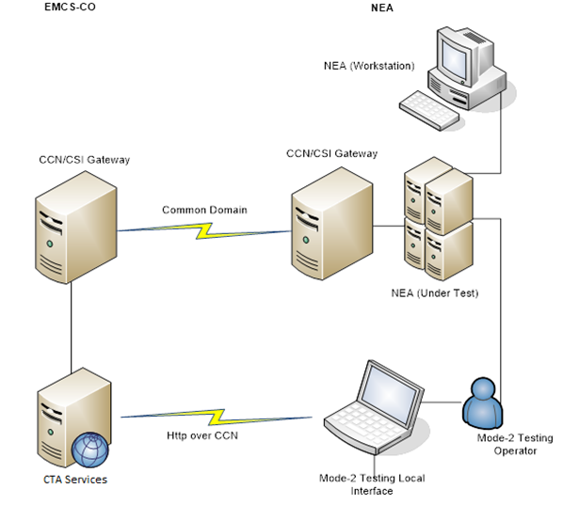
Figure 1: Conformance Testing Environment
The Conformance Testing environment consists of the NEA connected through the CCN/CSI to the CTA in the Central Test Site of the EMCS-CO, which can simulate any correspondent of the NEA messages (it can play the role of any NA site). The local interface communicates with the CTA server via a web-based interface. The CTA is pre-loaded with all the test scenarios and datasets included in the Conformance Testing Database [R09].
The CTA Administrator will verify that the CTA is available and running for Conformance Testing. EMCS-CO will provide the necessary support for keeping all tools located at EMCS-CO premises online.
The NA’s CT coordinator (the person responsible for the CT) should gain access to both the NA coordinator and NA operator user profiles at an early stage.
The NA’s tester(s) should gain access on NA operator user profile.

General Pre-requisites
Below are listed the pre-requisites NAs need to define before the CT is started. NAs need to:
- Establish a connection with ITSM DC and CTA
NAs must obtain access to ITSM via CCN (HTTP service) so that they can establish a connection between the CTA Local Interface and the CTA Server at ITSM. Connectivity tests against CTA should be performed before the CT Campaign starts to ensure the communication between the CTA and CCN gateway per NA. This test is not considered part of Conformance Testing, but is intended only to verify the communication;
- Ensure the use of the correct CCN/CSI Queues for CT
The correct CCN/CSI queues must be configured so that a CTA assigned queue is used and not an actual (operational) NA-CSI queue. NAs can request the creation of their new CTA assigned queues through the Application Configuration Tool. The ACT allows the NAs to submit their configuration requests for their business application in a guided manner. The tool is accessible through: http://act.ccntc.ccncsi.int:7003/act/, and credentials are already provided to each NA CCN Local Administrator.
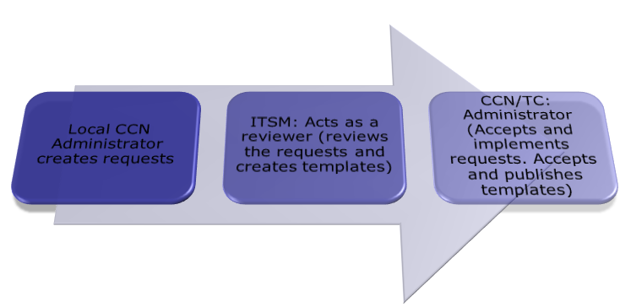
Figure 2: ACT submission workflow

In case a change in the configuration of the NEA is mandatory, the NA CCN Local Administrator should update the file via the ACT tool [Annex 1: Start up guide for CT Environment preparation];

- Configure the National Applications with Standard Reference Data
Reference and registration conformance test data are pre-loaded in CTA. National applications must be configured to use standard reference data from the supplied IE734 bundle, the supplied IE931 message data, and the supplied IE713 economic operator data. The latest reference and registration conformance test data are published on CIRCABC in the following locations:
https://circabc.europa.eu/ui/group/5d0c005e-c8e5-4193-900b-53c21899fd31/library/0b2b456a-c7fd-44f8-a4c9-b2a312e952c6?p=1&n=10&sort=modified_DESC
- Ensure the correct population of CCN Correlation ID
Under Mode-2 execution at Test Campaign level (MODE-2 Pre-CT and MODE-2 Actual-CT), CTA verifies the “Correlation Identifier” of NEA messages under test. NAs are invited to follow the correlation principle as explained in detail in Section II. VI. 2 of DDNEA [R04]. In case of an invalid “Correlation Identifier”, CTA generates results based on the message input. NAs should re-execute the related scenario and correct their implementation in case the verification of the Correlation Identifier provides the outcome “CCN Correlation Id Validation Result – Failed”. The main scope of this exercise would be to ensure the correct sequence of message exchange flow in Operations.

Specific Pre-requisites
The following pre-requisites need to be performed:
- Configuration set-up by ITSM Support (CCN queues, CCN User Profiles);
- Configuration of CCN/CSI message types for both Central and National Gateways by ITSM Support and by NA CCN Local Administrator;
- Creation of CCN profiles for accessing CTA by NA CCN Local Administrator;
- Creation of HTTP users for accessing CTA Web Interface by NA CCN Local Administrator.
Warning! Please pay attention because CCN Queues, CCN/CSI message types and User Profiles are case sensitive.

Configuration set-up by ITSM Support
Every EMCS queue has to follow always the below syntax pattern:
<QUEUE NAME.XXXX@GATEWAY NAME>
The maximum length of a queue name (including ‘@’) is 30 ASCII characters.
Detailed reference can be found in DDNEA Section IX Transport of Messages via CCN/CSI [R04].

Messages should only be exchanged between queues belonging to the same Environment.

CCN/CSI queues set-up for the National Gateways by ITSM Support
The following queues must be configured on each NA Gateway for the NEA application to successfully communicate with the Central CTA tool. The queues’ configuration will be performed through ACT requests raised by the NAs:
Queue | Description
CTA-NEA-CORE-XML-RCT-QUE.EMCS | The queue is used for the reception or sending of “Core flow” EMCS business IE messages
CTA-NEA-ADMIN-XML-RCT-QUE.EMCS | The queue is used for the reception or sending of technical messages (e.g., IE906 and IE917 refusal messages)
CTA-NEA-ED-RCT-QUE.EMCS | The queue is used for the reception of the External Domain messages
CTA-NEA-REPORT-RCT-QUE.EMCS | The queue is used for the reception of CCN/CSI generic Reports (e.g., IE908, IE909, IE910 and IE911)
Table 5: NA CCN Queues

CCN/CSI queues set-up for the Central Gateways by ITSM Support
Generic sets of queues have been created. The number of queues in CTA is only dependent on the maximum number of countries (<=3) that CTA can impersonate for one scenario:

  - CTA-CORE1-XML-XX-RCT-QUE.EMCS
COUNTRY 1
  - CTA-ADMIN1-XML-XX-RCT-QUE.EMCS

  - CTA-CORE2-XML-XX-RCT-QUE.EMCS
COUNTRY 2
  - CTA-ADMIN2-XML-XX-RCT-QUE.EMCS

  - CTA-CORE3-XML-XX-RCT-QUE.EMCS
COUNTRY 3
  - CTA-ADMIN3-XML-XX-RCT-QUE.EMCS

Figure 3: CTA QUEUES used by NAs

The following queues are configured by ITSM Support on the Central Gateway for the CTA application where xx is the value of the country code of the member state in question and y represents the number of Countries that CTA can impersonate in each scenario (1, 2 or 3).

Queue | Description
CTA-COREy-XML-xx-RCT-QUE.EMCS  Example (LU):  CTA-CORE1-XML-21-RCT-QUE.EMCS  CTA-CORE2-XML-21-RCT-QUE.EMCS  CTA-CORE3-XML-21-RCT-QUE.EMCS | The queue is used for the reception or sending of EMCS “Core” business IE messages
CTA-ADMINy-XML-xx-RCT-QUE.EMCS  Example (FR):  CTA-ADMIN1-XML-15-RCT-QUE.EMCS  CTA-ADMIN2-XML-15-RCT-QUE.EMCS  CTA-ADMIN3-XML-15-RCT-QUE.EMCS | The queue is used for the reception or sending of technical messages (e.g., IE906 and IE917 refusal messages)
CTA-ED-xx-RCT-QUE.EMCS  Example (CY):  CTA-ED-01-RCT-QUE.EMCS | The queue for the communication with External Domain
CTA-REPORT-xx-RCT-QUE.EMCS  Example (SI):  CTA-REPORT-27-RCT-QUE.EMCS | The queue is used for the reception of CCN/CSI generic Reports (e.g., IE908, IE909, IE910 and IE911)
Table 6: Central CTA CCN Queues
Important Note:
The proper configuration of RCT queues by NAs’ NEA is a pre-requisite for the successful execution of the scenarios. In case the above mapping is not correctly followed by the NAs’ NEA, then CTA will not be able to finish successfully the scenarios. For example, when CTA impersonates COUNTRY1 in a scenario step, the testing operator should send to the Conformance Test Application (CTA), the IE message to CORE1 QUEUE. The same approach should be followed in case a scenario involves either COUNTRY2 = CORE2 or COUNTRY3 = CORE3.

Configuration of CCN/CSI message types
The following table lists the messages that are in the scope of EMCS Phase 4.2 Conformance Test Protocol [R09], including the External Domain messages that could be used for Mode-1 CT activities.
IE ID | Reference | IE Name
IE701 | C_REQ_SUB | COMMON REQUEST
IE702 | C_REQ_REF | REFUSAL OF COMMON REQUEST
IE704 | N_REJ_DAT | GENERIC REFUSAL MESSAGE
IE717 | C_CCR_DAT | CONTROL REPORT
IE721 | C_COO_SUB | ADMINISTRATIVE COOPERATION COMMON REQUEST
IE770 | C_AVA_DAT | BUSINESS PROCESS UNAVAILABILITY SCHEDULE
IE801 | C_EAD_VAL | E-AD/E-SAD
IE802 | C_EXC_REM | REMINDER MESSAGE FOR EXCISE MOVEMENT
IE803 | C_EAD_NOT | NOTIFICATION OF DIVERTED E-AD/E-SAD
IE807 | C_STP_NOT | INTERRUPTION OF MOVEMENT
IE810 | C_CAN_DAT | (CONFIRMATION OF) CANCELLATION OF E-AD
IE813 | C_UPD_DAT | CHANGE OF DESTINATION
IE818 | C_DEL_DAT | ACCEPTED OR (PARTIALLY) REFUSED REPORT OF RECEIPT/EXPORT
IE819 | C_REJ_DAT | ALERT OR REJECTION OF AN E-AD/E-SAD
IE821 | C_LST_VAL | LIST OF E-AD/E-SAD AS RESULT OF A GENERAL QUERY
IE829 | C_EXP_NOT | NOTIFICATION OF ACCEPTED EXPORT
IE836 | C_INV_DIS | EXPORT DECLARATION INVALIDATION NOTIFICATION TO MSA OF DISPATCH/CONSIGNOR
IE837 | C_DEL_EXP | EXPLANATION ON DELAY FOR DELIVERY
IE839 | C_CUS_REJ | CUSTOMS REJECTION OF E-AD
IE840 | C_EVT_DAT | EVENT REPORT
IE861 | C_RES_DAT | BASIS FOR RECOVERY OF DUTIES
IE867 | C_COO_RES | ADMINISTRATIVE COOPERATION RESULTS
IE934 | C_PAC_DAT | DATA PACKAGING
Table 7: List of Messages belonging to EMCS Phase 4.2

Configuration of User Profiles by ITSM Support
For the successful rollout of the CT Campaign, the following configuration settings are performed by ITSM Support teams in alignment with the National teams.

User Profiles for accessing the National Gateways created by ITSM Support
The user profiles for accessing the National Gateways of the Conformance Test environment are the following.
User Profile | Description
CTA-READ-RCT-PRF.EMCS | Read access to NA queues
CTA-WRITE-RCT-PRF.EMCS | Write access to NA queues
Table 8: User Profiles for accessing the National Gateways

User Profiles for accessing the Central Gateways created by ITSM Support
The user profiles for accessing the Central Gateway of the Conformance Test environment are the following.
User Profile | Description
CTA-READ-RCT-PRF.EMCS | The read access to the Central CTA CCN queues:  - CTA-COREy-XML-xx-RCT-QUE.EMCS;  - CTA-ADMINy-XML-xx-RCT-QUE.EMCS;  - CTA-REPORT-xx-RCT-QUE.EMCS;  - CTA-ED-xx-RCT-QUE.EMCS.
CTA-WRITE-RCT-PRF.EMCS | The write access to the Central CTA CCN queues:  - CTA-COREy-XML-xx-RCT-QUE.EMCS;  - CTA-ADMINy-XML-xx-RCT-QUE.EMCS;  - CTA-REPORT-xx-RCT-QUE.EMCS;  - CTA-ED-xx-RCT-QUE.
Table 9: User Profiles for accessing the Central Gateway

Configuration of User Profiles by NAs’ CCN Local Administrator
To access CTA through CCN/CSI infrastructure, the NAs’ CCN Local Administrator should assign its NA users with the following two (2) CCN User Profiles:
User Profile | Description
CTA-READ-RCT-PRF.EMCS | Reads messages from the NEA queues
CTA-WRITE-RCT-PRF.EMCS | Deletes messages from the NEA queues  Writes messages on the CTA queues
Table 10: NA CCN User Profile for accessing the CTA

Accessing CTA Web Interface by NA CCN Local Administrator
An HTTP access needs to be configured to the CTA server to access CTA and perform CT activities.
The CTA is available at the address: http://ctatms-rct.itsm.ccncsi.int:6001/cta/
To establish user access to EMCS Phase 4.2, a CCN profile for accessing the CTA Web Interface has been created.
To access the CTA Web interface, the NAs’ CCN Local Administrator has to locate the profile through the CCN Administration portal and associate the existing national users (either new users or users already registered for the EMCS Phase 4.2 CT Campaign) with the following profile.
User Profile | Description
CTA-NAOPERATOR-<MODE>-PRF.TAX | Access to Phase 4.2 functionality
CTA-NACOORDINATOR-<MODE>-PRF.TAX | Access to Phase 4.2 functionality
Table 11: NA CCN User Profile for accessing the CTA Web interface

Access CTA Web Interface as ITSM Administrator
The following profile is for ITSM use only.
User Profile | Description
ITSM-ADMIN-RCT-USR.EMCS | Web interface administration access of CTA
Table 12: ITSM CTA administration profile
NAs should not use this profile otherwise it will prevent them from performing any test.

CTA Business Roles
During the execution of business scenarios under Mode-2 (while in CD operational mode), CTA can impersonate the following business roles:
- MSA of Dispatch;
- MSA of Destination;
- New MSA of Destination;
- Former MSA of Destination;
- Requesting MSA;
- Requested MSA;
- Third MSA;
- Issuing MSA;
- Addressed MSA;
- Consignor;
- Consignee;
- MSA of Export.

For example, in one scenario, when NEA plays the role of MSA of Dispatch, CTA can impersonate both the MSA of Destination and the Third MSA.

CTA Navigation
For each Test Campaign, CTA is the access point for:
- Planning the Conformance Testing (CT), by providing a National Project Plan (a list of planned dates for activities);
- Executing the Conformance Tests to assess the readiness for entry into production;
- Reporting on the Test Executions.

The following roles exist in CTA for the users of the National Administration:
- NA Coordinator
The role of the NA Coordinator is to plan the CT Execution by updating the National Project Plan and to follow up on the CT Preparation and Execution. The NA Coordinator can also generate reports about CT activities. The National Project Manager and the National CT Coordinator should be assigned the NA Coordinator user profile;
- NA Operator
The role of the NA Operator is to prepare and execute the Conformance Testing as planned by the NA Coordinator. The NA Operator can also generate reports about CT activities.

Important Note:
The roles are not exclusive. Several roles can be assigned to a single user. EMCS CPT advises that the National Project Manager and National CT Coordinator should have both roles assigned to their profiles (NA Coordinator and NA Operator).
Logging in CTA, the user may select from the side bar the “Menu” icon and then, by selecting the “Conformance Testing” option, the user will be redirected to a new page. In the “Conformance Testing” page, the user (NA Coordinator or NA Operator) can access the Business Thread to which the CT activities are related, by pressing the “View” button associated with this Business Thread in the Conformance Testing page (Figure 4).
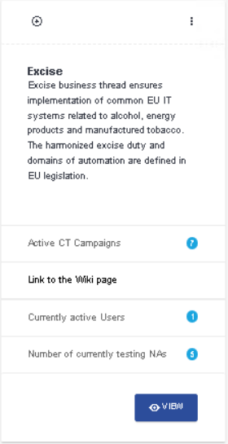
Figure 4: Conformance Testing Overview
In the “Business Thread Overview” page, the user can see details and the Business Domains belonging to this Business Thread. The user (NA Coordinator or NA Operator) can access the Business Domain to which the CT activities are related by pressing the “View” button (Figure 5).
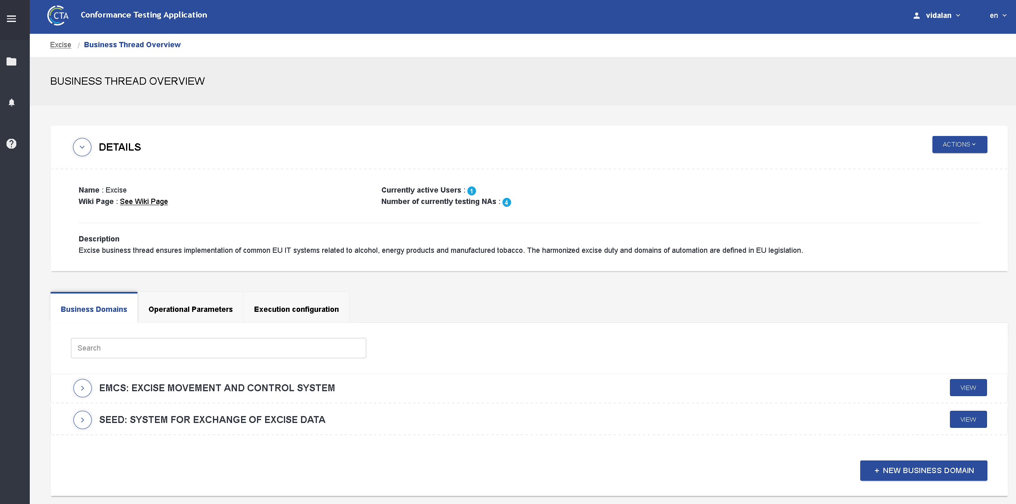
Figure 5: Business Thread Overview
In the “Business Domain Overview” page, the user (NA Coordinator or NA Operator) can see details and the CT Campaigns belonging to this Business Domain and the related recorded Deviations (if any). The user can access EMCS Phase 4.2 CT Campaign by clicking on the “View” button associated with this CT Campaign in the list of CT Campaigns (Figure 6).
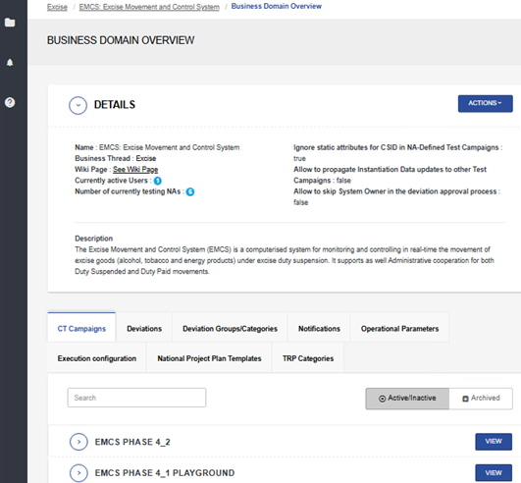
Figure 6: Business Domain Overview
The user can access a Test Campaign by clicking on the “View” button associated with this Test Campaign in the list of Test Campaigns (Figure 7).
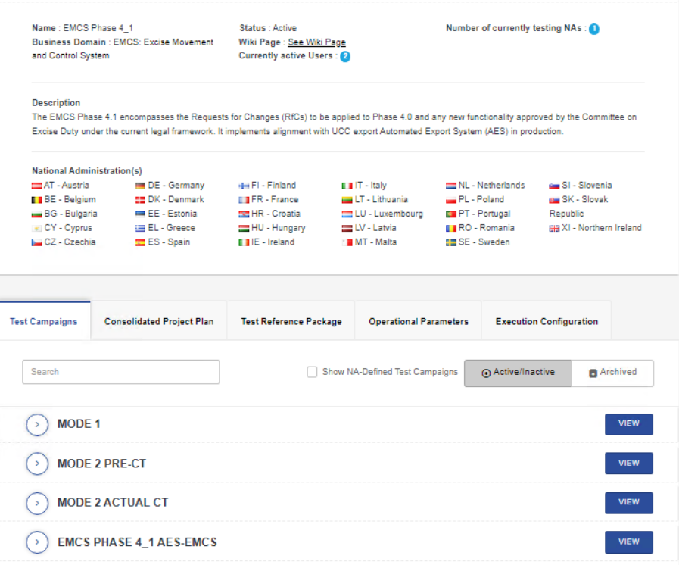
Figure 7: CT Campaign Management
In each Test Campaign, a menu bar allows the user to navigate between the various pages available at the Test Campaign level (Figure 8).
Figure 8: Test Campaign Menu

The figures presented above provide a first overview of the pages available to CTA. For detailed information, the user may refer to the respective User Manual [R07]. Presentation of the CTA and its basic functionalities will follow in the planned CTA training for EMCS Phase 4.2 by the EMCS CPT to the concerned National Administrations. Additionally, useful end-to-end information may be found within the CTA Wiki and specifically in the ‘Getting Started with CTA’ guide. The full functionality of CTA is thoroughly described in the CTA Functional Specifications [R08].

Testing Organisation
This section provides detailed information on the:
- Conformance Testing organisation in terms of planning, roles, and responsibilities;
- Applicable communication method each involved stakeholder should follow;
- Conformance Testing Campaign lifecycle;
- Scope of subject of EMCS Phase 4.2.

Roles and Responsibilities
Figure 9 presents the parties involved in EMCS Phase 4.2 CT.
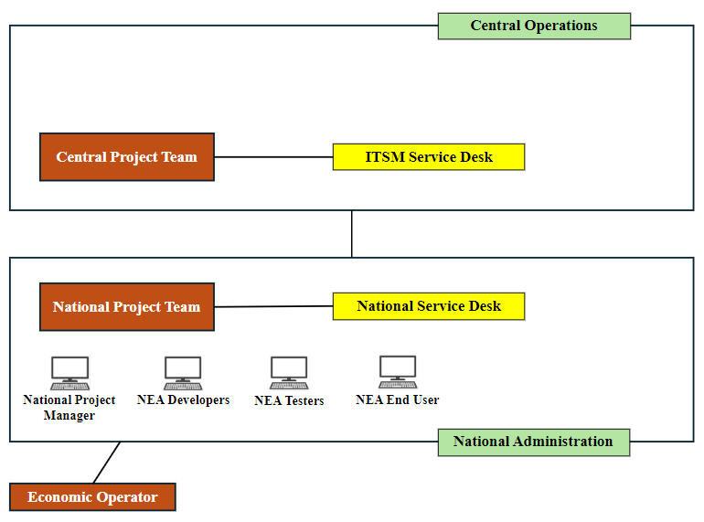
Figure 9: Parties involved in EMCS Phase 4.2 CT

The following table summarises the roles and responsibilities of ITSM Support (including CCN/CSI services) and of NA teams.
Actor | Roles and Responsibilities
NA National Project Manager | The National Project Manager is designated by the NA to supervise all the EMCS CT activities performed by the National Project Team. In CTA, the relevant user profile that the respective user should acquire is the “NA Coordinator”. The National Project Manager:  - Updates the NPP on CTA whenever information is changing in the NA’s national planning [see section 6.2];  - Creates a Test Plan (which includes details of the test team and the development team);  - Initiates the Conformance Testing procedure by submitting a request to the ITSM Service Desk with formal proof of compliance with the preconditions;  - Coordinates the test execution and verification of results at the National Site;  - Creates deviations;  - Submits the recommended CTA Report after each CT Mode (including Mode-1, Mode-2 Pre-CT, and Mode-2 Actual-CT) and the Test Summary Report only for Mode-3. The Test Summary Report template can be found in Annex 7 (section 6.7);  - Include the latest TRP in the CTP explorer to view the content of the TRP (Test Cases, Message Instances, and Country-Specific Instantiation Data).
NEA Tester | The Tester is designated by the NA to perform all testing activities related to Phase 4.2 CT. In CTA, the relevant user profile that the respective user should acquire is the “NA Operator”.  The Tester:  - Performs CT activities.  - Updates Country Specific Instantiation Data (CSID);  - Creates and Updates NA-Defined Reference Data.
CCN/CSI Services | During Conformance Testing, the CCN/CSI services are provided by ITSM Support via the National Service Desk to the NAs regarding problems they may encounter or questions they may raise while using the CCN/CSI gateway.
ITSM | ITSM is responsible for the operation of the Central Test Site and manages the CTA.  ITSM Support:  - Includes the ITSM Service Desk and provides assistance to the NAs in case they encounter issues with the communication (connectivity or message exchanges) between the NEA and the Central Test Site;  - Provides guidance to the National Project Managers for performing the tests;  - Centralises all test results for reporting to the EMCS CPT and assesses and evaluates the severity of the errors detected during the Conformance Testing.  ITSM CTA Administrator at Central level:  - Sets up the CT Environment;  - Monitors the CT Environment;  - Is responsible for the technical configuration of the CTA.  ITSM Excise CT Coordinator:  - Ensures the communication and coordination with the NAs;  - Performs the required actions in CTA for setting up the CT Campaign;  - Defines the CT Campaign scope in CTA;  - Uploads either a full or an incremental TRP version in CTA;  - Provide CTP Explorer with the initial TRP for the CT Campaign;  - Creates/Updates NA-Defined Reference Data;  - Creates/Updates deviations in CTA;  - Monitors scenario execution through log files;  - Follows up on the CT issues and NAs’ recorded Incidents;  - Submits a Consolidated Planning Report of the CT activities to EMCS CPT;  - Submits analysis on the CT activities to each NA (upon completion of Mode-2 Pre-CT and upon completion of Mode-2 Actual-CT);  - Uploads NAs’ National Project Plans, log files, Test Summary Reports, and CT analysis on the ITSM Publishing Platform.  ITSM Excise CT Tester:  - Supports NA in test troubleshooting;  - Diagnoses problems encountered during testing;  - Analyses test results and log files on NAs’ request.  ITSM Service Desk:  - Normal service call handling;  - Close coordination with ITSM Excise CT Coordinator for CT-related requests.
Table 13: CT Roles and Responsibilities

Planning and Milestones
As per EMCS Master Plan v3.00 [R11], the EMCS Phase 4.2 corrective release will be at the full rollout of EMCS Phase 4.2 set for Mr on 12/02/2026.
National planning should aim at delivering the Phase 4.2 CT Campaign activities within the reference dates and ensure the smooth transition to Operations. Please refer to Annex 2 (section 6.2) for the latest NPP template file.
Reference Dates for Phase 4.2 CT Campaign within Common Domain
Task | Testing Mode | Ref. Start Date | Ref. End Date
CD-84 | NEA Testing (Mode-1) | 09/06/2025 | 19/12/2025
CD-86.1 | NEA Conformance Testing Mode-2 Pre-CT | 16/06/2025 | 16/01/2026
CD-86.2 | NEA Conformance Testing Mode-2 Actual-CT | 23/06/2025 | 30/01/2026
CD-87 | NEA International Testing (Mode-3) | 07/07/2025 | 11/02/2026
CD-88 | NEA End-to-End International Testing (Mode-3 Plus) | 07/07/2025 | 11/02/2026
Table 14: Reference dates for EMCS Phase 4.2 CT Campaign

Communication and Synchronisation
When performing Conformance Testing, effective communication and synchronisation are essential. For that purpose, the Excise Conformance Testing Team (ITSM3-TES Excise CT Team) will use the following communication means:
- ITSM Synergia (ESS) [see section 4.3.1];
- CTA Support Form [see section 4.3.2.2];
- E-mail (ITSM_TES_EXCISE@itsmtaxud.europa.eu);
- Telephone.

During the CT Campaign, ITSM Support and more specifically the Excise Conformance Testing Team, will provide the NAs with:
- Coordination;
- Technical Support (including Application Management, Infrastructure Support, CCN Support services);
- Assistance in troubleshooting issues encountered during the testing activities.

ITSM Synergia ESS
The NAs should create an Interaction for each request for coordination or issues detected during the CT Campaign, via the Synergia ESS application (available at the following URL: https://ITSMtaxud.europa.eu/smt/ess.do, with the same credentials used as for the ITSM Portal):
- Create Interaction;
- Select Urgency;
- Select the corresponding Service related to testing “EMCS (Trans-European System) CONF”;
- Press the “Submit” button.

In Synergia ESS, four (4) specific templates applicable to EMCS Phase 4.2 CT Campaign have been created. These templates have specific Campaign identifications (pre-filled text), i.e., EMCS-P4.2-NA-XX, where XX is replaced by the country code. The use of templates facilitates communication and minimises the introduction of errors into the logging of incidents/interactions.
The NAs should apply one of the four templates available on Synergia ESS, presented in Table 15.
Template | Name | Description
Error Problem Report | EMCS P4.2: Error Problem Report | NA tester requests ITSM Support to analyse/clarify the reason for the failure of a test case result.
CT Coordination | EMCS P4.2: CT Coordination | NA requests information from ITSM Support for any type of coordination of the campaign (e.g. organise a conference call to discuss an issue found etc.).
CTP/Specifications issue | EMCS P4.2: CTP/Specifications issue | NA requests ITSM Support to clarify doubts on the CTP or specify Common Specifications related information.
Test Summary Report | EMCS P4.2: Test Summary Report | NA submits to ITSM Service Desk their Test Summary Report for Mode 3.
Table 15: Synergia ESS CT Templates
Once requests are submitted and the solution is reached, the Interaction under Synergia ESS is updated with the solution. In parallel, an e-mail is sent to the person who logged the Interaction. The Interaction becomes the communication channel between the NA and the ITSM teams for the specific requests. For additional specific information on Synergia ESS, NAs are invited to consult the manual on the use of ESS, which is available on the ITSM Portal under: ITSM Publishing Platform: /Common/Synergia folder.
The CT coordinator ensures the traceability of service requests and may create Known Errors (if needed) during the CT Campaign. The Known Errors related to the CTP and/or CTA will be available to all NAs on ITSM Portal under: ITSM Publishing Platform: /Call Centre/Known Errors.

Complementary information
Each NA can follow up on the status of their testing activities on the ITSM Portal under: ITSM Publishing Platform: /Excise/ EMCS Phase 4.2 CT Campaign folder. NAs have access only to read the generic folders and those folders dedicated to their own administration. Every person interacting with ITSM Support during the Conformance Testing Period has to be registered in Synergia, and therefore authorised by the National Project Manager, and indicated in the NA's CT Contact details, communicated through the Weekly CT Report. Access can be requested via https://itsmtaxud.europa.eu/sites/itsm-portal/home.html by pressing on the User Access Management Forms link.
The ITSM3-TES Excise CT Coordinator ensures traceability of service requests, follows up on the actions needed to be taken, and initiates their closure.
The CT Weekly Report is published on CTA Wiki and is available to all NAs under the following link:
https://webgate.ec.europa.eu/fpfis/wikis/spaces/CTA/pages/2123046116/EMCS+Phase+4.2+CT+Campaign
For urgent interaction, NAs could address directly to the ITSM3-TES Conformance Testing mailbox ITSM_TES_EXCISE@itsmtaxud.europa.eu.

CTA Wiki
CTA will give the ability to provide links to wiki pages of every main artefact (Business Thread, Business Domain, CT Campaign, Test Campaign). Information regarding CT planning, documentation and reporting will be published in due time for NAs’ consultation and consideration.
The CTA Wiki page is accessible to everyone via ECAS account under the following link:
https://webgate.ec.europa.eu/fpfis/wikis/display/CTA
In the CTA Wiki page, the user can find:
- CTA Getting Started Guide;
- CTA Functional Specifications;
- CTA Technical Specifications;
- CTA Guide Videos;
- CTA User Manuals;
- Upcoming CTA Events;
- CTA related blogs;
- Links to related CIRCABC location.

Request Support
CTA offers a functionality to the user for support in Test Cases issues via a Support Form. This form can be accessed with the following process. In Test Session page, in the section of Test Cases, on the right the user can check the checkboxes of the Test Cases he/she needs to get support to. Clicking on “Request Support” button, a form appears. The user fills-in the form and by pressing the “SEND” button, the issue recorded is sent to ITSM Support. For detailed information on the Request Support process, the user may refer to section 4.3.6.5.1.1.22 in the respective User Manual [R07].
Due to internal procedures, all requests will be linked to the e-mail address of the CTA user, thus CTA user has to be registered in Synergia.

Testing Lifecycle Overview
Each NEA can be considered as a black box, which interacts with other NEAs over the Common Domain and with the Trader applications over the External Domain. Exchanges in the National Domain are part of the NEA.
Each NEA is tested in gradual stages, whereby all interfaces are emulated first, and then the emulators are gradually replaced by real-life systems that approach the operational environment as much as possible. Each NA will therefore have to define its own testing strategy, thereby deciding upon the emulator usage and the scope of the tests to be performed.
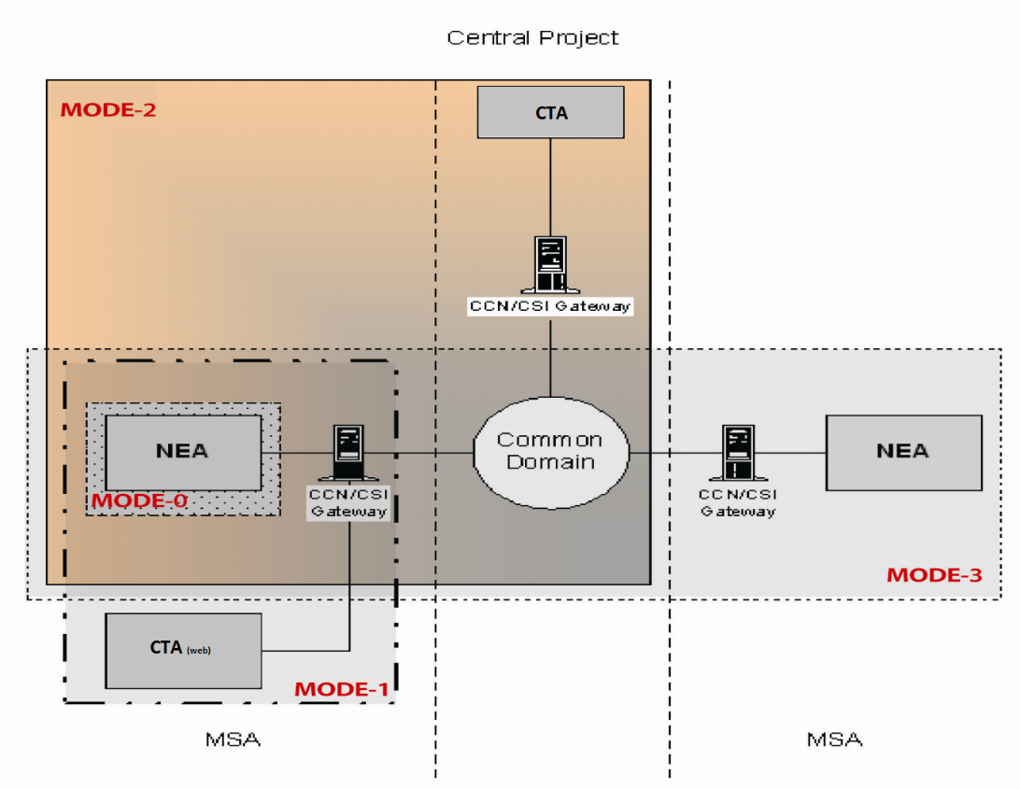
Figure 10: Testing modes
The testing of each NEA will be organised in “modes” that will be performed in sequence. This section provides an overview of the different testing modes that the NEA will undergo.
ITSM Support will provide the necessary support (ITSM Service Desk, CT related services, CCS/CSI related services) and will ensure that all tools located at Central Test Site premises are available. The CTA Administrator will verify that the CTA is available and running for Conformance Testing.
Before the start of the Conformance Testing Modes, it is recommended that the NAs perform a Connectivity Test with CTA in order to ensure that the connectivity to the application is properly working and CTA web interface can be accessed and messages can be exchanged. This test is not considered part of Conformance Testing but intends to verify the communication with the application. ITSM Excise CT Coordinator recommends that this should be tested either prior to Mode-1 or Mode-2.
The testing modes are shown below:
- Mode 0 (or Integration) Testing during development;
- Mode-1, which may either use the Mode-1 functionality of the central CTA server application, or for which NAs may make their own arrangements;
- Mode-2 (or Conformance) Testing, during which the various functions in the CD will be tested. This will be carried out against the Central Test Site (ITSM Infrastructure), where the CTA will be operated to test the conformity of the NEA against the test scenarios in the CTP [R09];
- Mode-3 (or International) Testing during which each NEA performs connectivity tests (message exchanges) towards NEA-XI in a separate testing environment.

Mode 0 – Integration Testing
Mode 0 is the integration testing during which the NEA modules are tested against the specifications with emphasis on the functionality (except for XML message mapping or CCN/CSI interface-related issues). NAs may optionally test using the loopback facility of the local CCN/CSI gateway (LCT mode, refer to Annex 1: Start-up guide for CT Environment preparation) to test successful interfacing with the CCN network.
Role | Responsibilities
NA | - Execute the testing and verify the results with self-developed tests and test procedures  - Provides confirmation to the ITSM Excise CT Coordinator that the testing is successful
ITSM | NAs do not need support from ITSM Support teams in Mode 0 Testing
Table 16: Mode-0 Roles and Responsibilities

Mode-1 - National Compliance Testing
Mode-1 focuses on the testing of the whole NEA’s functionality and the interface with the CCN/CSI. Mode-1 is performed at the NA’s premises, under the NA’s responsibility, supported using CTA.
The Mode-1 Testing environment consists of the:
- NEA under test connected through the CCN/CSI to the CTA in the Central Test Site;
- The CTA web interface is accessible by the CTA Operator at the NA under test site.
During Mode-1, CTA:
- Has the ability to send and receive both CD and ED messages that will be sent over CCN queues (different queues will be used for CD and ED messages);
- Supports the export of XML IE instances to be used in Mode-1 testing (local use).

Role | Responsibilities
NA | - Test execution and verification of results; to send and receive at least one message;  - Provides the CTA-6 Report for Mode-1 to ITSM Excise CT Coordinator;  - Provides all test log files to the ITSM Excise CT Coordinator to demonstrate the successful completion of Mode-1 tests upon request;  - Optionally verifies the structure of all message types.
ITSM | - Informs the NA that the CT environment is ready for Mode-1 testing;  - Analyses and diagnoses problem statements and/or resolves issues;  - Supports the NA in case of difficulties in establishing communication with the Conformance Test Environment;  - Supports and organises conference calls (either scheduled or ad-hoc) with NAs if needed.
Table 17: Mode-1 Roles and Responsibilities

Mode-2 - Conformance Testing
CT Mode-2 covers the complete system testing over the CCN/CSI infrastructure and verifies the interface of the NEA under test within the Common Domain.
Mode-2 Conformance Testing is performed in two stages, called Pre-Conformance Testing (Pre-CT) and Actual-Conformance Testing (Actual-CT).
Pre-Conformance Testing is a preliminary stage during which the NAs prepare themselves for the Actual-Conformance Testing. During Mode-2, the NAs are authorised to use the ITSM infrastructure, centrally located, to execute the tests.
CT Mode-2 takes place at the NAs’ premises, executing a full set of predefined test scenarios that mandate the exchange of IEs using the CTA.
During Mode-2, CTA supports:
- The creation of NA-defined scenarios to be used during Pre-CT (local + central use);
- Conformance Testing only for CD, therefore NAs need to emulate ED, since CTA does not provide this feature.

Mode-2 Prerequisites for the NAs:
- Before Conformance Testing can start, NAs need to establish successful connectivity with CTA in order to ensure the communication of the NEA and CTA via the CCN gateway. This can be done either prior to Mode-1 or prior to Mode-2, depending on whether NAs wish to make use of the Mode-1 facilities provided by the CTA Server application;
- Before an NA that has decided to perform Mode-1 moves on to Mode-2 CT, evidence shall be provided to the ITSM Excise CT Coordinator by the CTA-6 Report, showing that Mode-1 tests have been successfully completed;
- Time slots need to be allocated for the specific testing mode and should be communicated via the NPP update on CTA (agree with ITSM on the CT time slots when to perform Pre-CT and Actual-CT);
- Contact ITSM Excise CT Coordinator four (4) weeks prior to the start of Pre-CT and Actual-CT about the plan of activities.

Pre-Conformance Testing
Pre-Conformance Testing is divided into Official Testing and NA-Defined Testing.
- Official Testing intends to verify the capability of the system to respect the protocol. It consists of exchanging a number of pre-defined messages in a pre-defined order between the NEA and CTA. During Official Testing, the NAs will use the scenarios and test data defined in the Conformance Testing Protocol Database. Every test scenario will be executed at least once with a Dataset defined in the Conformance Testing Protocol Database;
- NAs can perform NA-Defined Testing on a daily basis. The NA user can modify the IE message templates and a scenario from the Conformance Testing Database can be used. In case support is needed by the ITSM Excise CT Coordinator, NAs should provide related information.

Role | Responsibilities
NA | - Runs all CTP test scenarios and datasets within the official CT Scope for EMCS Phase 4.2;  - Provides the CTA-8 Report for Mode-2 Pre-CT to ITSM Excise CT Coordinator;  - NA may also choose to perform “NA-Defined Testing”:  - With own scripts - propose before the start of the NA’s Defined Testing, the scenarios and the data to be exchanged within the involved IEs;  - With scenarios defined in the Conformance Test Protocol Database. The NA should provide to the ITSM Excise CT Coordinator the scenarios of the Conformance Test Protocol Database they will follow and the roles that its NEA will simulate.
ITSM | - Analyses and diagnoses problem statements and/or resolves issues;  - Supports the NA in case of difficulties to establish communication with the Conformance Test Environment;  - Acts as the CTA Central Application administrator;  - Supports and organises conference calls (either scheduled or ad-hoc) with NAs if needed.
Table 18: Mode-2 Pre-CT Roles and Responsibilities
The Pre-Conformance Testing is considered finished when at least all CTP Test Cases within official CT Scope for EMCS Phase 4.2 have been run successfully.

Actual-Conformance Testing
At the beginning of this mode, a Kick-off conference call could be organised between the NA and the EMCS CPT upon bilateral communication. The main purpose of this conference call would be to discuss any issues detected during Pre-CT and confirm that the NA can proceed with the Actual-Conformance Testing. The Kick-off conference call is organised after the CTA-8 Report for Pre-CT is provided and after CTA test logs are analysed by ITSM Excise CT team. The same is applicable at the end of the Actual-Conformance Testing in order to assess if the NA is certified to continue, this is a mandatory step during Conformance Testing Campaign.
Actual-Conformance Testing is based on the Conformance Testing Protocol Database (CTP Database) and consists of exchanging a number of pre-defined messages in a pre-defined order between the NEA and CTA. Actual-Conformance Testing does not differ from the Pre-Conformance Testing.
Role | Responsibilities
NA | - Executes the scenarios and datasets;  - Provides the CTA-8 Report for Mode-2 Actual-CT to ITSM Excise CT Coordinator.
ITSM | - Provides a Consolidated Test Report for Mode-2 Actual-CT to EMCS CPT;  - Analyses and diagnoses problem statements and/or resolving issues;  - Supports the NA in case of difficulties to establish communication with the Conformance Test Environment;  - Supports and organises conference calls (either scheduled or ad-hoc) with NAs if needed.
Table 19: Mode-2 Actual-CT Roles and Responsibilities

AES-EMCS Conformance Testing
The AES-EMCS Conformance Testing was first introduced under EMCS Phase 4.1. In the context of EMCS Phase 4.2, a newly defined test campaign titled “EMCS Phase 4_2 AES-EMCS” will become available (provisionally in July 2025) in CTA under the EMCS Phase 4.2 CT campaign. This campaign reflects changes introduced in the AES DDNXA specifications, establishing a dependency that is addressed through the relevant RfCs. These changes will be incorporated into the current Test and Release Protocol (TRP).
AES-EMCS Test campaign offers NAs the opportunity to optionally extend their testing, incorporating the AES message types, which in real Excise business cases are going to be exchanged in the National Domain.
In this specific campaign, through the Single Message Exchange functionality (in the same approach as described in Table 24) the following AES-originated message types can be exchanged from/to CTA:
IE519, IE532, IE534, IE535, IE536, IE537, IE539 and IE598.
Additionally, a predefined official scope has become available in the “EMCS Phase 4_2 AES-EMCS” test campaign to serve the test execution of predefined scenarios. The dedicated Export test cases are listed below:
- BS-16(l)_DS;
- BS-16(m)_DS;
- BS-16(n)_DS;
- BS-16(o)_DS;
- BS-16(p)_DS.
Although, in real business cases, the AES message types are exchanged within the National Domain, for the previous-mentioned five test cases the message exchanges from/to CTA are performed via the CORE queues (see Section 2.3.2.1).
The datasets and the templates of the AES message types, as well as the above-mentioned test cases, are incorporated in the Conformance Test Protocol [R09], in alignment with the following RfCs: UCCAES2935, UCCAES2936, UCCAES2938, and UCCAES2939.
According to the requirements of AES P1 CTOD [R12], Certificate A4 includes the certification of the Block 4 functionality – AES-EMCS interface (TES interoperation) with evidence to be provided to the ITSM3-TES Customs team when necessary. In case of the testing in EMCS Phase 4.2, a formal certification of the functionality against CTA will not be requested, nevertheless, these test cases are part of EMCS Phase 4.2 CT campaign and are strongly recommended.
Role | Responsibilities
NA | - Executes the scenarios and datasets (Optional);  - Provides the CTA-8 Report for EMCS Phase 4_1 AES-EMCS to ITSM Excise CT Coordinator (Optional).
ITSM | - Analyses and diagnoses problem statements and/or resolves issues;  - Supports the NA in case of difficulties in establishing communication with the Conformance Test Environment;  - Supports and organises conference calls (either scheduled or ad-hoc) with NAs if needed;  - Includes the progress of the AES-EMCS Test campaign in the EMCS Phase 4.2 Conformance Test Reports per NA.
Table 20: AES-EMCS Test Campaign Roles and Responsibilities

CS/MIS2 Conformance Testing
With the phase-out of CS/MISE and the upcoming migration to CS/MIS2, a dedicated Conformance Testing (CT) phase is foreseen. This testing will be essential to ensure the accuracy and reliability of message exchanges within the CS/MIS2 system, as well as to verify the correct execution of actions performed through the User Interface. The CT phase will play a key role in supporting NAs to ensure a smooth transition. As development is still ongoing, detailed information regarding the organisation and timeline of the CT phase will be communicated well in advance.

Mode-3 - International Testing
This is a mandatory international testing phase between NAs and does not involve the Central Test Site.
Under this mode, NAs test their NEA by exchanging messages with one or more other NEAs run by other NAs (in RIT mode of test configuration). The international testing of a given NEA with more than one NA is required.
During this mode:
- NEA tests its conformance against other voluntary NAs, with the support of ITSM if required;
- No dedicated testing tool is used;
- Organisation is up to NAs that take part in.

Role | Responsibilities
NA | - Executes the tests and verifies the results;  - Provides the Test Summary Report for Mode-3 CT to the ITSM Excise CT Coordinator and the test scenarios that were executed (see Annex 7);  - Provides all test log files to demonstrate the successful completion of Mode-3 tests to the ITSM Excise CT Coordinator, if necessary or requested.
ITSM | - Assists NAs in finding partners for Mode-3 testing;  - System support;  - Assists NAs in analysis, diagnosis, and solving of problem statements;  - Provides support and organises the conference calls with NAs if needed.
Table 21: Mode-3 Roles and Responsibilities

Mode-3 plus – End-to-End Testing
Mode-3 Plus is a non-mandatory testing phase between the Economic Operators (end-to-end testing), and it is under the NAs’ (National Project Manager) responsibility to:
- Ensure full end-to-end International testing;
- Execute a pre-production testing phase, which extends testing so that it simulates real operations.

Mode-3 plus Prerequisites for NAs
- Successful execution of Mode-3 Testing with at least two (2) NAs;
- Execution of national testing with the involved economic operators (under national responsibility);
- Submission of a test report for Mode-3.
Role | Responsibilities
NA | - Involve Economic Operators in execution of the tests from both consignor and consignee sides;  - Contact their EcOps to test Mode-3 Plus (it is recommended to involve at least one “big” EcOp);  - Indicate participation in Mode-3 Plus to the EMCS CPT via the NPPs;  - Provide to ITSM (by e-mail) a list of EcOps that will participate in Mode-3 Plus two (2) weeks before the start of this Mode (the related template in Annex 6: Mode-3 Test Summary Report template);  - Provide ITSM (by e-mail) with a list of contact persons in charge of the organisation of Mode-3 Plus;  - Provide to their committed EcOps the test specifications that will be executed during Mode-3 Plus Testing;  - If a volunteer EcOp is not able to find a partner to run Mode-3 Plus Testing, its NA should take over the responsibility to support the EcOp in finding a partner from another volunteer NA.
Economic Operator(s) | - It is essential that the volunteer EcOps are committed to their NA to participate in Mode-3 Plus Testing;  - Establishment of Mode-3 Plus Partner with EcOps from the other NAs, as done in real business;  - During the week leading up to the start of the Mode-3 Plus Testing, the EcOps should confirm to their NAs that they are ready to start Mode-3 Plus Testing on the planned date.
ITSM | - Indirect support through ITSM Service Desk;  - Coordination and Follow-up of the activities:  - Active contact with the NAs;  - Collect weekly information from NAs about EcOps to test Mode-3 Plus and publish it on CIRCABC;  - Collect weekly information from NAs about their testing activities during Mode-3 Plus.  - Monitoring of the test execution during Mode-3 Plus.
Table 22: Mode-3 plus Roles and Responsibilities

The communication during this Mode will be confined to the EMCS CPT and NA:
- NAs are free to give as much information as possible. However, NAs need to check with their EcOps what information can be given (data protection);
- If an EcOp has objections to their data being published on CIRCABC, information about this EcOp should not be communicated to the EMCS CPT;
- EcOps that are not willing to share this information may still register for participation.

Procedures and summary of tasks to be performed
The ITSM Excise CT Coordinator will coordinate the Conformance Testing. Table 23 summarises the actions that need to be performed for each entity in order to execute the Conformance Test Campaign.
Action | NA | ITSM
Set up the necessary infrastructure to perform the tests | √ | √
Define time slots for the Mode-2 tests – NAs have to communicate dates via NPP functionality in CTA | √ | √
Upon completion provide e-mail notification that Mode 0 is completed | √ | √
Run the tests and, upon completion, prepare and submit a CTA-6 Report for Mode-1 | √ | Support
Run the tests and, upon completion, prepare and submit a CTA-8 Report for each phase of Mode-2 | √ | Support
Organise a coordination conference call for Kick-off/End of Mode-2 Actual-CT, for each NA | √ | √
Run the tests and, upon completion, prepare and submit a Test Summary Report for Mode-3 and the test scenarios that were executed | √ | Support
Run the tests and, upon completion, prepare and submit a Test Summary Report for Self-Certification (only for Northern Ireland) | √ | −
Submit to the EMCS CPT one CT report per NA |  | √
Table 23: List of actions to be performed

EMCS Phase 4.2

Changes Introduced for Phase 4.2
The final versions of the Common Specifications are FESS v4.22 and DDNEA v3.23. The changes for EMCS were approved by the EMCS Change Advisory Board and should be implemented in the Phase 4.2 release. The changes are included in the respective release scope document for EMCS Phase 4.2 FESS and DDNEA [R05].

EMCS Phase 4.2 CT Scope

CT Scope
The scope of this CT Campaign is to validate the compliance of the NEAs against the new changes introduced for EMCS Phase 4.2 release [see section 4.6.1]

Mode-2 CT Scope
The CT Scope for EMCS Phase 4.2 incorporates a list of scenarios, in alignment with the related changes introduced for FESS and DDNEA [R05] for EMCS Phase 4.2.
The details of the scenarios that apply to Phase 4.2 CT can be found in the CTP for Phase 4.2 [R09]. For the reader’s convenience, a consolidated file is enclosed below and lists the Mandatory (98) and Optional (42) test scenarios in the scope of EMCS Phase 4.2 Conformance Testing Campaign. Both Mandatory and Optional test cases -140 in total- are available in CTA under the Official Test Scope. NAs are invited to execute any other test case specified in CTP, which they consider necessary, under a NA-Defined Test Scope.

Optionality of test scenarios
The optionality of the test scenarios listed in the CTP indicates whether a scenario is optional or mandatory for EMCS Phase 4.2 CT.
The optionality should be taken into account when an NA executes a scenario, so as to estimate the importance of a possible failed scenario. The optional character of a scenario is indicated at scenario step level:
- If a scenario step is indicated as ‘optional’, the scenario is indicated as ‘optional’;
- If a scenario has all its steps indicated as ‘mandatory’, then the scenario is considered mandatory.

Traceability Matrix
Each CTP scenario for EMCS Phase 4.2 corresponds to specific involved sections of DDNEA v3.23 and FESS v4.22. The mapping between the CTP scenarios and the involved sections of the common specification artefacts are embedded in an excel file in Section 2.2.1 of CTP for EMCS Phase 4.2 [R09].

Conformance Testing Protocol Explorer (CTP Exp)
CTP Explorer can be used to provide an advanced view of the CTP content that is maintained through the CTP database.
The CTP Explorer system is provided as a stand-alone desktop application, which can be executed and used in the user’s local workstation. The CTP Explorer outlines the organisation and the test specifications (scenarios & test data) to be executed during Conformance Testing. The CTP content is loaded in the application package via the Test Reference Package (TRP). In addition to the TRP, other configuration files, according to the Business Domain under CT, should be loaded beforehand in the application package.
The system shall provide the functionality of navigating through the CTP content in a user-friendly manner. More specifically, the user can filter and view CTP content regarding Test Cases, Test Scenarios, Message Instances, and Country Specific Instantiation Data defined in CTP. CTP Explorer provides the National Project Managers with the required information in order to effectively organise the testing sessions.
More specifically, CTP Explorer system comprises the following main functionalities:
- Dashboard:
  - Viewing general information and volumetric graphs regarding the available data via CTP Explorer;
  - Loading a different TRP Version to view content.
- Instantiation of Country Specific Data:
  - Viewing and filtering the available Instantiation Data, using different criteria.
- Message Instances:
  - Viewing and filtering the available Message Instances, using different criteria;
  - Instantiating the available Message Instances with Country Specific Data and Dynamic Tags (strategy NOW and GUID);
  - Viewing the deviations between an erroneous and its corresponding correct Message Instance.
- Test Scenarios:
  - Viewing and filtering the available Test Scenarios, using different criteria;
  - Viewing the details of a particular Test Scenario.
- Test Cases:
  - Viewing and filtering the available Test Cases, using different criteria;
  - Viewing the details of a particular Test Case;
  - Define the scope of exported Test Cases to be used by CTA;
  - Instantiating the message templates of each test case step with Country Specific instantiation data.
- TRP Comparison:
  - Viewing the comparison results between the loaded TRP Version and a candidate for comparison TRP Version.

Conformance Test Specification

Test validation
The criterion for each test validation is the conformance of the test output to the expected output.
For each test, this leads to checkpoints such as:

- The messages are received in the indicated sequence;
- No mandatory fields are missing;
- No business rules and conditions are violated;
- No Code lists are violated;
- The result data conform to the Common Specifications of FESS [R02] and DDNEA [R04];
- The errors reported are the expected ones (e.g., if a rule or condition is violated, the appropriate error is displayed).

Creation / View of National Deviations in CTA
In some cases, NAs would like to deviate from the normal CT scope (e.g., mandatory scenarios not performed, rules not implemented due to national legislation constraints). These deviations can imply that an NA:
- Will not run all scenarios in scope;
- May break some validation rules.
Consequently, the not executed and the failed scenarios in the test results should be compared to the NAs’ applicable deviations to define their final status. One deviation may apply to one or more test scenarios.
National Project Managers, National CT Coordinators, and National Testers (NA Coordinator or NA Operator user profiles) can access the Deviations page at the Business Domain page (Figure 6) and view all the Deviations of his/her National Administration.
Note: All Member States are requested to re-register the applicable Deviations for the current Phase, even though they may have been registered in a previous Phase.
A new Deviation can be declared, registered, and maintained only by NA users linked to the NA Coordinator user profile.
The declared Deviations will be used in reports and namely during the verifications of CT Execution Results, to assess the conformity of NA’s implementation. In case of approval of a Deviation or case of rejection of a Deviation (if test case fails or is not executed), a Known Error will be registered for Conformance Testing or/and Production after the completion of CT activities.
The NA user has the possibility to specify, for a scenario, a result different from the one concluded by CTA. The result concluded by CTA will be kept in CTA’s database for tracking, analysis, and reporting purposes. The result specified by the NA user will supersede the one concluded by CTA, meaning that it will become the official result of the scenario.
The Excise CT Coordinator can supersede test results as well. In case the deviation has been registered and approved beforehand, the result, initially marked as failed, will be passed at the end of this procedure. The result specified by the Excise CT Coordinator will supersede the ones concluded by CTA and/or by the NA user. This is the official test result of the scenario.
This is to support the process of the decision on NA’s readiness, based on the CT Report and related validation performed by ITSM and DG TAXUD. For detailed information on the Deviations’ process and related workflow, the user may refer to the respective User Manual [R07].

Error/Problem handling
In case the test output differs from the expected one, the test is considered “failed”.
The problem originator (in most cases, a member of the NA Test Team) establishes a problem statement and submits it to the National Project Manager using the Error/Problem Report form.
An expert analysis must then be performed by the NA (in collaboration with ITSM during the Conformance Testing session) on the failure to establish a diagnosis.
Possible causes include:
- Wrong testing procedure;
- CTA error;
- TRP/CTP error;
- NEA error.
The proper procedure shall then be initiated at the NA level and/or at the Central level, depending on the diagnosis.
In case an unexpected NEA error is encountered, a severity rating is assigned to the error (by ITSM during the Conformance Testing session), related to its business impact. Such errors can be critical, major, or minor.
In case of a critical error, the testing cannot progress due to an error that technically prohibits further testing of the application. The system is unacceptable at this stage. The business can by no means be performed without fixing this problem.
With a major error, a module cannot be further tested for the failing functionality, but a workaround permits testing of the rest of the application. Business can be performed using a workaround.
When a minor error is encountered, the functionality cannot be verified, but this does not have a significant impact on the business.
In case that a CTA error is encountered, the relevant procedure should be initiated by opening an Interaction in Synergia ESS [see section 4.3.1]. Using the template “EMCS P4.2 CT Error Problem Report”, the NAs should attach the diagnostic request file:
Notes:
- NEA errors are to be distinguished from exceptions/functional errors already documented for the application;
- There is no relation between the optionality of a test scenario and the NEA error severity rating. An optional test can cause a critical error and vice versa.

Technical Conformance criteria
Technical conformance criteria for entering a phase of the operational EMCS are as follows:
- All the mandatory test scenarios specified in the actual CTP document are successfully completed;
- All critical errors have been fixed and satisfactorily re-tested;
- All major errors have either been fixed or satisfactorily re-tested;
- A plan has been proposed for fixing the remaining minor errors.

Annexes

Annex 1: Start up guide for CT Environment preparation
This is a short start-up guide for the NAs during the environment preparation concerning the set-up of CCN queues and connectivity tests with the central test application. The configuration at the CCN level should be ready at least four (4) weeks prior to the start of CT.
The Application Configuration Tool (ACT) is a web-based application that facilitates the CCN configuration processes in an easier and faster manner. The purpose of this application is to guide the end user during the workflow and perform cross checks against the LDAP repository to minimise all delays and deliver “Ready-To-Implement” configuration requests.
An Application Configuration Request (ACR) is submitted by the Development Centres to the CCN/TC to implement a new application available on the CCN/CSI backbone.
The NA should follow the steps below to properly set up the communication layer towards the Back Up/CT environment. In particular:
STEP 1 | The NAs should ensure that a CCN user account is pre-configured by their Local CCN Administrator.

STEP 2 | The NA should ensure that the CCN user has access to the CCN ACT tool and access to the application domain of EMCS. To gain access to these application domains, the NAs have to communicate with their Local CCN administrator.

STEP 3 | ACT Requests per system domain (EMCS) and per mode (LCT, RCT, RIT, and PROD) can be created by using the existing templates already created for Phase 4 (“EMCS-NDEA”, “EMCS-Template”, “cta template”). In case the need for new CCN EMCS QUEUES is raised, the same templates can be used. In particular, for the creation of the queues needed for CTA, the NAs should use the “cta template” to facilitate the procedure. For a detailed description of the queues, the user may refer to the DDNEA specification [R04], section IX.III.1.1.  In Figure 11 a simple and basic ACT request example is displayed.
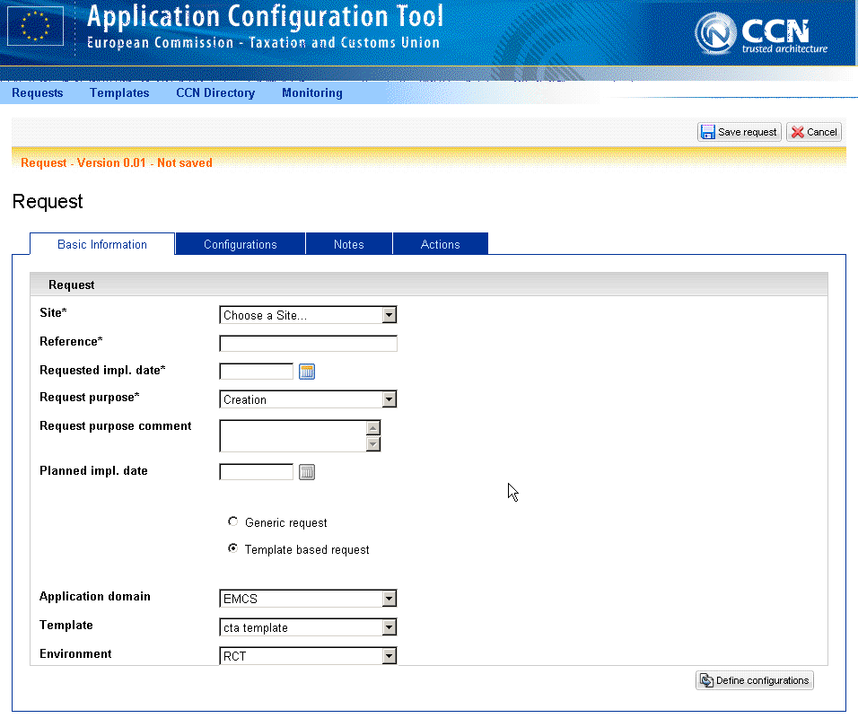
Figure 11: ACT Request for EMCS CT Queues

Once the end user enters the necessary information to the request form (select Site, type a “Reference” preferred name, choose the Application domain of interest (EMCS), select a template (“cta template” for the creation of the CTA queues), select the mode where the new request will run (“RCT” for the creation of queues for the Conformance Testing activities), the next step is to “Define Configurations”. Applicable queue names to the previously chosen domain appear (the queue names are predefined in the templates and are created by ITSM Support), as shown in Figure 12 and Figure 13 below.

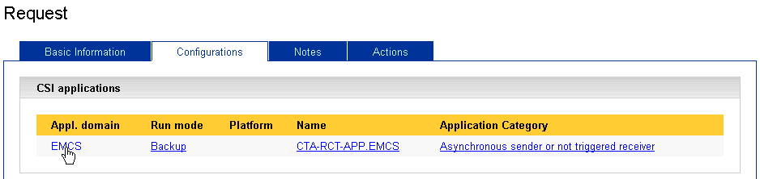
Figure 12: ACT – CSI Applications Domain
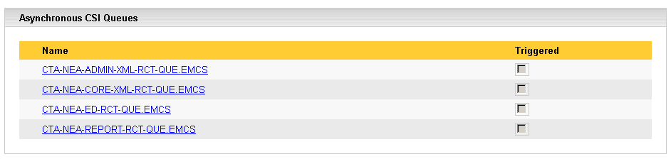
Figure 13: ACT - Asynchronous CSI Queues List

Note that if the system(s) is hosted in a new platform, the new platform must be also defined at CCN level. A separate ACT request must be submitted for the definition of the platform. This will be a generic and not template-based request. An example screen is shown below.

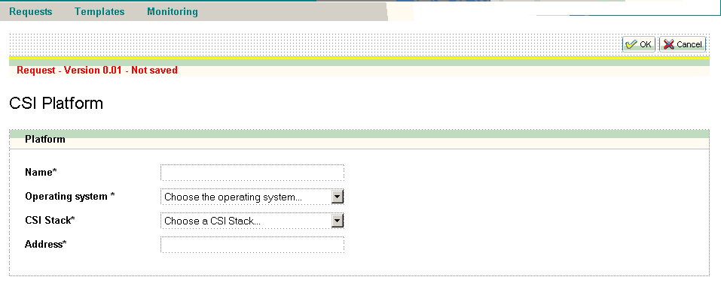
Figure 14: ACT - platform creation request example

STEP 4 | After the ACT request is submitted by the NA, ITSM CT Coordinator reviews the request and contacts the issuer in case of errors in the forms and/or additional information is needed. Following the process, the requests are accepted and implemented. New configuration files are then provided to the NA by the ITSM Support through Synergia ESS Portal.

STEP 5 | NA must configure its National System(s) in accordance with the CCN Queues and the Message Types supported by each Queue. The exact entities that have already been defined for Phase 4 at CCN level are presented in sections 2.3.2.1 and 2.3.2.2.  A graphical representation of the application configuration request lifecycle for the NAs is depicted in Figure 15.

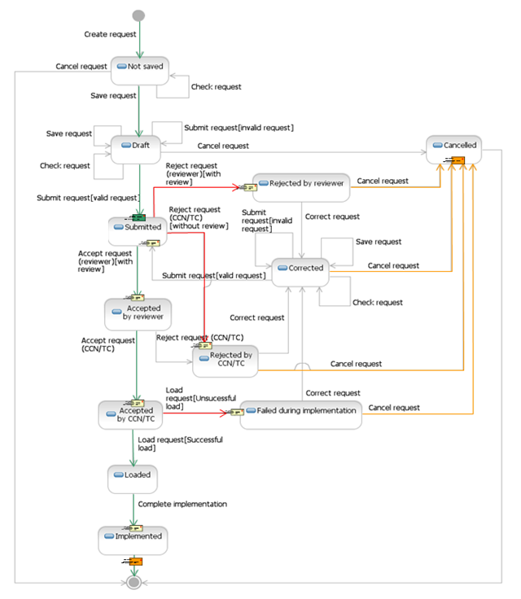
Figure 15: ACT Request lifecycle for the NAs

Annex 2: National Project Plan Template
An NPP reporting template with the reference dates of the EMCS Phase 4.2 CT Campaign (“National Project Plan Reporting Template v23.00”) is produced in CTA. The NAs are invited to fill in the template in the CTA environment at any time. The updates will not be linked to the monthly updates, but to occasions when information is actually changing in each NA’s national planning. For detailed information on the NPP update process, the user may refer to the respective User Manual [R07].
A sample of the template is also published in .pdf format for consultation under the following location on CIRCABC:
https://circabc.europa.eu/ui/group/5d0c005e-c8e5-4193-900b-53c21899fd31/library/d6ea82bf-889d-4670-bb99-416ac08f21b0/details

Annex 3: Connectivity Tests
This test case aims to verify the existence of correct usernames and passwords to access the Phase 4.2 functionality of the Conformance Test Application (CTA) in Mode-1 and Mode-2.
- Access the CTA web tool under: http://ctatms-rct.itsm.ccncsi.int:6001/cta/;
- Once the user is successfully logged in CTA, he/she can navigate through all available options.

Pre-Conditions:
- The reference data is pre-loaded in CTA for the user’s convenience;
- The NA shall load the Reference Data in their NEA application: this is a critical step; otherwise, the validations will not pass. The CTA and the NEA should use the same version of the Reference Data. It is important to clarify that CTA obtains the reference data from TRP. With the view of facilitating EMCS Conformance Testing, the IE734 is decoupled from SEED Conformance and Production environments. The applicable version of IE734.xml, which is embedded in EMCS TRP, can be found in the Full TRP package via CTP Explorer files. For NA’s convenience, the Reference Data applicable to EMCS Phase 4.2 CT campaign can be found in the link provided in Section 2.3.1. under “Configure the National Applications with Standard Reference Data” part;
- The user must be authenticated with the respective profile [see section 2.3.2.5].

Mode-1 Connectivity Test Case
Mode-1 allows the user to send and receive messages within the Common Domain and External Domain. The following test case aims to verify the connection establishment between NEA and CTA. The Mode-1 test execution steps are described in Table 24.
Step | Description
STEP 1 | Log into CTA and select the MODE-1 Test Campaign (the NA user should be linked to the NA Operator user profile).
STEP 2 | Select Execution tab and then choose the Single Message-Based Exchanges option from the drop-down menu or choose the Test Sessions option from the drop-down menu to run one specific scenario.
STEP 3 | In the Single Message-Based Exchanges page configure are the following:  - Message Template: select one IE message;  - Role of NA: in the drop-down menu select MSA of Destination;  - Impersonating NA: in the drop-down menu select the country that CTA will simulate;  - Role of CTA: which will be the CTA role;  - Message Direction: outgoing or incoming;  - Operation Mode: in the drop-down menu select Common Domain or External Domain;  - Click on the “SAVE” button.  As result, a message is displayed “Parameters saved successfully, CTA Role is: MSA of Dispatch”.
STEP 4 | As soon as the user presses the “SAVE” button, the message gets to ‘‘RUNNING’’ mode.
STEP 5 | To view result, click on the log event panel on the right in case it is collapsed. As result the View Log Event page is displayed.
STEP 6 | To verify the successful submission of the messages the user should check the IE Sent Log Event details.
Table 24: Mode-1 Test Execution Steps

Mode-2 Indicative Test Case
This test case aims to verify the execution of a Phase 4.2 Mode-2 scenario under MODE-2 Pre-CT Test Campaign level. The Mode-2 test execution steps are described in Table 25.
Step | Description
STEP 1 | Log into CTA and select the MODE-2 Pre-CT Test Campaign (the NA user should be linked to the NA Operator user profile).
STEP 2 | Select Execution tab and then choose the Test Sessions option from the drop-down menu.
STEP 3 | In the Test Sessions page select scope. Then create a test session. A long list of scenarios will be presented.
STEP 4 | Select scenario AP-21(a)_DS_1 where the NEA plays the role of destination. The scenario includes the following steps:  - CTA (MSA of Dispatch) - NEA (MSA of Destination) IE801;  - CTA (MSA of Dispatch) - NEA (MSA of Destination) IE904;  - NEA (MSA of Destination) - CTA (MSA of Dispatch) IE905;  - NEA (MSA of Destination) - CTA (MSA of Dispatch) IE818.  In terms of the three first steps, the messages come from dataset A and while the last one is based on dataset R. All message exchanges in EMCS Phase 4.2 format.
STEP 5 | After choosing this scenario, select the country that CTA impersonates, press “CREATE” and then start the test session.
STEP 6 | The NA will receive the first message sent by CTA according to this scenario (IE801) that should be found in the queue CTA-NEA-CORE-XML-RCT-QUE.EMCS.
STEP 7 | Then, the NA will receive the second message sent by CTA according to this scenario (IE9045) that should be found in the queue CTA-NEA-CORE-XML-RCT-QUE.EMCS.
STEP 8 | After receiving both IE801 and IE904, the NA should create an IE904 message with the NEA taking into consideration the roles played by the NEA and CTA in the third step of the scenario.
STEP 9 | The NA should use the ARC values from the IE801 and IE904 messages received in the first two steps to populate the ARC field of the IE905 message.
STEP 10 | Send the created IE905 message to the appropriate queue (the NA should use their NEA to send the message).
STEP 11 | Then, the NA should create an IE818 message with the NEA taking into consideration the roles played by the NEA and CTA in the fourth step of the scenario.
STEP 12 | The NA should use the ARC values from the IE801 and IE904 messages received in the first two steps to populate the ARC field of the IE905 message.
STEP 13 | Send the created IE818 message to the appropriate queue⁹ (the NA should use their NEA to send the message).
STEP 14 | In CTA, a message should appear stating that the scenario was completed with success.
Table 25: Mode-2 Test Execution Steps

To confirm that all the steps were executed, the user can access the MODE-2 Pre-CT Test Campaign, click on the Execution tab, select Test Sessions in the dropdown menu, choose the Test Session he/she needs to check and then click on the “VIEW” button. On the Test session page, at the right side there is a collapsible panel containing the last 100 log events generated in the context of the Test Session.

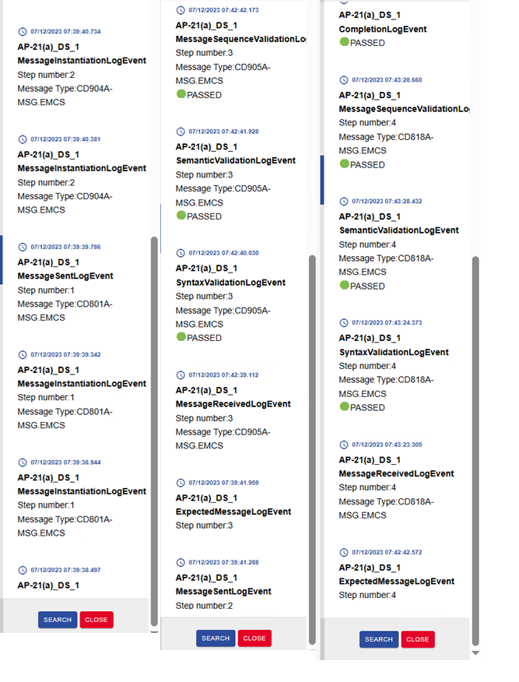
Figure 16: CTA – Test Results example

Annex 4: EMCS Phase 4.2 CT Mode-3 Suggested scenarios
To support the NEAs International Testing, the following CTP for EMCS Phase 4.2 scenarios have been selected to be executed during Mode-3:
- Business scenarios: This collection of EMCS Phase 4.2 scenarios is indicative to test the level of compliance of the NEA under test with the EMCS Phase 4.2 message exchange protocols, therefore with the core general threads of FESS;
- Exception Handling: This collection of Exception Handling scenarios is indicative to test the level of compliance of the NEA under test with the DDNEA for EMCS Phase 4.2 exception handling protocols in relation to out-of-sequence transitions.

Annex 5: EMCS Phase 4.2 CT Mode-3 Plus Suggested scenarios
To support the Mode-3 Plus of Member States, which is a non-mandatory testing phase between the Economic Operators (end-to-end testing), some suggested scenarios can be found in Section 2.2.2.6 in CTP for EMCS Phase 4.2 [R09].

Annex 6: EMCS Phase 4.2 CT Connectivity summary
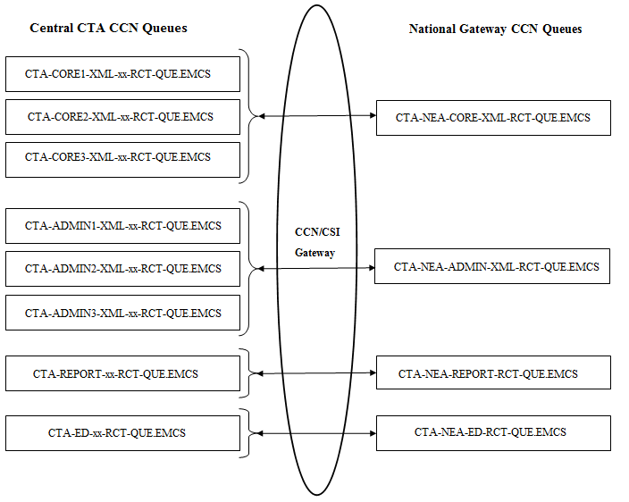

Figure 17: CTA – Test Part 1

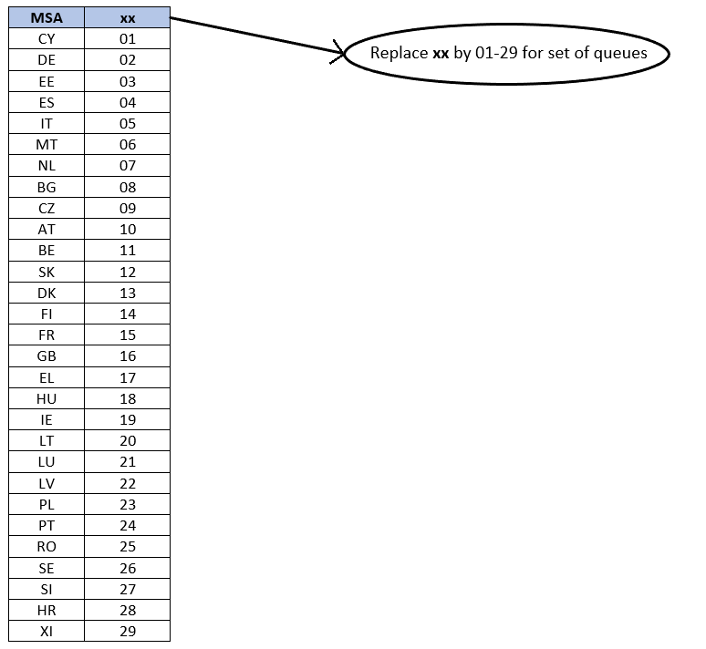
Figure 18: CTA – Test Part 2

Annex 7: EMCS Phase 4.2 Mode-3 Test Summary Report template

AES related messages are not included in Table 7
Only applicable for AES-EMCS Test campaign (see Section 4.4.3.3)
The National Project Plan (NPP) of each NA should be updated in CTA.
The Test Reference Package (TRP) is a term used for the CT Coordinator to enclose (refer to) all business input that is uploaded to CTA for the purposes of CT execution (i.e., for the successful exchange of Test Messages during CT), in the context of a given CT Campaign. It shall be noted that the TRP will be published on CIRCA BC for NAs’ information, but it will not be used by the NAs. NAs will still receive a readable version of CTP which will also be published on PICS.
See Annex 3: Connectivity Tests
The case of run one specific scenario is described in details in section 6.3.1.2.
For example, the NA of Latvia has to send the IE818 message to the CTA-CORE1-XML-22-RCT-QUE.EMCS@ITSM.TC queue to effectively communicate and interact with CTA.

