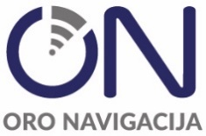

PUBLIC LIMITED LIABILITY COMPANY ORO NAVIGACIJA

INVITATION TO DEMONSTRATE VOICE COMMUNICATION SYSTEM

- Public limited liability company Oro Navigacija intends to procure Centralised voice communication system. We are kindly inviting the Suppliers to present your System (online demo – versions).
- Consultations will be held with each interested supplier individually not later than by the 10th of October, 2025.
- The information submitted by suppliers during consultations shall be considered confidential.
- Consultations shall be held remotely. Suppliers are requested to present system.
- Contact persons:
- Darius Oženeckas, e-mail ozeneckas.d@ans.lt, +370 610 05002.
- Aušra Jasukaitienė, e-mail jasukaitiene.a@ans.lt, +370 682 61245.

Please indicate a date and time that is convenient for you no later than 3rd of October, 2025.

