TECHNICAL SPECIFICATION
INSPECTION OF GAS LEAKS IN MAIN GAS PIPELINES BY FLYING
- DEFINITIONS AND ABBREVIATIONS
  - Contracting entity – AB “Amber Grid” (hereinafter - the Contracting entity). More information on the Contracting entity and its activities is available at www.ambergrid.lt.
  - Supplier – an economic entity – a natural person, private legal entity, public legal entity, other organizations and their divisions, or a group of such persons with whom the Buyer enters into a Contract.
  - Contract – a contract concluded between the Supplier and the Buyer for natural gas (methane) leak measurement and reporting services.
- PROCUREMENT OBJECT
Procurement object – natural gas (methane) leak detection (hereinafter - gas leaks) inspection service using aircraft and special equipment to detect gas leaks from underground gas pipeline networks and the submission of reports on detected gas leaks (hereinafter - the Services).
- SCOPE OF THE PROCUREMENT OBJECT
Preliminary procurement volumes:
No. | Object | Unit of measurement | Preliminary quantity*
1. | Gas leak inspection service for main gas pipelines | pcs. | 2
2. | Report | pcs. | 2
Note:
*The Contracting entity does not undertake to order the entire quantity of services specified in the "Preliminary quantity." Orders are coordinated according to the agreed order submission procedure.
- PLACE OF PERFORMANCE OF CONTRACTUAL OBLIGATIONS
  - During the provision of the services, the underground gas pipeline in the territory of the Republic of Lithuania shall be inspected by a manned aircraft according to the routes provided in advance by the Contracting entity, which are located from the border of the Republic of Belarus to the border of the Republic of Latvia; from the border of the Republic of Belarus to the border of the Kaliningrad Region of the Russian Federation; from Vilnius to Visaginas; from Panevėžys to Klaipėda; from Marijampolė to Klaipėda; from Elektrėnai to the border of the Republic of Poland.
  - The exact coordinates of the pipelines in ESRI Personal Geodatabase or ESRI SHP format (or equivalent) will be provided as a separate annex to the Technical Specification after signature of the Contract.
Note:
**The total length of the gas pipeline, including parallel sections, is approximately 2,288 km (see Figure 1). During the entire term of the Contract, the length of the gas pipeline used for the provision of services may vary by up to 10%.

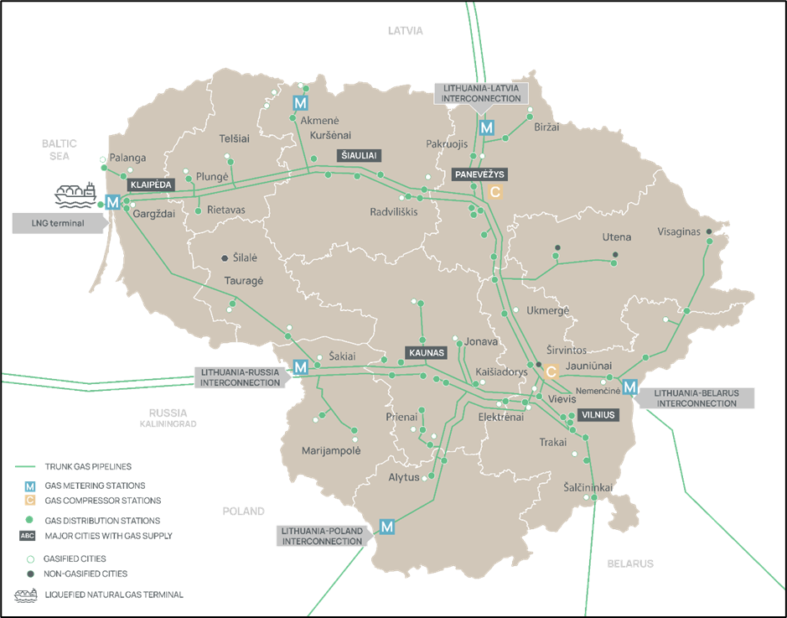
Fig. 1. Gas pipeline in the territory of the Republic of Lithuania (green)

- REQUIREMENTS FOR THE PROCUREMENT OBJECT
  - Description of the procurement object
    - The Supplier undertakes and must state in the tender that the flights will be carried out in accordance with visual flight rules and that the gas leak inspection services will comply with DVGW Technical Rule G 501: Airborne Remote Gas Detection Methods or other equivalent document requirements (applicable in the EU).
    - During the term of the Contract, the Supplier shall perform gas leak inspections and submit reports. These services shall be paid for in accordance with the signed service transfer and acceptance act.
    - The Supplier performs gas leak detection services using its own aircraft and special gas leak detection equipment. If the Supplier uses rented equipment to perform gas leak detection services, it must provide information about the equipment supplier/manufacturer, indicating the company name, legal entity code, VAT payer code, company registration date, and registration address.
    - The Supplier is responsible for obtaining all flight permits or other mandatory documents required for the flight.
    - The Supplier is responsible for performing the service in full. Any interference occurring during flight is the responsibility of the Supplier.
    - Special gas leak detection equipment shall detect gas leaks of 500 ppm and above. The minimum detection limits for special equipment must be confirmed by a document issued and signed by an officially certified company. When submitting a tender, the Supplier must attach documents specifying the technical parameters of the gas leak detection equipment.
    - In areas where gas pipelines are laid in parallel, the Supplier must check each pipeline strand individually, unless special gas leak detection equipment is designed to detect gas leaks from two parallel pipelines in a single pass.
    - If the Supplier detects particularly large gas leaks during the flight, it must immediately, but no later than within 5 working days, forward the information to the Contracting entity. The Supplier must provide the measured gas leak size, coordinates in the LKS-94 coordinate system, and an aerial photograph of the leak location.
    - After completing the gas leak inspection, the Supplier must prepare a detailed report in digital format (pdf and xls format), which must include the coordinates of the detected gas leaks in the LKS-94 coordinate system, the intensity of gas leaks in ppm or g/h, wind speed (m/s), temperature parameters (ºC), and an aerial photograph of the gas leak location must be attached.
    - When preparing a detailed report, the Supplier must assess the cause of the detected natural gas leaks (methane) and exclude methane of biological origin (manure fertilization, marsh gas, animal carcasses, farms, livestock, cattle, etc.) from the report.
    - The structure (content) of the report must be agreed with the Contracting entity before it is prepared.
    - The Supplier must submit the report to the Contracting entity or approval no later than 30 calendar days after the completion of the flight.
    - The Supplier must provide a detailed methodology used to prepare the report.
    - In performing the Contract, the Supplier undertakes to comply with the following environmental requirements: to reduce paper consumption, to refrain from unnecessary copying and printing of documents. All information and/or documents necessary for the performance of the Contract shall be submitted and agreed in electronic format by electronic means.
    - After completing the gas leak inspection, the Supplier must prepare data files in ESRI Personal Geodatabase or ESRI .shp format (or equivalent), indicating the locations of the detected gas leaks in the LKS-94 coordinate system, and the intensity of gas leaks in ppm or g/h.
    - At the end of the Contract, the Supplier shall ensure the transfer of all data related to the Services, including photographs and reports, to the Contracting entity.
    - If the Supplier has made conversions of the units of measurement in the analysis of the determined gas leakage results, in this case the Supplier must attach to the final report a detailed methodology for the conversion in order to avoid any shortcomings in the correlation of the flow.
    - The Supplier must include the following in the price of the services: flight costs (preparation, organization, insurance, piloting, aviation fuel, navigation, flight fees, necessary documents, permits, downtime, etc.), equipment transportation to/from Lithuania costs or rental (staff accommodation, meals, transportation, downtime, etc.).
    - Since the Supplier will be provided with information about facilities and assets that are important for ensuring national security and that may pose a risk or threat to national security, service providers, sub-suppliers, economic entities whose capacities are relied upon, manufacturers, persons performing technical or software maintenance and support, or persons controlling them, must comply with the national security requirements set out in the Law on the Protection of Objects of Importance to Ensuring National Security and the Law on Public Procurement of the Republic of Lithuania (Article 92(14), (15) of the Law on Public Procurement).
    - All data collected during the flyby must be processed only within the European Union. All data collected must remain confidential. Data must be protected against unauthorised interception or use, in line with EU cybersecurity rules.
    - The Supplier undertakes not to disclose the administered data, not to transfer it to third parties, and to ensure its high-quality protection.
    - The Supplier undertakes that all archived information will be protected from third parties during the term of the contract and, upon expiry of the contract, will be transferred to the buyer free of charge and securely in an agreed format.
    - The Buyer is the owner of all collected data. The Supplier undertakes, at the request of the Contracting entity (or in the event of termination of the contract), to export and transfer all data accumulated during the entire period of service provision (measurement data, aerial photographs, data sets, reports, etc.) in a format agreed with the Buyer (.xls, .csv, etc.).
    - The Supplier undertakes to permanently destroy within 15 calendar days all data provided by the Contracting entity, data collected with the resources of the Supplier on the facilities operated by the Contracting entity, data of employees and equipment, measurement data, reports, upon written request of the Contracting entity. After destroying the data, the Supplier must submit a signed official letter confirming the transfer and destruction of the data.
    - After the termination of the contract between the Supplier and the Contracting entity, the Supplier must remove all accumulated archival data and all possible copies thereof from its system and not transfer them to third parties.
    - The Supplier must immediately inform the Contracting entity of any possible cases of data misappropriation, leakage, or cyber security incidents in the Supplier's infrastructure and take all possible measures to control the situation.
  - Procedures and deadlines for fulfilling contractual obligations
    - The Supplier undertakes to perform gas leak inspections in 2026 using aircraft and special equipment to detect gas leaks from the entire length of the underground gas pipeline (2,288 km) and to submit a report on the detected gas leaks to the Contracting entity.
    - During the term of the Contract, it is planned to purchase at least one gas leak inspection service for the entire gas pipeline. After the first gas leak inspection is completed in 2026, the Supplier shall agree with the Contracting entity on the provision of further services, with the second gas leak inspection service tentatively scheduled for 2028. The Contracting entity does not undertake to order the entire quantity of services specified in the "Preliminary quantity." Orders shall be submitted in accordance with the order submission procedure agreed between the Supplier and the Contracting entity.
    - The Contracting entity undertakes to provide the Supplier with the available main gas pipeline routes in ESRI Personal Geodatabase or ESRI SHP format (or equivalent) within 10 calendar days after the signing of the contract in order to ensure the proper provision of gas leak detection Services.
    - The Supplier must submit and agree with the Contracting entity a schedule for the performance of the Services within 20 calendar days of signing the Contract. The schedule shall be to the nearest day or week and shall be so arranged as to ensure that the Services are performed within the time limits specified in the Technical Specification. The actions and deadlines set out in the schedule may be adjusted by the Supplier with the prior written agreement of the Contracting entity, but the final date for the completion of the Services shall not be later than that set out in this Technical Specification. The schedule must be provided in digital .pdf, .xls, .docx or equivalent format.
  - Documentation to be provided during the performance of the Contract
    - The Contracting entity shall provide the Supplier with the main gas pipeline routes in ESRI Personal Geodatabase or ESRI SHP format (or equivalent).

No. | Object | Units of measurement | Preliminary quantity  During the provision of services¹ | Fee in EUR excluding VAT* | Price in EUR excluding VAT²
1. | Gas leak inspection service for main gas pipelines | pcs. | 2
2. | Report | pcs. | 2
Tender price in EUR excluding VAT³
VAT**

¹ Indicated preliminary/maximum/specific quantity of the Procurement object. The Contracting entity is not obliged to purchase the entire quantity indicated (if the quantity is preliminary or maximum).
² The price in EUR excluding VAT is calculated by multiplying the price in EUR excluding VAT by the indicated preliminary/maximum/specific quantity.
³ If you buy on a fixed price/reviewed price basis (preliminary or maximum quantities): It does not constitute an obligation on the part of the Contracting entity to pay the successful Supplier the specified amount during the term of the Contract and will be used only for the evaluation and comparison of Tenders. The successful Supplier will be paid only for the actual quantity. If you buy a preliminary quantity and disclose the Contract value: The Tender price in EUR excluding VAT will only be used for the evaluation and comparison of tenders. The Contract will be awarded to the successful Supplier for the amount specified in Section 8 of the SPC/the attached draft Contract.

