TECHNICAL SPECIFICATION
CONSULTING SERVICES ON REVIEW OF THE TECHNICAL DESIGN DOCUMENTATION AND ITS SAFETY JUSTIFICATION FOR THE RECONSTRUCTION OF THE IGNALINA NUCLEAR POWER PLANT BITUMINIZED RADIOACTIVE WASTE STORAGE FACILITY AND UPGRADE TO THE DISPOSAL FACILITY

INTRODUCTION

Client
The Client of this public procurement contract is the State Nuclear Power Safety Inspectorate (hereinafter referred to as VATESI).

Abbreviations and terms
Disposal facility – INPP bituminized radioactive waste near-surface disposal facility (Building 158). This Disosal facility is a bituminized radioactive waste management facility where bituminized radioactive waste is placed without the intention of being retrieved;
AtTD of disposal facility– technical design for the construction of the storage facility reconstruction and upgrade into a disposal facility;
NF – nuclear facility
Schedule – Schedule for the execution of the Agreement;
INPP – State Enterprise Ignalina Nuclear Power Plant;
LR – Republic of Lithuania
RW – radioactive waste
bituminized RW – B and C radioactive waste;
Design documentation – Technical design and its safety justification (and related to the safety justification) documentation for the reconstruction of storage facility and conversion into a disposal facility;
PSAR – Preliminary Safety Analysis Report
LRW – liquid radioactive waste;
SI SSC – safety-important structures, systems and components
Storage - INPP Bituminized waste storage facility (Building 158). This storage facility is a bituminized radioaktive waste management facility for storing radioactive waste.
IAEA – International Atomic Energy Agency
TS – technical specification
VATESI – State Nuclear Power Safety Inspectorate

Context
    - General Information
INPP bituminized radioactive waste storage – building 158 (hereinafter referred to as the Storage)
The storage facility is a nuclear facility (hereinafter referred to as the NF). It is planned to reconstruct and upgrade this storage facility into a disposal facility, which will also be classified as a NF.
The storage facility is located in the northwestern part of the protected industrial site of the State Enterprise Ignalina Nuclear Power Plant (hereinafter referred to as the INPP), approximately 200 m west of the INPP Unit 1 (assigned to the NF) and approximately 600 m from the southern shore of Lake Drūkšiai (see Figure 1). The storage facility is connected to building 150 by pedestrian and technological galleries on the eastern side and to building 158/2 on the western side (see Figures 1 and 2). The complex for the treatment, bituminisation and cementation of liquid radioactive waste (hereinafter referred to as LRW), as well as the temporary storage facility for cemented LRW, are classified as BEO. The minimum distance between the Storage Facility and these buildings is about 10 m. The tanks for receiving and storing sewage water (building 151), as well as the tanks for storing liquid operational waste and emergency sewage water (building 154) are located on the northern side of the Storage Facility – about 50 meters from it, between the Storage Facility and these buildings there is an internal road No. 19 (see Fig. 1, 2). The special laundry (building 156) and the clean bitumen warehouse (building 161) are located on the southern side of the Storage Facility – about 23 meters from it, between the Storage Facility and these buildings there is an internal road No. 10 (see Fig. 1, 2). A clean bitumen supply line has been laid from the bitumen warehouse to building 150 via an above-ground overpass, part of which is installed on the Storage Facility. Fire extinguishing systems and heat supply pipelines have also been installed on the Storage Facility
The storage facility is intended for the reception and storage of bituminized radioactive waste (hereinafter referred to as bituminized RW). In accordance with BSR-3.1.2-2010 [7], bituminized RW is classified as RW of classes B and C, i.e. short-lived low- and intermediate-level RW, which must be placed in a near-surface disposal facility.
The construction of the storage facility began in 1981, and operation began in 1987.
The storage facility was filled with bituminized RW until the end of 2015, since then the processes of bituminization of the INPP LRW and filling the storage facility with bituminized RW have been permenantly suspended.
1
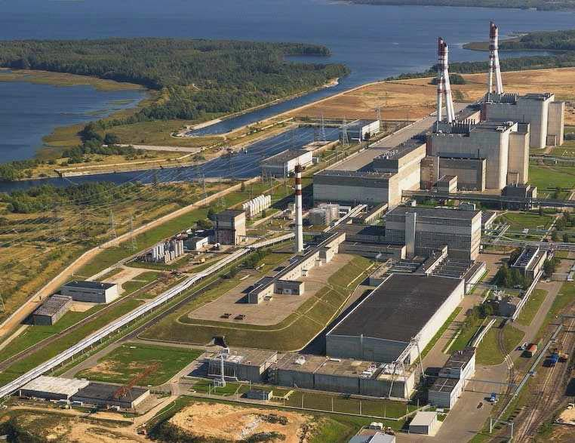
10
9
8
7
6
3
4
5
2
1
Figure 1. Location of the storage facility in the INPP territory
1 – 150 building, LRW processing, bituminization and cementing building; 2 – 151 building, fragile water reception and storage tanks; 3 – 154 building, liquid operational waste and emergency fragile water reception tanks; 4 – 156 building, special laundry; 5 – Storage (158 building); 6 – 158/2 building, storage of cemented SRA; 7 – 161 building, clean bitumen warehouse; 8 – INPP internal road No. 10; 9 – INPP internal road No. 19; 10. – INPP first power unit.
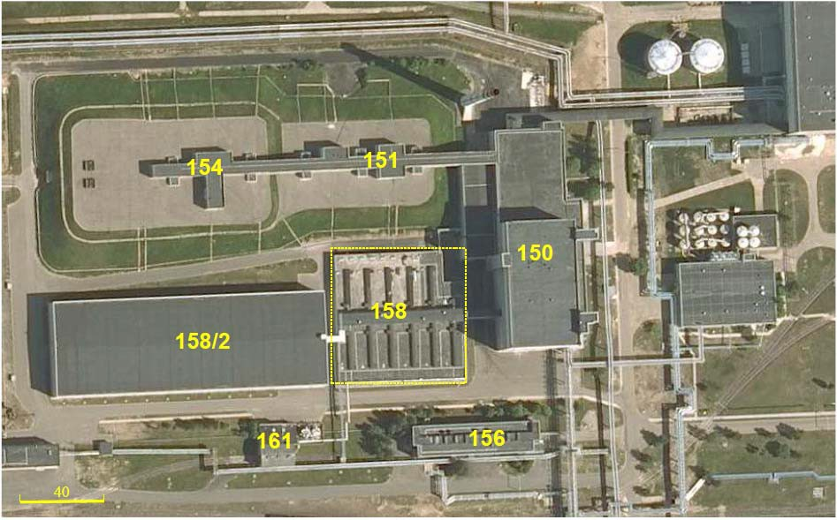
Kelias Nr.19
Kelias Nr.10
Figure 2. Other INPP structures located near the Storage Facility
The storage facility is a rectangular (75.3×74.1m) two-floor above-ground structure, which includes (see Fig. 3 - 4):
• Vaults (canyons);
• Communication corridor;
• Communication channels;
• Service room;
Control and measuring instrument rooms (located near the outer part of the communication channels).
    - Basement of storage
When installing the foundation of the Storage Facility, the surface soil, which was unsuitable for the installation of the foundation of the Storage Facility structure, was removed and an additional engineering base ("pillow") was installed in its place. Since no sand or sand-gravel mixture with suitable properties was found, the base was formed from M50 grade sand-free concrete.
    - Storage foundation (see Figure 4)
Three PM-1 type monolithic reinforced concrete (M200 grade concrete) foundation slabs and one PM-2 type are installed on the concrete base ("pillow"). The main reinforcement elements of the PM-1 and PM-2 type slabs are made of Kr5 (Kr6) frame blocks.
    - The First Floor of starage (see Figures 3-4)
The first floor of the Storage Facility, located from -0.25 to +6.25, is divided by internal partitions into 12 vaults (canyons), of which 11 canyons have a volume of 2500 m³ each (filling volume – 2000 m³) and one vault (canyon) has a volume of 1000 m3 (filling volume – 800 m³). The total filling volume of all 12 canyons is 22800 m³ (i.e. this Storage Facility capacity is 22800 m³ of bituminous RA). The layout plan of the vaults (canyons) is presented in Figure 3. The supporting reinforced concrete walls of this floor are built of factory-made P-1 type concrete slabs (M200 brand concrete). The dimensions of these slabs are 1150x300x6300 mm (width x thickness x height). The first-floor structure also used reinforced concrete slabs of type P-1-1, P-1-2 and P-1-3 and a thickness of 300 mm, reinforced with Kr3 reinforcing blocks.
To improve the shielding properties of the walls, the external walls were built of SB type concrete blocks with dimensions of 6000x1200x300 mm The blocks were laid at a distance of 200 mm from the wall, and the gap was filled with M300 brand concrete, the water resistance of which corresponds to class B8 (this means that water with a pressure of 0.8 MPa acting on concrete of this brand will not penetrate through it). The total thickness of the vault (canyon) walls is ~800 mm.
For the first floor, factory-made reinforced concrete slabs of the NP-1 type (made of M200 brand concrete) with dimensions of 5980x1490x220 mm were used. Supports were built to hold the slabs - reinforced concrete columns (diameter 400x400 mm) with crossbars. The columns were placed on support blocks.
Monolithic overlap of reinforced concrete slabs of type PM-3 and PM-4 (concrete of grade M300) forms the second layer of the vault (canyon) overlap. Three slabs of type PM-3 cover, respectively, 1 - 9 vaults (canyons). A slab of type PM-4 covers 10 - 12 vaults (canyons). The thickness of the slabs varies from 280 mm at the edge to 480 mm in the center, thus creating the necessary roof slope for water runoff.
The overlapping panels are covered with a thermal insulation layer of polystyrene, bitumen is poured on it, and the latter is covered with several layers of Ruberoid. In order to ensure good waterproofing properties of the roof, in 2003 and 2005 the roof was additionally covered with a membrane coating "Wolfin GWSK", the thickness of which is ~2 mm.
The inner surfaces of the walls of vaults (canyons)No. 1 - 4 are covered with a cement-silicate ("concrete-glass") layer (i.e. non-combustible material). And the inner surfaces of vaults (canyons)No. 3 - 6, No. 10 - 12 from the canyon floor to a height of 4.5 m are covered with carbon steel sheets (steel sheet thickness 4 mm.), and from 4.5 m to 5.5 m - with stainless steel sheets (sheet thickness 3 mm). The bottom of each vault (canyon) is covered with cement mortar, grade B25 (high-strength concrete), and the thickness is 50 mm. The surface of the cement mortar is covered with rubber-bitumen mastic, the thickness of which varies from 5 to 50 mm. Not only the walls of canyons No. 10 - 11, but also the bottom are covered with carbon steel sheets (sheet thickness 4 mm).

Figure 3. Plan of the storage vaults (canyons) layout, section A-A, see Figure 4
    - The Second Floor of Storage (see Figure 4)
The second floor is from +6.25 to +12.20 (Fig. 4). It houses technological channels (communication channels and communication corridors), bituminized RW supply pipelines with heating steam pipelines, components of fire extinguishing systems (water and foam), as well as other systems and components, a service room, etc.
The supporting walls of the communication corridor are built of non-combustible materials - FS-4 type factory reinforced concrete blocks, the thickness of which is 400 mm. From the +6.30 to +8.85 mark, the corridor is divided into three parts by partitions of FS-3 type factory blocks 300 mm thick. The communication corridor (at the +8.85 mark) is covered with factory concrete blocks 180-330 mm thick. The main service room is also separated with these blocks (i.e. these blocks form the floor of the service room). The central part of the communication corridor, intended for the pipeline through which bituminized RW was supplied, is separated off with two rows of demountable blocks, the thickness of which is 200 mm.
The walls of the service room are 380 mm thick and are made of silicate bricks. There are windows along the southern wall of the room. The roof is flat, with a slope for water drainage.
The supportive walls of the communication channels are built of factory-made reinforced concrete blocks of the SP3C type, with a thickness of 300 mm. The overlap is formed of factory-made slabs 220 mm thick, a 30 mm thick concrete layer (M200 brand concrete), four waterproofing layers of roofing felt, as well as a protective gravel layer reinforced with bitumen.
The second floor does not completely cover all the vaults (canyons) of the Storage Facility. The areas not covered by the second-floor overlap are insulated with several 30 mm thick concrete layers. To improve waterproofing, a layer of Ruberoid and polyethylene is placed between the layers. In 2003, the roof was additionally covered with a membrane coating “Wolfin GWSK”, the thickness of which is ~2 mm. A gallery with three communication channels connects the Storage Facility with the technological LRW processing and supply facilities located in building 150. The gallery also serves as a walking path for personnel servicing the Storage Facility and the Cemented LRW Storage Facility. The transition to the Cemented LRW Storage Facility is served by the second gallery, located in the western part of the Storage Facility at the level of +8.85.

Figure 4. Plan of the storage facility
    - Storage auxiliary systems:
• Ventilation system;
• Drainage system;
• Fire protection system;
• Heating system;
• Radiation protection system;
• Salt concentrate temperature monitoring system;
• Physical security system;
• Auxiliary equipment.
    - Brief description of the technological process
There are two bitumen plants at INPP. Both are located in Building 150. The first bitumen plant (УБ -1) was put into operation in 1987, and the second (УБ -2) in 1993. Both bitumen plants have been out of operation since 2015.
Drained water and liquid water from INPP technological buildings (1st and 2nd power units, special laundry and others) are collected and stored in tanks for receiving and storing waste water, liquid operational waste and emergency waste water, which are installed in the complex of buildings 151 and 154.
Water from the sewage water tanks in building 151 was supplied to one of two interconnected evaporation plants located in building 150, which, as already mentioned, was equipped with bitumen plants. In the evaporator, the water was evaporated until the salt concentration in it reached 130 g/l. After that, the concentrate was further concentrated in the re-evaporation plant until a salt concentration of about 360-390 g/l was reached. From this evaporation plant, the concentrate (concentrated LRW or cubic residue) was supplied to one of two extruder-type bitumen plants, where it was mixed with bitumen and, with the help of a bitumen compound transportation and discharge system into the vaults (canyons), was fed into a designated vault (canyon) of the Storage Facility.
The bitumen compound transportation and discharge system into the vaults (canyons) was an integral part of the bitumen plants, which consisted of the following subsystems:
• compound transportation and heating systems;
• steam supply systems;
• condensate removal systems;
• monitoring and control systems.
One part of the subsystem components of the bituminized RW transportation and release system into canyons is located in Building 150, the other part is located in the Storage Facility.
The calculated specific activity of evaporation concentrate according to the design is 3.7x108 Bq/dm3, bituminized RW - 1.85x109 Bq/kg. Detailed information on the activities of bituminized RW in each vault (canyon) will be provided in the Preliminary Safety Analysis Report (hereinafter – PSAR) of the disposal facility, which will be submitted to the Supplier for review together with the TD the disposal facility.
The following vaults (canyons) No. 1 - 6, 10, 12 were completely filled with bituminized RW (see Fig. 5). Table 1 presents the periods of filling the Storage with bituminized RW, the amounts of bituminized RW stored in the filled canyons. A decision was made at INPP that three vaults (canyons): No. 7, 8 and 9 will not be filled with bituminized RW (see Fig. 5). About 14422 m³ of bituminized RW are accumulated and stored in the Storage Canyons.
Table 1

Number of Canyon | Canyon filling period, years | Volume of bituminized RW, m³
1 | 1987 – 1989 February | 1963
2 | 1989 February – 1990 August | 2054
12 | 1991 May – 1991 December | 844
3 | 1992 January – 1994 June | 1964
4 | 1994 July – 1996 July | 1745
5 | 1996 September – 2001 April | 2002
6 | 2001 May – 2006 December | 1862
10 | 2007 January– 2014 May | 1950
11 | 2015 | 38
Total volume of waste – stored bituminous RA and clean bitumen, including:  • Volume of bitumen used for protective bottom and top layers;  • Bitumen/bituminous RA supplied during start-up-adjustment modes of the bitumen plant |  | ~14422

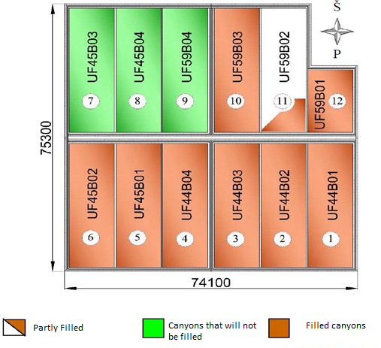
Figure 5 Storage Vault (Canyon) Filling Plan

According to the RA storage method envisaged in the Storage Project, bituminized RA is stored in canyons without packaging (see Figure 6).

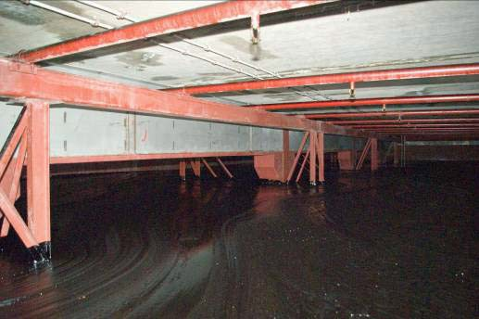
Figure 6 Filled vault (canyon)
    - Description of Planed Disposal Facility
Based on the draft design No. S/19/669 version 8 of the storage facility reconstruction and upgrade into a disposal facility (VATESI submitted conclusions on this document on 09/01/2023 in letter No. 22.1-13), a design solution for the storage facility reconstruction and upgrade into a disposal facility is proposed with an engineering barrier 5.8 m thick and an additional load-bearing structure resting on all walls of the structure (including the walls between the canyons), that is, on the upper ends of the internal walls and support columns, after balancing of the load on the storage facility foundation slabs by filling all the vaults (canyons) up to the ceiling with inert material (sand). It should be noted that, together with the conclusions of the review of the coceptual design of the Repository, VATESI has forwarded the aspects that need to be resolved during the design process (they will be presented to the Supplier during the initial meeting). It should also be noted that using the solutions of the preliminary design of this disposal facility, the Supplier hired by INPP carried out the Transboundary Environmental Impact Assessment procedures and prepared the Environmental Impact Assessment Report. VATESI, by letter No. (13.5Mr-43)22.1-174 of 29 February 2024, submitted a conclusion that it approves the Environmental Impact Assessment Report and the planned economic activities of INPP. Based on the positive conclusions of VATESI and other environmental impact assessment entities, the Environmental Protection Agency operating in the Republic of Lithuania, by letter No. (30-2)-A4E-5434 of 26 April 2024, adopted a decision to approve the planned economic activities - the reconstruction and upgrade of the Storage Facility into a disposal facility.
When reconstructing the bituminized RW storage facility and upgrading into a landfill, steel-reinforced concrete structures supporting a 5.8 m thick engineering barrier would be installed on the 158th floor of the reinforced concrete structure (see Figures 7 – 9).

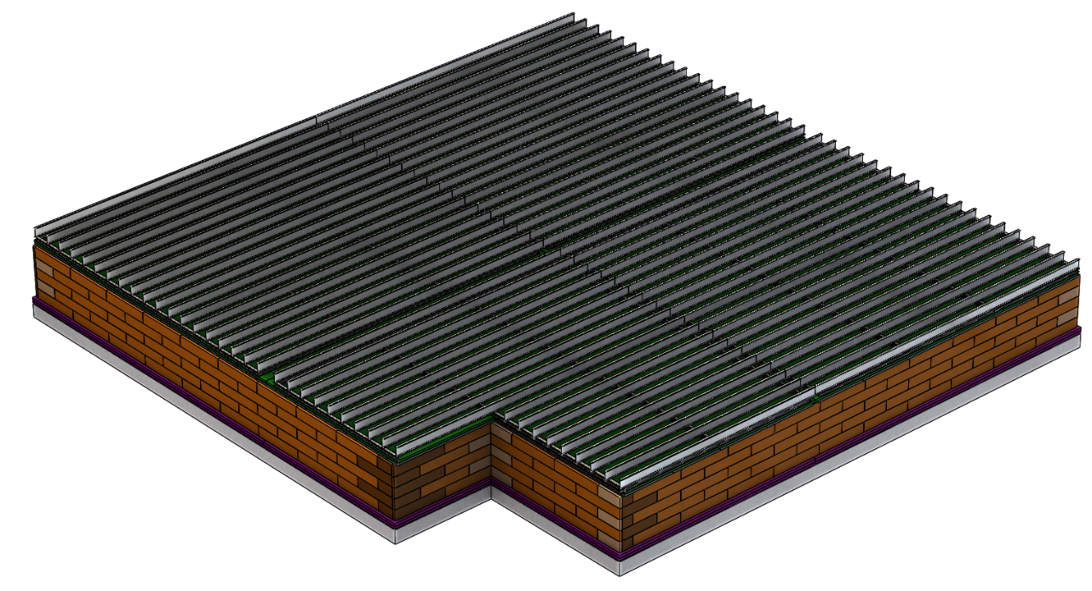
Figure 7. Reconstruction of the storage facility (structure 158) and upgrade into a disposal facility by installing a 5.8 m thick engineering barrier. Storage facility with supporting structures of the engineering barrier on the floor
Concreting in this case both increases the load-bearing capacity of the beams (prevents bending) and protects them from corrosion.
During the reconstruction of the Storage Facility and upgrading into a disposal facility, the Storage Facility and its foundations will be waterproofed using a chemical substance that acts on the basis of concrete crystallization. The waterproofing method and waterproofing material will be specified during the preparation of the technical design for the reconstruction of the Storage Facility and upgrade into a disposal facility (hereinafter referred to as the Repository TD). The metal structures of the future disposal facility will be coated with an appropriate anti-corrosion coating, the steel elements of the engineering barrier (main supporting double-girder beams) will be concreted with concrete resistant to frost cycles (e.g. using F200 frost-resistant concrete) after previously coating them with corrosion-resistant primers, paints or special coatings, these solutions will also be specified in the Repository TD.
In case subsoil water temporarily accumulates in the filled soil during snowmelt and after prolonged rains, the following compensatory measures are planned, such as: drainage of rainwater and groundwater; groundwater drainage around the disposal facility; application of waterproofing of the disposal facility foundations. The specified compensatory measures will be selected in more detail in the disposal facility TD.
The installation of a 5.8 m thick engineering barrier ensures the protection of the disposal facility structures from environmental (atmospheric) impacts (temperature, humidity, mechanical, etc.).
By pouring soil layers of different purposes (and therefore properties) onto the aforementioned supporting structures layer by layer and compacting them appropriately, an engineering barrier is formed (the structure is shown in Figures 8 and 9), which is covered from above with the upper vegetation layer formed by planting the embankment that conceals the landfill (and protects it from external influences) with vegetation typical of the region.
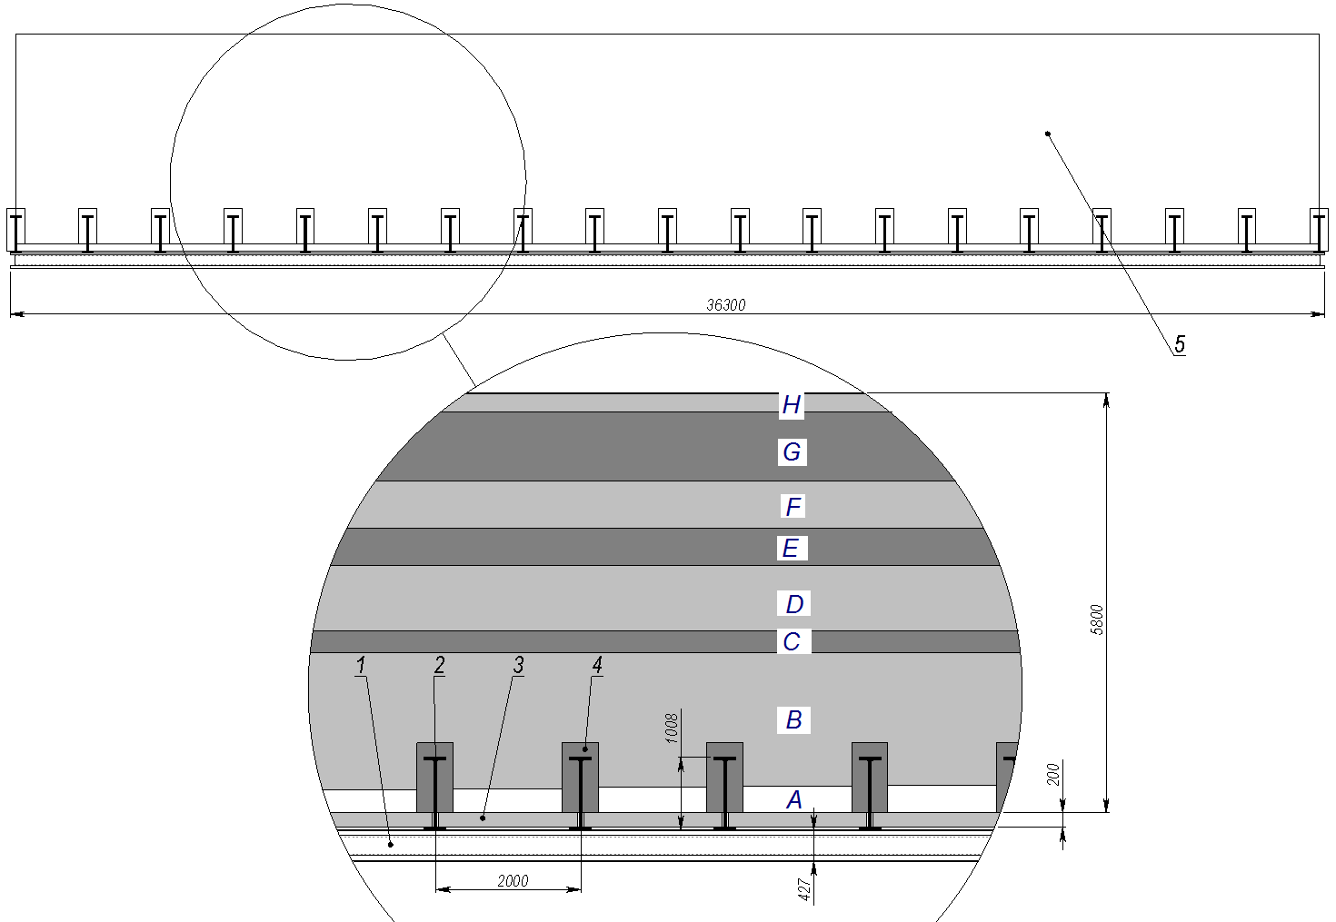
Figure 8. Cross-section diagram of a 5.8 m thick engineering barrier:
1 – HD310x310x500 double-wall profile, 2 – HE1000B double-wall profile, 3 – 200 mm thick concrete slabs, 4 – concreted HE1000B double-wall profiles, 5 – 5.8 m thick layered engineering barrier (A – 0.2 m thick drainage layer (fine sand); B – 2.0 m insulating layer (limnoglacial clay); C – 0.3 m drainage layer (gravel sand); D – 0.7 m protective layer (moraine clay); E – 0.6 m drainage layer (dusty sand); F – 0.6 m drainage layer (gravel); G – 0.8 m drainage layer (crushed stone); H – 0.2 m vegetated layer
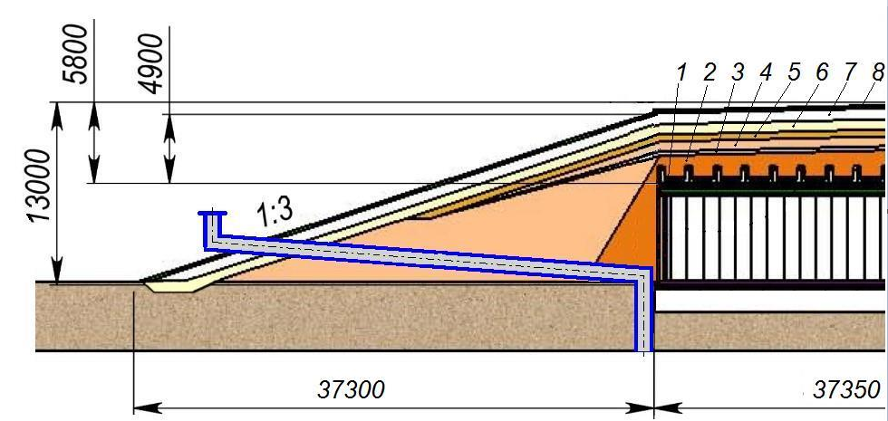

Figure 9. Storage facilities (structure 158) reconstructed and upgraded into a disposal facility with a 5.8 m thick engineering barrier structure:
1 – drainage layer (0.2 m of sand); 2 – insulating clay layer (1.5-2.4 m) installed with a slope of 1:0.6; 3 – drainage layer (0.3 m of gravelly sand); 4 – protective clay layer (0.7 m); 5-7 – drainage layers (0.6 m of sand, 0.6 m of gravel and 0.8 m of crushed stone); 8 – 0.2 m thick vegetative layer

Above in this section of the TS, only a brief summary of the reconstruction of the Storage Facility and upgrade into a disposal facility and the description of the disposal facility itself is provided. Upon the Supplier's request, the conceptual design of the disposal facility, together with other documents for the reconstruction of the Storage Facility and upgrade into a Repository, specified in subparagraphs 21 - 25 of clause 4.3 of this TS, will be provided to the Supplier for review upon signing this procurement Agreement. Detailed technical solutions for the reconstruction of the Storage Facility and upgrade into a disposal facility will be provided in the TD of the Repository. The TD of the Repository will also provide and describe the technical maintenance, monitoring, inspections and monitoring of the safety-inportant structures, systems and components (hereinafter referred to as the SS SSC). This description will be prepared taking into account the aging of the SSC.

OBJECTIVES OF CONSULTING SERVICES

General Objective

To provide scientific and technical support to VATESI, which carries out state regulation and supervision of the safety of NF in Lithuania, in carrying out the review of the design documentation for the reconstruction of the Storage Facility and upgrade into a disposal facility and its documentation justifying the safety.

In this TS the technical design for the reconstruction of the Storage Facility and upgrade into a disposal facility and the safety-substantiating (and safety-substantiating) design documentation (hereinafter – design documentation) shall be understood as:
− Technical design for the reconstruction of the Storage Facility and upgrade into a disposal facility (referred to as the disposal facility TD in the above TS);
− Preliminary (initial) safety analysis report for the reconstruction the Storage Facility and upgrade of into a disposal facility (hereinafter – the PSAR of disposal facility), prepared on the basis of the decisions of the TD of the disposal facility and the legal acts of the Republic of Lithuania;
− Other additional documentation related to the TD of disposal facility and PSAR and related to the reconstruction of the Storage Facility and upgrade into a disposal facility.
In this TS, review services mean the analysis and evaluation of design documentation, the provision of comments, recommendations, conclusions, and proposals. When providing review services, the following shall be provided:
- comments, recommendations, and conclusions on the compliance of the design solutions provided in the design documentation with the nuclear safety requirements established in the legal acts of the Republic of Lithuania (hereinafter referred to as the LR) and the documents of the International Atomic Energy Agency (hereinafter referred to as the IAEA), which regulate and are applied to radioactive waste management, as well as in the design and construction of nuclear facilities;
- proposals for the improvement, optimization, and correction of the submitted design documentation, in order for the design solutions provided in the design documentation to comply with the safety requirements and standards established by the legal acts of the Republic of Lithuania and the IAEA.
VATESI, taking into account the comments, recommendations, conclusions and proposals submitted by the Supplier, will make decisions on the concordance of the design documentation and/or will submit comments and proposals to INPP on the improvement, optimization and correction of the design documentation documents.

Specific Objectives
The Supplier shall, on the basis of the concluded contract, provide scientific and technical support to VATESI, taking into account the requirements set out in the contract, as well as the safety requirements and standards set out in the legal acts of the Republic of Lithuania and IAEA documents, when reviewing the following design documents planned to be submitted by INPP:
− TD of disposal facility;
− PSAR of disposal facility.
− Other additional documentation related to the TD of disposal facility and PSAR and related to the reconstruction of the Storage Facility and upgrade into a disposal facility.

SCOPE AND DESCRIPTION OF SERVICES

The scope of the design documentation review services is established in this TS, and is also defined by the nuclear, radiation and physical safety requirements imposed on such documentation. The Supplier must assess the relevant risks and take into account that the scope of the services is determined by the solutions and data provided in the design documentation, as well as the detail, completeness and compliance of the information provided with the requirements established by the safety requirements and standards. Having assessed this, the design documentation review services are divided into main and additional tasks.
Main tasks related to the review of design documentation:
Main task No. 1. Initial review of design documentation;
Main task No. 2. Review of revised design documentation
Main task No. 3. Preparation of the final review report.
Additional tasks related to the review of project documentation:
Additional task No. 1. Participation in meetings related to the discussion of the results of the review of design documentation, review of the responses provided by INPP, and revised design documentation solutions.
The Supplier must, within 14 calendar days from the date of the introductory meeting (kick-off meeting) organized by the Client, prepare and agree with the Client a schedule for the execution of the Agreement (hereinafter referred to as the Schedule), which must indicate the terms of review services, review reports, their agreement, correction and other terms related to the execution of the Agreement and the provision of services. Due to the risks provided for in paragraph 4.2 of the TS, in the event of changes in the terms of provision of services and (or) implementation of the Agreement, in the event of other unforeseen circumstances, the Supplier must promptly update the Schedule and repeatedly agree this Schedule with the Client. The Client must review and agree the Schedule within 5 calendar days.

Main task No. 1. Initial review of project documentation.
The Supplier, in accordance with the Schedule, the requirements and conditions established by the TS, as well as the nuclear, radiation, and physical safety requirements and standards established in the legal acts of the Republic of Lithuania, standards, and IAEA documents, must review the design documentation specified in the contract, submit comments and conclusions on the compliance of the design solutions provided for in the design documentation with the safety requirements established in the legal acts of the Republic of Lithuania, standards, and IAEA documents, as well as submit recommendations and specific proposals for the improvement, optimization, refinement, and adjustment of the solutions established in the design documentation.
Within 3 months of receiving the documents, the Supplier must prepare and submit to VATESI an initial review report with comments, preliminary conclusions on the compliance of the design solutions provided for in the design documentation with the safety requirements established in the legal acts of the Republic of Lithuania, standards and IAEA documents, together with providing recommendations and specific proposals in this report for the improvement, optimization, refinement, and adjustment of the solutions established in the design documentation. The requirements for submitting the initial review report are specified in TS Annex No. 1 “Requirements for design documentation review reports”.
VATESI, having received the initial review report from the Supplier, reviews it and, if there are no comments, ambiguities or questions, informs the Supplier about the acceptability of the initial report within the terms specified in the Schedule. Otherwise, the draft of the initial review report is requested to be adjusted and resubmitted to VATESI for approval within the terms specified in the Schedule, but no later than within 1 month. If the draft of the review report is re-prepared incorrectly, if there is unclear and (or) unsubstantiated information, VATESI may apply sanctions to the Supplier provided for in the Terms and Conditions of the Agreement
The initial review report must be prepared, adjusted in accordance with the comments provided by VATESI, coordinated and submitted within the deadlines specified in the VATESI Schedule.
After the initial review report has been agreed with VATESI, the comments and preliminary conclusions presented in this report, together with VATESI's comments and preliminary conclusions, shall be submitted to INPP, which, based on these comments and preliminary conclusions, shall adjust the design documentation and/or submit reasoned responses and explanations (hereinafter referred to as responses), additional information and/or documents related thereto, if the design documentation cannot be adjusted in accordance with the submitted comments and preliminary conclusions and/or INPP proposes another solution. The estimated preliminary deadline for the submission of INPP's responses, additional information related thereto and/or corrected design documentation will be specified in the Schedule.
Scope and quantities of purchased services
Having assessed the information known during the preparation of the TS, it is planned that the need to perform the initial review of the design documentation will occur when INPP VATESI submits the following documents for review:
− TD of disposal facility;
− PSAR of disposal facility.
− Other additional documentation related to the TD of disposal facility and PSAR and related to the reconstruction of the Storage Facility and upgrade into a disposal facility.

Main task No. 2. Review of revised design documentation.
IAE pateikus atsakymus į Teikėjo ir VATESI pateiktas pastabas ir preliminarias išvadas, su jais susijusią atsakymus ir išvadas pagrindžiančią papildomą informaciją bei koreguotą projektinę dokumentaciją su siūlomais patikslinimais (toliau – koreguota projektinė dokumentacija) VATESI, VATESI persiunčia visa tai Teikėjo peržiūrai.
After INPP has submitted responses to the comments and preliminary conclusions submitted by the Supplier and VATESI, additional information substantiating the responses and conclusions related to them, and the revised design documentation with the proposed adjustments (hereinafter referred to as the revised project documentation) to VATESI, VATESI shall forward all of this to the Supplier for review.
Having received the revised design documentation from VATESI, the Supplier must review it, including the responses provided by INPP, in accordance with the Schedule, the requirements and conditions established in this TS, as well as the nuclear, radiation, physical safety requirements and standards established in legal acts. Within 1 month of receiving the documents, the Supplier must prepare and submit to VATESI an interim review report with comments and conclusions on the compliance of the design solutions provided for in the design documentation and revised design documentation with the safety requirements established in the legal acts of the Republic of Lithuania and IAEA documents, along with providing recommendations and specific proposals for the improvement, optimization, refinement, and adjustment of the solutions established in the design documentation and (or) revised design documentation. The interim report must also contain relevant comments, conclusions and recommendations, as well as specific proposals for improving, optimizing, refining, and correcting the design documentation, if any discrepancies are identified between the design and corrected design documentation. The requirements for submitting an interim review report are specified in TS Annex No. 1 “Requirements for design documentation review reports”.
VATESI, having received the interim review report from the Supplier, reviews it and, in the absence of comments, ambiguities or questions, informs the Supplier about the acceptability of the interim review report within the terms set out in the Schedule. Otherwise, the interim review report is requested to be corrected and resubmitted to VATESI for approval within the terms set out in the Schedule, but no later than within 1 month. If the interim review report is re-prepared incorrectly, if there is unclear and/or unsubstantiated information, VATESI may apply sanctions to the Supplier as provided for in the terms of the Agreement.
The interim review report must be prepared, adjusted in accordance with the comments provided by VATESI, coordinated and submitted within the deadlines specified in the VATESI Schedule.
After the interim review report has been agreed with VATESI, the Spplier’s comments and conclusions (if any) presented in this report, together with VATESI's review comments and conclusions (if any), are submitted to INPP, which, based on these comments and conclusions, corrects the design documentation and/or provides reasoned responses and explanations (hereinafter referred to as responses), additional information and/or documents related to them, substantiating the responses and conclusions, if the design documentation cannot be corrected in accordance with the submitted comments and preliminary conclusions and/or INPP proposes another solution.
Scope and quantities of purchased services
Having assessed the information known during the preparation of the TS, it is planned that the need to review the design and (or) adjusted design documentation, INPP responses, and related additional documents will occur when INPP VATESI submits the following documents for review:
− revised TD of disposal facility; and (or)
− revised PSAR of disposal facility; and (or)
− INPP responses;
− Other additional documentation related to the TD of disposal facility and PSAR and related to the reconstruction of the Storage Facility and upgrade into a disposal facility.

Main Task No. 3. Preparation of the Final Review Report.
After all issues and other aspects arising during the review of the design documentation and revised design documentation have been agreed and resolved between VATESI, INPP and the Supplier, and after the Supplier has reviewed the final version of the revised design documentation, including all related documentation, within 1 month of receiving the documents the Supplier must prepare and submit to VATESI a final review report, with conclusions on the compliance of the design solutions provided for in the design documentation and revised design documentation with the safety requirements established in the legal acts of the Republic of Lithuania, standards and IAEA documents. All this will form the basis on which VATESI will be able to make a decision on the concordance of the design documentation. The requirements for the submission of the final review report are specified in TS Annex No. 1 “Requirements for design documentation review reports”.
VATESI, having received the final review report from the Supplier, reviews it and, in the absence of comments, ambiguities or questions, informs the Supplier about the acceptability of the final review report within the terms specified in the Schedule. Otherwise, the final review report is requested to be corrected and resubmitted to VATESI for approval within the terms specified in the Schedule, but no later than within 1 month. If the final review report is re-prepared incorrectly, if there is unclear and (or) unsubstantiated information, VATESI may apply sanctions to the Supplier as provided for in the terms of the Agreement.
The final review report must be prepared, adjusted in accordance with the comments provided by VATESI, agreed and submitted within the deadlines specified in the Schedule.
Scope and quantities of purchased services
Having assessed the information known during the preparation of the TS, it is planned that the need to review the design and (or) adjusted design documentation, INPP responses, and related additional documents will occur when INPP VATESI submits the following documents for review:
− revised TD of disposal facility; and (or)
− revised PSAR of disposal facility; and (or)
− INPP responses;
− Other additional documentation related to the TD of disposal facility and PSAR and related to the reconstruction of the Storage Facility and upgrade into a disposal facility.

Additional task No. 1. Participation in the discussion of the results of the review of project documentation
Upon request by VATESI, the Supplier 's experts will be required to participate in meetings between VATESI and INPP, where, taking into account the results of the VATESI review, including the results of the Supplier's review, the issues of acceptability of the responses provided by INPP, the revised design documentation, and other related documents, and related aspects, will be examined.
VATESI will inform the Supplier about the need to participate in these meetings no later than 14 calendar days before the start of the relevant meeting.
Sufficient number of Supplier experts with the necessary expertise must participate in the meetings.
Scope and quantities of purchased services
Having assessed the information known during the preparation of the TS, it is planned that the need to participate in the discussion of the results of the review of the design documentation will occur when the following documents planned to be submitted to INPP are reviewed:
− TD of disposal facility (including corrected versions of the TD of disposal facility or separate parts of this TD); and/or
− PSAR of disposal facility (including corrected versions of the PSAR of disposal facility or separate parts of this PSAR); and/or);
− INPP responses; and/or
− Other additional documentation related to the TD of disposal facility and PSAR and related to the reconstruction of the Storage Facility and upgrade into a disposal facility.

ARRANGEMENT OF ACTIVITIES

Obligations of Cient
After signing the Agreement, VATESI will hold an introductory (kick-off meeting) meeting with the Supplier (this meeting may be organized using remote communication means). The meeting will be held within 7 calendar days from the entry into force of the Agreement. During this meeting, aspects of the implementation of the Agreement, the terms of providing review services, including the terms of coordination of the documents prepared by the Supplier with VATESI, the terms of submission of INPP responses and corrected project documentation, will be discussed with the Supplier.
During the implementation of the Agreement, VATESI:
- Inform the Supplier of the planned initial meeting with the Supplier and hold this meeting. This meeting may be organized using remote communication means;
- Review and inform the Supplier of the acceptability of the reports prepared by the Supplier within the deadlines specified in the schedule;
- Provide the requested documents, necessary and available general information to the Supplier, as well as maintain contacts with INPP in order to obtain the necessary documents and information;
- Organize or participate in meetings with the Supplier, INPP;
- Assign its employees for the successful implementation of the contract.
- VATESI will provide the Supplier with the following working conditions free of charge:
  - suitable office space at VATESI headquarters for meetings (if necessary);
  - assistance in obtaining permits to visit INPP (if necessary);
  - provide documentation necessary for review;
  - provide transportation to INPP when VATESI employees travel to INPP (if such a need arises during the implementation of the Agreement.

Risks
The risk that would prevent the successful implementation of the contract is the late submission of the design documentation, the revised design documentation specified in this TS, and/or INPP's responses to the Supplier's and VATESI's comments to VATESI and the Supplier.

Safety Requirement and Standards
The term “Safety requirements and standards” in this TS includes the laws of the Republic of Lithuania, the nuclear safety requirements of the Republic of Lithuania and the IAEA, directives, standards, codes and other normative documents regulating the design solutions established in the design documentation (hereinafter referred to as legal acts). The Supplier must comply with the current versions of the legal acts. The list of legal acts specified in this clause below is a minimum list of legal acts, therefore, when providing services, the Supplier must comply with all other legal acts necessary for the performance of review services. A complete list of legal acts and other information about legal acts and references to them (in Lithuanian and English) can be found on the VATESI website: www.vatesi.lt.
When providing review services to VATESI, the Supplier must familiarize itself with and take into account the other documents specified below and accompanying them, but not specified in these TS, as well as the INPP documents reviewed and/or agreed by VATESI prior to the conclusion of this contract, related to the reconstruction of the Storage Facility and its upgrade into a disposal facility, on which VATESI has submitted its comments and/or conclusions:
- Law of the Republic of Lithuania on Nuclear Safety;
- Law of the Republic of Lithuania on Nuclear Energy;
- Law of the Republic of Lithuania on Radiation Protection;
- Law of the Republic of Lithuania on Radioactive Waste Management;
- Law of the Republic of Lithuania on Civil Construction;
- Law of the Republic of Lithuania on Fire Safety;
- Nuclear Safety Requirements BSR-3.1.2-2017 “Pre-disposal management of radioactive waste at nuclear installations”;
- Nuclear Safety Requirements BSR-3.2.2-2016 “Radioactive Waste Disposal Facilities”;
- Nuclear Safety Requirements BSR-1.9.3-2016 “Radiation Safety at Nuclear Facilities”;
- Nuclear Safety Requirements BSR-1.8.8-2020 “Lifting Equipment and Their Equipment Important for the Safety of a Nuclear Facility”;
- Nuclear Safety Requirements BSR-1.4.2-2014 “Management of Construction of a Nuclear Facility”;
- Nuclear Safety Requirements BSR-1.7.1-2014 “Fire Safety of Safety-Important Structures, Systems and Components of a Nuclear Energy Facility”;
- Nuclear Safety Requirements BSR-1.8.2-2015 “Categories of Modifications of a Nuclear Facility and Description of the Procedure for Performing Modifications”;
- Nuclear Safety Requirements BSR-1.8.9-2020 “Nuclear Facility Buildings and Their Structures;
- Construction Technical Regulation STR 1.04.04:2017 “Design of a Structure, Project Expertise”;
- Lithuanian Hygiene Standard HN 73:2018 “Basic Radiation Safety Standards”
- IAEA Fundamental Safety Principles (Safety Fundamentals, No. SF-1, IAEA, 2006);
- IAEA Specific Safety Requirements, Part 5 – SSR -5 “Disposal of Radioactive Waste” (“Disposal of Radioactive Waste, Specific Safety Requirements Part 5, 2007”);
- IAEA Safety Guide No. 29 for Near Surface Disposal Facilities for Radioactive Waste (Specific Safety Guide No.-29, IAEA, 2014);
- IAEA Radioactive Waste Disposal Safety Case and Safety Assessment Guide No. 23 – “The Safety Case and Safety Assessment for the Disposal of Radioactive Waste (Specific Safety Guide No.-29No. 23, IAEA, 2012)
- Modernization of the bituminized waste storage facility. Landfill concept. Landfill sketch design. Volume I, issue 8, No. ArchPD-1399-78381. VATESI submitted its conclusions on the Landfill sketch design in letter No. 22.1-13 dated 2023-01-09 (will be submitted to the Supplier for review after signing the contract);
- Modernization of the bituminized waste storage facility. Landfill concept. Landfill concept safety justification report No. S/22/740, Volume II, issue 8, No. ArchPD-1345-7838 (will be submitted to the Supplier for review after signing the contract);
- Modernization of the bituminized waste storage facility. Landfill site assessment report No. S/22/280, issue 10, No. ArchPD-1345-78389 (will be submitted to the Supplier for review after signing the contract);
- Modernization of the bituminized radioactive waste storage facility. Environmental impact assessment report, No. ArchPD-1345-78636. VATESI 2024-02-29 letter No. (13.5Mr-43)22.1-174, which presents VATESI's conclusion that the environmental impact assessment report and the planned economic activities of the INPP are approved. The Environmental Protection Agency adopted a decision to approve the planned economic activities - the reconstruction and upgrade of the storage facility into a Repository (will be submitted to the Supplier for review after signing the contract);
- Storage building No. 158, at the address Visaginas municipality. Drūkšinių village. Elektrinės str. 4, K18 control engineering geological and geotechnical research report No. 53470-2025 (will be provided to the Supplier for review after signing the contract).

Language of design documentation and other documents
The Design documentation, INPP responses to the Supplier 's review will be submitted in English (original). The initial review report, interim review report and final review report must be prepared in English (if international experts are involved) or Lithuanian (if the contract is performed by the Supplier from Lithuania) on electronic media.
All other documents (financial statements, etc. documents) must be prepared in Lithuanian and (or) English (1 copy), depending on the country of the Supplier with whom the Agreement will be signed. These documents must be submitted for proper signing and approval in accordance with the procedure established in the Agreement.).

Requirements on Reporting
The Supplier, when performing the contract, will be obliged to prepare and submit reports to VATESI in accordance with the terms of the contract and the requirements set out in TS Annex No. 1 "Requirements for project documentation review reports".
___________________

ANNEX NO. 1
OF TECHNICAL SPEFIFICATION

CONSULTING SERVICES ON REVIEW OF THE TECHNICAL DESIGN DOCUMENTATION AND ITS SAFETY JUSTIFICATION FOR THE RECONSTRUCTION OF THE IGNALINA NUCLEAR POWER PLANT BITUMINIZED RADIOACTIVE WASTE STORAGE FACILITY AND UPGRADE INTO THE DISPOSAL FACILITY

Reporting Requirements on Review of Design Documentation
- The initial, interim and final review reports shall include:
  - specifydocuments under reviewed;
  - describe process of review ;
  - detailed comments are provided, indicating the section of the design documentation to which the comment is submitted;
  - conclusions on the compliance of the design solutions provided for in the design documentation with the safety requirements established in the legal acts of the Republic of Lithuania and IAEA documents when carrying out radioactive waste management;
  - recommendations are provided for the design documentation regarding the improvement of the safety of the design solutions provided for in this documentation and compliance with the safety requirements.
- The comments of the experts conducting the review of the design documentation must be discussed by all experts and summarized so that the review report does not contain repetitive or contradictory comments.
- When preparing detailed comments, the section and page of the document to which the comment is submitted must be indicated, and the identified inconsistencies and/or proposals for improving, optimizing, correcting and refining the submitted design documentation must be indicated so that the drafter of the design documentation can clearly understand the essence of the comment and properly take the submitted comment into account.
- Comments must be assigned a category indicating their importance:

  - Category 1 includes comments that indicate non-compliance of planned or ongoing activities related to the submitted safety justification document with nuclear safety requirements and regulations, other legal acts, safety analysis reports or justifications, standards, technical documents of facilities, factual circumstances or documents of the management system of the undertaking, due to which the activities, the safety of which is justified by the safety justification document submitted by the undertaking, cannot be permitted or must be restricted;
  - Category 2 includes comments to which the economic entity must provide a reasoned response (if the economic entity will still seek a positive decision from VATESI on the relevant safety justification document) and, if necessary, amendments to the relevant safety justification document and/or other documents. They indicate one or more of the following discrepancies::
    - non-compliance with nuclear safety requirements and regulations, other legal acts, safety analysis reports or justifications, standards, technical documentation of facilities, factual circumstances or documents of the management system of the economic entity that do not meet the criteria for a Category 1 remark;
    - non-compliance with the requirements of regulatory technical documents of a recommendatory nature on nuclear safety;
    - non-compliance with recognized good practice ;
    - grammatical, typing or proofreading errors that make it impossible to clearly understand the text of the document.
  - Category 3 includes comments that the economic entity may disregard at its discretion, indicating minor grammatical, typing or proofreading errors that do not hinder the understanding of the text of the safety justification document, and/or other minor inaccuracies that were assessed during the review and assessment of the safety justification document as not affecting the final results of the safety analysis and justification..
- The detailed comments referred to in point 1.3 of this Annex and the information referred to in points 3-4 are provided in the comments and responses evaluation table, which is an integral part of the review report.
Taking into account the INPP responses, the additional information provided and the corrected design documentation, the interim and final review reports must assess the responses provided by INPP, if necessary, clarify the remaining comments, provide conclusions, recommendations and proposals regarding the compliance of the design solutions provided in the design documentation with the safety requirements set out in the legal acts of the Republic of Lithuania, standards, and IAEA documents, so that VATESI can make a decision on the concordance of the design documentation or submit comments and proposals on the improvement of the design documentation documents.

