REQUIREMENTS FOR PROCUREMENT OBJECT

REQUIREMENTS SPECIFICATION FOR PUBLIC PROCUREMENT OF PORTALS ARCHITECTURE MODERNIZATION
MODERNIZATION SERVICES

Content

1 Project Goals and Objectives 4
1.1 Terms and abbreviations 4
1.2 Legal acts regulating the modernization and operation of the information system and the provision of services 4
1.3 Project goal and objectives 6
1.4 Description of Issues to be Addressed During Project 7
1.5 Procurement goal and objectives 7
2 DESCRIPTION OF THE CURRENT SITUATION 7
2.1 Organizational structure 7
2.1.1 Target Groups and Impact Scope 7
2.1.2 Functional structure of ESPBI 9
2.2 Description of project’s domain 11
2.2.1 Technologies 13
3 DESCRIPTION OF THE DESIRED STATE OF THE SYSTEM 13
3.1 Desired state of portals 13
3.2 Desired state of terminology server 16
4 DESCRIPTION OF FUNCTIONAL REQUIREMENTS 18
4.1 Functional requirements for portals modernization 18
4.1.1 Requirements for development of Upgraded DAO 18
4.1.2 Requirements for development of Portal Database 18
4.1.3 Requirements for development of Active resource synchronizer 20
4.1.4 Requirements for development of event publisher 20
4.2 Functional requirements for development of ESPBI document registry 20
4.3 Functional requirements for medical terminology server 22
4.3.1 General terminology server requirements 22
4.3.2 Terminology server set-up 23
4.3.3 Classifier versioning requirements 23
4.3.4 Classifier data exchange 23
4.3.5 Terminology server access control 24
4.4 Functional requirements for foreign patient code handling scenarios 24
4.5 Functional requirements for patient summary 25
4.5.1 Requirements for patient summary generation and structure 25
4.5.2 Requirements for patient summary data entry and editing 25
4.5.3 Requirements for diagnosis handling and FHIR condition resources 25
4.5.4 Requirements for patient representatives and authorization handling 26
4.5.5 Requirements for primary care specialist and healthcare facility information 26
4.5.6 Requirements for implant information management (additional functionality outside of only patient summary) 26
4.5.7 Requirements for technical adjustments and FHIR resource integration 27
5 NON-FUNCTIONAL REQUIREMENTS 27
5.1 Acceptance criteria for non-functional requirements 27
5.2 System architecture requirements 27
5.2.1 General requirements for architecture 27
5.2.2 Requirements for database 28
5.2.3 Requirements for infrastructure usage 28
5.2.4 Requirements for availability 28
5.3 Requirements for extensibility 29
5.4 Requirements for the making and restoration of backup copies 29
5.5 Requirements for system monitoring 29
5.6 Requirements for system administration 30
5.7 Requirements for reliability 30
5.8 Requirements for performance 30
5.9 Requirements for software and licensed software 31
5.10 Requirements for the application of standards 32
6 REQUIREMENTS FOR SERVICE PROVISION 33
6.1 Requirements for the workplace 33
6.2 Requirements for ordering additional services 33
6.3 Requirements for RPO implementation 34
6.4 Requirements for service provision phases and software development iterations 35
6.4.1 Requirements for documentation and its coordination 43
6.4.2 Requirements for analysis and design 44
6.4.3 Deployment requirements 44
6.4.4 Testing requirements 44
6.5 Requirements for System adoption 46
6.6 Requirements for warranty 46
6.7 Requirements for project management 47
7 SPECIFIC REQUIREMENTS FOR THE PROVISION OF SERVICES 48
7.1 Security requirements 48
7.1.1 Requirements for data protection and information security management 48
7.1.2 Requirements for the application of safety legislation 49
7.1.3 Data security requirements for the provision of services 50
7.1.4 Requirements for the security of user management 50
7.1.5 Audit requirements 51
7.1.6 Requirements for risk, threat and vulnerability management 52
7.1.7 Requirements relating to national security 52
7.1.8 Other safety requirements 52
8 ACCESSORIES 53

PAVEIKSLŲ SĄRAŠAS
fig. 1 Users of ESPBI IS diagram 8
fig. 2 Current ESPBI IS logical architecture 9
fig. 3 Portals logical architecture 12
fig. 4 To-be architecture of Portals 14
fig. 5 Data exchange activity diagram 15
fig. 6 Data exchange sequence diagram 15
fig. 7 Data synchronization activity diagram 16
fig. 8 Data synchronization sequence diagram 16
fig. 9 Proposed terminology server architecture 17

LENTELIŲ SĄRAŠAS
1 table. Terms and abbreviations used 4
2 table. Description of System Users 8
3 table. Description of ESPBI IS logical architecture 10
4 table. External systems that interact with ESPBI IS 10
5 table. Terminology server architecture modules 17
6 table. Service implementation stages 37

Project Goals and Objectives

Terms and abbreviations

- Terms and abbreviations used are presented in table 1 “Terms and abbreviations used “.
1 table. Terms and abbreviations used
Term/abbreviation | Description
ARS | Active resource synchronizer
Contracting Authority, CA or Buyer | Registrų Centras or RC
D&D | Documents and datasets
DAO | Data access object
ESPBI IS | Elektroninė sveikatos paslaugų ir bendradarbiavimo infrastruktūros informacinė sistema (Electronic information system of health services and cooperation infrastructure)
FHIR | Fast Healthcare Interoperability Resources
GUI | Graphical user interface
HIS | Hospital information system
IHE | Integrating the Healthcare Enterprise
IS | Information system
LIS | Laboratory information system
PHCI | Personal health care institution
Procurement | Portals architecture modernization
RC | Registrų centras (Registry Centre)
RPO | Requirements for Object of Purchase
SAM | Sveikatos apsaugos ministerija (Ministry of Health)
Solution | Software developed during the provision of services described in this technical specification.
Provider | The company that is providing software development services for the implementation of the project.
System | ESPBI IS
LMB | Lietuvos medicinos biblioteka (Lithuanian library of medicine)

Legal acts regulating the modernization and operation of the information system and the provision of services

- Regulation (EU) 2016/679 of the European Parliament and of the Council of 27 April 2016 on the protection of natural persons regarding the processing of personal data and on the free movement of such data, and repealing Directive 95/46/EC (General Data Protection Regulation - GDPR)
- Law on Legal Protection of Personal Data of the Republic of Lithuania
- Law on the Health System of the Republic of Lithuania
- Law on Healthcare Institutions of the Republic of Lithuania
- Law on Health Insurance of the Republic of Lithuania
- Law on the Rights of Patients and Compensation for Health Damage of the Republic of Lithuania
- Law on Nursing and Midwifery Practices of the Republic of Lithuania
- Description of Organizational and Technical Cybersecurity Requirements Applicable to Cybersecurity Entities, approved by Resolution No. 818 of the Government of the Republic of Lithuania of 13 August 2018 on the Implementation of the Law on Cybersecurity of the Republic of Lithuania
- Order No. 515 of the Minister of Health of the Republic of Lithuania of 29 November 1999 on the Accounting and Reporting Procedures for the Activities of Healthcare Institutions
- Order No. 65 of the Minister of Health of the Republic of Lithuania of 1 February 2001 on the Approval of the Procedure for Providing Information about Patients to State Institutions and Other Entities and the Establishment of Criteria for Health Information Confidentiality (as amended by Order No. V-1328 of the Minister of Health of the Republic of Lithuania of 21 November 2018)
- Order No. 112 of the Minister of Health of the Republic of Lithuania of 8 March 2002 on the Approval of the Rules for Prescription Writing and the Dispensing of Medicinal Products, Medical Devices, and Reimbursable Medical Aid Items in Pharmacies, as well as the Storage of Paper Prescriptions after the Dispensing of Medicinal Products, Medical Devices, and Reimbursable Medical Aid Items in Pharmacies
- Other legal acts regulating the operation of state information systems, data security, and functions.
- Law on the Management of State Information Resources of the Republic of Lithuania
- Description of the Procedure for the Establishment, Development, Modernization, and Liquidation of State Information Systems, approved by the Government of the Republic of Lithuania on February 27, 2013, by Resolution No. 180 "On the Approval of the Description of the Procedure for the Establishment, Development, Modernization, and Liquidation of State Information Systems"
- Methodology for the Management of the Life Cycle of State Information Systems, approved by Order No. T-29 of the Director of the Information Society Development Committee under the Ministry of Transport and Communications on February 25, 2014, "On the Approval of the Methodology for the Management of the Life Cycle of State Information Systems"
- Law on Cybersecurity of the Republic of Lithuania
- Description of General Requirements for Electronic Information Security and Guidelines for the Content of Security Documents, approved by the Government of the Republic of Lithuania on July 24, 2013, by Resolution No. 716 "On the Approval of the Description of General Requirements for Electronic Information Security and Guidelines for the Content of Security Documents" and the Lithuanian Standards LST EN ISO/IEC 27002 and LST EN ISO/IEC 27001
- Recommendations for Data Provision Formats and Standards, approved by Order No. T-36 of the Director of the Information Society Development Committee under the Ministry of Transport and Communications on March 25, 2013, "On the Approval of Recommendations for Data Provision Formats and Standards"
- Methodological Recommendations for Ensuring User-Friendliness of Public and Administrative Electronic Services, approved by Order No. T-65 of the Director of the Information Society Development Committee under the Ministry of Transport and Communications on May 5, 2014, "On the Approval of Methodological Recommendations for Ensuring User-Friendliness of Public and Administrative Electronic Services"
- Technical Supervision Recommendations for Projects that Develop Electronic Services and IT Solutions, approved by Order No. T-126 of the Director of the Information Society Development Committee under the Ministry of Transport and Communications on November 22, 2017, "On the Approval of Technical Supervision Recommendations for Projects that Develop Electronic Services and IT Solutions"
- Methodological Recommendations for Creating and Testing Websites Adapted for People with Disabilities, approved by Order No. T-237 of the Director of the Information Society Development Committee under the Ministry of Transport and Communications on December 27, 2011
- Methodology for the Development of Electronic Services, approved by Order No. 3-416(1.5 E) of the Minister of Transport and Communications of the Republic of Lithuania on October 7, 2015, "On the Approval of Methodological Documents"
- Open Web Application Security Project (OWASP) Testing Guide v4, Penetration Testing Execution Standard (PTES), Open-Source Security Testing Methodology Manual (OSSTMM), Information Systems Security Assessment Framework (ISSAF), SANS, NIST SP 800-30, or Equivalent Security Testing Methodologies.
Related legal acts that need to be amended:
- The model of the functional, technical, and software architecture of the Lithuanian e-Health system, approved by the Minister of Health of the Republic of Lithuania on October 2, 2019, by Order No. V-1119 "On the Approval of the Functional, Technical, and Software Architecture of the Lithuanian e-Health System."
- Requirements for the integration of healthcare institutions’ information systems with the e-Health services and cooperation infrastructure, and technical conditions, approved by the Minister of Health of the Republic of Lithuania on December 17, 2010, by Order No. V-1079 "On the Approval of the Requirements for the Integration of Healthcare Institutions’ Information Systems with the e-Health Services and Cooperation Infrastructure."
- Description of the Procedure for the Use of the Electronic Health Services Cooperation and Infrastructure Information System, approved by the Minister of Health of the Republic of Lithuania on May 26, 2015, by Order No. V-657 "On the Approval of the Procedure for the Use of the Electronic Health Services Cooperation and Infrastructure Information System."
- The regulations of ESPBI IS are adjusted in accordance with the Description of the Procedure for the Establishment, Development, Modernization, and Liquidation of State Information Systems, approved by the Government of the Republic of Lithuania on February 27, 2013, by Resolution No. 180 "On the Approval of the Description of the Procedure for the Establishment, Development, Modernization, and Liquidation of State Information Systems."
- The technical description (specification) of ESPBI IS is prepared after the updated ESPBI IS regulations are approved. The technical description (specification) of ESPBI IS is prepared in accordance with the Description of the Procedure for the Establishment, Development, Modernization, and Liquidation of State Information Systems, approved by the Government of the Republic of Lithuania on February 27, 2013, by Resolution No. 180 "On the Approval of the Description of the Procedure for the Establishment, Development, Modernization, and Liquidation of State Information Systems."

Project goal and objectives

- Goal – ensure the efficient and sustainable operation, reliability, performance, and further development of the national eHealth system
- Objectives:
  - Decompose the subsystem that makes up the ESPBI IS
  - Transform the overall architecture of ESPBI IS from a centralized (monolithic) system into an architecture of independent, interconnected components based on service-oriented and, where possible, microservices architectural principles.
  - Improve the speed and security of ESPBI IS.
  - Perform modeling of documents and datasets (D&D).
  - Enhance the accessibility of e-health services.
  - Create conditions for expanding the scope of medical information that will be stored and exchanged.
  - Transition to a new version of the HL7 FHIR standard.
  - Approbate the openEHR standard for creating a semantic electronic health record data model.
  - Develop technical tools for transitioning from document exchange to data set exchange.
  - Ensure the automated use of e-stamps.
  - Streamline e-signing processes by using automated signing with e-stamps.

Description of Issues to be Addressed During Project

- Decreasing System Performance: System performance is declining, with increasing unavailability of ESPBI IS.
- Inefficient communication between Portals and ESPBI core: Multiple and repeated read requests create unnecessary load on ESPBI core.
- Accumulation temporary data: Drafts of documents are saved to ESPBI core, which creates load on ESPBI core and uses up storage.

Procurement goal and objectives
- Goal: modernize ESPBI IS to achieve higher levels of maintainability and improve performance.
- Objectives:
  - Develop data storage solution for portals.
  - Develop data exchange mechanisms to ensure data integrity in resource storage.
  - Develop and deploy to production created software to at least 1 portal, at most to 3.
  - Develop and deploy document registry.
  - Develop and deploy medical terminology server.
  - Improve ESPBI IS handling of the foreign patients.
  - Improve and deploy patient summary functionality.

DESCRIPTION OF THE CURRENT SITUATION

Organizational structure

- ESPBI IS’s owner is SAM, ESPBI IS administrator is RC.

Target Groups and Impact Scope

- Main groups that use eHealth system:
  - Patients.
  - Specialists of healthcare institutions.
  - Pharmacy specialists.
- The diagram bellow shows the users of ESPBI IS.

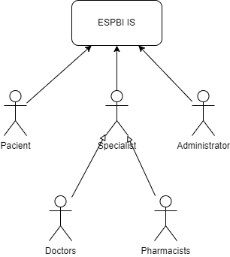
fig. 1 Users of ESPBI IS diagram
2 table. Description of System Users
No. | Target group | Description | Benefits of the system
 | Patients | Residents of the Republic of Lithuania (including foreign nationals in Lithuania and Lithuanian citizens residing in the EU and EEA) who use healthcare services, regardless of whether they are healthy or ill. | - Ability to initiate and receive healthcare services in minimal time.  - Improved access to eHealth services.  - Enhanced quality of healthcare services due to time savings for healthcare professionals.  - Increased satisfaction with eHealth services.  - Extended healthy life expectancy.
 | Doctors | Specialists engaged in personal health care , or other health care-specialists. | - Time savings for routine, repetitive tasks.  - Reduced administrative burden.  - Improved skills.  - Better teamwork and collaboration.  - Improved working conditions.  - Convenient and fast health and treatment data analysis.  - Ability to improve service accessibility and quality for patients.  - Increased job satisfaction.
 | Pharmacists | Specialists engaged in pharmaceutical activities and point-of-sale workers. | - Time savings for routine, repetitive tasks.  - Improved working conditions.  - Ability to improve service accessibility and quality for patients.  - Increased job satisfaction.
 | Administrators | RC specialist that monitors state of the system and has access to system configuration.

Functional structure of ESPBI

- The main parts of the ESPBI IS are as follows:
  - Portals:
    - Patient Portal: Provides authenticated users with information about their own or their represented persons’ health records.
    - Doctors’ Portal: Provides authenticated healthcare service providers specialists with functions for working with information stored in the eHealth system.
    - Pharmacists’ Portal: Provides authenticated pharmacy specialists with functions for working with information stored in the eHealth system.
    - Administrators Portal: Provides authenticated system administrators with functions to monitor system and to manage system parameters and configuration.
  - Portal Business Logic: Supports the functionality of the portals and facilitates interaction with the ESPBI IS data exchange platform
  - Data exchange platform: Handles HL7 FHIR standard queries and data from the portals as well as external systems (such as HIS or pharmacies information systems).
  - ESPBI IS Database: Stores all the information accumulated by the ESPBI IS by healthcare specialists, pharmacists and patients.

- The diagram and table below present the ESPBI IS logical architecture and its description.
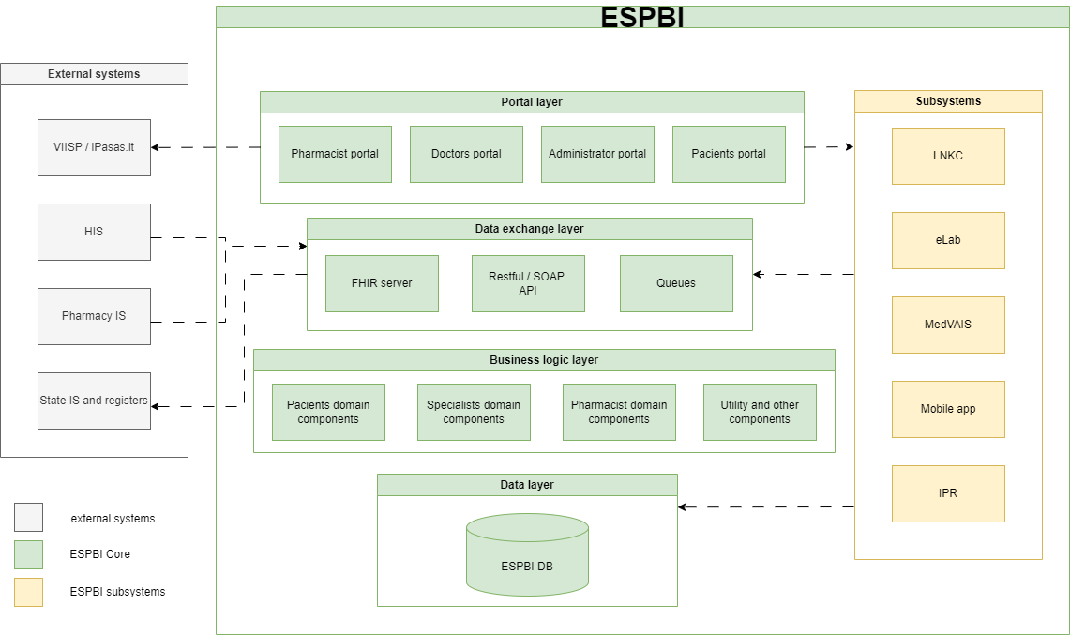
fig. 2 Current ESPBI IS logical architecture

3 table. Description of ESPBI IS logical architecture
Layer | Component | Description
Portal layer | Doctor portal | Provides services for healthcare professionals working in institutions that do not have healthcare information system.
Portal layer | Patient portal | Provides personal information and services to authorized users (patients)
Portal layer | Pharmacist portal | Provides services for pharmacists and point-of-sale workers working in institutions that do not have their own information system.
Portal layer | Administrator portal | Provides ESPBI administrators capabilities to monitor and manage ESPBI IS.
Data exchange layer | FHIR server | Component that provides data exchange services for FHIR resources.
Data exchange layer | Restful / SOAP API | Component that provides data exchange services by using Restful or SOAP services.
Data exchange layer | Queues | Component that provides data exchange services by using queues. Used only for informational message exchange.
Business logic layer | Patient domain components | Manage patients access to electronic services
Business logic layer | Specialist domain components | Manage specialists access to electronic services
Business logic layer | Pharmacist domain component | Manage pharmacist and point-of-sale workers access to electronic services
Business logic layer | Utility and other components | Manages utility and other logic for ESPBI such as classifications, data analysis, audit and other.
Data layer | ESPBI database | FHIR resources and management database designed to store FHIR messages and stores all required information in DB tables, which would be suitable for any analysis, operational automated data verification (according to operational requirements) and their transfer to the information systems of other institutions.

- The ESPBI system executes data exchange with various external institutions and systems. The table below highlights the key groups of systems, and the type of information transmitted between ESPBI and these connected systems:

4 table. External systems that interact with ESPBI IS
Component | Transmitted information
VIISP/iPasas | Data related to the EPBI IS users' identity verification service
HIS | Data generated by HIS required for e-prescription management, along with health history records.  Data generated by HIS for medical imaging, received along with electronic medical history records.
Pharmacy IS | Pharmacies and pharmaceutical specialists provide data for the dispensing of medications or reimbursable medical aid items, medical supplies based on e-prescriptions.
State information systems and registers | ESPBI IS receives personal information about patients, as well as details about licensed healthcare professionals and institutions. Additionally, it gathers data related to health insurance status, eligibility for state-funded healthcare, and social benefits. ESPBI IS provides aggregated and individual healthcare data for further analysis, as well as various data to other institutions such as Police Department, National Health Insurance Fund, State Data Agency, Regitra.

Description of project’s domain

- Main purpose of portals is to provide user interface and partial business logic for ESPBI services. Whether the user is patient, specialist, pharmacist or administrator.
- From architectural point of view portals are instances in portal layer and despite having their own backend they are highly dependent on business logic layer, which in this case is ESPBI core.
- Communication between portals and business logic layer is conducted via data exchange layer FHIR server component.
- Communication between portal web and portal API (portal backend) is conducted via Restful API services.
- The figure below depicts the logical architecture of portals and subsystems dependency with ESPBI core.
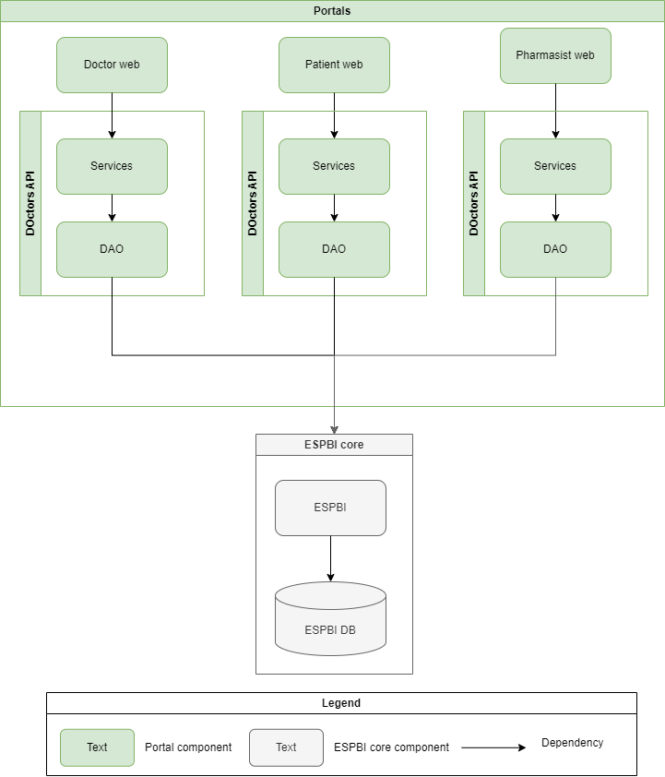
fig. 3 Portals logical architecture

- Portals logical architecture diagram shows functional components that current portals are built on. Every portal is comprised of following components:
  - Portal web – a GUI component that shows data to users.
  - Services – a component that represents a collection of services. One service implements a Restful API handler that provides access to CRUD operations on the resource. Services are used by Portal Web component. The set of these services depends on portal.
  - DAO – a component responsible for data exchange between ESPBI and portals.

Technologies

- Technological stack of Portals, ESPBI and related components:
  - Portal API and ESPBI core– spring: 3.2.2 (Java 1.8)
  - DB: oracle (ojdbc8): 19.18.0.0.
  - Portal web:
    - Angular.js - 1.5.11
    - Angular: 16.1.8

DESCRIPTION OF THE DESIRED STATE OF THE SYSTEM

Desired state of portals
- The goal is to create a data exchange mechanism for portals that will have the capability to store the information for fast retrieval. Subsequently this solution will lessen the load on the ESPBI core.
- The solution will comprise of these main components:
  - Upgraded DAO - this component is the original DAO component with new extended functionality. This new functionality will provide data to portals from portal database. Extended DAO functionality will be dedicated to read-only operation. Other operations (create, update, delete) will remain as is, which is that portals will communicate directly with ESPBI core. The read-only rule of upgraded DAO has an exception on draft documents, which means that upgraded DAO will write draft documents to portal database.
  - Portal database – this component is a separate portals data storage that stores data that is used in portals. Portal database is composed of 2 data storages:
    - Portal resources database - is used to store patient medical data, organizational data and classifiers. This storage is used as a cache for portals. Portals used it only for read operations.
    - Portals temporary storage - is used to temporary store draft documents.
  - Active resources synchronizer (ARS) – this component subscribes to event publisher and updates portal resource storage with up-to-date data.
  - Event publisher – this component registers successful create, update and delete operations events on ESPBI. These events are published for ARS to subscribe to and thus ensure that data changes reach portal database.
- The diagram below illustrates the to-be logical architecture of portals.

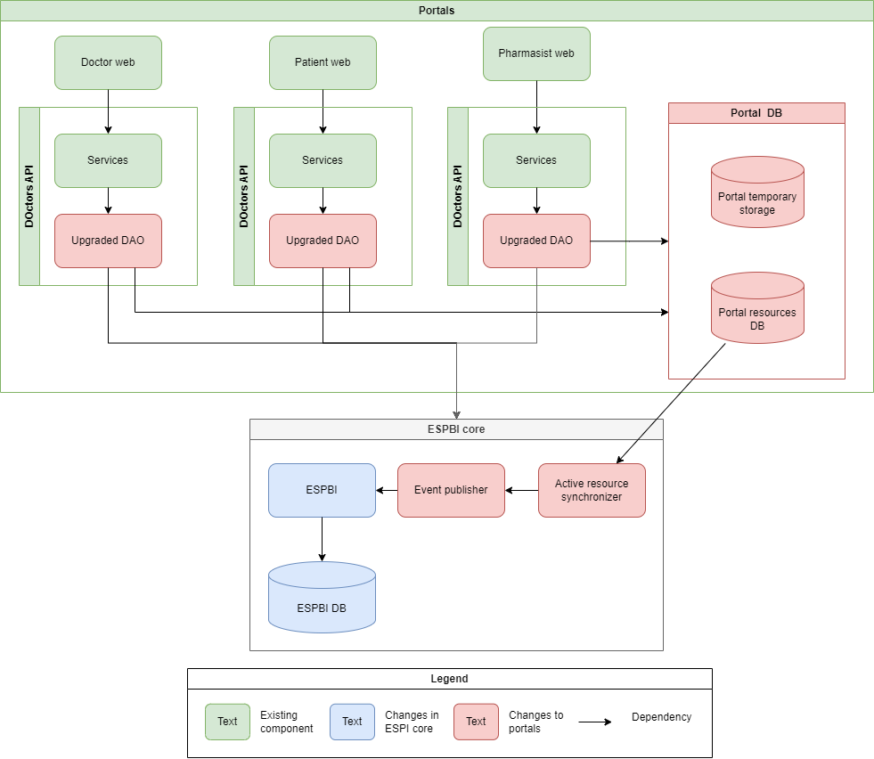
fig. 4 To-be architecture of Portals
- The diagram below shows the workflow of data exchange and caching mechanism. Diagram is prepared using UML activity diagram notation.

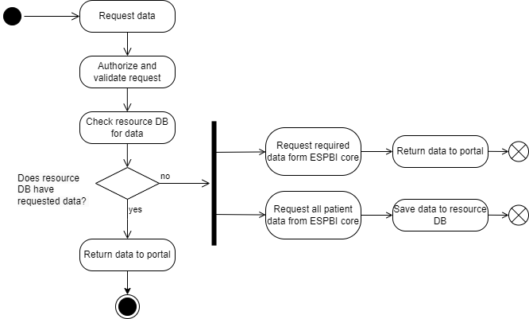
fig. 5 Data exchange activity diagram
- The diagram below shows the communication of components in scenario when there is no requested data in the resource database. Diagram is prepared using UML sequence diagram notation.
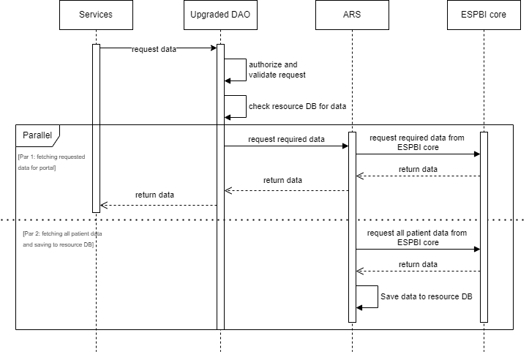
fig. 6 Data exchange sequence diagram
- The diagram below illustrates the workflow for synchronizing updated resources to the resource database. Diagram is prepared using UML activity diagram notation.
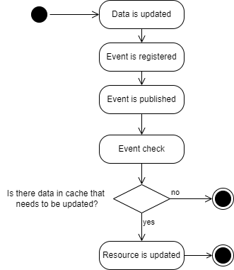
fig. 7 Data synchronization activity diagram
- The diagram below illustrates the workflow for synchronizing updated resources to the resource database. The scenario depicts the case where the updated resource need to be synchronized with resource database. Diagram is prepared using UML sequence diagram notation.
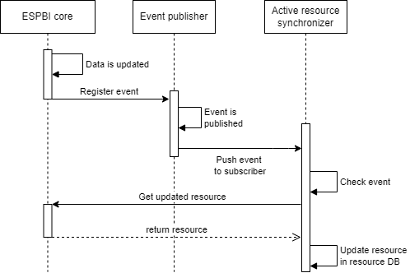
fig. 8 Data synchronization sequence diagram

Desired state of terminology server
- Terminologies are not currently managed in a centralized manner and lack standardized endpoints. To address this the aim is to establish a centralized terminology server to streamline and standardize terminology management. While the new terminology server will centralize the management of all medical terminologies, the core ESPBI terminology will remain unchanged due to the ESPBI IS FHIR version not being upgraded at this time. Only terminologies related to LMB will be included in the centralized server, leaving the existing core ESPBI terminologies as they are.
- The Centralized Terminology Server shall be the main tool for classifier management, accessible to all related systems via standardized APIs. Below the principal architecture of the TO-BE situation is provided:
  - eLAB module is currently under development. While some terminologies related to eLAB are being managed within the system, the goal is to migrate them to the new centralized terminology server.
  - Admin Portal - portal is currently used to manage the existing core ESPBI terminologies, which will remain unchanged during this project.
  - HIS (Healthcare Information Systems) - approximately 600 installations of healthcare information systems in Lithuania will use terminologies provided by the new terminology server.
  - LMB (Lithuanian Library of Medicine) - responsible for managing specific terminologies related to medical laboratory research, diagnosis, and other specialized areas.
  - VLK and other IS - provide terminologies for the core ESPBI. However, they are not within the scope of this project.
- The diagram below depicts proposed architecture for terminology server.
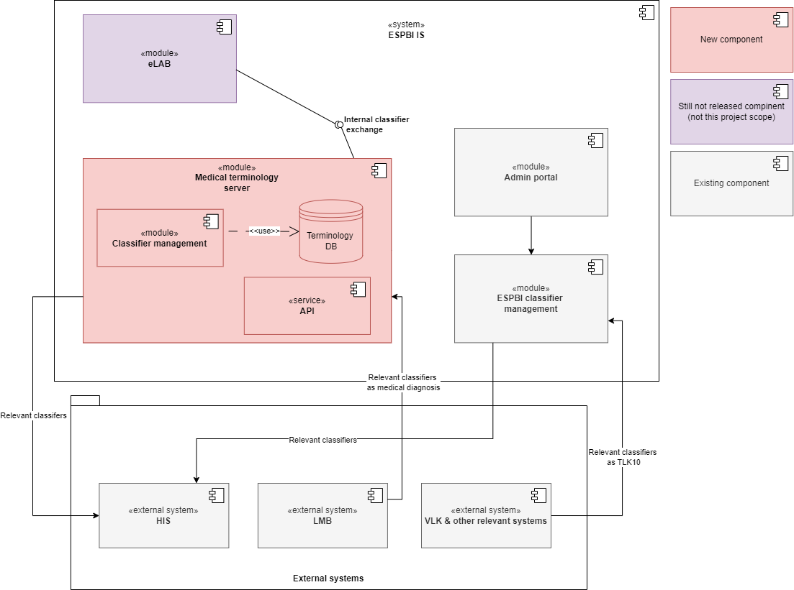
fig. 9 Proposed terminology server architecture
- The table below explains the proposed architecture and its components.
5 table. Terminology server architecture modules
Module | Description
eLAB | eLAB is currently under development, however part of the system is already operating in the production environment. The module managing medical classifiers is currently in use, but with the introduction of the new terminology server eLAB will transition to receiving classifier data directly from it and will not be the source.
Admin portal | Admin portal is used to manage other (not medical) classifiers managed in ESPBI.
EPSBI classifier management | Module which is used to manage other (not medical) classifiers.
Medical terminology server | New module implemented during this project that will manage medical classifiers.
HIS | External healthcare institution information systems.
LMB | National medical classifiers information system.
VLK & other relevant systems | External systems using medical classifiers.

DESCRIPTION OF FUNCTIONAL REQUIREMENTS

Functional requirements for portals modernization

Requirements for development of Upgraded DAO
- In the following table are provided functional requirements for upgraded DAO components.
No. | Requirement
 | For each - Patient Portal, Doctors Portal, Pharmacist Portal - a DAO component must be extended with additional functionality described in following requirements.
 | API methods of DAO components must be changed to provide data to portal web from resource database storage.
 | Up to 290 methods must be changed in DAO components. The methods are distributed:
 | Up to 200 methods common to all portals.
 | Up to 90 methods specific to each portal. The number of methods is a sum across all of portal specific methods.
 | DAO components must provide the requested data form resource database.
 | If resource database does not have required information, DAO will request that information from ARS component.
 | Portal components (such as API gateways, controllers and models) must realize the same validation rules (including authorization) on read operations as they are currently realized in ESPBI core.
 | DAO components must be able to save draft documents to temporary storage. Draft documents are considered documents that have not been approved. When the user initiates the approvement process the document is no longer considered draft document.
 | DAO components must be able to send draft documents to ESPBI core when the user initiates approvement process of document.

Requirements for development of Portal Database
- The following table outlines functional requirements for portals database storage component.
No. | Requirement
 | Portals database component must be accessible to Patient portal, Doctor portal, Pharmacist portal.
 | Portal database must be separate database instance from database of ESPBI core.
 | Portal database is a composition of 2 databases:
 | Portal resource database;
 | Portal temporary storage.

- The following table provides functional requirements for portals resource database component.

No. | Requirement
 | Portal resource database must store all information that can be required by portal on patient and organizational data. Portal resource database should store:
 | Patient general data;
 | Patient historical medical records;
 | Patient active operational records (records with end date. i.e.: prescription, planned visits, encounters etc.);
 | Specialists’ data;
 | Organizations’ data;
 | Medical classifiers.
 | After a configurable amount of time all data about specific patients (patient’s general data, patient’s historical medical records, patient’s active operational records) should be removed from portal resource database.
 | If during that time, any data about that patient is updated or read by the portals, the data removal time must be counted from that date.

- The following table provides functional requirements for portals temporary storage component.
No. | Requirement
 | Portal temporary storage must store draft versions of medical documents from Doctor and Pharmacist portal.
 | Specified documents must be saved as draft versions in temporary storage:
 | E113-ND – pregnancy data, history and care plan;
 | E113-RV – risk factors;
 | E096-NT – examination of the pregnant woman, delivery care plan, appointments;
 | E096-AN – cases of near misses and losses during pregnancy, delivery, or postpartum period;
 | E096-PART – partogram;
 | E003 – inpatient epicrisis;
 | E025 – outpatient epicrisis.
 | Documents that are no longer drafts must be removed from temporary storage. When the user initiates the approvement process the document is no longer considered draft document.

Requirements for development of Active resource synchronizer
- In the following table are provided functional requirements for active resource synchronizer (ARS) component. Data exchange workflow is depicted in Figures 6 and 7 for, for data synchronization workflow refer to Figures 8 and 9.
No. | Requirement
 | ARS component must have access to portal database.
 | When resource database does not have data requested by DAO, DAO will request data from ARS component. In this case ARS component will:
 | Request the required data from ESPBI core and return that data to requester.
 | Request all resources of that patient from ESPBI core and save it to the resource database for later usage. The final set of resources that must be requested in this way must be prepared and agreed upon by Buyer during analysis phase.
 | The ARS must subscribe to the event publisher to receive events related to updates of resources.
 | Upon receiving an updated event for a necessary resource, the ARS must retrieve the updated data from the ESPBI core and update the portal resource database accordingly.

Requirements for development of event publisher
- In the following table are provided functional requirements for event publisher component.
No. | Requirement
 | Event publisher component must be created as part of ESPBI core.
 | The ESPBI core must be modified so that any successful write event for a resource—such as a create, update, or delete operation—is registered with the event publisher component.
 | Up to 150 methods for writing operations must be change.
 | The write event must include, but is not limited to, the following attributes:
 | Patient id (if the resource is a medical record of a patient);
 | Resource type;
 | Reference for resource location;
 | Resource version.
 | Events must be published.
 | Event publisher component must have capabilities to allow other component to subscribe for chosen event topic.
 | Other component can subscribe to unrestricted amount of unique event topics. Events are group in topic depending on the document or resources that were successfully written. Set of event topics and documents or resources each topic encapsulates must be determined during analysis phase.
 | Event Publisher must support a configurable set of subscribing components, along with the specific resources each subscriber is subscribed to.
 | Event publisher must have capabilities to add, remove or update subscribers with resources they subscribe to.

Functional requirements for development of ESPBI document registry
- The following table provides functional requirements for ESPBI document registry.
No. | Requirement
 | Implement the document registry based on the FHIR DocumentReference resource and integration point, ensuring the cataloging of medical documents while preserving and utilizing document metadata for search purposes.
 | All medical documents stored in ESPBI (compositional and binary) must have a reference of it stored in document registry.
 | Document registry must have capability to:
 | Upload reference to document;
 | Uploaded document can be stored outside of ESPBI core database (i.e. eLAB documents).
 | Edit reference to document:
 | Update/change description of document or documents meta data;
 | Change status;
 | Change reference to document;
 | Search the necessary document references based on metadata provided in the registry entries, focusing on the metadata suggested by IHE XDS, such as document author, responsible organization, document type, document class, treatment episode (encounter), clinical specialization, version, creation date, and document status.
 | Access to registry entries is administrated using ESPBI access rights and access is provided based on the requesters role.
 | Retrieval of documents or resources is not part of documents registry functionality. Document or resources retrieval must be conducted using dedicated FHIR endpoints (i.e. Composition, Binary, etc.).
 | Preliminary scope of registry entry attributes (a final set of attributes must be negotiated and agreed up on during analysis phase):
 | Text – system generated human-readable text from meta data;
 | masterIdentifier – unique document identifier;
 | Identifier – additional document identifiers;
 | Subject – reference to patient the document pertains to;
 | Type – document type;
 | Class – document category;
 | Author – authors of document;
 | Custodian – organization that sent the document;
 | Created – datetime of document creation;
 | Indexed – datetime of document receival;
 | Status – status of documents registry entry;
 | docStatus – status of the document;
 | Description – description of the document;
 | mimeType – format of the document;
 | Location – link to document of resource;
 | Format – encoding of document;
 | Context – context information of the document;
 | Confidentiality – security label;
 | authorSpeciality – qualification of documents author;
 | clinicalSpeciality – clinical field to which the document belongs. Field is not mandatory. For example, if the document is Form 025 completed by a general practitioner, it may contain a variety of information. However, if the document is a cardiology questionnaire, then clinicalSpeciality = cardiology.
 | Encounter – reference to visit during which the document was generated and sent;
 | Version – version of the document structure;
 | Other attributes determined during analysis phase.
 | The value sets for these DocumentReference attributes should be aligned with the IHE XDS value sets where possible, considering local requirements.
 | Capability to register documents to document registry must be created when new structured or unstructured document, o any other resource, that should be registered in document registry is provided to ESPIBI. This capability must be realized by extending functionality of API to require needed metadata.
 | A record must be created in the document registry for each document already present in ESPBI (medical, certificate, unstructured) to ensure it contains complete information.
 | Document registry will be created based on FHIR v0.0.82 infrastructure.

Functional requirements for medical terminology server
- The following table provides functional requirements for medical terminology server.

General terminology server requirements
No. | Requirement
 | The solution must support the storage, exposure and management of medical classifiers, while other non-medical classifiers will continue to be managed within ESPBI using a separate module that is not part of this tender. For more details, refer to the diagram of the terminology server (see Desired state of terminology server).
 | Some classifiers will be created within the terminology server while others will be sourced externally (received from external sources as LMB). The externally received classifiers must remain unchanged with mechanisms in place to ensure their integrity. Classifiers created within the terminology server should be managed and edited as needed. Therefore, there will be 2 types of classifiers: local ones and the ones received from 3rd parties.
 | The terminology server must support the import of certain terminologies from external sources. The solution should include a task management mechanism for managing import operations. This mechanism must allow users to enable or disable specific imports, configure the import frequency, and monitor import errors. Additionally, the mechanism should support classifiers’ enrichment with additional information during the import received process and ensure the accurate logging and display of import statuses. Moreover, it should be possible to select and review which version is received.
 | The terminology server shall provide the possibility to configure classifier availability periods (e.g., start/end dates).
 | An implementation guide must be provided to assist HIS (Healthcare Information Systems) and other integrators in adapting their systems to interact with the centralized terminology server.
 | The terminology server shall support bulk import and export of classifiers, as well as bulk editing capabilities, using formats such as CSV or Excel files.
Terminology server shall include a user interface with the following functionalities:
- Manage classifier versions including viewing version history, activating specific versions, etc.
- Define parameters for classifiers received from external sources e.g. specifying data to be retrieved from the LMB server based on CodeSystem or ValueSet standards.
- Review logs
- Search for classifiers based on metadata, such as name, ID, or version.
- View and edit metadata for classifiers, including descriptions, effective dates, etc.
- Support user roles and permissions to ensure only authorized users can perform specific actions, such as editing or activating versions.
- Create and modify classifiers (only those that are created within terminology server shall be modified and it should not be allowed to modify those received from external sources as LMB).
- Manually import / export
Other necessary actions for terminology server to fully operate.
 | The terminology server user interface should have an intuitive and user-friendly interface ensuring that system management is performed through visible interactive elements (GUI) rather than requiring code-based interactions.

Terminology server set-up
No. | Requirement
 | The Provider who will be implementing the terminology server must not only deliver the terminology server tool but also perform all necessary configuration for integrating LMB’s classifiers into the system.
 | The Provider responsible for implementing the terminology server must ensure that it is equipped with all the classifiers provided by LMB, which shall be identified and aligned during the project analysis phase. Upon receiving this list, the service provider must integrate, configure, and make these classifiers available via a centralized API endpoint for all connected systems.

Classifier versioning requirements
No. | Requirement
 | A classifier versioning mechanism must be in place to track the history of versions, identify the active version, compare differences between versions, and activate a desired version when needed. All changes to classifiers must be recorded in a version control system, ensuring traceability of configurations applied to each data source.
 | Versioning mechanism must maintain trail of all changes and activations, including user information and timestamps.
 | Each version must include metadata such as version number, creation date, author, etc.

Classifier data exchange
No. | Requirement
 | The solution must have the ability to provide classifiers via a standardized REST API. Single central endpoint must be provided for classifier distribution.
 | Classifier data should be received from LMB server and provided to external and internal sources as indicated in terminology server diagram (see Desired state of terminology server).
 | Data to external sources should be provided via standardized data endpoints.
 | When adding a new data source or changing its requirements, administrators must have the option to review and approve proposed configurations before applying them.
 | Provider must integrate all LMB classifiers, perform necessary configuration, and provide them via a centralized API endpoint. LMB will provide classifiers version data that should be captured and based on the version respective classifiers should be received.

Terminology server access control
No. | Requirement
 | Actions with classifiers must be permitted only based on user rights and roles.
 | User rights and roles must be configurable through the centralized ESPBI rights management system. It would be managed by separate component (admin portal). Terminology server shall ensure compatibility with the ESPBI rights management mechanism to provide centralized and secure rights management.

Functional requirements for foreign patient code handling scenarios
- The following table provides additional requirements for foreign patient code handling scenarios.
No. | Requirement
 | The solution must resolve the issue of identifying foreign patients by using the ILTU code, ensuring each foreign citizen has a unique ID during registration.
 | The solution shall be capable of accepting and processing the ILTU code received from the Foreigners' Register through a web-services API. The solution shall replace the current integration, which operates through DB-LINK, with a web-services API. Exact integration details shall be analyzed during implementation process.
 | The solution shall ensure that the existing data received through DB-LINK is migrated or adapted to be compatible with the new web-services API.
 | The solution shall extend the functionality of the new web-services API to include the ILTU code as an additional parameter for data exchange.
 | The system shall validate the received ILTU code through the new web-services API to ensure it meets format and data integrity standards defined by the Foreigners' Register.
 | The solution shall send a notification (via email and/or SMS) to the patient after new patient registration.
 | The solution shall include the following information in the notification: ILTU code, ESI code (if available), and other general information as date of registration, patient name, etc. The notification should be configurable by system administrators and different types of notifications could be managed for different patients according to institution or nationality.
 | The solution shall ensure that the notification is generated in English for foreign patients and in Lithuanian language for Lithuanian patients.
 | The solution shall log the delivery status of notifications, including "Successfully sent" and "Failed to send" (with error code and reason).

Functional requirements for patient summary

Requirements for patient summary generation and structure
- The following table provides functional requirements for patient summary generation and structure.
No. | Requirement
 | Patient summary is a medical document used to collect and summarize all key data about a patient. It serves as a resource for patients when traveling or when their medical data is requested by legal authorities, etc.
 | The patient summary generation service must be updated to produce a summary according to the revised structure defined in PatientSummary_v.1.0.xml. This structure may be adjusted during the project. The final structure of patient summary must be negotiated and approved by Buyer during the analysis phase.
 | The logic used to generate the patient summary must be revised according to the changes specified in Annex 2.
 | The patient summary information display screen within the system must be updated to present all data elements introduced in the new structure.
 | The patient summary PDF document export process must be updated to reflect all data elements available in the new structure. Two PDF variants must be supported: one with an official stamp (it is not user signature, but rather the organization (Registrų centras) official stamp and one without.

Requirements for patient summary data entry and editing
- The following table provides functional requirements for patient summary data entry and editing.
No. | Requirement
 | Patient summary should be accessible in specialist portal and in patient portal. Specialist portal shall have the possibility to edit available data fields and patient should be able to access patient summary via patient portal. Moreover, document should be accessible for HIS as well.
 | Access rights to patient summary should be managed via existing ESPBI admin portal functionality.
 | The summary generation interface, where a specialist can review automatically gathered patient data, must be updated to allow the manual entry of certain data elements (e.g., blood type, harmful habits, past diseases, vaccination records, implants).
 | Patients must not be able to edit field of patient summary.

Requirements for diagnosis handling and FHIR condition resources
- The following table provides functional requirements for handling diagnosis and FHIR condition resource type.
No. | Requirement
 | The patient summary must support two different FHIR Condition resource structures. Some conditions that were used from start of the system deployment (2015) to 2025 will have one structure and by 2025 conditions resource structure will change. Data should be merged in patient summary from both types of conditions. The algorithm for merge will be provided by the Buyer during the project analysis phase.
 | Diagnoses are not entered manually into the summary, but they are imported.
 | Diagnoses will be collected in different formats due to varying diagnosis entry processes:
 | Type A: Diagnoses created at each visit without a clear end date or disease episode.
 | Type B: Diagnoses with a defined lifecycle, created once and reused across multiple documents, then closed when the patient recovers.

Requirements for patient representatives and authorization handling
- The following table provides functional requirements for patient representatives and authorization handling.
No. | Requirement
 | The system must ensure accurate handling of patient representative information. Currently there is an issue where related person as children are incorrectly identified as representatives. Representatives and related persons should be managed as separate categories and patient summary should manage these both of these categories separately. Both representatives and related persons data must be captured accurately, ensuring they are clearly distinguished in patient summary.

Requirements for primary care specialist and healthcare facility information
- The following table provides functional requirements for primary care specialist and healthcare facility information.
No. | Requirement
 | The system must correctly display information about the patient’s family specialist and the healthcare institution with which the patient is registered (more data points should be included in the patient summary). If patient data changes only the latest data should be displayed (history is not necessary).

Requirements for implant information management (additional functionality outside of only patient summary)
- The following table provides functional requirements for implant information management.
No. | Requirement
 | The solution must correctly handle implant information including the entire implant lifecycle.
 | The forms (E025 and E003) must be modified to allow implant details to be recorded. No external integrations are planned at this stage and validation rules must be established to prevent redundant data entries.
 | Classifier should be developed which would be used to identify which ACHI code should require to enter implant information.
 | On forms E025 and E003 when registering a surgical procedure for the patient the system must determine based on the ACHI procedure code (and additional classifier) whether implant information needs to be entered.
 | Validation must be implemented to require the entry of implant information when ACHI procedure code requires it. This validation should be applied during the provision of forms E025 and E003. Additionally, the validation functionality must include the ability to enable or disable it as needed.
 | Implant classification (e.g., via SNOMED) will be required and may be connected to the terminology server.
 | Implant lifecycle requirements:
 | When the procedure involves implant insertion, a new implant resource must be created (a dedicated FHIR resource).
 | When the procedure involves implant removal, the existing implant resource must be selected, and its end date recorded.

Requirements for technical adjustments and FHIR resource integration
- The following table provides functional requirements for implant information management.
No. | Requirement
 | E025 and E003 data structures must be updated to support implant information.
 | The Procedure resource structure may need adjustments to associate it with the relevant implant resource. The Procedure represents the operation, and the Device resource will represent the implant itself.
 | Import the implant and medical device classifiers from LMB (terminology provider) or create these classifiers within terminology server (Service provider shall create these classifiers within terminology server).
 | Implement a review and management interface for newly added classifiers in the ESPBI administrator portal.

NON-FUNCTIONAL REQUIREMENTS

Acceptance criteria for non-functional requirements
- All specified requirements must be implemented.
- The Provider or RC may propose an alternative method for implementing a specific requirement or substitute the requirement with an equivalent functionality that does not negatively affect the objectives, goals, and final results of the Procurement and does not contradict the requirements of the legislation regulating procurement. Each proposed alternative or functionality change must be approved by RC. In the case of substituting a requirement with an equivalent functionality, the Provider must provide a written justification, including a description of the impact and criticality of the change, demonstrating that it does not affect the overall functionality of the System. Additionally, an assessment of the time costs for the replaced functionality must be conducted (detailing the time required to implement the replaced functionality and presenting the time costs for implementing the new functionality). The implementation of alternative specification requirements must follow the change management procedure defined in the Service Delivery Regulation.

System architecture requirements

General requirements for architecture

- Implementation of the solution architecture should maintain the multi-layer (multi-tier) architecture of ESPBI IS which would allow for easier expandability of the system. The layers are described in section 2.1.2 and are as follows:
  - Portal layer.
  - Data exchange layer.
  - Business logic layer.
  - Data layer.
- Solution should be implemented following SOA (Service-Oriented Architecture) principles with the goal of minimizing dependencies between components.Solution must be compatible with fault tolerance, exception handling, load balancing and configuration tools that are used in ESPBI. The chosen software for implementation of these aspects must be negotiated with and approved by Buyer.
- Solution must support data exchange in XML (eXtensible Markup Language) or JSON (javascript object notation) format.
- Implementation of the solution must ensure data integrity and availability via use of dedicated data exchange layers. If some data is updated all other components must have the access to newest data available in real time.
- The size of the data entity or the size of data storage must not be constrained by software or its architecture.
- All the solution components must support Unicode UTF-8 encoding.
- To ensure high availability of the solution component duplication measures must be implemented. Furthermore, additional measures should be implemented such as: server duplication, load balancing, data backups etc.
- In cases where it is necessary, the solution must use well-established and stable third-party software solutions.

Requirements for database
- The configuration of the database and application server must be discussed, negotiated, and formally approved by the Buyer prior to implementation.
- The solution should have no limitations regarding the number of data entries except cases when there are hardware constraints.
- Portal database should be implemented using open-source solutions (i.e. PostgreSQL or equivalent) if possible. The technological stack of Portal database must be negotiated and agreed up on with the Buyer prior to implementation.
- Portal database structure should be able to handle new medical documents without changing the database structure, when the new medical document can be handled as a standard Composition resource.

Requirements for infrastructure usage
- Solution must use open documents and data formats.
- Development of the solution must use the technology stack described in section 2.2.1 Technologies.
- The developed solution must use RC hardware infrastructure for the deployment of the solution.

Requirements for availability
- The technology stack used for the software developed must be fully compatible with the existing technologies and infrastructure of the Buyer. The solution must leverage existing infrastructure components, such as the RC firewall, wherever applicable, to ensure seamless integration and minimize duplication of resources.
- The solution must ensure high availability of services by using software solutions such as messaging queues, message brokers, component duplication, load balancers etc.
- Measures used for ensuring solution availability should be automatic in nature (especially in case of incidents) and the only manual intervention should be when system must be reinstated to stable state.
- Measures for ensuring availability must be described in detail in design documentation.
- The solution must adhere to the principal of 24/7 availability, ensuring continuous uptime without interruption.
- Solution must be available 99,99% of the time.
- Solution must ensure robustness and fault tolerance measures when user provide incorrect inputs. Solution must provide message to the user about incorrect action and proceed to stable work state.
- Data synchronization must not have a negative effect on solutions availability.

Requirements for extensibility

- The solution should ensure further development and introduction of additional functionality without impacting the development of other components.
- The solution should be capable to scale with additional hardware resources added vertically and horizontally.

Requirements for the making and restoration of backup copies

- The provider shall define and implement the processes, tools and rules for making backups in accordance with the backup policy provided by RC, using the backup tools and resources available to RC.
- The solution must allow you to recover data from backup copies of data. The Provider shall define and implement the processes, means and rules for the restoration of copies.
- The solution being developed must be coordinated with the reserve copying equipment available at the Centre of Registers in order to ensure the possibility of manual and automatic backup of all stored data, i.e. the solution must be installed in such a way that the reserve copying equipment available to the Centre of Registers can be fully used (the reserve copying equipment currently used by the Centre of Registers – EMC Networker).
- The solution must be coordinated with the reserve copying equipment available at the Centre of Registers, so that technical administrators have the opportunity to set automatic backup according to the specified frequency, the established place of data storage (logical disk, remote stations, etc.), the categories of documents to be copied, records, documents, as well as to carry out copying of the entire System.
- The solution must be aligned with the reserve copying equipment available at the Centre of Registers so that the technical administrators have the right to initiate the procedure for restoring system data from the backup copy. The integrity of the data must be ensured when the data are restored.
- The solution must be so aligned with the reserve copying equipment available to the Centre of Registers in such a way as to make it possible to generate a log of the reserve copy in the System and to ensure the possibility to view and print the log in which the following are to be recorded: the date, time of the backup copy, the method of making the backup copy (automatic, manual), the name of the reserve copy file, the place of storage of the reserve copy file and other information agreed during the Project. It must be possible to view and print the journal of the reserve copy.
- In case of incident when resource database must be recovered, resource database must have the ability to resynchronize organizational data (general data about patients, specialists data, health care institutions data) from ESPBI core.

Requirements for system monitoring
- Monitoring of created components, software tools and services checkpoints should be integrated with already-used software solutions.
  - Each checkpoint must be accessible via https protocol.
  - Communication with checkpoints should not noticeably impact solution performance.
  - The checkpoint should return the state of the component:
    - “OK” – service is up and running.
    - “FAIL” – service is down.

Requirements for system administration

- The System Administrator will be able to view the System Users Audit Log, which will record all user actions, the systematic error messages they receive. The date, time, username of the action, the IP address of the network of Internet access users or the IP and MAC addresses of users of the internal network must be recorded.
- The System administrator must be able to preview and manage configuration of subscribers to event publisher. In addition System administrator must be able to preview and manage resources the subscribers subscribe to.

Requirements for reliability

- The solution must maintain the ability to be restored in no longer than in 1 working day when solution is down due to software and not hardware fault.
- In the event of a systemic error, the solution must provide all services (functions) for the provision of which the disrupted component is not required.
- During the copying and archiving procedures, the services (functions) provided by the solution must not change.
- During the design of the developed solution, the procedures for storing, transmitting and archiving data must be described: with what periodicity, to what information media and what databases should be copied, where and for how long these copies must be stored.
- Procedures shall be in place for the maintenance of the System and for the updating of the System to ensure the reliability and security of the data.

Requirements for performance

- The provider must ensure the following performance requirements for web services:
  - For simple web services, where the execution time of an individual web service does not exceed 100 milliseconds, when working simultaneously 20 000 parallel users, each of whom makes one request per second, the response time must not exceed 2 seconds.
  - For complex web services where the completion time of an individual request exceeds 100 milliseconds, performance criteria must be negotiated and agreed upon with the RC during the development.
  - Other exceptional cases for performance criteria must be negotiated and agreed upon with the RC.
- The implementation of the components must ensure that when working with the external portal time 5 thousand concurrent users and their actions – reading, inserting, changing and removing documentary records, performing other actions (the execution time of which does not depend on interfaces with external systems), the average response time (the duration from the receipt of the server's HTTP request to the sending of the HTTP response) does not exceed 1 second, in the presence of a 30 thousand HTTP requests per minute. There may be exceptions that must be aligned with RC (e.g., generating reports, importing or exporting data, uploading large-scale files, actions that include queries and receiving responses from third-party systems, etc.)
- The implementation of components used in the Portal must ensure that, when interacting with the internal system components, 50 users performing actions such as reading, inserting, modifying, and deleting documentary records, as well as executing other tasks (where performance is not dependent on interfaces with external systems), the average response time (measured from the server's receipt of an HTTP request to the transmission of the HTTP response) must not exceed 1 second under a total load of 8.5 thousand HTTP requests per minute. Exceptions to this rule, such as report generation, data import/export, uploading large files, or actions involving third-party system interactions, must be negotiated and agreed upon with the RC.
- Auditing of requests that exceed the established performance requirements must be realized. The audit record shall contain sufficient data to determine which function of the solution does not meet the performance requirements.
- During the acceptance testing phase (or any other agreed time), the Provider must ensure that all necessary conditions are in place for RC's representative specialists to conduct performance testing. If required, the Provider must perform any configuration or programming tasks necessary to ensure the test of solution's performance under various usage scenarios. The Provider is not responsible for supplying any software or hardware needed for the execution of the performance testing.
- The Provider must carry out the necessary solution programming and / or configuration works, based on the results of the performance tests performed by the RC representatives, if the test results do not meet the performance and speed requirements specified in the above points.
- Solution must ensured that the actions taken by the System Users and service users do not block the actions of other System users and service users and do not affect the speed of the System (unless, for reasons of data integrity, system users and service users are blocked from accessing the data processed by other System users or e-users at that time).

Requirements for software and licensed software

- The solution will be developed according to the principle that the RC does not have to purchase additional paid software necessary for the operation of the solution's functionality. However, if it is not possible to use free software to realize certain functionalities, it will be purchased and handed over to the RC together with the necessary licenses.
- The use of the solution must not be limited by license requirements.
- Providers used commercial off-the-shelf-software, which is necessary for the operation of the solution, must be accompanied by all the necessary licenses so that the RC does not have to purchase additional licenses (or otherwise invest) for the operation of the software for at least 10 years.
- All costs of the required license software must be included in the offer.
- If the software offered is licensed depending on the number of users (people or systems) using the System, the parameters of the servers, etc., the Provider shall provide licenses that ensure the rational and efficient operation and use of the solution.
- All necessary licenses must be acquired in the name of the RC. All (named) licenses necessary for operation must be handed over to the RC. The licences submitted should not be valid before the start of the pilot phase and no later than the start of the warranty maintenance phase.
- The Provider must guarantee compensation to RC for any claims related to the use of copyrights, patents, licenses, or trademarks associated with the goods or services used in connection with the developed software, except in cases where such claims arise due to the fault of RC.
- If existing libraries or sets of libraries that fulfill the required functionality are already in use by the Buyer, the Provider must prioritize reusing these libraries to maintain consistency and system integrity.
- In cases where replacement of the Buyer's existing libraries is necessary, the Provider must ensure that such replacements do not disrupt the system's integrity or operational continuity.
- Any proposed changes to libraries must be documented and submitted to the Buyer for approval as part of the change management procedure outlined in the Service Provision Regulation.
- The Provider is responsible for ensuring that the reuse or replacement of libraries complies with all licensing agreements and does not infringe on any intellectual property rights.
- All software that will be created within the scope of the Service provision must be fully transferred to the RC (all property rights and source codes are transferred).
- The source code must be delivered exclusively on electronic media and must comply with the following requirements:
  - The source code must be provided as file packages prepared for compilation, with clear documentation specifying the standard compilation or build tools and the compilation or build process.
  - Source code must included data migration, launch and other scripts for starting the solution and other information necessary for the successful launch of the solution from the source code.
  - The source texts must be accompanied by comments (indicate documentation, e.g. javadoc or similar documentation of an equivalent programming language) and comply with good practices in the formatting of software code, the designation of variables, methods, and classes or user interfaces.
- The Provider must deliver the complete source code to the Buyer upon project completion, or as agreed upon in the project milestones. The delivered source code must be fully documented, including build instructions, configuration files, and any necessary dependencies required for successful compilation, deployment, and operation. The source code must be provided in a format that is compatible with the Bueyrs’s environment and version control system. Any third-party libraries or components used must be clearly identified, along with links to documentation and licensing terms.
- Third-party libraries or components used must be provided to the Buyer in their compiled form.
- The source code provided by the Provider must be written in a clear and readable manner to facilitate maintenance, future development, and collaboration. The following standards must be adhered to:
  - Use industry-standard formatting guidelines specific to the programming language (e.g., PEP 8 for Python, Google's Java Style Guide, etc.).
  - Variable, function, class, and file names must be descriptive and follow consistent naming conventions (e.g., camelCase, PascalCase, or snake_case depending on the language).
  - Hardcoded values should be avoided, and configuration files or constants should be used where applicable.
  - The source code must be compatible with the GitLab version control system used by RC and must support continuous integration practices.
  - RC code repository tool (GitLab) must be used for deployment processes.
  - During the development of the solution, RC intends to conduct both automatic and manual source code analysis, as well as code reviews, on the GitLab platform. The Provider agrees to consider these reviews and implement any changes in accordance with the RC’s feedback and comments.
- Integration with external systems must be implemented following best practices based on the principles of Dependency Management. Integration packages should be developed as standalone software libraries and managed using dependency deployment tools such as Maven, Composer, or similar tools.
- The RC will provide all the necessary resources (hardware) of computing and computer networks, license software necessary for their operation (operating systems, virtualization software, server management, data storage management, network equipment management, data archiving, backup copying), therefore, the price of these components should not be included in the offer price.

Requirements for the application of standards
- The following or equivalent standards must be applied to the development of the solution, without limitation (specify the mandatory applicable standards:
- SOAP Web Services Data Exchange Protocol Simple Object Access Protocol (SOAP v1.1), www.w3.org/TR/soap/);
- REST API documented with OpenAPI (https://swagger.io/specification/).
- web service functionality description language WSDL Web Services Description Language, http://www.w3.org/TR/wsdl or equivalent;
- SSL or equivalent cryptographic protocol for ensuring the security of information transmitted over the Internet and other networks (CRYPTIC protocol) Secure Sockets Layer (SSL)) in the following communication scenarios: system - user and system - system - system;
- Web Service Security WS-Security Web Services Security, www.oasis-open.org/committees/wss/) or equivalent standards and specifications;
- HTTP Hypertext Transfer Protocol (HTTP, https://tools.ietf.org/html/rfc2616);
- JSON JavaScript Object Notation, https://tools.ietf.org/html/rfc7159);
- URI Uniform Resource Identifier, https://tools.ietf.org/html/rfc3986);
- XML Extensible Markup Language, https://www.w3.org/TR/xml/);
- LDAP Lightweight Directory Access Protocol, https://tools.ietf.org/html/rfc4511);
- (specify the standard used, e.g. AMQP(s).) Advanced Message Queuing Protocol (AMQP),http://docs.oasis-open.org/amqp/core/v1.0/amqp-core-messaging-v1.0.html);

REQUIREMENTS FOR SERVICE PROVISION

Requirements for the workplace
- According to the designated procedures, the Buyer will provide access to its resources (hereinafter referred to as "access") for the Provider's employees participating in the execution of the Procurement object (hereinafter referred to as "Provider specialists"):
- Provider specialists will be granted access to the Buyer's applications: JIRA, CONFLUENCE.
  - Depending on the specifics of the Procurement object, a Provider specialist may be granted access to DB schemas necessary for the execution of the Procurement object in the DEV environment.
  - Provider specialists, application programmers will be granted access to the Buyer's GIT repository for managing source text versions of the Procurement object software, and servers dedicated to the execution of the Procurement object in the Buyer's infrastructure development environment (DEV), without granting administrative rights, and necessary DB schemas.
- As required, the Buyer will provide secure remote access – a virtual desktop infrastructure, hereinafter – VDI, through which Provider specialists will access the Buyer's resources necessary for service provision.
- As needed, the Buyer may provide Provider specialists' computer workplaces with secure remote VPN access to the resources dedicated to them necessary for the execution of the Procurement object.
- Provider's specialists will not be granted access to the Buyer's production data or production environments. All development, testing, and maintenance activities shall be conducted within the Buyer's development (DEV) and testing (TEST) environments using anonymized or synthetic data provided by the Buyer.

Requirements for ordering additional services
- There are dedicated 1000 hours for additional changes.
- Services will be ordered via the Buyer's JIRA by submitting tasks – specific tasks are assigned to the Provider's specialist(s), who are previously granted access to the Buyer's.
- 12 months warranty should be applied to all changes requested by additional ordering of services.
- When the provision of services does not start on the date of signing the Contract but from the day the order for services is submitted, then the provision of services will start to be counted from the first task assigned to the Service Provider or their specialist in JIRA.
- Amendments to the requirements set out in the RPO, the Technical Specification, or other annexes to the Service Agreement may be initiated by either the Provider or the Buyer.
- Changes may arise due to circumstances that were unforeseeable and uncontrollable at the time of the tender submission or the conclusion of the purchase agreement. These include situations that could not have been reasonably foreseen and controlled, as well as the risks associated with such occurrences.
- Any amendment must be implemented after both the Provider and the Buyer have approved the change in writing, formalizing the agreement as an annex to the contract. Implementation must comply with the terms of the Service Agreement and this technical specification, adhering to the principles of public procurement. The following activities should be applied, considering the nature of the change:
  - Document the effect of the change, assess its criticality level (minor, medium, critical), and describe the consequences.
  - Ensure the change is not critical and does not affect the functionality of the entire solution.
  - If the change is functional, ensure it is marked on the test plan and will be additionally tested.
  - Document changes made to technical documentation and business processes related to the change in functionality.
  - Ensure the change is authorized and signed by a person authorized by the Buyer.
  - Ensure the change is notified to all parties involved in the provision of the Services.
  - Ensure the change does not complicate the achievement of the procurement goals.
  - Ensure any changes related to functionality are entered in the change log.
- If the change in functionality is carried out without following the procedures set out above, such a change is considered invalid.

Requirements for RPO implementation
- The Provider or Buyer may propose an alternative method of implementing a separate RPO requirement or exchanging a requirement for equivalent functionality, which should not negatively affect the purpose, tasks, and final outcomes of the Procurement, nor should it violate the regulations governing procurement. Each proposed alternative or replacement functionality must be approved by the Buyer. In cases where a requirement is exchanged for equivalent functionality, the Provider must provide a written justification, including a description of the impact and criticality of the change, demonstrating that the change does not affect the overall functionality of the System. An evaluation of the replaced functionality's time costs must also be performed (detailing the time costs for implementing the replaced functionality and presenting the time costs for implementing the new functionality). A change management procedure defined in the Service Provision Regulation must be applied for implementing alternative specification requirements.
- The Service Provision Regulation must include a dedicated section outlining the procedure for proposing and assessing the changes made during the Project timeline. The specific section must detail the steps for submitting proposals, the criteria for evaluation, the roles and responsibilities of all involved parties, and the timeline for decision-making processes.
- The Provider may propose alternative architectural implementation methods that would ensure equivalent or better system performance, high availability, scalability, interoperability, support, security, and convenience. Each proposal must be evaluated and approved by the Buyer.
- Along with the proposal, the Provider must submit the proposed software's technical documentation and documents confirming that the Provider is the manufacturer of the proposed equipment, or an official representative and/or authorized partner entitled to sell, install, and configure the proposed equipment.
- Along with the Contract, the Provider signs a data processing agreement.
- The Provider ensures that the person implementing the technical part of the Contract signs the Confidentiality pledge provided by the Buyer.
- The Provider must follow the current versions of laws and regulations during the execution of the Contract. The Provider is also bound by any new or amended laws and regulations relevant to the execution of the Contract if they arise during the Contract period. If new or amended laws conflict with the requirements described in the Technical Specification, the Provider must comply with the requirements following the versions of the laws and regulations in effect at the time of the Contract execution.
- Within 20 business days of the Contract coming into effect, the Provider must organize an introductory meeting with the Client and submit for coordination and presentation the Service Provision Regulation, covering the following main parts (but not limited to):
  - service performance and presentation deadlines;
  - organizational structure of service provision;
  - communication procedures;
  - quality checking, delivery, and coordination procedures;
  - other important information.
- The Provider must communicate with the Buyer during meetings, in writing, and by email, and participate in the discussion of documents being prepared with interested parties and assist in presenting and discussing the content of the documents submitted, as well as provide other consultations related to the preparation of the Specification for the Client. The content of all meetings must be recorded as specified in the Service Provision Regulation.
- The Provider is responsible for providing the necessary tools and technical equipment for the Services.
- During the execution of the Contract, the Provider's specialists invited will participate in meetings organized by the Buyer.
- Each Provider's specialist providing Services must fill in a daily time sheet in the Buyer's JIRA system every workday of Service provision.
- The Provider's proposed specialist(s) must be able to communicate verbally and in writing in Lithuanian and English (no less than C1 level according to the Common European Framework of Reference for Languages). If the specialist does not know Lithuanian or English, the requirement can be met by ensuring translation services during the execution of the contract, which must be included in the proposal price.

Requirements for service provision phases and software development iterations

- Procurement services must be implemented in accordance with the procedures of the Client for the management of changes in registers and information systems at all stages of the lifecycle. The services should be provided using an incremental information system development method. The duration of phases and the breakdown of work into increments must be coordinated with the Buyer.
- Development is separated into 4 increments:
  - Iteration I - Modernization of Patient portal and functionality described in sections 4.2, 4.3, 4.4, 4.5.
  - Iteration II - Modernization of Doctors portal.
  - Iteration III - Modernization of Pharmacist portal.
- Detailed analysis and design phases must be prepared for all 4 iterations with possible improvements and documentation updates during subsequent phases.
- Implementation of Iteration I must be done during the service provision.
- Iterations II and III are considered additional programming services that the Buyer may choose to order from the Provider.
- The Buyer must provide explicit confirmation before the commencement of development for Iterations II and III. For requirements on service orders see section 6.2.
- The Provider must ensure that the design and development of Iteration I facilitates the potential future implementation of Iterations II and III without requiring significant rework or causing disruption to the system's integrity.
- Solution development needs must be registered in the Buyer's Jira system in the Solution Development project, selecting Issue type Epic. If needed, a detailed description of an Epic may use an Epic template prepared in the Buyer's Confluence system. The Epic is broken down into Stories, smaller elements of the product backlog.
- The Provider, having completed a part of programming work, must refine the analysis and design outcomes.
- The go-live for all functionalities across all iterations should be completed within 9 months at the latest from the signing of the contract.
- Each functionality must have a minimum warranty period of 12 months from its individual go-live date.
- If certain functionalities go live in stages, with some functionalities becoming operational before others, each functionality shall have its own separate warranty period.
- Additional increments that are not included in the project scope (iteration II and iteration III) must be ordered no later than 3 months from the date of contract signing.
- Service provision regulation document should be prepared not later than 10 business days after signing the contract.

6 table. Service implementation stages
Stage | Responsibilities | Result | Results / Requirements
Initiation | Provider:  - Prepares the Service Provision Regulation and other planning documents.  - Coordinates with the Buyer on project objectives.  Buyer:  - Provides necessary information regarding the current system architecture and requirements for portals modernization.  - Offers comments and recommendations on the Service Provision Regulation. | R-1 – Project initiation documentation | - Prepared Service Provision Regulation, detailing project goals, priorities, phase scopes and results, stakeholders, work schedule, quality requirements, risk and their management methods, communication principles, responsibilities, criteria for interim and results acceptance, change management procedures.
Detailed analysis | Provider:  - Conducts assessment of current and needed states.  - Prepares detailed analysis documentation.  - Carries out other activities planned for the analysis stage.  Buyer:  - Provides necessary information.  - Provides comments and recommendations.  - Approves the Provider's stage results. | R-2.1. – Portal requirement analysis | - Detailed analysis documentation created, including but not limited to:  - Requirements refinement for portal architecture modernization.  - Detailed specifications for data exchange scenarios and interactions between components.  - Risk assessment and mitigation strategies for solution.
Detailed analysis |  | R-2.2. – Portal data exchange scenarios
Detailed analysis |  | R-2.3. – Portal risk assessment report
Design | Provider:  - Analyses existing design documentation and prepares design documentation versions.  - Develops designs for functional components.  - Analyses and supplements interface description documents.  - Conducts design and prepares design documentation versions.  - Coordinates new interfaces with data providers and recipients.  Buyer and TP:  - Supplies the Provider with all relevant information about the current system architecture, data structures, and exchange mechanisms.  - Reviews the design documentation and provides comments and recommendations on the design. | R-3 – Finalized design documentation | - Detailed analysis documentation versions created.  - Technical architecture document created, illustrating the modernized portals.  - Logical database model for functional components.  - Design document, including:  - Functional descriptions.  - Design decisions and rationale.  - Schematics of databases, program subsystems, and modules.  - Data flow diagrams showing different possible scenarios.  - Interface specifications created.  - Updated technical description (specification).  - Initial user interface guidelines prepared, covering:  - Structure and design reflecting changes due to changes.
Programming | Provider:  - Prepares the development and internal testing environment in Buyer infrastructure;  - Carries out necessary programming and software configuration works, implements functional and non-functional requirements;  - Performs internal testing of the developed software (including stress testing);  Refines and updates the analysis and design documentation to reflect changes or modifications made during the phase. | R-4.1. – Internal testing report | - Development iterations plan prepared and coordinated with Buyer;  - Development and testing environment prepared in Buyer infrastructure;  - Internal testing report;  - Updated interface specifications and initial WSDL/WADL versions reflecting changes due to decomposition;  - Revised documentation of R-2 and R-3 that incorporates any changes or modifications made during the phase.
Programming |  | R-4.2. – Updated documentation
Installation into the Buyer's TEST environment | Provider:  - Develops an deployment plan for integration into the Buyer's test environment for internal testing.  - Prepares and provides software suitable for installation in the Buyer's testing environment.  - Prepares data loading and launch scripts into the Buyer's test environment.  Buyer and TP:  - Reviews and evaluates the deployment plan;  - Provides the necessary information;  - Controls the testing environment;  - Reviews and evaluates the integrative testing plan.  Buyer:  - Installs the provided software into the Buyer's testing environment.  Data providers/recipients:  - Reviews and evaluates the integrative testing plan. | R-5.1. Software installed in TEST | - Ready-made software for installation in the Buyer's testing environment.  - Developed testing scenarios.  - The software is installed in the Buyer's testing environment.  - Developed internal testing scenarios.  - Prepared data for integration testing (in the form of SQL and / or other scripts).  - An integration test plan has been prepared and agreed with the Buyer.
Installation into the Buyer's TEST environment |  | R-5.2. Integration test plan
Acceptance testing (AT) | Provider:  - Prepares acceptance testing plan.  - Prepares acceptance testing scenarios.  - Provides neccesary tools for performing acceptance testing.  - Fixes registered issues and defects.  - Updates all project-related technical documentation;  - Retests the software and related software components that had issues and defects.  - Makes further adjustments to the software based on additional comments and corrects any subsequent errors;  - Creates all technical documentation for the project;  - Prepares a test report.  Buyer and TP:  - Provides feedback on the acceptance testing plan and testing scenarios;  - Participates in acceptance testing.  - Tests the performance of the system.  Buyer  - An independent Provider selected by the Buyer conducts security testing according to the methodologies and scenarios specified in this technical specification;  - Accepts the software for trial operation. | R-6 – AT report | - Acceptance testing successfully conducted;  - Errors identified during testing have been corrected;  - User instructions have been updated;  - Acceptance testing report has been compiled.  - Performance testing report has been completed.  - Security testing report has been completed.  - Error elimination reports have been prepared.
PROD setup | Provider:  - Develops a setup plan for the production environment;  - Drafts a plan for initiating operations;  - Prepares and supplies software that is ready for setup in the Buyer's production environment;  - Creates data loading and launch scripts for the Buyer's production environment;  Buyer and TP:  - Reviews and evaluates the deployment plan;  - Provides all necessary information required for the deployment;  - Leads the launch of new functionalities;  Buyer:  - Installs the provided software into the production environment;  - Monitors and controls the production environment. | R-7 – PROD setup documentation | - Software is ready for installation in the production environment.  - Software has been installed in the production environment.  - Data prepared for production operations, available in SQL and/or other script formats.  - A plan for initiating operations has been prepared and approved.  - New functionalities have been launched and the system is confirmed ready for operation within the specified timeframe.  - Comprehensive installation documentation prepared, detailed in section 6.4.3:  - Installation documentation:  - A summary description of the implemented solution.  - Detailed descriptions of data structures, attributes, and data exchange protocols.  - A technical realization description, which includes details of the requirements for the technical solution and the system’s expansion capabilities.  - Other relevant documentation as required.  - Source code and comprehensive instructions for assembling the project.  - Installation plan:  - Defined responsibilities of all participants involved in the installation.  - Detailed descriptions of the installation activities.  - A schedule outlining the timing of installation activities.  Schematic diagram of the installation process, showing how decomposed components integrate with existing systems.
Acceptance - rendition | Provider:  - Updates all relevant technical documentation;  - Provides a final report on the fulfillment of the contract upon completion of all services.  Buyer and TP:  - Reviews, accepts, and approves the results delivered by the Provider;  - Participates in the signing of the delivery-acceptance act;  - Provides feedback on the provided documentation and offers suggestions for improvements. | R-8 – Final report and delivery-acceptance act | - Finalised report outlining the execution and outcomes of the contract;  - Delivery-acceptance act;  - All project-related documentation has been created and finalized.
Warranty | Provider:  - Prepares a comprehensive document outlining the warranty supervision procedure;  - Provides 12 months of warranty service, as stipulated in the contract.  Buyer:  - Operates the developed system as intended;  - Documents any errors detected during the system’s operation. | R-9 – Warranty documentation | - Detailed and harmonized document outlining the warranty supervision procedures;  - The specifics of the warranty care to be provided are described in section 6.6 "Requirements for warranty care".

Requirements for documentation and its coordination

- All project documentation prepared by the Provider must be prepared in Confluence in both Lithuanian and English languages, in accordance with the rules of the respective language grammar and formatting rules illustrated with diagrams, tables, graphs and other visual means, the presented material is arranged clearly, consistently and in detail.
- Amended documents provided by the Provider must visibly tracked within Confluence to clearly indicate modifications.
- The documents agreed with the Buyer must be amended during subsequent stages, if changes are made to the modified System, considering the results of the acceptance testing, other project activities and circumstances that are related to the content of the submitted documentation. The project documentation must be actualized (updated) and the final versions submitted within the deadlines agreed with the Buyer, but no later than by the date of submission of the final delivery-acceptance transfer act.
- Preliminary versions must be maintained in Confluence. Comments and corrections in draft documents must be provided using Confluence’s commenting and change-tracking functionalities. Additionally, version control must also be implemented using Confluence’s built-in versioning features.
- The provider will have to prepare the documentation indicated in section 6.4 table "Stages of service implementation".
- All documents prepared by the Provider must be agreed upon with both the Buyer and the Service Provider. Detailed principles and deadlines for the coordination of documents must be outlined and agreed upon in the Service Provision Regulation developed by the Provider.
- The final versions of the documents must be available in Confluence. Intermediate versions of documents are to be maintained only in Confluence.
- All Project documentation prepared by the Provider must be approved by the responsible persons of the Buyer.
- The Buyer and other interested parties must submit comments on the evaluated documentation:
  - Within no more than 10 days for documents up to 100 pages.
  - Within a period agreed with the Provider, not less than 10 days, for documents exceeding 100 pages.
- After receiving comments, the Provider must make the required corrections according to the following timelines:
  - for documents up to 100 pages, corrections must be made within 5 working days;
  - for documents over 100 pages, corrections must be completed within a maximum of 10 working days.
- The Buyer’s GitLab repository must be used to store the system source codes.
- For processes ensuring and installing system quality, the Buyer’s GitLab repository must be used.
- During the system development, the Buyer intends to conduct both automatic and manual software source code analysis review procedures on the GitLab platform. The Provider must consider these reviews and make changes in accordance with the Buyer's comments.
- During the system development, static code analysis tools must be coordinated and utilized with the Buyer to ensure code compliance with good practices, correct syntax formation, and security vulnerability checks.
- For the development of the system and its components, frameworks such as Spring, Spring Boot, Symfony, or equivalents must be used for the creation of web and/or microservices.
- The system and its components must be capable of operating with a common data layer (Persistent Storage).
- The systems must be able to operate with a common memory layer (RAM).
Integration must be conducted in accordance with good practices based on 'Dependency Management' principles, where integration packages are developed as separate software libraries and implemented using tools like Maven, Composer, or equivalents.

Requirements for analysis and design
- The detailed requirements analysis document must include use cases prepared according to the functional and non-functional requirements of the Technical Specification and the needs expressed by the Buyer. These use cases should include usage case diagrams and detailed descriptions, specifying steps (main course, alternative course, exceptional progress), and other constraints using Unified Modeling Language (UML) notation. All functional and non-functional requirements of the Technical Specification must be linked to the content of the detailed analysis document (chapters, appendices, diagrams, etc.). This linking must be clear in illustrating how each requirement of the RPO is designed and realized.
- During the analysis and design stages, the Provider shall conduct meetings with operational specialists appointed by the Buyer and specialists from other relevant institutions to ensure all stakeholder inputs are considered.
- During the detailed analysis and design stages, the Provider shall refine the functional and non-functional requirements of the RPO to develop a System that fully meets the expressed needs of the Buyer.

Deployment requirements
- The data backup mechanism must be configured, and data recovery procedures must be described and tested to ensure reliability and quick restoration in case of data loss.
- The installation of versions of the system must be carried out in stages, with each service station using the System separately to ensure system integrity and minimal disruption.
- The installation of versions of the system must follow the prescribed order:
  - A new version of the System is installed in the DEV environment.
    - tests are performed on the installed version of the System.
    - if testing is unsuccessful, necessary changes are made to the System, and the installation process is repeated.
    - after successful completion of the tests, the installation process advances to the next stage.
  - A new version of the System, successfully tested in the DEV environment, is installed in the TEST environment.
    - tests are performed on the installed version of the System.
    - if testing is unsuccessful, necessary changes are made to the System, and the installation process is repeated.
    - after successful completion of the tests, the installation process is deemed complete.
- During the installation of the version, the server where the installation work is being carried out will be inaccessible to users to prevent interference and maintain security.

Testing requirements
- Version tests of the System (hereinafter referred to as "Testing") must be carried out.
- The Provider must select and possibly add to the following testing goals based on the Technical Specification and Buyer's needs):
  - Ensure that all functional and non-functional requirements have been implemented.
  - Verify that the requirements have been implemented to the appropriate extent.
  - Determine whether the implementation satisfies the Buyer and other interested parties.
  - Identify, register, and correct any functionality errors (bugs).
- The following tests must be carried out by selecting the necessary types from the list below:
  - Conducted by the Provider without the participation of the Buyer’s representatives but must provide evidence of such testing – internal testing reports, scripts for automatic testing (scripts must be uploaded to the Buyer's code versioning system GitLab) and a list of identified inconsistencies. Internal testing must be performed in the Provider's development environment. Automatic tests must be included in the automatic CI/CD processes. The provider must perform the following internal tests:
    - Integration. Must be conducted to verify that individual modules or components of the system interact correctly with each other, ensuring that data flows between modules as intended.
    - Functional. Must be conducted to ensure that the system's functionalities align with the specified requirements and functions correctly as a whole in the developed environment.
    - Performance. Must be conducted to validate that the system meets performance criteria under expected and peak load conditions, ensuring responsiveness, stability, and scalability.
    - Security. Must be conducted to identify and rectify security vulnerabilities in the system, ensuring data protection and compliance with security standards (OWASP).
  - User acceptance testing. Carried out in the TEST environment with the participation of the Provider, Buyer, and other interested parties. During this test, the implementation of the test objectives (determination of the level of implementation) must be checked. Acceptance testing activities must be carried out based on the acceptance testing plan submitted by the Provider, with acceptance testing scenarios developed by the Provider in a specified test management tool (e.g., Buyer's test manager XRAY).
    - During UAT, the Buyer will form a group of "testers" consisting of representatives from the Buyer, the Provider, and other interested parties as needed. Based on the observations provided and legal provisions, the Provider shall improve the parts created in the System.
    - The tests carried out shall ensure that the system version is suitable for test operation.
    - During the testing, the recording of identified errors (problems) and incomplete scenarios in electronic form in the led log of observed errors (problems) and their statuses must be carried out. Unless otherwise agreed, errors and scenarios must be recorded in JIRA.

    - UAT must be carried out based on the hardware purchased by the Buyer.
    - The Provider will have to prepare and provide all the data, tools, or other resources necessary for testing.
    - The Provider will also have to compile other testing data that will be needed to verify the functional and non-functional requirements of the RPOs. Other necessary testing data, necessary tools, and conditions must be detailed in the acceptance testing plan and agreed with the Buyer.
    - The UAT is completed when the criteria for acceptance of the test specified in the test plan are met.
    - The tests carried out shall ensure that the system version is suitable for test operation.
- The Provider must prepare the system and its components for automated testing and deployment processes (CI/CD) in the GitLab tool used by the Buyer.
- The CI/CD processes agreed upon and concluded by the Provider with the Buyer must ensure the following:
  - Checking the quality of artifacts and code.
  - Verification of the security of artifacts and code. The Buyer will provide the necessary tools to check the security of the code.
  - Automatic execution of tests.
  - Installing the software into the testing environment.
  - Installing the software into the test operation environment.
  - Installing the software into the production environment.
- On his own initiative, the Buyer may remain involved in the process of additional system tests to ensure the quality of the system and compliance with the requirements. The Provider must consider the results of tests conducted by the Buyer's representatives, recorded in the JIRA system, to address all identified defects (violations, recommendations). The Provider must also create the necessary conditions for conducting scheduled tests (included but not limited to): providing the source code, providing login data to system components, creating users necessary for testing, enabling / disabling system components, creating access opportunities for specialized testing and testing software, performing other necessary activities that ensure the full-fledged execution of the testing process.

Requirements for System adoption
- The final acceptance of the System or its individual components will occur after all acceptance criteria have been met.
- The Provider must provide the final versions of the documentation and the Source Code of the System to the Buyer before the formal submission of the System, especially if there have been changes since the last delivery.
- All services will be formally accepted by signing the final delivery-acceptance act.
- To ensure smooth continuity of the Purchase, the following provisions apply:
  - The Provider, without prejudice to the intellectual property rights of any copyright holder or third parties, contractually transfers to the Buyer the copyrighted rights to the custom-made software and the prepared design documents. This includes, but is not limited to, the indefinite use of the created software without additional remuneration; the right to make copies, modify, further develop, and transfer the software to another technological platform; and the right to use and modify the source code.
  - If the software created for the Project uses software of copyright holders or third parties that is integrated into or associated with the custom-made software, its transfer to the Buyer does not limit the Provider's right to further develop, improve, distribute, or perform other necessary actions with the developed software or prepared design documents without separate consent from the Buyer.
  - Along with the software, as defined by the Law on Copyright and Related Rights of the Republic of Lithuania, the source code is also transferred to the Buyer. The moral rights of the author of the software may not be exercised in a manner that restricts the property rights of the copyright holder, including the right to adapt, modify, and distribute these works freely. These rights are transferred and granted in the territory of the Republic of Lithuania and EU countries for an indefinite period.
  - The Provider shall transfer to the Buyer the System software developed during the Project and its source code or upon the date of acceptance of the services of individual components of the System.
  - The Provider shall not disclose any information related to the provision of services to third parties without the written permission of the Buyer or as required by law.

Requirements for warranty
- The Provider will be obliged to ensure warranty maintenance of the System being developed and the installed licensed software.
- The Provider during warranty is responsible for incidents that are directly caused by the functionality that was created during this service provision.
- The term of warranty maintenance will be 12 months from the date of signing the final act of delivery-acceptance act and transfer of services.
- Warranty service must be provided for:
  - Functionality of the created software.
  - Standard licensed software configuration.
  - Functionality of integration interfaces with external systems.
  - Configuration of the production (PROD) environment and the test (TEST) environment.
  - All the submitted documentation.
- The Buyer must be provided with software tools for monitoring the progress of recording errors and their elimination.
- During the warranty service, the Provider will have to provide general system maintenance services that ensure the correct operation of the system:
  - Recording of system errors or inaccuracies.
  - Correction, testing, installation of system errors or inaccuracies, and submission of the source texts of the updated software tools to the Buyer.
  - Adjustment of system documentation according to the corrections made.
  - Providing advice on the developed software on warranty issues.
- The Provider shall ensure that warranty maintenance services are available 24 hours a day, 7 days a week, including weekends and public holidays.
- In the document of the warranty maintenance procedure, the Provider shall describe in detail the conditions of warranty service:
  - Reaction time to the problem:
    - For critical issues:
      - For critical issues, the Provider must react within 1 hour of receiving the notification, regardless of whether it is during working hours, non-working hours, weekends, or holidays.
      - Critical issues must be resolved, and the system restored to normal operation within 2 hours from the receipt of the notification.
      - If the critical issue cannot be resolved within the specified time, the Provider must immediately inform the Buyer, explaining the reasons and providing an updated estimated time for resolution.
    - For non-critical issues:
      - For non-critical issues reported during the Buyer's working hours, the Provider must react within 2 hours.
      - Non-critical issues reported outside of working hours will be acknowledged at the start of the next business day.
      - Non-critical issues must be resolved within 2 working days from receipt of the notification.
  - Telephone and e-mail consultations ("Hot Line") must be provided on weekdays during the officially approved business hours of the Buyer.
  - The Provider must establish an on-call support team capable of handling critical issues that occur outside the Buyer's standard working hours.
  - After making changes/corrections, an update of the source texts of the systems and submission to the Buyer for assessment must be carried out.
  - Before the Buyer accepts the system for production operation, the Provider must provide and coordinate the document of the warranty maintenance procedure.
- For the duration of the warranty, issue severity will be classified as:
  - Critical issue:
    - A problem that causes a complete system outage or failure of critical functionalities, severely impacting the Buyer's operations and requiring immediate attention.
    - Examples include system crashes, data corruption, security breaches, or any issue preventing users from performing essential tasks.
  - Non-critical issue:
    - A problem that causes minor disruptions or inconveniences but does not halt operations or critical functionalities.
    - Examples include cosmetic errors, minor bugs, or issues with workaround solutions.

Requirements for project management
- The Provider must ensure that all communication during the Project is conducted in Lithuanian. If experts from foreign countries are involved, the Provider must provide translation services into Lithuanian at its own expense.
- The Provider must communicate and coordinate exclusively with the Buyer regarding all aspects for the project. All interactions with project partners and other interested parties shall be conducted through the Buyer. This includes maintaining open lines of communication and collaboration with the Buyer throughout the project duration.
- The Provider shall regularly inform the Buyer about the progress of the Services and, upon the Buyer's request, prepare and present results at various stages of service provision.
- The Provider must submit and agree with the Buyer on the Regulation of Service Provision, which should detail the stages of the provision of services and their results (presentations), a calendar schedule for the execution of phases corresponding to the detailed deadlines specified by the Buyer, describe communication and risk management measures and the procedure for combining documents.
- Interim reports on the provision of Services must be submitted to the Buyer within 5 working days from the end of the reporting period.
- The Provider must continue to cooperate directly with the Buyer, the Project partners, and other interested parties throughout the project, ensuring all stakeholders are engaged and informed.

SPECIFIC REQUIREMENTS FOR THE PROVISION OF SERVICES

Security requirements

Requirements for data protection and information security management
- Data safety must be ensured in accordance with the Data Security Regulations of the System, the protection of personal data must be ensured on the basis the Law on Legal Protection of Personal Data of the Republic of Lithuania and Regulation (EU) 2016/679 of the European Parliament and of the Council of 27 April 2016 on the protection of natural persons with regard to the processing of personal data and on the free movement of such data, and by which repealing Directive 95/46/EC (General Data Protection Regulation).
- The Provider must ensure compliance with the Law on The Management of Information Resources of the State of the Republic of Lithuania, the Law on Cybersecurity of the Republic of Lithuania, the Description of the General Requirements for Electronic Information Security, approved by Resolution No. 716 of the Government of the Republic of Lithuania of 24 July 2013 "On the Description of general requirements for electronic information security, Description of the guidelines for the content of security documents T-29 Description of organizational and technical cybersecurity requirements applicable to cybersecurity entities, approved by Resolution No. 818 of the Government of the Republic of Lithuania of 13 August 2018 "On the Implementation of the Law on Cybersecurity of the Republic of Lithuania", and other relevant legal requirements including government resolutions on electronic information security.
- After the completion of the System Purchase activities, the data stored in the System must be protected from unauthorized access, use, alteration, disclosure, destruction or loss.
- Personal data transmitted through public data transmission channels must be encrypted.
- It is forbidden to make personal identification numbers publicly available.
- The system must ensure the correct management of emergency situations caused by incorrect user actions or other information system issues. Users or systems must be informed about the occurrence of such a situation and possible further actions.
- Measures must be implemented to trace activities of system users through the System interface, with audited data specifics to be coordinated with the Buyer during analysis and design phases
- To prevent excessive accumulation of audit information, moments for making audit records must be identified during detailed analysis in collaboration with the Buyer.
- In the event of system malfunctions, appropriate notifications must be provided to users.
- When designing modifications for the System, the Provider must coordinate with the Buyer on protections for specific functionalities to safeguard against various threats:
  - Security vulnerabilities such as unauthenticated access and software vulnerabilities must be addressed.
  - Unauthorized user session interception.
  - Unauthorised interception or insertion of data.
  - Insertion of harmful code, including Injection attacks and Cross-Site Scripting (XSS);
  - Other security breaches as listed in the Open Network Program Security Procurement (SSP) and documented by the Open Web Application Security Project (OWASP) at www.owasp.org.
- Secure coding practices and standards such as those by OWASP must be adhered to in software development, ensuring no unauthorized data access or other security breaches.
- Security checks (threat simulations, source code views, etc. security checks provided for in the secure coding standards and good practice) must be carried out at each stage of software development in accordance with the methodology for the development of electronic services, approved by the Order of the Minister of Transport of the Republic of Lithuania of 7 October 2015, which sets out the requirements for intrusion resistance testing, which must be carried out from electronic ones the independent service provider of the entity carrying out the development of the services (the Provider). Security checks must be based on the security verification methods specified in generally accepted methodologies (OWASP application security verification standard, OWASP Testing Guide, Penetration Testing Execution Standard (PTES), Open-Source Security Testing Methodology Manual (OSSTMM), Information Systems Security Assessment Framework (ISSAF), SANS, NIST SP 800-30" or equivalent security verification methodologies).
- The security of web services provided by the system must comply with the WS-S (Web Services Security) standards.
- The Provider must use certificates provided by the Buyer to secure web services.
- The Provider must immediately inform about electronic information security incidents observed in the Buyer's information technology infrastructure during the performance of the contract, inoperative or improperly functioning security measures, non-compliance with information security requirements, signs of criminal activity, information system security vulnerabilities, other important security events and, in agreement with the Buyer, take appropriate measures and actions to identify electronic measures and actions to identify the cause of the information security incidents, to avoid the associated risks.
- When providing services in accordance with the requirements set out in the Agreement, the Provider shall implement appropriate organizational and technical measures to protect information from accidental or unlawful destruction, alteration, disclosure, as well as from any other unlawful processing.

Requirements for the application of safety legislation

- The main security (both software and data) legislation that must be followed in the development of the System are:
  - Regulation (EU) 2016/679 of the European Parliament and of the Council of 27 April 2016 on the protection of natural persons regarding the processing of personal data and on the free movement of such data, and repealing Directive 95/46/EC (General Data Protection Regulation (GDPR)), security management standard LST ISO/IEC 27001:2017 "Information technology. Security methods. Information security management systems. Requirements", LST ISO/IEC 27002:2017 "Information Technology. Security methods. Information Security Controls Practice Regulations" and ISO/IEC 27701:2019 "Security Methods – ISO/IEC 27001 and ISO/IEC 27002 Supplement to Privacy Management – Requirements and Guidelines".
  - Law on Legal Protection of Personal Data of the Republic of Lithuania.
  - Law on Cybersecurity of the Republic of Lithuania.
  - Description of organizational and technical cybersecurity requirements applicable to cybersecurity entities, approved by Resolution No. 818 of the Government of the Republic of Lithuania of 13 August 2018 "On the Implementation of the Law on Cybersecurity of the Republic of Lithuania.
  - Requirements for electronic information security of information systems, approved by Order No V-941 of the Minister of National Defense of the Republic of Lithuania of 4 December 2020 "On the approval of the Methodology for Conformity Assessment of Information Technology Security";
  - Description of the general requirements for electronic information security, approved by Resolution No. 716 of the Government of the Republic of Lithuania of 24 July 2013 "On the approval of the Description of the General Requirements for Electronic Information Security, the Description of the Guidelines on the Content of Security Documents and the Assessment of the Importance of Electronic Information Constituting the State Information Resources and the Description of the Guidelines for the Classification of State Information Systems, Registers and Other Information Systems";
  - Recommendations of data reporting formats and standards approved by order No T-36 of 25 March 2013 of the Director of the Information Society Development Committee under the Ministry of Transport and Communications "On the approval of recommendations for data reporting formats and standards".
- The Provider will be required to carry out a system conformity assessment in accordance with the above-mentioned legislation and submit a report on such an assessment, which must be agreed with the RC. The conformity assessment shall be carried out no later than the start of the test operation of the System.

Data security requirements for the provision of services
- Security of development and maintenance of information resources (secure coding, etc. must be ensured as required by the Lithuanian standards LST EN ISO/IEC 27001 and LST EN ISO/IEC 27002LST ES ISO/IEC 27002.
- The security requirements set out in the data security regulations of the registers and information systems managed by the Buyer, documents implementing the security policy, the description of the procedure for managing cyber and electronic information security incidents and other legal acts (and in cases where such requirements change or arise after the signing of the public contract of sale).
- Data security must be ensured by:
  - ensuring the integrity, availability and confidentiality of data.
  - recording the actions performed by the System users with the data, including the search and revision of the data (the identified group of System users must be required to enter the reason and/or legal basis for the actions performed in the system).
  - creating tools enabling the System Administrator to verify the actions of system users.
  - for work with components, the System users are divided into groups according to the nature of the data processing, with some of them being given special rights (roles) to perform certain processing activities. Descriptions of the groups and roles of system users must be drawn up at the analytical and design stage.
  - the information stored may not be deleted by any other means or under any circumstances other than those provided for at the analytical and design stages).
  - The provider must match the file formats that are allowed to be uploaded to the System and coordinate them with the Client (e.g. the attachment of potentially unsafe ones that can automatically launch (E.g., it must not be allowed to pin potentially unsafe ones that can automatically launch). Self-executive files).

Requirements for the security of user management
- The system must automatically terminate a user's work session after a period of inactivity defined by parameters and inform the user of the reason for the disconnection with a message. The system administrator must be able to change the value of the inactivity period setting.
- The system usernames, passwords, and other personal data that are subject to data protection laws must be stored with proper enforcement of access control and information encryption.
- The system must be able to divide users into separate roles with different rights of access to individual system functions. A system user shall be able to view and modify only the information and use only the functions that are defined by their access rights.
- According to the requests made by a system user, only the data that they have the right to view must be displayed.
- If the authentication method selected is "System Utilities", users must be able to initiate the procedure for changing their passwords.
- It must be possible to:
  - Set the minimum required number of characters for the login password.
  - Change the value of the minimum number of characters required for the password.
- It must be possible to set and change the complexity requirements of login passwords for different groups of users. For example, a user's password must consist of at least 12 characters, including at least 2 numbers and at least 1 capital letter; an administrator's password must consist of at least 16 characters, including at least 2 numbers and at least 1 capital letter.
- The system must not allow the reuse of a user's previous six passwords.
- The system must prevent passwords from being easily guessed.
- The system must not display the password as it is being entered.

Audit requirements
- The use of all system components (user actions) and their operations must be audited.
- An audit record-keeping component must be implemented, which:
  - Receives and stores data on the operation and use of the system.
  - Provides the ability to analyze audit records (search, filtering by various parameters). The required analytical actions with audit records must be identified and agreed upon with the Buyer during the analysis and design stages.
  - Protects log entries from unauthorized or unintentional alteration and deletion.
  - Performs removal and archiving of audit records in accordance with established rules, which must be agreed upon during the analysis and design stage.
  - Allows the export of selected audit entries to a standard file format, such as CSV or an equivalent file.
- The system must allow users with appropriate permissions to review audit records to the extent defined during the detailed analysis and design stage.
- The system must audit and store information (audit records) during the following events:
  - User authentication events, including login and logout sessions.
  - Searches performed and the search criteria (phrases) used.
  - Changes to system parameters or settings.
  - Modifications to data entities, including updating, inserting, and deleting data.
  - Viewing of data entities.
- When storing audit records in the database, the following information must be stored:
  - Who performed the action (user).
  - When the action was performed (date and time).
  - What data was viewed.
  - What data was updated.
  - What data was inserted.
  - IP address of the user.
  - What data was deleted.
  - What search phrases were used.
  - Other information identified during the analysis and design phases.
- Data sent to or received from internal and external systems through integration interfaces must be audited, retaining the following information:
  - From which system, register, or database the data was obtained.
  - To which system, register, or database the data was sent.
  - Date and time of data receipt or sending.
  - The data sent or received (if there is a need for this).
  - Other information identified during the detailed analysis and design phase.

Requirements for risk, threat and vulnerability management

- The system must include risk, threat, and vulnerability management:
  - The Provider must follow recognized methodologies for the secure development of software, such as ISO/IEC 27034-1 or equivalent.
  - The Provider must ensure that all employees involved in the development of the software are familiar with methodologies for secure software development.
  - The Provider must provide a list of all third-party components used in the system.
  - The Provider must take appropriate action (i.e., reasonable effort) to ensure that third-party components meet the client's security requirements.
- During the acceptance testing phase, pilot phase, or any other agreed-upon time, the provider shall provide all necessary conditions for client representatives who will conduct penetration testing. If necessary, the provider must perform configuration or programming work required to test the security of the system in various usage scenarios. The provider is not obligated to supply any software or hardware to run these tests.
- The provider must carry out the necessary system programming and/or configuration work, considering the results of the penetration tests conducted by the client's representatives, to eliminate all identified significant security vulnerabilities before the system is put into operation.

Requirements relating to national security
- The Provider must ensure that the services offered comply with the requirements specified in the "Description of the Organizational and Technical Cybersecurity Requirements Applicable to Cybersecurity Entities," approved by Resolution No. 818 of the Government of the Republic of Lithuania dated August 13, 2018, "On the Implementation of the Law on Cybersecurity of the Republic of Lithuania“.
- The Provider must sign an agreement on the processing of personal data as set out in Article 28(3) of Regulation (EU) 2016/679 (General Data Protection Regulation), which must determine the subject matter and duration of the processing of personal data, the nature and purpose of the data processing, the type of personal data and the categories of data subjects, as well as the obligations and rights of the Client.
- The Provider is responsible for complying with the requirements of the occupational safety and health legislation in force in the Republic of Lithuania and other documents regulating occupational safety and health at work.

Other safety requirements

- Management of security patches and updates:
  - The Provider must use the latest stable versions of the software and its patches/fixes for the development of the system. During the installation of the system into the production environment, it must be ensured that the system uses the latest stable versions of the software, if this does not change the essential principles of the system's architecture and functionality as defined at the design stage. Versions of software components that are in the testing stage or have been officially announced by the software manufacturer as no longer supported, improved, or developed from a certain date (end-of-life products) must not be used.
- Prevention of unauthorized access:
  - Any unauthorized or undocumented remote or local access/accounts, or any secret (undocumented) functionality that may compromise the security of the system, is prohibited.
- Secure configuration:
  - The Provider must provide detailed instructions for configuring the security of the system and platform (operating system, database management system, middleware);
  - The Provider must provide a list of platform components, system services, and ports necessary for the functioning of the system. All components that are not necessary for the system's functionality must be deactivated before the system begins operation.
- Network architecture:
  - Data flows between different levels must be documented, indicating the ports and protocols required for communication, and must be limited by firewalls.
  - The external portal of the system must be in a network segment separate from the internal subsystems of the system.

ACCESSORIES
- Description of the procedure for managing changes in registers and information systems maintained by the State Enterprise Centre of Registers at all stages of the life cycle.
- Patient summary structure

