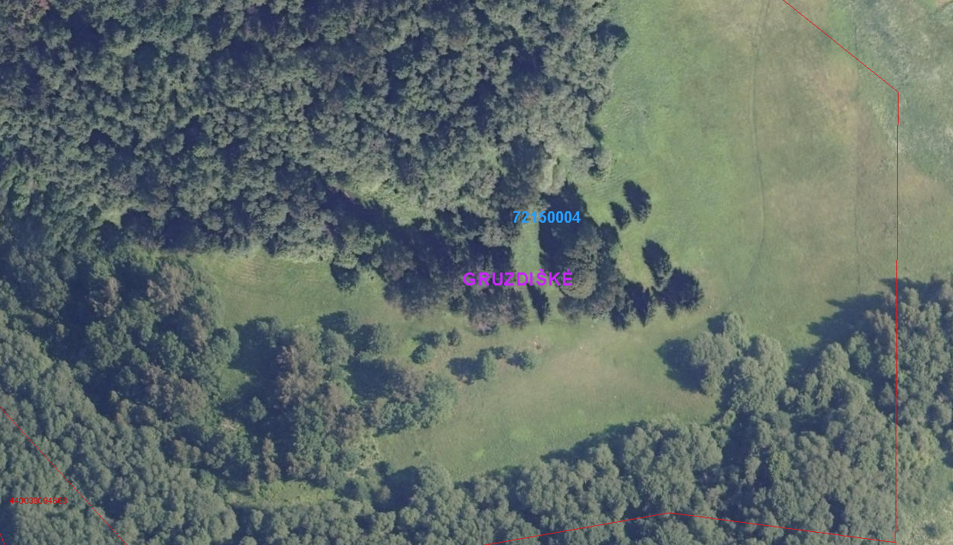
Laiptai su porankiu
Nuoroda: https://www.geoportal.lt/map/#s=3346&x=452055.54835467006&y=6140674.458765501&l=13&b=aerial-recent
