ANNEX 1
TO THE PROCUREMENT CONDITIONS
(LOT 1)

TECHNICAL SPECIFICATION
UNIVERSAL JACKET (5-LAYER FIELD UNIFORM)

CHAPTER I
GENERAL PROVISIONS
- Universal jackets (5-layer field uniforms) (hereinafter referred to as jackets) are designed to be worn in spring and autumn.
- Jackets must comply with the requirements specified in this technical specification.
- The warranty period for jackets is at least 12 months under active use conditions, calculated from the date of delivery of the goods from the Buyer’s warehouse, and 24 months from the date of signing the documents for acceptance of the goods into the warehouse.
CHAPTER II
TECHNICAL REQUIREMENTS
- The design of jackets must comply with LST EN ISO 8559-1 (ISO 8559-1) or an equivalent standard. Jackets must be designed and sewn in such a way as to provide protection from precipitation, wind, and cold, ensure a proper fit to the soldier's body, and restrict the soldier's movements as little as possible.
- Jackets are tailored for men.
- The sizes of jackets required by soldiers are presented in Table 1, compiled in accordance with the size system adopted by the Lithuanian Armed Forces. If necessary, non-standard sizes of jackets may be requested, not exceeding 2% of the quantity ordered.
Table 1
TABEL OF JACKET SIZES
Height, cm | Chest circumference, cm
Height, cm | 84 | 88-92 | 96-100 | 104-108 | 112-116 | 120-124
158 | x | x | x
164-170 | x | x | x | x | x
176-182 | x | x | x | x | x | x
188-194 |  | x | x | x | x | x
200-206 |  |  | x | x | x | x

- Sketches of the jacket model are provided in sketches 1-4 of the appendix to the technical specifications (hereinafter referred to as the 'Annex').
- The description and sketches provide measurements in centimeters for the basic size of the jacket: height – 188-194 cm, chest circumference – 96-100 cm, waist circumference – 84-88 cm.
- The basic dimensions and permissible deviations for jackets are given in Table 2.
Table 2
TABLE OF BASIC JACKET SIZE DIMENSIONS

No. | Measurement location and dimension | Measurement size, cm | Permissible deviations, cm
1. | Back length | 83,5 | ±1
2. | Width under the armpits, ½ | 65 | ±1
3. | Bottom width ½ | 60 | ±1
4. | Shoulder length | 17 | ±0,5
5. | Sleeve length | 68 | ±1,0
6. | Sleeve width (at widest point), ½ | 25,5 | ±1,0
7. | Sleeve bottom width ½ | 16 | ±0,5
8. | Collar height | 11 | ±0,5
9. | Collar length (measured at the seam where it is sewn into the front) | 59,5 | ±1,0
10. | Hood height | 37,5 | ±1,0
11. | Hood width ½ | 26 | ±1,0
12. | Side pocket length | 29 | ±1,0
13. | Inner pocket length | 18 | ±0,5
14. | Length of upper pocket on sleeve | 19,5 | ±0,5
15. | Length of lower sleeve pocket | 15 | ±0,5
16. | Length of the armpit fastening opening | 19,5 | ±0,5

- Unless otherwise specified in Table 2 and in the technical specifications, a tolerance of 4 % of the specified dimensions is permitted for dimensions up to and including 10 cm, and a tolerance of 2 % of the specified dimensions is permitted for dimensions exceeding 10 cm.
- The seams of the jacket must be hemmed according to the sketches in the Annex. When performing single finishing hems (unless otherwise specified in the requirements below), the hem is sewn 0.5-0.6 cm from the seam. The density of the finishing stitches is 3.5-4 stitches/cm.
- The type of sewing thread, the thickness of the stitches, and the density of the stitches must ensure the strength of the seam. All seam ends must be secured.
- The seams must be selected in such a way as to ensure the proper strength and quality of the product's seams during use. If necessary, the product's seams must be reinforced with additional rivets and/or by spraying them with special machines.
- In order to ensure that individual fibers of the insulation material do not penetrate through the top or lining of the jacket during use, the insulation material (before it is attached to the lining or joined to other parts of the jacket) may be protected on both sides by by placing layers of non-woven material.
- The edges of all lining details sewn together with insulation material must be additionally reinforced by sewing the seams and/or spraying them with special machines.
- The jacket must be sewn to a high standard: no creases or distortions in the seams/stitches (the width of the seam/hem must be even along the entire length of the seam/stitch), no skipped, bunched, loose, or incorrectly tightened stitches, broken sewing threads, insufficient tightening of the material, fraying of seams/stitches due to missing or improperly made reinforcements, hem overlaps in visible areas, damage to the material by the sewing machine needle, etc.). All seam/stitch ends must be secured.
- Matching details on the jacket must be arranged symmetrically. Different shades of details on the jacket are not allowed.
- Jackets must be cleaned of any traces of the manufacturing process (threads, fluff, markings, etc.), free of stains, and neatly packaged.
SECTION ONE
REQUIREMENTS FOR MATERIALS
- The top layer (hereinafter referred to as the base fabric) is a waterproof, breathable polyamide fabric coated on the inside with a PTFE-based (or equivalent) bicomponent membrane.
- The base fabric is printed with a patented hidden (universal) pattern (see Appendix
- 5 sketch), the colors of which, according to the PANTONE TEXTILE color catalog, are close to the following color codes and, according to the pattern, consist of:
- gray-green (base) color – 13-0607 TP ̴ 15% of the area,
- green color – 17-0115 TP ̴ 30% of the area,
- brown color – 17-1417 TP ̴ 25% of the area,
- straw color – 17-1022 TP ̴ 20% of the area,
- chaki color – 16-0730 TP ̴ 10% of the area.
- After signing the sale and purchase contract, the winning supplier will be provided with a sample of the fabric design with a full design report and a computer (working) file with an image of the fabric printed with the hidden design.
- “The base fabric must comply with the minimum environmental protection criteria set out in Section IX ‘Textile Products’ of Annex 2 to the ‘Description of the Procedure for Applying Environmental Protection Criteria in the Implementation of Green Public Procurement’, approved by Order No. D1-508 of 28 June 2011 of the Minister of Environment of the Republic of Lithuania.
- The base fabric must comply with the technical characteristics specified in Table 3.
Table 3
TECHNICAL CHARACTERISTICS OF THE BASE FABRIC

No. | Indicator name, dimension | Indicator value | Test method code
1. | Fiber composition, % | top layer: 100 PA;  bottom layer: 100 PTFE (or equivalent) | specify
2. | Surface density, g/m² | 105 (+20; -10) | LST ISO 3801 (ISO 3801);  LST EN 12127 (EN 12127), or equivalent
3. | Breaking force, N  warp direction  weft direction | ≥ 750  ≥ 500 | LST EN ISO 1421 (ISO 1421), method 1 or equivalent
4. | Tear strength, N  warp direction  weft direction | ≥ 40  ≥ 40 | LST EN ISO 4674-1 (ISO 4674-1) method A or equivalent
5. | Resistance to crushing at a nominal pressure of 12 kPa, pumps | ≥ 100 000 | LST EN ISO 12947-2 (ISO 12947-2) or equivalent
6. | Steam resistance Ret, m²Pa/W | ≤ 5 | LST EN ISO 11092 (ISO 11092) or equivalent
7. | Resistance to surface wetting, class | ≥ 4 | LST EN ISO 4920 (ISO 4920) or equivalent
8. | Resistance to water penetration at a water pressure increase rate of 60 ± 3 cm/min, cm  new  after 5 washes | ≥ 1000  ≥ 800 | LST EN ISO 811 (ISO 811) or equivalent  Washing and drying procedures according to LST EN ISO 6330 (ISO 6330): washing procedure – 4G, drying method – F
9. | Air permeability at 100 Pa pressure, mm/s | ≤ 5 | LST EN ISO 9237 (ISO 9237) arba lygiavertis
10. | Change in dimensions after washing, %  warp direction  weft direction | no more ± 4  no more ± 4 | LST EN ISO 5077 (ISO 5077) or equivalent  Washing and drying procedures according to LST EN ISO 6330 (ISO 6330): washing procedure – 4G, drying method – F
11. | Stain resistance, points
11.1. | to washing at 40º | ≥ 4 | LST EN ISO 105-C06 (ISO 105-C06), method A1S or equivalent
11.2. | to water | ≥ 4 | LST EN ISO 105-E01 (ISO 105-E01) or equivalent
11.3. | to sweat | ≥ 4 | LST EN ISO 105-E04 (ISO 105-E04) or equivalent
11.4. | to dry abrasion | ≥ 4 | LST EN ISO 105-X12,-X16  (ISO 105-X12,-X16) or equivalent
11.5. | to wet abrasion | ≥ 3 | LST EN ISO 105-X12,-X16  (ISO 105-X12,-X16) or equivalent
11.6. | to artificial light | ≥ 4 | LST EN ISO 105-B02 (ISO 105-B02) or equivalent
12. | Dominant spectral reflectance coefficient in the near IR radiation spectrum range 750-1100 nm, % | gray-green (base) color: 60 – 70  green color: 40 – 50  straw color: 35 – 45  chaki color: 35 – 50  brown color: 20 – 30 | specify
13. | Weaving | fabric, ripstop base* | specify
14. | Number of threads per centimeter  warp direction  weft direction | ≥ 40  ≥ 25 | LST EN ISO 7211-2 (ISO 7211-2) or equivalent
15. | Color difference **, Δ E_{CMC} | ≤ 2 | LST EN ISO 105-J03 (ISO 105-J03) or equivalent
Notes:
* Weaving with warp and weft threads in the direction of the warp and weft.
** Indicator 15, “Color difference,” is required during the performance of the contract and establishes the permissible color deviation from the sample held by the Lithuanian Armed Forces.

- Protective fabric – fabric in the color of the base fabric, plain weave, impregnated with silicone (or equivalent) polyamide fabric, meeting the technical characteristics specified in Table 4.
- The protective fabric must have the same infrared reflection properties as the main fabric.
Table 4
TECHNICAL CHARACTERISTICS OF PROTECTIVE FABRIC

No. | Indicator name, dimension | Indicator value | Test method code
1. | Fiber composition, % | 100 PA | specify
2. | Surface density, g/m² | 140 (+20; -10) | LST ISO 3801 (ISO 3801);  LST EN 12127 (EN 12127) or equivalent
3. | Maximum force, N  warp direction  weft direction | ≥ 1300  ≥ 900 | LST EN ISO 13934-1 (ISO 13934-1) or equivalent
4. | Breaking strength, N  warp direction  weft direction | ≥ 90  ≥ 90 | LST EN ISO 13937-2 (ISO 13937-2) or equivalent
5. | Resistance to crushing at a nominal pressure of 12 kPa, pumps | ≥ 200 000 | LST EN ISO 12947-2 (ISO 12947-2) or equivalent
6. | Resistance to surface wetting, class  new  after 5 washes | ≥ 4  ≥ 3 | LST EN ISO 4920 (ISO 4920) or equivalent  Washing and drying procedures according to LST EN ISO 6330 (ISO 6330): washing procedure – 4G, drying method – F
7. | Resistance to water penetration at a water pressure increase rate of 60 ± 3 cm/min, cm  new  after 5 washes | ≥ 60  ≥ 50 | LST EN ISO 811 (ISO 811) or equivalent  Washing and drying procedures according to LST EN ISO 6330 (ISO 6330): washing procedure – 4G, drying method – F
8. | Change in dimensions after washing, %  warp direction  weft direction | no more ± 4  no more ± 4 | LST EN ISO 5077 (ISO 5077) or equivalent  Washing and drying procedures according to LST EN ISO 6330 (ISO 6330): washing procedure – 4G, drying method – F
9. | Stain resistance, points
9.1. | to washing at 40º | ≥ 4 | LST EN ISO 105-C06 (ISO 105-C06) A1S metodas arba lygiavertis
9.2. | to water | ≥ 4 | LST EN ISO 105-E01 (ISO 105-E01) arba lygiavertis
9.3. | to dry abrasion | ≥ 4 | LST EN ISO 105-X12,-X16  (ISO 105-X12,-X16) arba lygiavertis
9.4. | to wet abrasion | ≥ 3 | LST EN ISO 105-X12,-X16  (ISO 105-X12,-X16) arba lygiavertis
9.5. | to artificial light | ≥ 4 | LST EN ISO 105-B02 (ISO 105-B02) arba lygiavertis
10. | Weaving | plain weave | specify
11. | Number of threads per centimeter  warp direction  weft direction | ≥ 35  ≥ 25 | LST EN ISO 7211-2 (ISO 7211-2) arba lygiavertis
12. | Color difference *, Δ E_{CMC} | ≤ 2 | LST EN ISO 105-J03 (ISO 105-J03) arba lygiavertis
Note:
* Indicator 12, “Color difference,” is required during contract performance and determines the permissible color deviation from the agreed working sample.

- The lining is a polyamide fabric in a color close to code 18-0617 TP (Covert green) according to the PANTONE TEXTILE color catalog, meeting the technical characteristics specified in Table 5.
- The lining must comply with the minimum environmental protection criteria set out in Section IX ‘Textile Products’ of Annex 2 to the ‘Description of the Procedure for Applying Environmental Protection Criteria in the Implementation of Green Public Procurement’, approved by Order No. D1-508 of 28 June 2011 of the Minister of Environment of the Republic of Lithuania.
Table 5
TECHNICAL CHARACTERISTICS OF THE LINING

No. | Indicator name, dimension | Indicator value | Test method code
1. | Fiber composition, % | 100 PA | specify
2. | Surface density, g/m² | 45 ± 10 | LST ISO 3801 (ISO 3801);  LST EN 12127 (EN 12127) or equivalent
3. | Maximum force, N  warp direction  weft direction | ≥ 600  ≥ 350 | LST EN ISO 13934-1 (ISO 13934-1) or equivalent
4. | Breaking strength, N  warp direction  weft direction | ≥ 20  ≥ 20 | LST EN ISO 13937-2 (ISO 13937-2) or equivalent
5. | Resistance to crushing at a nominal pressure of 12 kPa, revolutions | ≥ 100 000 | LST EN ISO 12947-2 (ISO 12947-2) or equivalent
6. | Air permeability at 100 Pa pressure, mm/s | ≥ 80 | LST EN ISO 9237 (ISO 9237) or equivalent
7. | Change in dimensions after washing, %  warp direction  weft direction | no more ± 4  no more ± 4 | LST EN ISO 5077 (ISO 5077) or equivalent  Washing and drying procedures according to LST EN ISO 6330 (ISO 6330): washing procedure – 4G, drying method – F
8. | Stain resistance, points
8.1. | to washing at 40º | ≥ 4 | LST EN ISO 105-C06 (ISO 105-C06) method A1S or equivalent
8.2. | to dry abrasion | ≥ 4 | LST EN ISO 105-X12,-X16  (ISO 105-X12,-X16) or equivalent
8.3. | to wet abrasion | ≥ 3 | LST EN ISO 105-X12,-X16  (ISO 105-X12,-X16) or equivalent
9. | Weaving | plain, ripstop* | specify
10. | Number of threads per centimeter  warp direction  weft direction | ≥ 55  ≥ 25 | LST EN ISO 7211-2 (ISO 7211-2) or equivalent
11. | Color difference **, Δ E_{CMC} | ≤ 2 | LST EN ISO 105-J03 (ISO 105-J03) or equivalent
Notes:
* Weaving with warp and weft threads in the direction of the warp and weft.
** Indicator 11, “Color difference,” is required during contract performance and determines the permissible color deviation from the agreed working sample.

- The insulation material must comply with the technical characteristics specified in Table 6.
- The method of reinforcing the insulation material fiber must ensure that the insulation material retains its thermal properties during operation and that individual fibers do not penetrate through other materials to the outside.
Table 6
TECHNICAL CHARACTERISTICS OF INSULATION MATERIAL

No. | Indicator name, dimension | Indicator value | Test method code
1. | Fiber composition *, % | Polyester 55 ± 5  Polyamide 25 ± 5  Polyethylene 20 ± 5 | specify
2. | Surface density, g/m² | 110 ± 15 | LST EN ISO 9073-1 (ISO 9073-1) or equivalent
3. | Thickness, mm | 10 ± 2 | LST EN ISO 9073-2 (ISO 9073-2) or equivalent
4. | Air permeability (at a pressure difference of 200 Pa, 20 cm² opening), mm/s | ≥ 1000 | LST EN ISO 9237 (ISO 9237) or equivalent
5. | Thermal resistance, m²K/W | ≥ 0,30 | LST EN ISO 11092 (ISO 11092) or equivalent
6. | Change in dimensions after washing, %  longitudinal  crosswise | no more ± 4  no more ± 4 | LST EN ISO 5077 (ISO 5077) or equivalent  Washing and drying procedures according to LST EN ISO 6330 (ISO 6330): washing procedure – 4G, drying method – F
Note:
* Other types of fiber insulation materials may be used, provided that they meet the technical characteristics of insulation materials specified in the table.

- Brushed knit – polyester, in a colour close to code 18-0617 TP (‘Covert Green’) according to the PANTONE TEXTILE colour catalogue, resistant to pilling, complying with the technical characteristics set out in Table 7.

Table 7
TECHNICAL CHARACTERISTICS OF THE BRUSHED KNIT
No. | Indicator name, dimension | Indicator value | Test method code
1. | Fiber composition, % | 100 PES | specify
2. | Surface density, g/m² | 190 ± 10 | LST ISO 3801 (ISO 3801);  LST EN 12127 (EN 12127 or equivalent)
3. | Fabric tendency (at 2000 rpm), degree of  pilling  fuzzing  felting | ≥ 3  ≥ 3  ≥ 3 | LST EN ISO 12945-2 (ISO 12945-2) or equivalent
4. | Change in dimensions after washing, %  longitudinal  crosswise | no more ± 4  no more ± 4 | LST EN ISO 5077 (ISO 5077) or equivalent  Washing and drying procedures according to LST EN ISO 6330 (ISO 6330): washing procedure – 4G, drying method – F
5. | Stain resistance, points
5.1. | to washing at 40º | ≥ 4 | LST EN ISO 105-C06 (ISO 105-C06), method A1S or equivalent
5.2. | to dry abrasion | ≥ 4 | LST EN ISO 105-X12,-X16  (ISO 105-X12,-X16) or equivalent
5.3. | to wet abrasion | ≥ 3 | LST EN ISO 105-X12,-X16  (ISO 105-X12,-X16) or equivalent
6. | Color difference *, Δ E_{CMC} | < 2 | LST EN ISO 105-J03 (ISO 105-J03) or equivalent
Note:
* Indicator 6, “Color difference,” is required during contract execution and determines the permissible color deviation from the agreed working sample.

- Mesh – polyester, close to color code 18-0617 TP (Covert Green) according to the PANTONE TEXTILE catalog, openwork knit fabric, meeting the technical characteristics specified in Table 8.
Table 8
Technical characteristics of the mesh
No. | Indicator name, dimension | Indicator value | Test method code
1. | Fiber composition, % | 100 PES | specify
2. | Surface density, g/m² | 85 ± 5 | LST ISO 3801 (ISO 3801);  LST EN 12127 (EN 12127) or equivalent
3. | Maximum force, N  warp direction  weft direction | ≥ 200  ≥ 200 | LST EN ISO 13934-1 (ISO 13934-1) or equivalent
4. | Stain resistance, points
4.1. | to washing at 40º | ≥ 4 | LST EN ISO 105-C06 (ISO 105-C06), method A1S or equivalent
4.2. | to dry abrasion | ≥ 4 | LST EN ISO 105-X12,-X16  (ISO 105-X12,-X16) or equivalent
4.3. | to wet abrasion | ≥ 3 | LST EN ISO 105-X12,-X16  (ISO 105-X12,-X16) or equivalent
5. | Color difference *, Δ E_{CMC} | ≤ 2 | LST EN ISO 105-J03 (ISO 105-J03) or equivalent
Note:
* Indicator 5, “Color difference,” is required during contract execution and determines the permissible color deviation from the agreed working sample.

- Knitted fabric – close to color code 18-0617 TP (Covert green) according to the PANTONE TEXTILE color catalog, corresponding to the technical characteristics presented in Table 9.

Table 9
TECHNICAL CHARACTERISTICS OF KNITTED FABRIC
No. | Indicator name, dimension | Indicator value | Test method code
1. | Fiber composition, % | Polyester 90 ± 5  Elastane 10 ± 5 | specify
2. | Surface density, g/m² | 220 ± 20 | LST ISO 3801 (ISO 3801);  LST EN 12127 (EN 12127) or equivalent
3. | Maximum force, N  warp direction  weft direction | ≥ 300  ≥ 300 | LST EN ISO 13934-1 (ISO 13934-1) or equivalent
4. | Extension (S), %  longitudinal  crosswise | ≥ 70  ≥ 100 | LST EN ISO 20932-1 (ISO 20932-1), method A or equivalent
5. | Reversible deformation (D) after 30 min relaxation, %  longitudinal  crosswise | ≥ 85  ≥ 90 | LST EN ISO 20932-1 (ISO 20932-1), method A or equivalent
6. | Change in dimensions after washing, %  longitudinal  crosswise | no more ± 4  no more ± 4 | LST EN ISO 5077 (ISO 5077) or equivalent  Washing and drying procedures according to LST EN ISO 6330 (ISO 6330): washing procedure – 4G, drying method – F
7. | Stain resistance, points
7.1. | to washing at 40º | ≥ 4 | LST EN ISO 105-C06 (ISO 105-C06) method A1S or equivalent
7.2. | to water | ≥ 4 | LST EN ISO 105-E01 (ISO 105-E01) or equivalent
7.3. | to dry abrasion | ≥ 4 | LST EN ISO 105-X12,-X16  (ISO 105-X12,-X16) or equivalent
7.4. | to wet abrasion | ≥ 3 | LST EN ISO 105-X12,-X16  (ISO 105-X12,-X16) or equivalent
7.5. | to artificial light | ≥ 4 | LST EN ISO 105-B02 (ISO 105-B02) or equivalent
8. | Color difference *, Δ E_{CMC} | ≤ 2 | LST EN ISO 105-J03 (ISO 105-J03) or equivalent
Note:
* Indicator 8, “Color difference,” is required during contract execution and determines the permissible color deviation from the agreed working sample.

- Fabric for the jacket pouch – waterproof, polyamide fabric in a colour close to code 18-0617 TP (‘Covert Green’) according to the PANTONE TEXTILE colour catalogue, with a water-repellent coating on the inner side, complying with the technical characteristics set out in Table 10.

Table 10
TECHNICAL CHARACTERISTICS OF THE FABRIC USED FOR THE JACKET POUCH

No. | Indicator name, dimension | Indicator value | Test method code
1. | Fiber composition, % | top layer 100 PA  bottom layer 100 PU | specify
2. | Surface density, g/m² | 100 ± 15 | LST ISO 3801 (ISO 3801);  LST EN 12127 (EN 12127) or equivalent
3. | Maximum force, N  warp direction  weft direction | ≥ 700  ≥ 500 | LST EN ISO 13934-1 (ISO 13934-1) or equivalent
4. | Breaking strength, N  warp direction  weft direction | ≥ 15  ≥ 15 | LST EN ISO 13937-2 (ISO 13937-2) or equivalent
5. | Resistance to water penetration at a water pressure increase rate of 60 ± 3 cm/min, cm | ≥ 800 | LST EN ISO 811 (ISO 811) or equivalent
6. | Change in dimensions after washing, %  warp direction  weft direction | no more ± 2,5  no more ± 2,5 | LST EN ISO 5077 (ISO 5077) or equivalentv  Washing and drying procedures according to LST EN ISO 6330 (ISO 6330): washing procedure – 4G, drying method – F
7. | Stain resistance, points
7.1. | to washing at 40º | ≥ 4 | LST EN ISO 105-C06 (ISO 105-C06) method A1S or equivalent
7.2. | to water | ≥ 4 | LST EN ISO 105-E01 (ISO 105-E01) or equivalent
7.3. | to dry abrasion | ≥ 4 | LST EN ISO 105-X12,-X16  (ISO 105-X12,-X16) or equivalent
7.4. | to wet abrasion | ≥ 3 | LST EN ISO 105-X12,-X16  (ISO 105-X12,-X16) or equivalent
8. | Color difference *, Δ E_{CMC} | ≤ 2 | LST EN ISO 105-J03 (ISO 105-J03) or equivalent
Note:
* Indicator 8, “Color difference,” is required during contract performance and determines the permissible color deviation from the agreed working sample.

- Hook-and-loop fasteners – in a colour close to code 18-0617 TP (‘Covert Green’) according to the PANTONE TEXTILE colour catalogue, complying with the technical characteristics set out in Table 11. The hook-and-loop fasteners must have infrared reflection properties. All cut edges of the hook-and-loop fasteners must be treated to prevent fraying.

Table 11
TECHNICAL CHARACTERISTICS OF HOOK-AND-LOOP FASTENERS
No. | Indicator name, dimension | Indicator value | Test method code
1. | Separating force, N/cm | ≥ 1,3 | LST EN 12242 (EN 12242) or equivalent
2. | Separating force after 10,000 opening-closing cycles, N/cm | ≥ 0,65 | LST EN 12242 (EN 12242) or equivalent
3. | Shear force, N/cm² | ≥ 6 | LST EN 13780 (EN 13780) or equivalent
4. | Shear force after 10,000 opening-closing cycles, N/cm² | ≥ 4 | LST EN 13780 (EN 13780) or equivalent
5. | Dimension change after washing*, % | no more ± 2 | LST EN ISO 5077 (ISO 5077) or equivalent
6. | Stain resistance, points
6.1. | to artificial light | ≥ 5 | LST EN ISO 105-B02 (ISO 105-B02) or equivalent
6.2. | to washing * | ≥ 4 | LST EN ISO 105-C06 (ISO 105-C06) or equivalent
6.3. | to dry abrasion | ≥ 4 | LST EN ISO 105-X12,-X16  (ISO 105-X12,-X16) or equivalent
6.4. | to wet abrasion | ≥ 3 | LST EN ISO 105-X12,-X16  (ISO 105-X12,-X16) or equivalent
Note.
* Washing must be carried out at a temperature of at least 40º C.

- Front closure zipper of the jacket – separating type, with spiral plastic teeth and two metal sliders. Zippers for attaching the jacket hood, jacket front pockets, sleeve pockets, and ventilation openings – with spiral plastic teeth and a single metal slider, ‘waterproof’. The hood attachment zipper must be of the separating type. The width of the zipper teeth track when closed – 0.6 (±0.05) cm. Zippers must comply with the technical characteristics set out in Table 12.
Table 12
TECHNICAL CHARACTERISTICS OF ZIPPERS
No. | Indicator name, dimension | Indicator value | Test method code
1. | Lock breaking strength, N | ≥ 400 | LST EN 16732 (EN 16732), Annex B or equivalent
2. | Braking force at top, N | ≥ 180 | LST EN 16732 (EN 16732), Annex D or equivalent
3. | Number of fastening/unfastening cycles without failure, cycles | ≥ 3 000 | LST EN 16732 (EN 16732), Annex F or equivalent
4. | Transverse strength of the tooth track, N | ≥ 600 | LST EN 16732 (EN 16732 Annex G or equivalent
5. | Transverse strength of the opening node, N | ≥ 150 | LST EN 16732 (EN 16732), Annex H or equivalent
6. | Lock strength, N | ≥ 100 | LST EN 16732 (EN 16732), Annex I or equivalent
7. | Stain resistance, points
7.1. | to washing* | ≥ 4 | LST EN ISO 105-C06 (ISO 105-C06) or equivalent
7.2. | to dry abrasion | ≥ 4 | LST EN ISO 105-X12,-X16 (ISO 105-X12,-X16) or equivalent
7.3. | to wet abrasion | ≥ 3 | LST EN ISO 105-X12,-X16 (ISO 105-X12,-X16) or equivalent
8. | Change in dimensions after washing *, % | < ± 2 | LST EN ISO 5077 (ISO 5077) or equivalent
Note:
* Washing must be carried out at a temperature of at least 40º C.

- Zippers – in a colour close to code 18-0617 TP (‘Covert Green’) according to the PANTONE TEXTILE colour catalogue. All zipper sliders (except for the jacket hood attachment and inner pocket zippers) must have zipper pulls of the same colour as the zipper, at least 6 cm long, to facilitate faster opening. The pull is formed by joining the ends of a tightly braided cord with a ‘textured’ surface piece, with a length of not less than 2 cm, a width of not less than 0.6 cm, and a thickness of not less than 0.4 cm.
- “All textile and elastic bands used in the jacket’s manufacture – in a colour close to code 18-0617 TP (‘Covert Green’) according to the PANTONE TEXTILE colour catalogue. Their widths must correspond to those specified in the product model description, the weaves must ensure their functionality (required stiffness or elasticity), and the edges/ends must be finished to prevent fraying.
- Elastic cord – in a colour close to code 18-0617 TP (‘Covert Green’) according to the PANTONE TEXTILE colour catalogue, with a diameter of 3 (±0.2) mm.
- Fastener clips – in a colour close to code 18-0617 TP (‘Covert Green’) according to the PANTONE TEXTILE colour catalogue, made of acetal or an equivalent material, with a steel (or equivalent material) spring inside. All fastener clips on the product must be attached through the two openings on the sides of the clip by threading a textile tape 0.7 (±0.1) cm wide, with the ends secured inside the product.
- Tips, toggles, and rings – in a colour close to code 18-0617 TP (‘Covert Green’) according to the PANTONE TEXTILE colour catalogue, made of acetal or an equivalent material. The tip must fully cover the end of the elastic cord.
- Eyelets and snaps – brass-coloured, matte, made of stainless (weather-resistant) metal. The inner diameter of the eyelets is 0.5–0.6 cm.
- Sewing/overlock threads – reinforced polyester or of equivalent or better quality, colourfast, matching the fabric colour. The colour of the overlock threads for the jacket’s base fabric components must be matched to the base fabric’s shade.
- The thickness of the sewing threads and the stitch density must ensure the seam strength.
- Textile materials used in the jacket’s manufacture must be of high quality and free of textile defects.
- All hardware used in the jacket’s construction must be of high quality (without any sharp edges), ensure the user’s safety (e.g., not pose a risk of snagging), and be durable during use (cord locks must not loosen on their own, tips must not detach from elastic cords, snaps must not open unintentionally, elastic cords must retain their elasticity, etc.).
- The colours of the materials used in the jacket’s manufacture are to be matched during the approval of the working sample.

SECTION TWO
REQUIREMENTS FOR THE JACKET MODEL
Requirements for jacket front fastenings
- The front of the jacket (along its entire length) fastens with a zipper.
- 49. On the right front side (on the inside, under the zipper), there is a 4 (±0.2) cm wide flap (widened to 5.5 (±0.2) cm at the bottom and narrowed to 3.5 (±0.2) cm at the top) covering the zipper lock at the top. narrowed to 3.5 (±0.2) cm at the top) is sewn onto the right front side (from the inside, under the zipper), covering the zipper pull at the top (sketches 1 and 4 in the Annex):
  - The upper and lower parts of the flap are cut from the main fabric;
  - The flap details must be fixed and ensure adequate flap rigidity during operation (must not interfere with the fastener opening/closing);
  - Insulation material sewn inside the flap;
  - The edge of the flap is trimmed with a single 0.2-0.3 cm wide flap;
  - A snap fastener is inserted in the lower widened part of the flap for attaching the flap to the left side of the jacket. Hidden snap fasteners (inserted only in the edge of the jacket) are inserted in the lower part of the edge.
Requirements for jacket collars
- The jacket collar is stiff – stand-up type.
- The outer part of the collar is cut from the main fabric, while the inner part is made of brushed knit fabric lined with insulation material.
- On the outer part of the collar (across its entire height), 2.5-3 cm from the front edge of the jacket, there are sewn-on “pockets” (see sketch 1 in the Annex):
  - A “pocket” formed from a folded piece of the main fabric, with the fold line trimmed with a single 0.2-0.3 cm wide trim;
  - The seam where the “pocket” is sewn onto the outer part of the collar is trimmed with a single 0.5-0.6 cm wide trim, hiding the edges of the pocket.
  - To fasten the edges of the cover, a rectangular piece of rough textile fastener (with hooks) measuring 2 (±0.1) x 7 (±0.2) cm is sewn onto the inside of each “pocket” (through one layer).
- A “pocket” is sewn into the bottom of the outer collar details to hide the zipper that attaches the hood to the jacket collar:
  - A “pocket” formed from a folded piece of the main fabric, measuring 2.5 (±0.1) x 36 (±1) cm;
  - The edges of the “pockets” are trimmed with a single 0.2-0.3 cm wide hem.
- The upper edge of the collar is trimmed with a 3 (±0.2) cm wide finishing strip, forming a tunnel for the elastic cord. The ends of the elastic cord (through pieces of lining fabric) are securely attached to the top edge of the collar at the seam.
- To adjust the length of the upper edge of the collar, two eyelets are inserted symmetrically (measured between the centers of the eyelets) 2 (±0.1) cm apart on the outer part of the collar (in the center of the back) using a fastener and elastic cord. The fastener and the location of the eyelets are covered by a flap sewn into the seam of the upper edge of the collar:
  - rectangular patch (with “cut” bottom corners), sewn from two pieces of main fabric;
  - Flap width – not less than 7 cm (measured at the widest point), flap height at the centre – not less than 4.5 cm (measured from the stitching line at the upper edge of the collar to the lower edge of the flap);
  - Flap edges overlocked with a single overlock stitch 0.2–0.3 cm wide;
  - Flap side corners (through all collar layers) are secured using a special reinforcement machine (sketch 4 in the Annex).
- The seams attaching the collar to the front yoke are reinforced together (sections up to 9 cm long, measured from the jacket front edge, may remain unreinforced).

Requirements for jacket hood
- The upper edge of the jacket hood with a widening forming an arc-shaped “flap” (sketch 3 in the Annex).
- The hood design provides for double volume adjustment, allowing the soldier to set it in the correct position and ensuring that the hood remains in the same position when the soldier performs different movements (turning his head, raising his arms, etc.) and protects the interior of the hood from precipitation (sketches 1-3 in the Annex)
  - The width of the hood is adjustable with a fastener and an elastic cord, which forms a 3.3 (±0.2) cm wide “tunnel” in the hood, widening at the top of the hood into a 4 (±0.2) cm wide “flap”:
    - A “tunnel” is formed by sewing a strip of the main fabric to the inside of the hood (only to the upper part of the hood, leaving the lining of the hood free) (at the same time, the front edges of the hood are reinforced);
    - The elastic cord is threaded through the two eyelets on the back of the hood and pulled out to the outside of the hood, forming a loop, onto which a fastener and a plastic ring are placed to prevent the elastic cord loop from slipping out of the fastener.
    - To prevent water from entering the hood, the middle part of the hood is elongated, with a flap formed in the back part to cover the eyelets with a fastener. The flap is attached to the hood with a rectangular hook-and-loop fastener measuring 2 (±0.1) × 9 (±0.3) cm: the soft side of the hook-and-loop fastener (with loops) is sewn to the flap, and the rough side of the hook-and-loop fastener (with hooks) is sewn to the hood.
  - The hood size is adjustable with 2 fasteners and 2 elastic cords running along the front edges of the hood (from the bottom of the hood “tunnel” to the bottom):
    - The location of the elastic cords is formed by reinforcing all layers of the hood with stitching (stitching is applied through the stitching of the hood lining, from the bottom stitching of the hood "tunnel" to the bottom of the hood).
    - The elastic cords are pulled out through the eyelets in the upper part of the hood and threaded through the other two eyelets, which are inserted through all layers of the hood.
    - Place the end caps on the free ends of the elastic cord.
- The hood is sewn with a lining made of lining fabric, quilted with insulation material in parallel stitches, 7-10 cm apart. The lining is attached to the top of the hood in two places (attached at the top of the head, through pieces of lining).
- The edges of the lining of the hood are reinforced by sewing two facings cut from the main fabric onto them: one facing is sewn onto the bottom of the lining of the hood, the other onto the front edges and top of the lining of the hood.
- To reinforce the flap of the hood, sew the edge of the hood to the lining, and sew protective fabric and non-woven material details into the upper part of the hood (where the flap is located). The flap of the hood is reinforced with a flap sewn through all layers of the hood (the tape is sewn across the width of the middle part of the hood).
- The hood is attached to/detached from the jacket collar:
  - 31 (±1) cm long zipper, sewn into the bottom seam of the hood;
  - two rectangular 2 (±0.1) x7 (±0.2) cm soft-sided textile fasteners (with loops) sewn onto the upper parts of the hood (sewn only onto the upper parts of the hood, the hood lining remains free), designed to fasten the hood into the “pockets” of the jacket collar .
- The ends of all elastic cords (through pieces of lining fabric) must be securely attached to the front edges of the hood.
- All fasteners on the hood must be secured with 0.7 (±0.1) cm wide textile straps, both ends of which are threaded through a single eyelet (together with an elastic cord) into the inside of the hood and secured there.
- The edges of the ridge are trimmed with a single 0.2-0.3 cm wide trim.
Requirements for the shoulder area and back of the jacket
- The shoulder pad detail sewn onto the jacket shoulder area (on top) must be cut from a single piece of protective fabric (sketches 1 and 2 in the Annex).
- The back of the jacket has sewn-on sides, the seams of which are trimmed with single 0.5-0.6 cm wide finishing strips.
- The side seams of the jacket are trimmed with single 0.2-0.3 cm wide trims (trimmed along the sides of the back).
Requirements for the front pieces of the jacket
- Each front panel of the jacket has a rectangular pocket measuring 2 (±0.1) x 29 (±1.0) cm with a zipper closure:
  - the zipper must be completely covered by the edges of the pocket, which are sewn with piping/frames formed from semi-folded pieces of the main fabric. For easier opening/closing of the zipper, the fold line of the main fabric piece is reinforced with a single 0.3-0.4 cm wide seam, with a cord sewn inside to ensure the proper stiffness of the edge of the piping/trim during use (it must not interfere with the opening/closing of the zipper).
  - A “pocket” sewn onto the upper edge of the pocket, formed from a semi-folded piece of protective fabric. The length of the “pocket” must be such that it completely conceals the clasp of the fastened zipper.
  - The edges of the pockets are trimmed with a single 0.1-0.2 cm wide trim;
  - The bottom edge of the pocket is reinforced by means of a special machine (across the entire width of the pocket).
  - Pocket bags cut from “insulated” special-purpose pocket fabric (it is permissible to use a rough knit if the proper quality of the product during use is ensured):
    - A pocket flap sewn onto the bottom pocket bag, cut from the main fabric. The height of the pocket flap must be at least 5.5 cm, measured from the pocket seam to the seam where the pocket flap is sewn onto the pocket bag. The seam where the pocket flap is attached to the pocket bag is topstitched with a single 0.2-0.3 cm wide topstitch (topstitched through the pocket flap).
    - The height of the pocket bag must be at least 36 cm, and the width must extend to the front edge of the jacket. For ease of use, the pocket bag must be attached to the front edge of the jacket with two pieces of lining fabric.
- For attaching the rank insignia, a rectangular piece of soft fabric measuring 5.0 (±0.2) × 9.0 (±0.2) cm (with loops) is sewn onto the right front panel of the jacket at chest height.
Requirements for jacket sleeves
- For distinctive markings, a rectangular piece of soft fabric (with loops) measuring 10 (±0.5) x 14 (±0.5) cm is sewn onto the upper part of each sleeve. The details of the hook-and-loop fastener are additionally reinforced with cross-stitching.
- There are two pockets (upper and lower) sewn into the front seam of the left sleeve of the jacket, and one upper pocket sewn into the front seam of the right sleeve. All pockets are inset, rectangular in shape, and fastened with zippers:
  - upper pockets measuring 2 (±0.1) x 19.5 (±0.5) cm, lower pocket –
2 (±0,1) x 15 (±0,5) cm size;
  - The zipper must be completely covered by the edges of the pocket, which are sewn with piping/frames formed from semi-folded pieces of the main fabric. For easier opening/closing of the zipper, the fold line of the main fabric piece is reinforced with a single 0.3-0.4 cm wide seam, with a cord sewn inside to ensure the proper stiffness of the edge of the piping/trim during use (it must not interfere with the opening/closing of the zipper).
  - A “pocket” sewn onto the upper edge of the pocket, formed from a semi-folded piece of protective fabric. The length of the “pocket” must be such that it completely conceals the clasp of the fastened zipper.
  - Inside the pockets (0.5-1 cm from the edge of the pocket), sew in a 2.5-3 cm high loop made of elastic cord (the ends of the elastic cord must be securely attached to the front seam of the sleeve).
  - Inside the right sleeve pocket, immediately below the elastic cord loop, four 2.5-3 cm wide loops are formed by sewing on a 2 (±0.1) cm wide elastic band:
    - one end of the elastic band is securely sewn to the front seam of the sleeve, the other end is folded over 1 cm and sewn to the bottom of the pocket bag with a 0.2-0.3 cm wide hem;
    - loops formed by attaching an elastic band to the bottom pocket bag (sewn across the entire width of the elastic band);
  - The edges of the pockets are trimmed with a single 0.1-0.2 cm wide trim;
  - The bottom edge of the pocket is reinforced by means of a special machine (across the entire width of the pocket).
  - Pocket bags cut from the lining:
    - A pocket flap sewn onto the bottom pocket bag, cut from the main fabric. The height of the pocket flap must be at least 3.5 cm, measured from the pocket seam to the seam where the pocket flap is sewn onto the pocket bag. The seam where the pocket flap is attached to the pocket bag is topstitched with a single 0.1-0.2 cm wide topstitch (topstitched through the pocket flap).
    - The width of the upper pocket bags shall be at least 13 cm, and that of the lower pockets shall be at least 11 cm (measured from the front seam of the sleeve to the seam of the pocket bag).
    - For ease of use, pocket bags and lining fabric details must be attached to the jacket sleeve “elbow area” detail seam.
- To protect the soldier's hands in the elbow area, the details of the sleeve "elbow area" are doubled: the lower detail is cut from the main fabric, the upper detail - from the protective fabric. To ensure freedom of movement for the soldier in the elbow area, the elbow area details (both upper and lower) are sewn with inserts (sketch 2 in Annex):
  - upper seams 9-10 cm long;
  - underarm seams 10.5-11.5 cm long;
  - The seams should be finished with a single 0.1-0.2 cm wide hem..
- The lower part of the sleeve is widened by sewing a triangular gusset cut from the main fabric into its lower part (sketch 2 in the Annex) The gusset seams are finished with a single 0.2-0.3 cm wide hem.
- To adjust the width of the sleeve at the bottom, sew the sleeve insert to the sleeve "elbow area" piece, and sew in the drawstring at the same time (sketches 1 and 2 in the Annex)
  - the cover is sewn from two pieces (the upper part is cut from protective fabric, the lower part from the main fabric);
  - non-woven material inside to soften the cover and maintain its shape;
  - The edges of the cover shall be trimmed with a single 0.2-0.3 cm wide trim.;
  - A rectangular textile fastener is attached to the sleeve cuff.:
    - A 2 (±0.1) × 7.5 (±0.3) cm piece of rough-textured fastening material (with hooks) shall be sewn onto the back of the jacket.
    - The soft side of a 2 (±0.1) x 14 (±0.5) cm hook-and-loop fastener (with loops) is sewn onto the sleeve.
- The bottom of the jacket sleeves (on the inside) is sewn with the main fabric trim details (cuffs and inserts), with the placket sewn in at the same time:
  - The sleeve hem detail is sewn with insulation material, while the insert hem detail is without insulation material. The seams connecting the sleeve hem and insert hem details are topstitched with a single 0.2-0.3 cm wide stitch (trimmed through the sleeve trim);
  - A 0.5 (±0.1) cm wide, 22.5 (±0.5) cm long strip sewn into the bottom of the sleeves, formed from a folded piece of protective fabric, designed to protect the bottom of the sleeves from abrasion;
  - The bottom of the handles is trimmed with a single 0.2-0.3 cm wide trim.;
  - The sleeve hem detail is reinforced with an additional 4.5-5 cm wide hem, measured from the bottom of the sleeve (no hem is made through the sleeve opening).
  - A 1 (±0.2) cm deep and 5 (±0.5) cm long seam sewn into the sleeve, reducing the circumference of the sleeve only at the bottom and ensuring proper overlap of the seam when adjusting the circumference of the sleeve.
- When sewing the jacket sleeve lining to the sleeve cuffs, sew in double cuffs made of knitted fabric (the cuff length must be at least 7 cm), which fit snugly around the wrist (pressing it well).
- For ventilation, rectangular openings measuring 2 (±0.1) x 19.5 (±0.5) cm are formed in the lower seam of the sleeves and in the armpit areas, fastened with zippers:
  - The zipper must be completely covered by the edges of the opening, sewn with piping/frames formed from semi-folded pieces of the main fabric. For easier opening/closing of the zipper, the fold line of the main fabric piece is hemmed with a single 0.3-0.4 cm wide hem, with a cord sewn inside to ensure the proper stiffness of the edge of the flap/frame during use (it must not interfere with the opening/closing of the zipper);
  - A “pocket” sewn into the upper edge (closer to the armpit) of the opening, formed from a semi-folded piece of protective fabric. The length of the "pocket" must be such that it completely conceals the clasp of the fastened zipper.
  - the edges of the opening (together with the sewn-in jacket lining) are trimmed with a single 0.2-0.3 cm wide trim;
  - The bottom edge of the opening is reinforced by means of a special machine (across the entire width of the opening).
- The seams of the sleeves are trimmed with single 0.2-0.3 cm wide finishing strips.
Requirements for jacket lining and inner pockets
- The jacket is sewn with a lining cut from lining fabric and quilted with insulation material. The body of the jacket is quilted with horizontal, vertical parallel seams on the sleeves, 7-10 cm apart.
- The jacket is sewn with two rectangular inner patch pockets measuring 18 (±0.5) x 21 (±1) cm (see sketch in Appendix 4):
  - The pocket is fastened across its entire width with a zipper with spiral plastic teeth (the width of the zipper teeth track is 0.3-0.4 cm).
  - The upper part of the pocket is cut from the main fabric, the lower part from mesh.
  - The bottom of the pocket is reinforced on the inside by sewing on a hem no narrower than 5 cm, cut from the lining.
- The bottom of the jacket lining is reinforced by sewing on a hem no narrower than 9.5 cm, cut from the main fabric.
- Sew ribbons no narrower than 6.5 cm wide onto the front sides of the jacket lining, cut from the main fabric, hiding the seams of the inner pocket edges.
- The seams of the hems and cuffs are finished with single 0.2-0.3 cm wide flatfolds.
- The lining of the jacket is reinforced with the top of the jacket at the upper part of the sleeve (attached through a piece of lining).
- The seam attaching the jacket lining to the bottom of the jacket is topstitched with a single 0.2-0.3 cm wide stitch (only through the lining, leaving the top of the jacket free).
- For hanging the jacket, a hanger no shorter than 10 cm in length made of a 1 (±0.2) cm wide textile strip is sewn inside it (into the seam of the collar).
- On the inside of the jacket (at the collar, above the hanger), there is a seam formed from a folded semi-knitted fabric detail, which is 25 (±1) cm long at the seam where it is sewn into the collar, and a height (at the widest point) of 4.5 (±0.2) cm.

Requirements for the bottom of the jacket
- The width of the bottom of the jacket is adjustable with 2 fasteners and an elastic cord sewn into a 3.0 (±0.2) cm wide hem at the bottom of the jacket:
  - The ends of the elastic cords (through pieces of lining fabric) must be securely attached to the front edges of the jacket.
  - To pull the elastic cord outwards, we bend the bottom of the jacket (at both side seams) and insert 2 eyelets (only into the lining of the jacket, the top of the jacket remains free);
  - elastic cord for fastening, a holder made of textile tape no shorter than 3.5 cm in length sewn into each side seam of the jacket lining;
  - The fastener must be secured with a 0.7 (±0.1) cm wide textile tape, both ends of which are sewn into the side seam of the jacket lining.
- Fold the bottom of the jacket (from the inside) and insert two pins to allow water to drain.
Requirements for jacket pouches
- Jackets are supplied with pouches designed for storing them during use.
- The pouch is cylindrical in shape, with a flap to cover the opening and 2 (+0.2) cm wide textile straps for compressing the case horizontally and vertically. The straps are tightened and secured in the desired position with at least two plastic buckles.
- The height of the pouch body is 33 (±3) cm, and the diameter of the bottom is 20 (±2) cm.
- All pouch details (body, bottom, and flap) are cut from the fabric intended for the jacket cover. Suppliers are permitted to cut pouch details from protective fabric.
- The side of the pouch body is sewn with a double, closed seam.
- The upper edge of the pouch body is sewn with a 1.5-2 cm wide closed seam, sewing in the edge of the cover flap at the same time and leaving an opening for threading a thick woven textile cord. The width of the flap detail at the stitching seam must be at least 19 cm.
- The seam at the bottom of the pouch and the edges of the flap must be sealed with a special machine to prevent fraying.
- The tightness of the textile cord is adjusted with a fastener.
CHAPTER III
APPROVAL OF WORK SAMPLES
- After signing the contract, working samples are coordinated and approved in accordance with the Lithuanian Armed Forces' samples (working samples must correspond to the Lithuanian Armed Forces' samples in terms of fabric printing, product design, and sewing technology).
- The following shall be submitted for approval of the working sample:
  - two identical products (base size);
  - measurement table for calibration;
  - product maintenance instructions for approval (to be included with each product);
  - technical description of the product (with samples and characteristics of the materials used in the manufacture of the product, proving their compliance with the requirements set out in the technical specifications).
A sample of the base fabric must be submitted in a single piece, no less than 1 m in length.
- If necessary, the product's dimensions, sewing technology, etc. may be adjusted during the coordination process, provided that this does not impair the product's appearance and functional characteristics.
- Mass production may only commence after the working samples have been approved.
CHAPTER IV
PRODUCT LABELING AND PACKAGING
- The labeling of products must comply with the requirements of the Rules for Labeling and Indicating Prices of Goods Sold in the Republic of Lithuania, approved by Order No. 170 of the Minister of Economy of the Republic of Lithuania on May 15, 2002 (“Approval of the Rules for Labeling and Indicating Prices of Goods Sold in the Republic of Lithuania”) (in their current version or the version of any legal act amending them, if such has been adopted), as well as with the requirements set forth in this technical specification.
- A marking strip must be sewn onto the inside of each product (the location to be agreed upon during the approval of the working model), indicating:
- supplier name or brand name;
- manufacturer’s name or brand name (if different from the supplier);
- product name (must match the name specified in the contract);
- fiber composition;
- size;
- contract date and number;
- batch and shipment index;
- date of manufacture;
- care label symbols (in accordance with LST EN ISO 3758 (ISO 3758) or an equivalent standard);
- the label “Skalbti be optinių baliklių” (en. “Wash without optical brighteners”);
- the inscription “Pagaminta Lietuvos kariuomenei” (en. “Made for the Lithuanian Armed Forces”).
The label may also contain additional information that the manufacturer believes every consumer should know.
- The product label must indicate that it can be washed in automatic washing machines (at a temperature of at least 40º C) and tumble dried.
- Marking strips must be made of satin ribbon or equivalent (the edges of the strip must not be sharp). The information on the marking strip must be easily legible throughout the entire period of use of the product.
- Each product shall be labeled with a label indicating:
- supplier name or brand name;
- manufacturer’s name or brand name (if different from the supplier);
- product name (must match the name specified in the contract);
- size;
- contract date and number;
- batch and shipment index;
- date of manufacture;
- NSN code.
- The labeling label must be securely attached, and the labeling details must be of sufficient size to enable the information provided to be easily read and understood. The location of the label must be chosen so that it can be easily read when the product is packaged in a polyethylene bag.
- Each product must be accompanied by maintenance instructions in Lithuanian. The instructions may be attached to the product or provided in a QR code on the label (or on a separate label attached to the product).
- The products are packaged individually, placing the jacket in a case (the packaging case must have a label sewn on it indicating the contract date and number and the size of the product), and placed in sturdy cardboard boxes (resistant to long-term storage and repeated transportation) according to size, no more than 10 items per box.
- Cardboard boxes containing products must weigh no more than 10 kg. Each cardboard box must be marked with the following clearly visible details:
- supplier name or brand name;
- manufacturer’s name or brand name (if different from the supplier);
- for imported goods, indicate the country of origin of the goods if it is not the same as the country where the manufacturer's registered office is located;
- product name (must match the name specified in the contract);
- size;
- quantity;
- contract date and number;
- batch and shipment index;
- date of manufacture;
- NSN code.
- Cardboard boxes shall be delivered stacked on standard-sized (120 × 80 cm) Euro pallets (hereinafter referred to as “Euro pallets”). The Euro pallets must be properly prepared for transport: the cardboard boxes must retain their original shape during transportation (they must not be compressed or otherwise mechanically damaged), they must be stacked so that they do not extend beyond the edges of the Euro pallet and evenly fill the pallet surface. The Euro pallet must be securely wrapped with packaging film so that the cardboard boxes cannot be separated from the pallet during transport. Each Euro pallet must have attached a sheet of paper no smaller than A4 size, displaying the following clearly visible information:
- supplier name;
- manufacturer’s name or brand name (if different from the supplier);
- product name (must match the product name specified in the contract);
- size;
- number of boxes;
- quantity of products in one box;
- total number of products on a Euro pallet;
- other information (to be specified if necessary).
- Boxes on Euro pallets must be stacked according to size. When stacking cardboard boxes containing products of different sizes on a Euro pallet, these boxes must be separated by stiff cardboard sheets or Euro pallets, or by other means.
- Product packaging (cardboard boxes) must comply with the minimum environmental protection criteria specified in Section II “Packaging” of Annex 2 to the Procedure for the Application of Environmental Protection Criteria in Green Public Procurement, approved by Order No. D1-508 of the Minister of Environment of the Republic of Lithuania on 28 June 2011.
CHAPTER V
ACCEPTANCE OF GOODS
- Products are accepted in batches and consignments. Each batch of goods must be marked with a contractual mark and accompanied by a declaration of conformity in accordance with LST EN ISO/IEC 17050-1 (ISO/IEC 17050-1) form A.2 or an equivalent standard.
- The buyer shall check the quality of the goods from the selected batch in accordance with the terms of the contract and may perform laboratory tests on them. If the results do not meet the requirements specified in the technical specifications, the entire batch of goods delivered at that time shall be rejected.

In case of differences in interpretation the Lithuanian text shall prevail

Annex
to the technical specification

JACKET WITH ATTACHED HOOD FROM THE FRONT

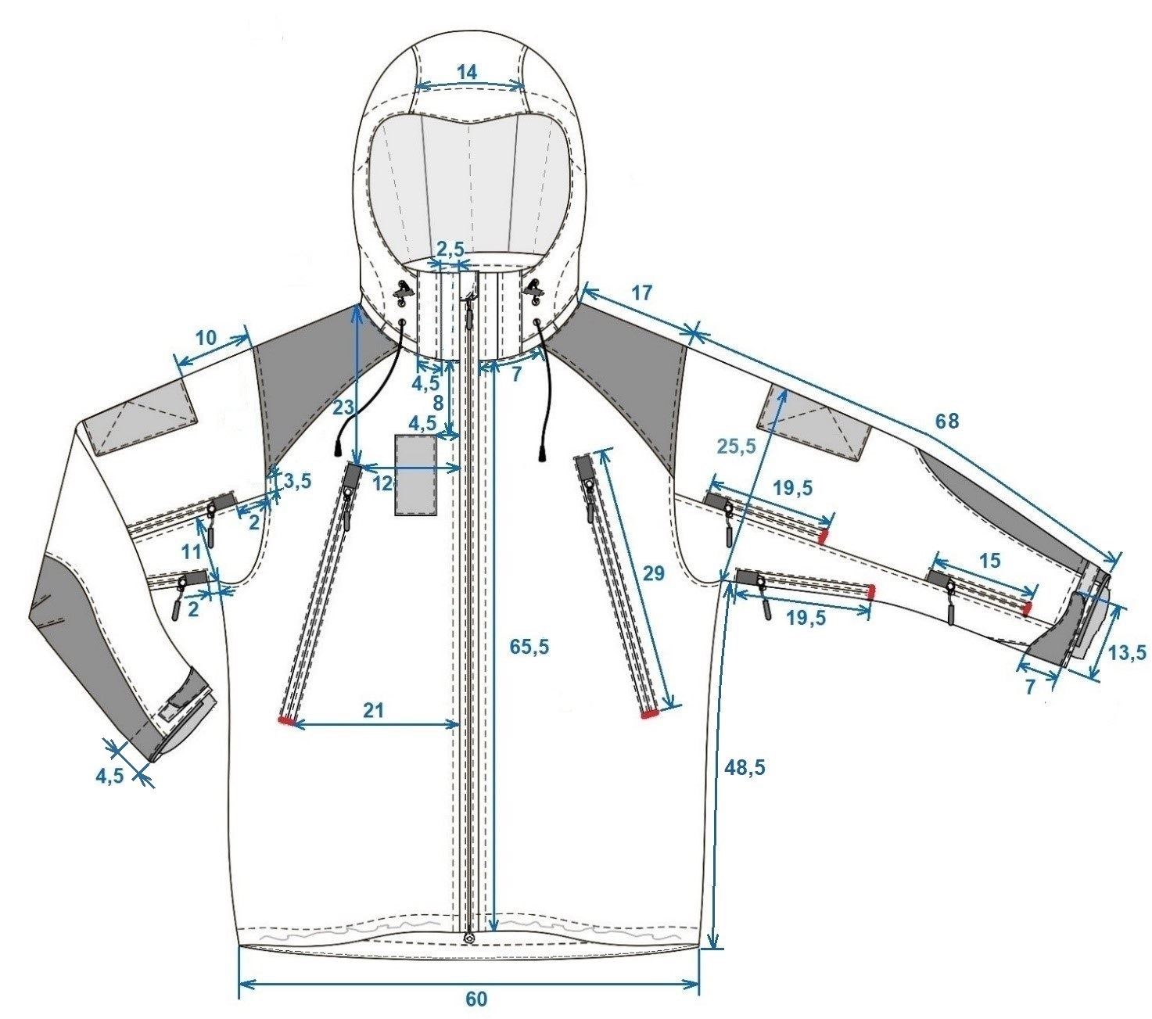

Sketch 1

Note. The red color is applied to the reinforcements using a special machine.

JACKET WITH ATTACHED HOOD FROM THE BACK

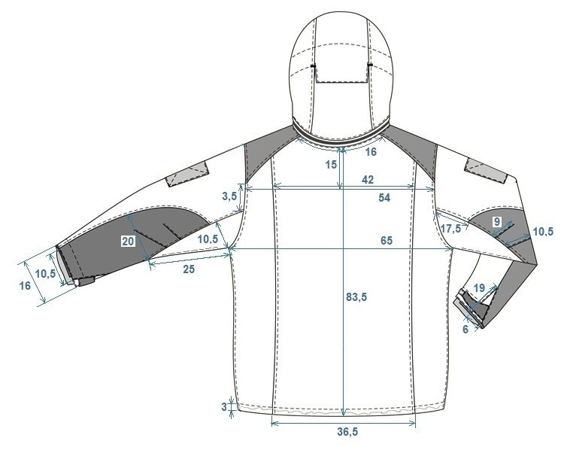

Sketch 2

Note. The red color is applied to the reinforcements using a special machine.
.
JACKET HOOD FROM THE SIDE

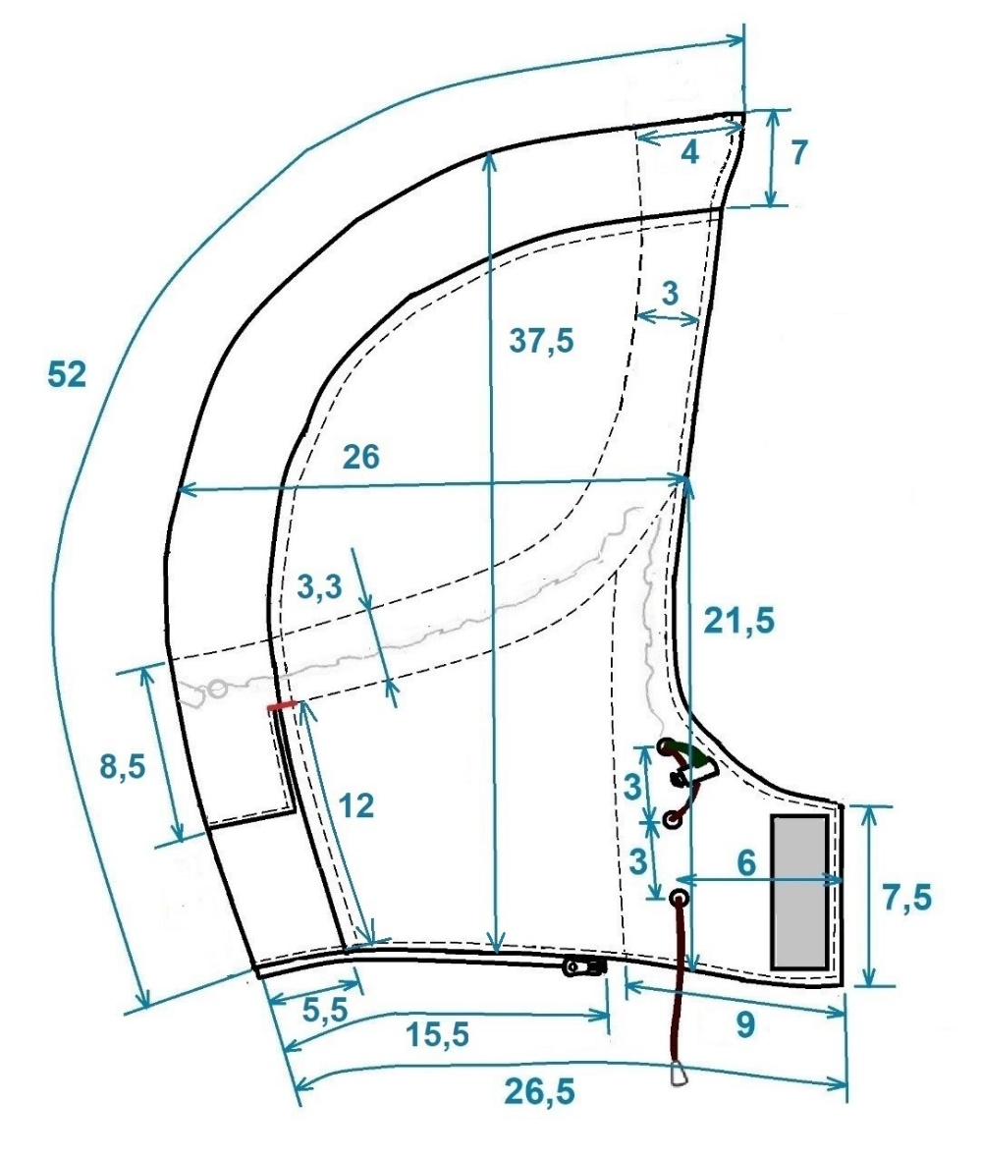
Sketch 3

Note. The red color is applied to the reinforcements using a special machine.

INSIDE VIEW OF THE JACKET

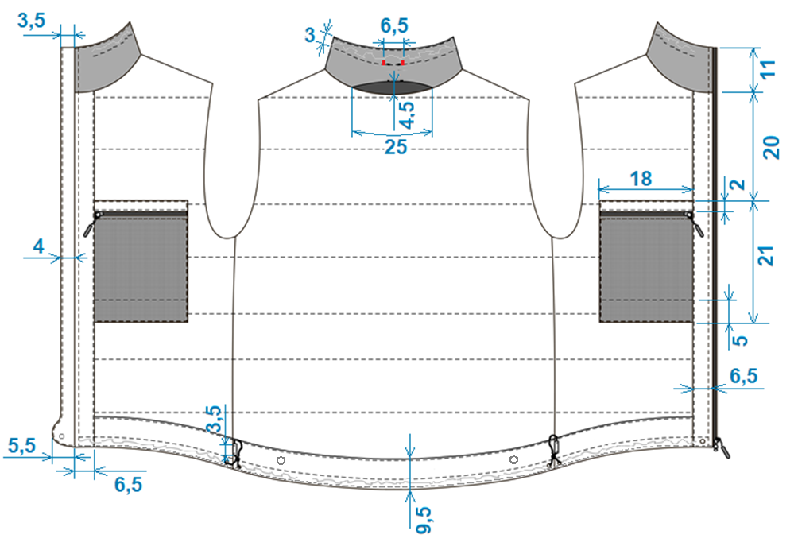

Sketch 4

Note. The red color is applied to the reinforcements using a special machine.

HIDDEN (UNIVERSAL) DESIGNS

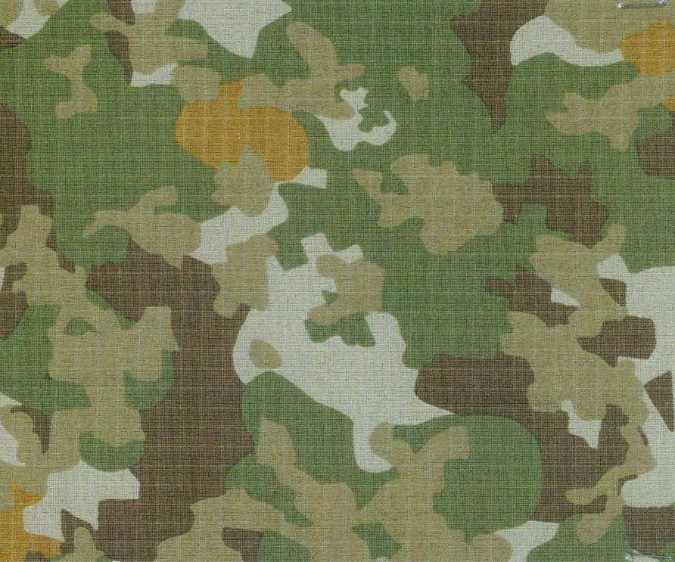

Sketch 5

