ANNEX 1
TO THE PROCUREMENT CONDITIONS
(LOT 3, 4, 5)

TECHNICAL SPECIFICATION FOR WINTER CLOTHING SETS
GENERAL PROVISIONS
- A winter clothing set (hereinafter referred to as a set) is one of the elements of the outdoor clothing system designed to protect soldiers from precipitation, wind, and cold.
- The set consists of a jacket and trousers with suspenders.
- The set must comply with the requirements set out in this technical specification.
- The standard sizes of the sets required for soldiers are presented in Tables 1 and 2, compiled in accordance with the size system adopted by the Lithuanian Armed Forces.
Table 1
TABLE OF JACKET SIZES
Height, cm | Chest circumference, cm
Height, cm | 84 | 88-92 | 96-100 | 104-108 | 112-116 | 120-124
158 | x | x | x
164-170 | x | x | x | x | x
176-182 | x | x | x | x | x | x
188-194 |  | x | x | x | x | x
200-206 |  |  | x | x | x | x

Table 2
TABLE OF TROUSER SIZES
Height, cm | Waist circumference, cm
Height, cm | 72 | 76-80 | 84-88 | 92-96 | 100-104 | 108-112
158 | x | x | x
164-170 | x | x | x | x | x
176-182 | x | x | x | x | x | x
188-194 |  | x | x | x | x | x
200-206 |  |  | x | x | x | x
- Completed tables of jacket and trouser sizes (with quantities specified) shall be submitted to the supplier when concluding the contract. If necessary, non-standard jacket and trouser sizes may be requested, not exceeding 2% of the total contract quantity.
- The design of the set must be based on LST ISO 8559-1 (ISO 8559-1) or equivalent standard data. The sets must be designed and sewn in such a way as to provide good protection against precipitation, wind, and cold, ensure a proper fit to the soldier’s body, and restrict the soldier’s movements as little as possible.
- The warranty period for the quality of the sets is at least 24 months under active use conditions, calculated from the date of delivery of the goods from the Buyer’s warehouse and 36 months from the date of receipt of the goods at the Buyer’s warehouse.
- The standards mentioned in the technical specifications shall be read as “or equivalent.”

CHAPTER II
TECHNICAL REQUIREMENTS
- Sketches of the set model are provided in the Annex to the technical specifications (hereinafter referred to as the Annex): the jacket model is presented in sketches 1-2, and the trousers (with suspenders) model is presented in sketch 3.
- The basic dimensions (height – 188-194 cm, chest circumference – 104-108 cm, waist circumference – 92-96 cm) and permissible deviations are presented in Table 3.

Table 3
TABLE OF BASIC SET SIZES

No. | Measurement location and dimension | Measurement size, cm | Permissible deviations, cm
1. | Jacket
1.1 | Chest circumference ½ | 67 | ±2,0
1.2 | Bottom circumference of the product ½ | 64 | ±2,0
1.3 | Shoulder width | 17,1 | ±0,5
1.4 | Sleeve length | 70 | ±2,0
1.5 | Cuff circumference ½ | 16,5 | ±0,5
1.6 | Front length (with collar) | 84,5 | ±2,5
1.7 | Collar height | 10 | ±0,5
1.8 | Back length | 91 | ±1,0
1.9 | Width of the hood | 25 | ±0,8
1.10 | Height of the hood | 37,5 | ±1,0
1.11 | Front zipper length | 84 | ±1,0
1.12 | Lengths of upper front pocket zippers | 22 | ±1,0
1.13 | Lengths of bottom side pocket zippers | 18 | ±1,0
1.14 | Length of zippers on upper sleeve pockets | 16 | ±1,0
1.15 | Length of the zipper on the lower pocket of the left sleeve | 12 | ±1,0
1.16 | Inner pocket zipper length | 18 | ±1,0
1.17 | Length of the hood zipper | 32 | ±1,0
2 | Trousers
2.1 | Waist circumference ½ (stretched) | 54 | ±1,5
2.2 | Waist circumference ½ | 46 | ±1,5
2.3 | Hip circumference ½ | 64 | ±1,5
2.4 | Bottom width of trousers ½ | 26 | ±0,8
2.5 | Side seam length (with waistband) | 115 | ±3,0
2.6 | Step seam length | 81 | ±2,0
2.7 | Waist height | 4,5 | ±0,5
2.8 | Thigh width (5 cm below the widest point) | 36 | ±1,0
2.9 | Front fastener length | 24 | ±1,0
2.10 | Side pocket length | 20 | ±1,0
Note:
When measuring the length of pocket zippers, the length of the pocket is measured.

- The weight of the basic set (jacket and trousers with suspenders) must not exceed 4 kg.
- The seams of the set must be trimmed according to the sketches in the Annex. The density of the finishing stitches is 3.5-4 stitches/cm.
- The thickness of the sewing thread and the density of the stitches must ensure the strength of the seam. All seam ends must be secured.
- The seams must be selected in such a way as to ensure the proper strength and quality of the product's seams during use (wear or washing/drying). The seams of the lining of the set must be reinforced by stitching them with special machines and finishing them with single finishing stitches. Other seams of the product are reinforced with additional stitches and/or stitched with special machines as needed.
- The sewing of the set must be done with high quality: no creasing or distortion of seams/stitches (the width of the seam/stitch must be uniform along the entire length of the seam/stitch) and no tearing during use, no skipped, bunched, loose or incorrectly tightened stitches, broken sewing threads, insufficient tightening of the material, deterioration of seams/stitches due to missing or improperly made fastenings, stitching in visible places, damage to materials by the sewing machine needle, seams/stitches, etc. All seam/stitch ends must be secured.
- Matching items in a set must be arranged symmetrically. Different shades of the same item are not allowed in a set.
- The sets must be cleaned of any remnants of the technological process (threads, fluff, auxiliary marks, etc.) and neatly smoothed out.
SECTION ONE
MATERIAL REQUIREMENTS

- The color of the upper layer of the set (hereinafter referred to as the top fabric) is printed with a patented hidden (universal) pattern (see sketch in Annex 4), the colors of which, according to the PANTONE TEXTILE color catalog, are close to the following color codes and, according to the pattern, consist of:
- gray-green (base) color – 13-0607 TP ̴ 15% of the area,
- green color – 17-0115 TP ̴ 30% of the area,
- brown color – 17-1417 TP ̴ 25% of the area,
- straw color – 17-1022 TP ̴ 20% of the area,
- chaki color – 16-0730 TP ̴ 10% of the area.
- After signing the sale and purchase contract, the winning supplier will be provided with a sample of the fabric design with a full design report and a computer (working) file with an image of the fabric printed with the hidden design.
- The top fabric is waterproof, breathable, polyamide ripstop woven on the inside and coated with a PTFE-based (or equivalent) bicomponent membrane, meeting the technical characteristics specified in Table 4:
Table 4
TECHNICAL CHARACTERISTICS OF THE TOP FABRIC

No. | Indicator name, dimension | Indicator value | Test method code
1. | Surface density, g/m² | 115 ± 10 | LST ISO 3801 (ISO 3801) or equivalent;  LST EN 12127 (EN 12127), or equivalent
2. | Resistance to water vapor Ret, m²Pa/W | ≤ 7 | LST EN ISO 11092 (ISO 11092) or equivalent
3. | Air permeability, mm/s (100 Pa) | ≤7 | LST EN ISO 9237 (ISO 9237) or equivalent
4. | Resistance to crushing at a nominal pressure of 12 kPa, pumps | ≥ 200 000 | LST EN ISO 12947-2 (ISO 12947-2) or equivalent
5. | Resistance to surface wetting, points | ≥ 4 | LST EN ISO 4920 (ISO 4920) or equivalent
6. | Maximum force, N  warp direction  weft direction | ≥ 750  ≥ 500 | LST EN ISO 1421-1 (ISO 1421) or equivalent
7. | Tear strength, N  warp direction  weft direction | ≥ 70  ≥ 40 | LST EN ISO 4674-1 (ISO 4674-1) method A or equivalent
8. | Resistance to water penetration at a water pressure increase rate of 60±3 cm/min, cm
8.1. | new | ≥ 1000 | LST EN ISO 811 (ISO 811) or equivalent
8.2. | after 5 washes * | ≥ 900 | LST EN ISO 811 (ISO 811) or equivalent
9. | Stain resistance, points
9.1. | to washing at 40º | ≥ 4 | LST EN ISO 105-C06 (ISO 105-C06) or equivalent
9.2. | to water | ≥ 4 | LST EN ISO 105-E01 (ISO 105-E01) or equivalent
9.3. | to sweat | ≥ 4 | LST EN ISO 105-E04 (ISO 105-E04) or equivalent
9.4. | to dry abrasion | ≥ 4 | LST EN ISO 105-X12,-X16  (ISO 105-X12,-X16) or equivalent
9.5. | to wet abrasion | ≥ 3 | LST EN ISO 105-X12,-X16  (ISO 105-X12,-X16) or equivalent
9.6. | to artificial light | ≥ 4 | LST EN ISO 105-B02 (ISO 105-B02) or equivalent
10. | Change in dimensions after washing *, % | ± 4 | LST EN ISO 5077 (ISO 5077) or equivalent
11. | Color difference **, Δ E_{CMC} | < 2 | LST EN ISO 105-J03 (ISO 105-J03) or equivalent
Notes:
* Washing and drying procedures according to LST EN ISO 6330 (ISO 6330) or equivalent standard: washing procedure – 4G (40º, gentle wash), drying method – F (dry at a lower temperature).
** Indicator 11, “Color difference,” is required during contract performance and determines the permissible color deviation from the working sample agreed upon during contract performance.

- The top fabric must have infrared reflectivity (according to LST EN ISO 105-J01 (ISO 105-J01) or an equivalent standard): the spectral reflectance factor of the top fabric with a patented hidden (universal) pattern in the near infrared spectrum range (750-1100 nm) must be:
- gray-green (base) color: 60 – 70%;
- green color: 40 – 50 %;
- straw color: 35 – 45 %;
- chaki color: 35 – 50 %;
- brown color: 20 – 30 %
- The top fabric must comply with the minimum environmental protection criteria set out in Section IX ‘Textile Products’ of Annex 2 to the ‘Description of the Procedure for Applying Environmental Protection Criteria in the Implementation of Green Public Procurement’, approved by Order No. D1-508 of 28 June 2011 of the Minister of Environment of the Republic of Lithuania.
- Lining – in a colour close to that of the top fabric (to be agreed during sample matching), made of polyamide (PA 6 or PA 6.6) or an equivalent ripstop-weave fabric, complying with the technical characteristics set out in Table 5.

Table 5
TECHNICAL CHARACTERISTICS OF THE LINING

No. | Indicator name, dimension | Indicator value | Test method code
1. | Surface density, g/m² | 50 ± 10 | LST ISO 3801 (ISO 3801) or equivalent;  LST EN 12127 (EN 12127) or equivalent
2. | Number of threads per 10 centimeters  warp direction  weft direction | ≥ 700  ≥ 500 | LST EN ISO 7211-2 or equivalent
3. | Maximum force, N  warp direction  weft direction | ≥ 600  ≥ 400 | LST EN ISO 13934-1 (ISO 13934-1) or equivalent
4. | Tear strength, N  warp direction  weft direction | ≥ 25  ≥ 25 | LST EN ISO 13937-2 (ISO 13937-2) or equivalent
5. | Air permeability, mm/s (100 Pa) | ≥ 60 | LST EN ISO 9237 (ISO 9237) or equivalent
6. | Determination of antibacterial activity, A | ≥ 3 | LST EN ISO 20743 (ISO 20743) or equivalent
7. | Change in dimensions after washing *, % | ± 4 | LST EN ISO 5077 (ISO 5077) or equivalent
8. | Stain resistance, points
8.1. | to washing at 40º | ≥ 4 | LST EN ISO 105-C06 (ISO 105-C06) or equivalent
8.2. | to dry abrasion | ≥ 4 | LST EN ISO 105-X12,-X16  (ISO 105-X12,-X16) or equivalent
8.3. | to wet abrasion | ≥ 3 | LST EN ISO 105-X12,-X16  (ISO 105-X12,-X16) or equivalent
8.4. | to artificial light | ≥ 4 | LST EN ISO 105-B02 (ISO 105-B02) or equivalent
9. | Color difference **, Δ E_{CMC} | ≤ 2 | LST EN ISO 105-J03 (ISO 105-J03) or equivalent
Notes:
* Washing and drying procedures according to LST EN ISO 6330 (ISO 6330) or equivalent: washing procedure – 4G (40º, gentle wash), drying method – F (dry at a lower temperature).
** Indicator 9, “Color difference,” is required during contract performance and determines the permissible color deviation from the agreed working sample.

- The lining must comply with the minimum environmental protection criteria set out in Section IX ‘Textile Products’ of Annex 2 to the ‘Description of the Procedure for Applying Environmental Protection Criteria in the Implementation of Green Public Procurement’, approved by Order No. D1-508 of 28 June 2011 of the Minister of Environment of the Republic of Lithuania.
- The insulation must be made of polyester fiber:
  - The method of reinforcing the insulation fiber must ensure that the insulation retains its integrity and thermal properties during use (wear or washing/drying) and that individual fibers do not penetrate the lining or outer fabric.
  - The surface density of the insulation in the jacket body must be 200 g/m2, and in the jacket sleeves and trousers – 150 g/m2 (according to LST EN 29073-1 (ISO 9073-1) or an equivalent standard). A deviation of ±10% from the specified surface densities is permitted.
  - The thermal resistance of the jacket body insulation must be at least 0.46 m2K/W, and the thermal resistance of the jacket sleeves and trousers insulation must be at least 0.36 m2K/W (according to LST EN ISO 11092 (ISO 11092) or an equivalent standard).

- Reinforcing fabric – top fabric color, rip stop, polyamide cordura fabric, meeting the technical characteristics specified in Table 6:

Table 6
TECHNICAL CHARACTERISTICS OF REINFORCING FABRIC

No. | Indicator name, dimension | Indicator value | Test method code
1. | Surface density, g/m² | 125 + 15 | LST ISO 3801 (ISO 3801) or equivalent;  LST EN 12127 (EN 12127) or equivalent
2. | Resistance to crushing at a nominal pressure of 12 kPa, pumps | > 200 000 | LST EN ISO 12947-2 (ISO 12947-2) or equivalent
3. | Breaking force, N  warp direction  weft direction | ≥ 1100  ≥ 800 | LST EN ISO 13934-1 (ISO 13934-1) or equivalent
4. | Tear strength, N  warp direction  weft direction | ≥ 45  ≥ 40 | LST EN ISO 13937-2 (ISO 13934-1) or equivalent
5. | Stain resistance, points
5.1. | to washing at 40º | ≥ 3 | LST EN ISO 105-C06 (ISO 105-C06) or equivalent
5.2. | to water | ≥ 3 | LST EN ISO 105-E01 (ISO 105-E01) or equivalent
5.3. | to dry abrasion | ≥ 4 | LST EN ISO 105-X12,-X16  (ISO 105-X12,-X16) or equivalent
5.4. | to wet abrasion | ≥ 3 | LST EN ISO 105-X12,-X16  (ISO 105-X12,-X16) or equivalent
5.5. | to artificial light | ≥ 4 | LST EN ISO 105-B02 (ISO 105-B02) or equivalent
6. | Color difference **, Δ E_{CMC} | < 2 | LST EN ISO 105-J03 (ISO 105-J03) or equivalent
Notes:
* Indicator 6, “Color difference,” is required during contract execution and determines the permissible color deviation from the agreed working sample.

- The reinforcement fabric must have the same infrared reflection properties as the top fabric.

- Knitted fabric – in a colour close to that of the top fabric (to be agreed during sample matching), fibre composition: 45 (±5) % polyamide, 45 (±5) % polyester, 10 (±5) % elastane. The knitted fabric must comply with the technical characteristics set out in Table 7.”

Table 7
TECHNICAL CHARACTERISTICS OF KNITTED FABRIC

No. | Indicator name, dimension | Indicator value | Test method code
1. | Surface density, g/m² | 240 ± 10 | LST ISO 3801 (ISO 3801) or equivalent;  LST EN 12127 (EN 12127) or equivalent
2. | Resistance to crushing at a nominal pressure of 9 kPa, pumps | > 100 000 | LST EN ISO 12947-2 (ISO 12947-2) or equivalent
3. | Elasticity – recovery after stretching for 1 min, %  warp direction  weft direction | ≥ 80  ≥ 80 | LST EN ISO 20932-1 (ISO 20932-1) or equivalent

- Pouch fabric – moss-coloured or printed with a patented camouflage (universal) pattern, ‘waterproof’, polyamide (PA 6.6) fabric, complying with the technical characteristics set out in Table 8.
Table 8
TECHNICAL CHARACTERISTICS OF THE POUCH FABRIC

No. | Indicator name, dimension | Indicator value | Test method code
1. | Surface density, g/m² | 100 ± 10 | LST ISO 3801 (ISO 3801) or equivalent;  LST EN 12127 (EN 12127) or equivalent
2. | Resistance to crushing at a nominal pressure of 12 kPa, pumps | > 200 000 | LST EN ISO 12947-2 (ISO 12947-2) or equivalent
3. | Breaking force, N  warp direction  weft direction | ≥ 600  ≥ 400 | LST EN ISO 1421 (ISO 1421) or equivalent
4. | Tear strength, N  warp direction  weft direction | ≥ 11  ≥ 11 | LST EN ISO 4674-1(ISO 4674-1) method A or equivalent
5. | Surface wetness resistance, class | ≥ 5 | LST EN ISO 4920 (ISO 4920) or equivalent
6. | Resistance to water penetration at a water pressure increase rate of 60 ± 3 cm/min, cm | ≥1500 | LST EN ISO 811 (ISO 811) or equivalent
7. | Stain resistance, points
7.1. | to washing at 40º | ≥ 4 | LST EN ISO 105-C06 (ISO 105-C06) or equivalent
7.2. | to water | ≥ 3 | LST EN ISO 105-E01 (ISO 105-E01) or equivalent
7.3. | to abrasion (dry and wet) | ≥ 3 | LST EN ISO 105-X12,-X16  (ISO 105-X12,-X16) or equivalent

- It is preferable that the fabric of the pouches be made of recycled polyamide, but it must comply with all the technical characteristics set out in Table 8.
- All zippers used in the sewing of the set, except for the front closure of the jacket, the inner pockets of the jacket, and the front closure of the trousers, must be waterproof. All zipper pulls must have tabs for quicker opening.
- The color of all accessories used in the sewing of the set (zippers, cords, fasteners, etc.) must be close to the color of the top fabric (to be agreed upon when matching samples). All accessories on the outside of the product must have infrared reflection properties.
- All fasteners used in the sewing of the set must ensure the safety of the soldier (e.g., no risk of snagging) and the strength of the fastening (e.g., fasteners must not come loose during use).
SECTION TWO
REQUIREMENTS FOR THE MODEL SET
- The jacket fastens at the front with a spiral zipper (tooth width 10 (±0.5) mm) with two heads, with a flap sewn under the zipper (on the inside) covering the zipper at the top. To ensure warmth, the zipper is covered with two flaps, fastened together with at least six snaps.
- The jacket collar is straight, and the upper edge is adjustable with an elastic cord and fastener.
- The hood is attached to the jacket with a zipper and four snaps. The hood has a lining and insulation. The hood's size can be adjusted with elastic cords (in three directions) and fasteners, ensuring that the hood fits snugly on the soldier's head.
- Each sleeve has a slit pocket sewn into the upper part, fastened with a zipper.
- A hook-and-loop fastener (soft side) measuring at least 8x14 cm is sewn onto the upper part of each sleeve. The hook-and-loop fasteners are close to color code 18-0617 TP (Covert green) according to the PANTONE TEXTILE color catalog. The hook-and-loop fasteners must have infrared reflection properties. All cut edges of the hook-and-loop fasteners must be finished so that they do not fray.
- A slit pocket with a zipper closure is sewn into the lower part of the left sleeve.
- To ensure freedom of movement, two gussets are sewn into the elbow areas of the sleeves.
- Knitted cuffs (single) with an opening for the thumb are sewn onto the bottom of the jacket sleeves (the basic cuff length is at least 16 cm, and the width at the bottom is at least 10 cm). The bottom of the jacket sleeves is adjustable with a drawstring (the top of the drawstring is sewn from reinforced fabric) and a snap fastener.
- Two inset pockets are sewn into the front of the jacket at the top and fastened with zippers (tooth width 6 (±0.5) mm).
- Two patch pockets with flaps are sewn onto the bottom of the jacket. The pocket is fastened with a snap fastener (when fastening the pocket, the top of the pocket is folded over together with the flap).
- There is one pocket sewn onto the left side of the jacket, under the zipper flap.
- Jacket with two inner pockets, fastened with zippers (tooth track width 6 (±0.5) mm, spiral).
- To tighten the bottom of the jacket, a round elastic cord with fasteners, 3 (±0.2) mm in diameter, is sewn into the bottom of the jacket.
- To provide protection from the wind, a protective detail made of lining fabric is sewn onto the bottom of the jacket, the bottom of which is gathered with non-slip elastic. The protective detail can be fastened with three press studs or attached to the jacket when not needed.
- An elastic cord with fasteners is sewn into the waistband of the jacket to adjust the fit.
- The sleeves of the jacket (from the elbows to the bottom), the bottom of the sleeves, the shoulders, and the bottom of the back are reinforced with reinforcement fabric.
- There is a loop inside the jacket for hanging.
- Trousers with a waistband that fastens at the front with a 30 (±0.2) mm diameter button, sewn through a strip and stitched with a loop, waist raised at the back (must be at least 12 cm at the center of the back), elastic sewn inside (except at the back) for waist adjustment.
- The front of the trousers is fastened with a zipper (spiral, tooth width 6 (±0.5) mm), covered with a flap.
- For opening the side seams of the trousers, sew on zippers (tooth width 6 (±0.5) mm) with two heads. Sew on facings under the zippers (from the inside and from above).
- Two patch pockets with zippers are sewn onto the front of the trousers.
- To ensure freedom of movement, two seams are sewn on each side of the road.
- Elastic bands with fasteners are sewn into the bottom of the trousers for tightening.
- Hooks are attached to the bottom of the front sides of the trousers to hold them up.
- The width of the trouser legs is adjustable with press studs and a hook fastening.
- The seams, bottom, inner bottom, and back of the trousers are reinforced with reinforcement fabric.
- A loop is sewn into the inside of the trousers for hanging them up.
- Trousers with removable suspenders. The suspenders are constructed and crossed at the back from straps (4 cm wide) and elastic bands (4.2 cm wide). The suspenders are attached to loops sewn inside the trousers. The suspenders are fastened with hook-and-loop fasteners.
- Jackets and trousers are packed with pouches during use.
- The height of the jacket pouch shall not exceed 42 cm, the diameter of the bottom shall not exceed 24 cm, and the weight shall not exceed 80 g;
- The height of the trouser pouch shall not exceed 33 cm, the diameter of the bottom shall not exceed 20 cm, and the weight shall not exceed 60 g;
- The pouches are manufactured in the same size for all sizes and are fastened with textile straps and buckles.
CHAPTER III
APPROVAL OF WORK SAMPLES
- After concluding the contract, working samples are coordinated and approved.
- For the approval of the working sample, the supplier shall submit:
  - two identical products of the base size (with covers);
  - a table of measurements for comparison;
  - product maintenance instructions for approval (the text of which must be provided in QR code form with each product);
  - a technical description of the product (with samples and characteristics of the materials used in the manufacture of the product, proving their compliance with the requirements set out in the technical specifications).
- If necessary, the dimensions, sewing technology, etc. of the product may be adjusted during the coordination process, provided that this does not impair the appearance and functional characteristics of the product.
- Mass production may only commence after the working samples have been approved.

CHAPTER IV
PRODUCT LABELING, PACKAGING
- Product labelling must comply with the requirements of the Rules for the Labelling and Price Indication of Goods Sold in the Republic of Lithuania, approved by Order No. 170 of 15 May 2002 of the Minister of Economy of the Republic of Lithuania ‘On the Approval of the Rules for the Labelling and Price Indication of Goods Sold in the Republic of Lithuania’ (as amended, or any legal act replacing or amending them, if adopted), as well as with the requirements set out in this technical specification.
- A textile label must be sewn onto the inside of each product (the location to be agreed upon before the working sample is submitted).
- The edges of the marking tape shall not be sharp, and the information on it shall be easily legible throughout the entire period of use of the product.
- The marking on the textile tape shall indicate:
- supplier name or brand name;
- manufacturer’s name or brand name (if different from the supplier);
- product name (must match the name specified in the contract);
- fiber composition;
- size (in bold and enlarged font);
- contract date and number;
- batch and shipment index;
- date of manufacture (year, month);
- care label symbols (in accordance with LST EN ISO 3758 (ISO 3758) or an equivalent standard);
- the inscription “Pagaminta Lietuvos kariuomenei” (en. “Made for the Lithuanian Armed Forces”).
- Each product must be accompanied by care instructions in Lithuanian. The instructions must be provided in the form of a QR code on a textile label (or on a separate label attached to the product).
- Each product shall be labeled with a label indicating:
- supplier name or brand name;
- manufacturer’s name or brand name (if different from the supplier);
- product name (must match the name specified in the contract);
- size (in bold and enlarged font);
- contract date and number;
- batch and shipment index;
- date of manufacture;
- NSN code.
- The product label must be securely attached, and the label details must be large enough to be easily read and understood.
- Jackets and trousers are packed individually in boxes.
- Products packed in cases shall be placed in secondary packaging (placed in sturdy cardboard boxes resistant to long-term storage and repeated transportation) according to size, no more than 4 sets per box.
- Product packaging (cardboard boxes) must comply with the minimum environmental protection criteria set out in Section II ‘Packaging’ of Annex 2 to the ‘Description of the Procedure for Applying Environmental Protection Criteria in the Implementation of Green Public Procurement’, approved by Order No. D1-508 of 28 June 2011 of the Minister of Environment of the Republic of Lithuania.
- Cardboard boxes must be marked with the following clearly visible details:
- supplier name or brand name;
- manufacturer’s name or brand name (if different from the supplier);
- or imported goods, indicate the country of origin of the goods if it is not the same as the country where the manufacturer's registered office is located;
- product name (must match the name specified in the contract);
- size (in bold and enlarged font);
- contract date and number;
- batch and shipment index (in bold and enlarged font);
- quantity (in bold and enlarged font);
- date of manufacture;
- NSN code.
81. Cardboard boxes must be delivered stacked on standard-size (120 × 80 cm) Euro pallets (hereinafter – Euro pallets). Euro pallets must be properly prepared for transportation: during transport, the cardboard boxes must retain their original shape (not be compressed or otherwise mechanically damaged), be stacked so that they do not extend beyond the edges of the Euro pallet, and evenly fill the pallet’s surface. Each Euro pallet must be securely wrapped with packaging film so that the cardboard boxes cannot be separated from the pallet during transport. A sheet of at least A4 size must be attached to each Euro pallet, displaying the following clearly visible details:
- supplier name;
- manufacturer’s name or brand name (if different from the supplier);
- product name (must match the name specified in the contract);
- size;
- number of boxes;
- quantity of products in one box;
- total number of products on a Euro pallet;
- other information (to be specified if necessary).

CHAPTER V
ACCEPTANCE OF GOODS
82. Goods are accepted in batches and shipments. Each batch of goods must be marked with the contractual mark and accompanied by a declaration of conformity in accordance with LST EN ISO/IEC 17050-1 (ISO/IEC 17050-1) Form A.2 or an equivalent standard example (unless otherwise specified in the contract).
83. The Buyer, in accordance with the contract terms, inspects the quality of the selected batch of goods and may carry out laboratory tests. If the results obtained do not meet the requirements specified in the technical specification, the entire batch delivered at that time is rejected.

In case of differences in interpretation the Lithuanian text shall prevail

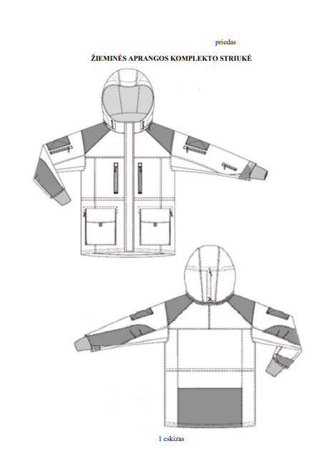
Sketch 1
WINTER CLOTHING SET JACKET
Annex

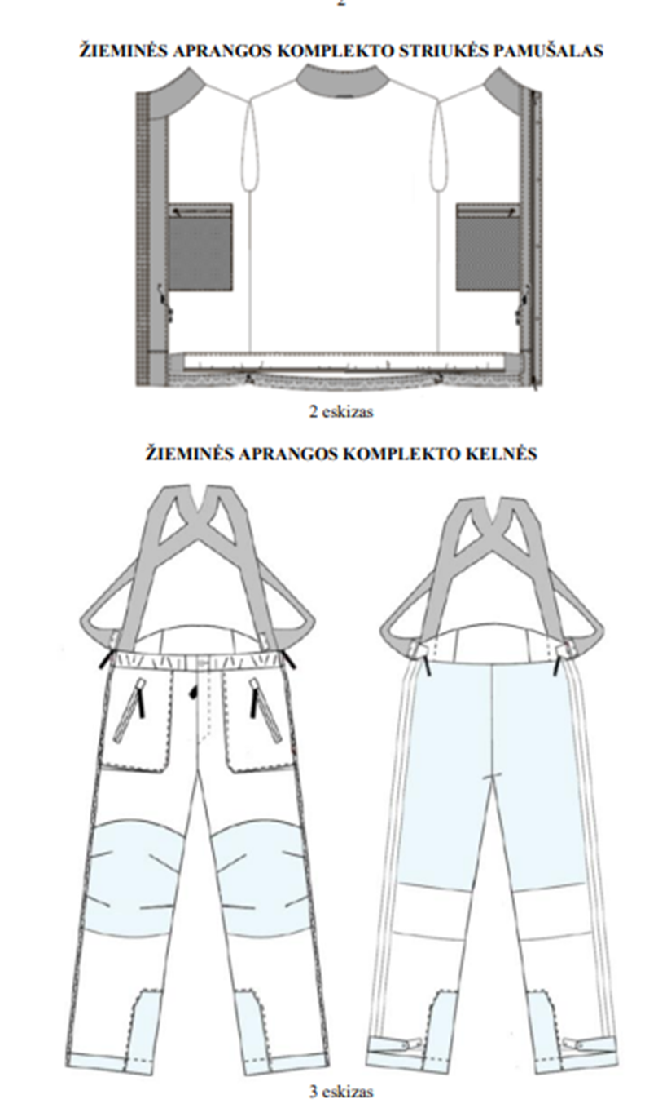
WINTER CLOTHING SET TROUSERS
WINTER CLOTHING SET JACKET LINING
Sketch 3
Sketch 2

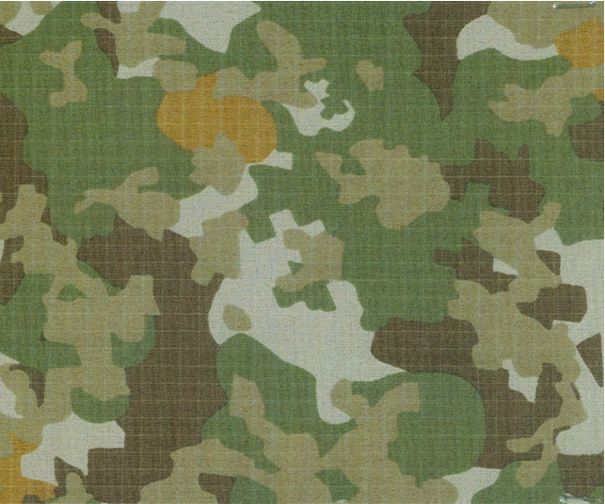

Sketch 4 of the Annex

