Translation from Lithuanian

STATE ENTERPRISE

IGNALINA NUCLEAR POWER PLANT

TECHNOLOGY DEPARTMENT

LABORATORY RESEARCH DIVISION

APPROVED by
The Head of Technology Department
Arūnas Garūbis

TECHNICAL SPECIFICATION FOR THE PROCUREMENT OF ENVIRONMENTAL SAMPLE COLLECTION AND RADIONUCLIDE CONCENTRATION MEASUREMENT SERVICES

_______________________2026 No. __________________________

Visaginas

SECTION
PROCUREMENT TYPE
- Procurement of services.

SECTION
OBJECTIVE
- The objective of this procurement is to acquire services for sampling and measuring radionuclide concentrations in air, atmospheric precipitation, water media and other environmental objects in order to implement the Radiological Environmental Monitoring Programme of State Enterprise Ignalina Nuclear Power Plant (hereinafter referred to as INPP or the Customer) No. DVSed-0410-3V11 (Clauses 7.3; 7.4; 7.6; 8) (hereinafter referred to as the Monitoring Programme), and also to ensure the performance of these services during an emergency at a nuclear facility (hereinafter referred to as NF), while participating in INPP emergency preparedness activities.
- Measurement of radionuclide concentrations in air, atmospheric precipitation, samples of Lake Drūkšiai water, borehole water, channel water and other environmental samples is necessary in order to comply with the requirements of Order No. V-3028 of 26 December 2020 of the Minister of Health of the Republic of Lithuania “On the Approval of the Description of the Procedure for Radiological Environmental Monitoring of Economic Entities” as well as the requirements of Order No. D1-546 of 16 September 2009 “On the Approval of the Regulations on Environmental Monitoring of Economic Operators”.
- The procured services are classified as a safety-important product.

SECTION
LIST OF ABBREVIATIONS
DCh Discharge Channel
DWSS Domestic wastewater sewer system
EML LRD Environmental Monitoring Laboratory
EPO Emergency Preparedness Organization
EPP Emergency Preparedness Plan
ICh Intake Channel
INPP Ignalina Nuclear Power Plant
ISFSF Interim Spent Fuel Storage Facility
ISWS Industrial and surface wastewater sewage system
LANDFILL Landfill Facility for Short-Lived Very Low Level Waste
LRD Laboratory Research Division
NF Nuclear Facility
PI VH Public Institution Visaginas Hospital
RPS EPO Radiation Protection Service
SE State Enterprise
SFDSF Spent Fuel Dry Storage Facility
SWRF Solid Radioactive Waste Retrieval Facility
SWTSF Solid Waste Treatment and Storage Facility

DESCRIPTION OF THE SERVICES AND SCOPE OF PROVISION
- When providing the services, the Supplier shall:
  - perform sample collection and testing in accordance with the Monitoring Programme approved by INPP and determine the activity concentrations of the radionuclides specified in the Programme, as well as other parameters specified therein.
- The Monitoring Programme includes:
  - sample collection and/or acquisition of samples;
  - determination of radionuclide activity concentrations in samples;
- Sampling of channel water shall be performed 3 (three) times per month at 5 (five) sampling points specified in Table 9 of this Specification. When taking water samples at SFDSF ISWS wastewater discharge points, it is mandatory to measure the water flow level in three pipes (3 measurements per month) using a wooden ruler in order to calculate the amount of INPP wastewater.
- Sampling from Lake Drūkšiai shall be performed once per year at 6 (six) sampling points (see Annex 4 to the Technical Specification). Sampling from Lake Drūkšiai must be performed in the lake water area, not closer than 50 metres from the shore.
- Preparation of atmospheric air and precipitation samples shall be performed using the method applied by the Supplier or according to the instruction provided by the Customer. Air filtration shall be carried out using FPP‑15 filter fabric or equivalent.
- Radiological environmental monitoring shall be performed in accordance with the requirements of Order No. V-3028 of 26 December 2020 of the Minister of Health of the Republic of Lithuania “On the Approval of the Description of the Procedure for Radiological Environmental Monitoring of Economic Entities.
- The Supplier must provide the results of these measurements, taking into account the type of object and the specifics of the tests performed:
- for samples of water discharged into the environment (DCh, ICh, ISWS‑1,2, ISWS‑3, ISWS‑SFDSF), the results of measuring gamma and H‑3 activity concentrations must be submitted no later than within 5 working days from sample collection. The results of measuring Sr‑90 and C‑14 activity concentrations must be submitted no later than within 20 working days from sample collection.
- for all other water samples, except monitoring borehole samples, the results of measuring gamma and H‑3 activity concentrations must be submitted no later than within 10 working days after sample collection. The results of measuring Sr‑90 activity concentration must be submitted no later than within 20 working days from sample collection. The results of measuring beta and alpha emitter activity concentrations must be submitted no later than within 10 working days from sample collection.
- for monitoring borehole samples, the results of measuring gamma, H‑3, Sr‑90 activity concentrations, as well as the water level, must be submitted no later than within 20 working days from sample collection.
- for atmospheric air samples, the results of measuring gamma and H‑3 activity concentrations must be submitted no later than within 7 working days from sample collection. The results of measuring Sr‑90 activity concentration must be submitted no later than within 20 working days from sample collection.
- for atmospheric precipitation samples, the results of measuring gamma and H‑3 activity concentrations must be submitted no later than within 10 working days from sample collection.
- for snow samples (if snow cover has formed), the result of measuring gamma activity concentration must be submitted within 7 working days from sample collection.
- for samples of bottom sediments, algae, fish, soil, grass, mushrooms, moss, meat products, milk, potatoes, cabbages and grain, the results of measuring gamma and Sr‑90 activity concentrations must be submitted no later than within 20 working days from sample collection.
- If, due to the specifics of the object, longer time limits are required, except for water discharge samples into the environment (DCh, ICh, ISWS‑1,2, ISWS‑3, ISWS‑SFDSF), such time limits shall be agreed in writing with the Customer.
- The quantities of testing and sampling to be performed by the Supplier in accordance with the monitoring programme are specified in Table 10 of this Technical Specification.
- Upon receiving the Customer’s request to perform comparative measurements for an inspecting organisation (e.g. VATESI, RPC, etc.), the Supplier undertakes to perform additional sampling and measurements once per calendar year at one or several agreed sampling points, after prior agreement with the Customer on the number of samplings, the measurement deadlines and the parameters.
- Also, upon receiving the Customer’s request, the service provider must perform repeated (unplanned) measurements. The number of unplanned measurements is specified in Table 10. The total number of all planned and unplanned measurements must be included in the service price. The planned tests specified in the technical specification account for not less than 86% of the contract value, while up to 14% of the contract value may be allocated to unplanned sample collection and testing services according to the needs of the Contracting Authority.
- During an emergency at the NF, the Supplier must perform unplanned sampling and measurements in air, water, soil samples and food products according to the pre-submitted sample collection and measurement rates (submitted as an annex to the contract).
- When taking samples and performing radionuclide activity concentration tests, the Supplier must comply with the following measurement and sample collection methods and/or standards (Tables 1 and 2).

Table 1. Applicable Methods and/or Standards
Serial No. | Sample type | Sampling methods and/or standards
 | Lake Drūkšiai water | ISO 5667-4:2016 Water quality. Sampling. Part 4. Guidance on sampling from natural and man-made lakes, or equivalent;
 | Channel water | LST EN ISO 5667-6:2018 Water quality. Sampling. Part 6. Guidance on sampling from rivers and streams, or equivalent;
 | Wastewater | LST ISO 5667-10:2020 Water quality. Sampling. Part 10. Guidance on sampling of wastewaters, or equivalent;
 | Groundwater | LST ISO 5667-11:2009 Water quality. Sampling. Part 11. Guidance on sampling of groundwaters, or equivalent;
 | INPP industrial site drainage water | Instruction for environmental sample collection and preparation for measurements, LTS-0412-8
 | Drinking water | Instruction for environmental sample collection and preparation for measurements, LTS-0412-8
 | Soil | LST EN ISO 18589-2:2017 Measurement of radioactivity in the environment. Soil. Part 2. Guidance for sampling strategy, sampling and pretreatment (ISO 18589-2:2015), or equivalent
 | Atmospheric air | Instruction for environmental sample collection and preparation for measurements, LTS-0412-8
 | Atmospheric precipitation | Instruction for environmental sample collection and preparation for measurements, LTS-0412-8
 | Bottom sediments | Instruction for environmental sample collection and preparation for measurements, LTS-0412-8
 | Algae | Instruction for environmental sample collection and preparation for measurements, LTS-0412-8
 | Each fish species from Lake Drūkšiai | Instruction for environmental sample collection and preparation for measurements, LTS-0412-8
 | Grass, mushrooms, moss, milk, potatoes, cabbages, grain | Instruction for environmental sample collection and preparation for measurements, LTS-0412-8
 | Meat products | Instruction for environmental sample collection and preparation for measurements, LTS-0412-8

Table 2. Applicable Measurement Methods and/or Standards
Serial No. | Monitoring Object | Measurement Parameters | Unit of Measurement | Sample Measurement Methods and/or Standards
 | Water | Gamma emitter activity concentration | Bq/kg | ISO 20042:2019 (en) Measurement of radioactivity — Gamma-ray emitting radionuclides — Generic test method using gamma-ray spectrometry, or equivalent
 | Water | Sr-90 activity concentration | Bq/kg | LST EN ISO 13160:2021 Water quality. Strontium 90 and strontium 89. Measurement methods using liquid scintillation counting or proportional counting, or equivalent methods
 | Water | H-3 activity concentration | Bq/kg | LST EN ISO 9698:2019 Water quality. Tritium. Test method using liquid scintillation counting, or equivalent
 | Water | C-14 activity concentration | Bq/kg | LST EN ISO 13162:2021 (en) Water quality. Carbon 14. Test method using liquid scintillation counting, or equivalent
 | Water | Beta emitter activity concentration / Alpha emitter activity concentration | Bq/kg | LST EN ISO 10704:2019 (en) Water quality. Gross alpha and gross beta activity. Test method using thin source layer, or equivalent
 | Water | Water level | m | Instruction for environmental sample collection and preparation for measurements, LTS-0412-8.
 | Atmospheric air | Gamma emitter activity concentration | 10⁻⁶ Bq/m³ | ISO 20042:2019 (en) Measurement of radioactivity — Gamma-ray emitting radionuclides — Generic test method using gamma-ray spectrometry or equivalent;  Instruction for environmental sample collection and preparation for measurements, LTS-0412-8
 | Atmospheric air | Sr-90 activity concentration | 10⁻⁶ Bq/m³ | LST EN ISO 13160:2021 Water quality. Strontium 90 and strontium 89. Measurement methods using liquid scintillation counting or proportional counting, or equivalent methods;  Instruction for environmental sample collection and preparation for measurements, LTS-0412-8.
 | Atmospheric precipitation | Gamma emitter activity concentration | 10⁴ Bq/(km²·day) | ISO 20042:2019 (en) Measurement of radioactivity — Gamma-ray emitting radionuclides — Generic test method using gamma-ray spectrometry or equivalent;  Instruction for environmental sample collection and preparation for measurements, LTS-0412-8.
 | Atmospheric precipitation | H-3 activity concentration | Bq/kg | LST EN ISO 9698:2019 Water quality. Tritium. Test method using liquid scintillation counting, or equivalent
 | Snow | Gamma emitter activity concentration | 10⁴ Bq/(km²·day) | ISO 20042:2019 (en) Measurement of radioactivity — Gamma-ray emitting radionuclides — Generic test method using gamma-ray spectrometry or equivalent;  Instruction for environmental sample collection and preparation for measurements, LTS-0412-8.
 | Bottom sediments | Gamma emitter activity concentration | Bq/kg (dry weight of bottom sediment) | ISO 20042:2019 (en) Measurement of radioactivity — Gamma-ray emitting radionuclides — Generic test method using gamma-ray spectrometry, or equivalent
 | Bottom sediments | Sr-90 activity concentration | Bq/kg (dry weight of bottom sediment) | LST EN ISO 13160:2021 Water quality. Strontium 90 and strontium 89. Measurement methods using liquid scintillation counting or proportional counting, or equivalent methods;  Instruction for environmental sample collection and preparation for measurements, LTS-0412-8.
 | Algae | Gamma emitter activity concentration | Bq/kg | ISO 20042:2019 (en) Measurement of radioactivity — Gamma-ray emitting radionuclides — Generic test method using gamma-ray spectrometry, or equivalent
 | Algae | Sr-90 activity concentration | Bq/kg | LST EN ISO 13160:2021 Water quality. Strontium 90 and strontium 89. Measurement methods using liquid scintillation counting or proportional counting, or equivalent methods
 | Each fish species from Lake Drūkšiai | Gamma emitter activity concentration | Bq/kg | ISO 20042:2019 (en) Measurement of radioactivity — Gamma-ray emitting radionuclides — Generic test method using gamma-ray spectrometry, or equivalent
 | Each fish species from Lake Drūkšiai | Sr-90 activity concentration | Bq/kg | LST EN ISO 13160:2021 Water quality. Strontium 90 and strontium 89. Measurement methods using liquid scintillation counting or proportional counting, or equivalent methods
 | Soil | Gamma emitter activity concentration | Bq/kg and Bq/m² | ISO 20042:2019 (en) Measurement of radioactivity — Gamma-ray emitting radionuclides — Generic test method using gamma-ray spectrometry, or equivalent
 | Soil | Sr-90 activity concentration | Bq/kg and Bq/m² | LST EN ISO 13160:2021 Water quality. Strontium 90 and strontium 89. Measurement methods using liquid scintillation counting or proportional counting, or equivalent methods;  Instruction for environmental sample collection and preparation for measurements, LTS-0412-8.
 | Grass, mushrooms, moss, milk, potatoes, cabbages, grain | Gamma emitter activity concentration | Bq/kg | ISO 20042:2019 (en) Measurement of radioactivity — Gamma-ray emitting radionuclides — Generic test method using gamma-ray spectrometry, or equivalent
 | Grass, mushrooms, moss, milk, potatoes, cabbages, grain | Sr-90 activity concentration | Bq/kg | LST EN ISO 13160:2021 Water quality. Strontium 90 and strontium 89. Measurement methods using liquid scintillation counting or proportional counting, or equivalent methods
 | Meat products | Gamma emitter activity concentration | Bq/kg | ISO 20042:2019 (en) Measurement of radioactivity — Gamma-ray emitting radionuclides — Generic test method using gamma-ray spectrometry, or equivalent

- If, while performing the tests, the Supplier intends to apply other (equivalent) methods or standards than those specified in Table 1 of this Technical Specification, such methods or standards must be agreed with the Customer in advance before the start of the relevant activity and the Customer’s consent must be obtained.
- Sample collection, preparation for measurement and all tests must be performed in a laboratory accredited as meeting LST EN ISO/IEC 17025 or equivalent for testing and measuring specific radionuclides in the relevant media.
- If the Supplier measures significantly higher activity concentrations of artificial radionuclides than those consistently measured, the Supplier must inform the Customer in writing no later than within 1 (one) working day from the date of receipt of the measurement or test results, specifying which radionuclides were identified and what their activity concentrations are.
- If the values obtained from radionuclide activity concentration measurements raise doubts, repeated measurements must be carried out immediately, in coordination with the Customer.
- The Supplier undertakes to store all types of samples at its premises (filters, bottom sediments, incinerated samples in ash form, evaporated samples in sediment form, etc.) for not less than 3 years from the date of measurement.

SECTION
REQUIREMENTS FOR THE PROCUREMENT OF SERVICES IMPORTANT TO SAFETY AT NUCLEAR FACILITY SITES OR THEIR CONTROLLED AREAS
- The Supplier must ensure that authorised INPP employees and/or authorised VATESI employees have the opportunity, at the place where the services are performed, to verify compliance with the requirements of the procurement documents, to participate in the service provision process and in sample acceptance at the Supplier’s premises, and to review documents related to the provision of the services. It must also provide the possibility to control the activities of the Supplier (including all levels of subcontractors) by performing independent checks (audits, inspections, etc.). Non-conformities identified during these checks must be eliminated in a timely manner, but not later than the completion of the contract.
- When performing services at nuclear facility sites or in controlled areas, the Supplier must ensure the safety and health of its employees and the employees of subcontractors, comply with the legal acts of the Republic of Lithuania on occupational safety and health, applicable regulatory documents, and the internal occupational safety and health requirements of State Enterprise Ignalina Nuclear Power Plant.
- The Supplier must prepare a Quality Assurance Plan in accordance with the requirements established by INPP (Description of the Procedure for the Evaluation of Suppliers and Subcontractors of Safety-Important Products of SE INPP and Control of their Activities, DVSta-1708-4 (https://altra.lt/apie-mus/administracine-informacija/planavimo-dokumentai/vidiniai-teises-aktai/) and submit it to INPP for approval no later than within 30 working days from the effective date of the contract.
- The Supplier must provide employees, at its own expense, with suitable personal protective equipment corresponding to the nature of the work performed and the identified risks and ensure its use.
- In the event of an accident, incident or hazardous situation, the Supplier must immediately inform the Customer and take urgent action to ensure employee safety.
- After the contract enters into force and before commencing activities at the nuclear facility site/controlled area, the Supplier’s personnel (and the personnel of all levels of subcontractors) must complete the Safety Culture and Physical Security training courses at the Competence Centre of the INPP Staff and Enterprise Development Division, and must receive introductory training on Civil Protection and Emergency Preparedness in the Safety Surveillance Group of the Safety Surveillance and Quality Management Division. Other training and/or certifications required for the Supplier’s personnel (and personnel of all levels of subcontractors) are determined by the head of the ordering division in accordance with the Training Programme for Personnel of Contractor Organisations Performing Works at the INPP Site, MC-1410-23 (https://altra.lt/apie-mus/administracine-informacija/planavimo-dokumentai/vidiniai-teises-aktai/). INPP shall provide such training free of charge.
- If, in the course of contract performance, the Supplier’s personnel (and personnel of all levels of subcontractors) need unescorted access to the INPP nuclear facility site, such access may be granted only after a reliability screening of individuals in accordance with the procedure established by the Law on Nuclear Energy, upon submission of the prescribed form documents to the INPP Physical Security Division. Documents for screening must be submitted not less than 40 working days before the start of the works (service provision) specified in the contract for the Supplier (and all levels of subcontractors). Screening and the decision on issuing a permit takes up to 40 working days from the date of submission of all required documents.
- During service provision, the Supplier must comply with the legal acts on occupational safety and health, fire safety and radiation safety, as well as the requirements of local regulatory acts on occupational safety and health and fire safety in force at INPP.

SECTION
ACTIVITY SCHEDULE AND TIME LIMITS
- Plans and quantities for sample collection and radionuclide concentration measurements are set out in Tables 3-10 of this Technical Specification.
- Based on the current Monitoring Programme to be sent by the Customer to the Supplier, the test performance methods and the requirements established in this Technical Specification, the Supplier shall assess the scope, procedure and frequency of the required tests and prepare, and agree with the Customer, a service delivery schedule:
  - Within 10 (ten) working days from the effective date of the contract (and later, from the start of each new service provision period), the Supplier shall prepare and submit to the Customer a service delivery schedule indicating:
  - the procedure and scope of sample collection, specifying precisely the number of samples to be collected, the volume, the required containers and other requirements;
  - the frequency and/or time of sample collection;
  - the number, exact name, frequency and/or timing of the tests;
  - the deadline for submission of test results and reports.
  - Upon receipt of the service delivery schedule prepared by the Supplier, the Customer shall review it and, within 10 (ten) working days, provide comments or inform the Supplier that the schedule has been approved.
  - When reviewing the schedule submitted by the Supplier, the Customer, taking into account the requirements of the monitoring programme, the requirements of this technical specification and its own capacities, may provide comments regarding the scope of testing and performance deadlines indicated in the schedule, as well as the scope, frequency and/or timing of sample collection.
  - Upon receiving the Customer’s comments on the schedule, the Supplier must take them into account and, within 5 (five) working days, submit an updated schedule to the Customer.
  - Upon receipt of the revised schedule, the Customer shall approve it within 5 (five) working days.
- When providing the services, the Supplier must comply with the schedule agreed with the Customer and perform sample collection and testing within the deadlines specified therein.
- Sample testing must be performed no later than within the time limit specified in the relevant testing method or standard from the time the sample was taken.
- Before concluding the contract and/or in the event of contract extension, the Customer must provide the Supplier with the valid Monitoring Programme.
- If the scope of the Monitoring Programme changes, the Customer must provide the Supplier with the updated Monitoring Programme and agree a new service delivery schedule within 3 working days.
- The total period of service provision is 12 months from the effective date of the contract, with the possibility to extend the contract on the same terms 2 more times for 12 months each (i.e. the total service provision period including all extensions may not exceed 36 months from the effective date of the Contract).

SECTION
TEST REPORTS
- After performing the tests, the Supplier must prepare a test report. The format of the report shall be chosen by the Supplier in agreement with the Customer. The test report (protocol) must be approved by the Supplier.
- Test report (measurement protocol) on measurement results shall be submitted electronically (in editable format, e.g. as an Excel spreadsheet). The deadlines for submitting results are specified in Clause 11 of this Specification. The test report (measurement protocol) must contain the following information:
  - the test (measurement) method used to perform the analysis;
  - detection limits;
  - the obtained measurement results with uncertainties. The measurement units are specified in Table 2 of this Specification.

SECTION
LOCATION OF SERVICE PERFORMANCE
- The layout diagram of water sample collection locations is provided in Annex 1 to this Specification.
- The layout diagram of bottom sediment sampling locations is provided in Annex 1.
- The layout diagram of algae sampling locations is provided in Annex 1.
- The layout diagram of permanent monitoring points (for air, precipitation, snow, soil and grass sampling) is provided in Annex 2 to this Specification.
- The layout diagram of soil sampling at permanent monitoring points is provided in Annexes 2, 5, 9, 10.
- The layout diagram of atmospheric precipitation and drainage water sampling locations in the INPP and SFDSF territories is provided in Annex 3.
- The layout diagram of “zero” background water, bottom sediment and algae sampling locations in Lake Drūkšiai is provided in Annex 4.
- The layout diagram of the monitoring borehole sampling network, the radioactive waste storage sites and the special sewer routes located between buildings 150 and 130 is provided in Annex 5.
- The layout diagram of the monitoring borehole sampling network located in the territory of INPP buildings 101/1, 101/2 is provided in Annex 6.
- The layout diagram of the monitoring borehole sampling network located at the INPP SFDSF site is provided in Annex 7.
- The layout diagram of the monitoring borehole sampling network located at the sludge storage area of the treatment facilities is provided in Annex 8.
- The layout diagram of the monitoring borehole sampling network and soil sampling points at the buffer storage site is provided in Annex 9.
- The layout diagram of the monitoring borehole sampling network and soil sampling points at the LANDFILL and ISFSF-SWTSF site is provided in Annex 10.
- The coordinates of Maišiagala monitoring boreholes are provided in Annex 11.
- Mushroom and moss samples are taken in the territories of the Vilkaragis Peninsula, Tilžė, Gaidė and Visaginas localities.
- Roe deer meat, elk meat and meat product samples (pork and beef) are taken within the 30 km zone from the boundary of the INPP territory (hunting samples).
- Milk, potato, cabbage and grain samples are taken within the 30 km zone from the boundary of the INPP territory, as close as possible to INPP and in the prevailing wind direction from INPP (to the north).

SECTION
EQUIPMENT
- The Supplier must have all equipment, containers and materials necessary for taking the samples and performing the tests specified in this Technical Specification. The equipment used for testing must comply with the requirements set out in the laboratory accreditation certificate.

SECTION
OTHER COSTS
- The Supplier must include in the tender price all costs necessary for providing the services, including but not limited to the costs of acquiring the required equipment, tools and containers, sample transport costs, the costs of carrying out unplanned tests, and any other costs related to the provision of the services specified in this Technical Specification. Other costs not included in the tender price will not be reimbursed to the Supplier.

SECTION
ENSURING EMERGENCY PREPAREDNESS
- The Supplier must comply with Nuclear Safety Requirements BSR‑1.3.1‑2020 “Ensuring Emergency Preparedness in Nuclear Installations”, approved by Order No. 22.3‑18 of 21 January 2020 of the Head of State Nuclear Power Safety Inspectorate.
- The Supplier must have sufficient technical and human resources to be able, in the event of nuclear and/or radiological accidents and incidents, to perform radiological monitoring outside the NF territory according to orders of the INPP Emergency Preparedness Organization (hereinafter – EPO).
- The Supplier must have sufficient technical and human resources so that, in the event of nuclear and/or radiological accidents and incidents, it can ensure radiological monitoring in accordance with the requirements of the INPP Emergency Preparedness Plan (hereinafter – EPP).
- In the event of nuclear and/or radiological accidents and incidents, the Supplier must carry out the orders of the EPO Radiation Protection Service (hereinafter – RPS) by performing sample collection and measurements of radionuclide concentrations in air, atmospheric precipitation, water and other environmental objects, ensure coordination of activities with the EPO headquarters, perform orders only upon receipt of an official instruction, and comply with the established procedure for information transfer and coordination of actions.
- Upon receiving the emergency preparedness and civil protection message from RPS “MUSTER HAS BEEN DECLARED”, the Supplier must contact EPO RPS or arrive at the designated location within 60 minutes from receiving the task.
- The Supplier must begin sample collection and radiological measurements as soon as possible, but no later than the same day, taking into account the order of EPO RPS.
- The Supplier must provide the first radiological monitoring data no later than within 30 minutes from the start of the measurements.
- During an accident, the Supplier must ensure the possibility to perform sampling and measurements in a continuous mode (24/7), ensure shift work and maintain constant communication with EPO.
- The Supplier must ensure staff mobilisation, transport preparedness and delivery of equipment to the place of execution.
- The Supplier must participate in emergency preparedness exercises in order to demonstrate actual response time and periodically verify emergency preparedness.
- Failure to comply with the response time requirements shall be considered a material breach of contract.

Head of Laboratory Research Division Vytenis Barkauskas

Prepared by
Jana Kociuba, phone +370 386 25082 Jelena Didenko, phone +370 386 25092

Table 3. Preliminary Monitoring Plan for Water Media
Serial No. | Monitoring Object | Parameters to be determined  Name, units | Monitoring frequency | Notes
1 | 2 | 4 | 5 | 6
1 | INPP discharge channel water (point “IK”, Annex 1) | Gamma emitter activity concentration, Bq/kg | Samples are taken and measured 3 times per month (once every 10 days) | Samples are taken and evaporated 3 times per month. Three times per month, the dry residue after evaporation is incinerated and measured with a gamma spectrometer. Once per month, the ash obtained during the month is collected and the composite monthly sample is measured.
1 | INPP discharge channel water (point “IK”, Annex 1) | Sr-90 activity concentration, Bq/kg | Samples are measured 2 times per year | Integrated and homogenised half-year samples are measured.
1 | INPP discharge channel water (point “IK”, Annex 1) | H-3 activity concentration, Bq/kg | Samples are measured once per month | Each time a sample is taken (3 times per month), a water sample (50 ml) is taken in a separate container and poured into a sealed container. Once per month, the H-3 content of the composite monthly sample is measured.
1 | INPP discharge channel water (point “IK”, Annex 1) | C-14 activity concentration, Bq/kg | Samples are taken and measured 4 times per year | Liquid scintillation method
2 | INPP intake channel water (point “PK”, Annex 1) | Gamma emitter activity concentration, Bq/kg | Samples are taken and measured 3 times per month (once every 10 days) | Samples are taken and evaporated 3 times per month. Three times per month, the dry residue after evaporation is incinerated and measured with a gamma spectrometer. Once per month, the ash obtained during the month is collected and the composite monthly sample is measured.
2 | INPP intake channel water (point “PK”, Annex 1) | Sr-90 activity concentration, Bq/kg | Samples are measured 2 times per year | Integrated and homogenised half-year samples are measured.
2 | INPP intake channel water (point “PK”, Annex 1) | H-3 activity concentration, Bq/kg | Samples are measured once per month | Each time a sample is taken (3 times per month), a water sample (50 ml) is taken in a separate container and poured into a sealed container. Once per month, the H-3 content of the composite monthly sample is measured.
2 | INPP intake channel water (point “PK”, Annex 1) | C-14 activity concentration, Bq/kg | Samples are taken and measured 4 times per year | Liquid scintillation method
3 | Lake Drūkšiai water at “zero” background investigation locations (points E1–E6, Annex 4) | Gamma emitter activity concentration, Bq/kg | Samples are taken and measured once per year (in summer) | Water at each point is taken from the upper lake layer (up to 0.5 m).
3 |  | Sr-90 activity concentration, Bq/kg | Samples are taken and measured once per year (in summer)
3 |  | H-3 activity concentration, Bq/kg | Samples are taken and measured once per year (in summer)
4 | Domestic wastewater system water:  – DWSS at the ISFSF-SWTSF site (point V5, Annex 1);  – DWSS at the industrial site (point V2, Annex 1);  – after the treatment facilities of SE “Visagino energija” (point V4, Annex 1) | Gamma emitter activity concentration, Bq/kg | Samples are taken 3 times per month (once every 10 days) | Samples are taken and evaporated 3 times per month. Three times per month, the dry residue after evaporation is incinerated and measured with a gamma spectrometer. Once per month, the ash obtained during the month is collected and the composite monthly sample is measured.
4 |  | Sr-90 activity concentration, Bq/kg | Samples are measured 2 times per year | Integrated and homogenised half-year samples are measured.
4 |  | H-3 activity concentration, Bq/kg | Samples are measured once per month | Each time a sample is taken (3 times per month), a water sample (50 ml) is taken in a separate container and poured into a sealed container. Once per month, the H-3 content of the composite monthly sample is measured.
5 | Drinking water:  – drinking water supply network of Visaginas  – Tilžė well  – Gaidė well | Gamma emitter activity concentration, Bq/kg | Samples are taken and measured 4 times per year | The drinking water sample is taken from the municipal water supply system of the City of Visaginas. Drinking water from the Tilžė and Gaidė wells is taken from the wells of residents of the respective settlements (with the permission of the well owners).
5 |  | Н-3 activity concentration, Bq/kg | Samples are taken and measured 4 times per year
5 |  | Beta emitter activity concentration, Alpha emitter activity concentration, Bq/kg | Samples are taken and measured 4 times per year
6 | Water of the bypass channel of the industrial waste landfill located in the INPP territory (point V1, Annex 1) | Gamma emitter activity concentration, Bq/kg | Samples are taken and measured once per month | Samples are taken at the end of the channel, as close as possible to borehole 29541 and Lake Drūkšiai
6 |  | Sr-90 activity concentration, Bq/kg | Samples are measured once per year | An integrated and homogenised half-year sample is measured
6 |  | H-3 activity concentration, Bq/kg | Samples are taken and measured once per month | Samples are taken at the end of the channel, as close as possible to borehole 29541 and Lake Drūkšiai
7 | Water of ISWS-1,2 at the INPP industrial site (point “ISWS-1,2”, Annex 1) | Gamma emitter activity concentration, Bq/kg | Samples are taken and measured 3 times per month (once every 10 days) | Samples are taken and evaporated 3 times per month. Three times per month, the dry residue after evaporation is incinerated and measured with a gamma spectrometer. Once per month, the ash obtained during the month is collected and the composite monthly sample is measured. Water is taken from the centre of the channel, from the sampling bridge located behind the oil trap
7 |  | H-3 activity concentration, Bq/kg | Samples are measured once per month | Each time a sample is taken (3 times per month), a water sample (50 ml) is taken in a separate container and poured into a sealed container. Once per month, the H-3 content of the composite monthly sample is measured.
7 |  | Sr-90 activity concentration, Bq/kg | Samples are measured 2 times per year | An integrated and homogenised half-year sample is measured
8 | Water of ISWS-3 at the INPP industrial site (point “ISWS-3”, Annex 1) | Gamma emitter activity concentration, Bq/kg | Samples are taken and measured 3 times per month (once every 10 days) | Samples are taken and evaporated 3 times per month. Three times per month, the dry residue after evaporation is incinerated and measured with a gamma spectrometer. Once per month, the ash obtained during the month is collected and the composite monthly sample is measured. Water is taken from the centre of the channel, from the sampling bridge located behind the oil trap
8 |  | H-3 activity concentration, Bq/kg | Samples are measured once per month | Each time a sample is taken (3 times per month), a water sample (50 ml) is taken in a separate container and poured into a sealed container. Once per month, the H-3 content of the composite monthly sample is measured.
8 |  | Sr-90 activity concentration, Bq/kg | Samples are measured 2 times per year | An integrated and homogenised half-year sample is measured
9 | ISFSF ISWS water (point “ISWS ISFSF”, Annex 1) | Gamma emitter activity concentration, Bq/kg | Samples are taken and measured 3 times per month (once every 10 days) | Samples are taken and evaporated 3 times per month. Three times per month, the dry residue after evaporation is incinerated and measured with a gamma spectrometer. Once per month, the ash obtained during the month is collected and the composite monthly sample is measured. Water is taken from the centre of the channel, from the sampling bridge.
9 | ISFSF ISWS water (point “ISWS ISFSF”, Annex 1) | H-3 activity concentration, Bq/kg | Samples are measured once per month | Each time a sample is taken (3 times per month), a water sample (50 ml) is taken in a separate container and poured into a sealed container. Once per month, the H-3 content of the composite monthly sample is measured
9 | ISFSF ISWS water (point “ISWS ISFSF”, Annex 1) | Sr-90 activity concentration, Bq/kg | Samples are measured 2 times per year | An integrated and homogenised half-year sample is measured
10 | Drainage water of the INPP industrial site (buildings 120/1, 120/2 points DV1, DV2, Annex 3) | Gamma emitter activity concentration, Bq/kg | Samples are taken and measured once per month | Drainage water from buildings 120/1 and 120/2 is sampled
10 |  | Sr-90 activity concentration, Bq/kg | Samples are measured 2 times per year | An integrated and homogenised half-year sample is measured
10 |  | H-3 activity concentration, Bq/kg | Samples are taken and measured once per month | -
11 | Water of monitoring boreholes No.  29523, 29218 (Annex 5) | Gamma emitter activity concentration, Bq/kg | Samples are taken and measured 2 times per year (1st quarter, 3rd quarter) | Before taking a sample from the borehole, the borehole must be emptied or 3 well volumes of water must be pumped out. Analysis of an incinerated sample or a 1-litre water sample is performed
11 | Water of monitoring boreholes No.  29523, 29218 (Annex 5) | H-3 activity concentration, Bq/kg |  | -
11 | Water of monitoring boreholes No.  29523, 29218 (Annex 5) | Water level, m |  | -
11 | Water of monitoring boreholes No.  29523, 29218 (Annex 5) | Sr-90 activity concentration, Bq/kg | Samples are measured once per year | Integrated and homogenised samples are measured
12 | Water of monitoring boreholes No.  29223, 29525, 29526, 29527, 29528, 29529, 29206, 29208, 29210 (Annex 5) | Gamma emitter activity concentration, Bq/kg | Samples are taken and measured 2 times per year (2nd quarter, 4th quarter) | Before taking a sample from the borehole, the borehole must be emptied or 3 well volumes of water must be pumped out. Analysis of an incinerated sample or a 1-litre water sample is performed
12 |  | H-3 activity concentration, Bq/kg |  | -
12 |  | Water level, m |  | -
12 |  | Sr-90 activity concentration, Bq/kg | Samples are measured once per year | Integrated and homogenised samples are measured
13 | Water of monitoring boreholes No.  29524, 72400, 29217, 29538, 72399 (Annex 5) | Gamma emitter activity concentration, Bq/kg | Samples are taken and measured 4 times per year (1st–4th quarter) | Before taking a sample from the borehole, the borehole must be emptied or 3 well volumes of water must be pumped out. Analysis of an incinerated sample or a 1-litre water sample is performed
13 |  | H-3 activity concentration, Bq/kg |  | -
13 |  | Water level, m |  | -
13 |  | Sr-90 activity concentration, Bq/kg | Samples are measured once per year | Integrated and homogenised samples are measured
14 | Water of monitoring boreholes No.  29201, 29202, 29205, 29214, 29216, 29219, 29222, 29522, 29530, 29531, 29532, 29533, 29534, 29535, 29536, 29537, 29541, 29542, 29543, 29544, 29545, 29546, 29547, 29548, 29549, 29550, 29551, 29552, 29553, 29554, 29555, 29556, 29557, 29558, 29559, 29560, 29561, 29562, 29563, 29564, 29565, 29566, 29567, 29568, 29569, 29570, 29571, 29572, 29573, 29574, 29575, 29576, 29577, 42564, 42565, 44605, 44606, 44607, 48214, 43988, 43989, 43990, 43991, 43992, 54311, 54313, 54315, 54316, 54317, 54319, 54320, 54321, 54322, 54324, 54326, 54312, 54314, 54318, 54323, 54325, 43993, 43994, 43995, 43996, 43997, 43998, 43999, 44000, 62632, 62633, 62634, 62635, 40285, 43255, 44037, 44039, 44040, 46403 (Annexes 5, 6, 7, 9, 10) | Gamma emitter activity concentration, Bq/kg | Samples are taken and measured 2 times per year (1st half-year, 2nd half-year) | Before taking a sample from the borehole, the borehole must be emptied or 3 well volumes of water must be pumped out. Analysis of an incinerated sample or a 1-litre water sample is performed
14 |  | H-3 activity concentration, Bq/kg |  | -
14 |  | Water level, m |  | -
14 |  | Sr-90 activity concentration, Bq/kg | Samples are measured once per year | Integrated and homogenised samples are measured
15 | Water of monitoring boreholes No.  35219, 35220, 35222 (Annex 8) | Gamma emitter activity concentration, Bq/kg | Samples are measured once per year (1st half-year) | Before taking a sample from the borehole, the borehole must be emptied or 3 well volumes of water must be pumped out. Analysis of an incinerated sample or a 1-litre water sample is performed
15 |  | H-3 activity concentration, Bq/kg | Samples are measured once per year (1st half-year) | -
15 |  | Water level, m | Samples are measured once per year (1st half-year) | -
15 |  | Sr-90 activity concentration, Bq/kg | Samples are measured once per year (1st half-year) | -
16 | Groundwater of Maišiagala monitoring boreholes No. 1, 2, 3, 4, 5, 6, 7, 8, 41, 42, PZ10 (in the swamp) (Annex 11) | H-3 activity concentration, Bq/kg | Samples are taken and measured once per quarter | Liquid scintillation counting method
16 |  | Gamma emitter activity concentration, Bq/kg | Samples are taken and measured once per quarter | Spectrometric method
Table 4. Annual Number of Radionuclide Concentration Measurements in Water Media
Serial No. | Parameters to be Determined, Parameter Name, Units of Measurement | Gamma Emitter Activity Concentration | Sr-90 activity concentration | H-3 activity concentration | C-14 activity concentration | Beta and Alpha Emitter Activity Concentration | Water level | Total number of measurements per year (excluding water level)
Serial No. | Monitoring object, quantity
 | INPP discharge channel water (DCh) | 48 | 2 | 12 | 4 | - | - | 66
 | INPP intake channel water (ICh) | 48 | 2 | 12 | 4 | - | - | 66
 | Lake Drūkšiai water at “zero” background investigation locations (6 points, E1–E6) | 6 | 6 | 6 | - | - | - | 18
 | Domestic wastewater system (DWSS) water (3 points):  – DWSS at ISFSF-SWTSF site (point V5, Annex 1);  – DWSS at the industrial site (point V2, Annex 1);  – after treatment facilities of SE “Visagino energija” (point V4,, Annex 1) | 144 | 6 | 36 | - | - | - | 186
 | Drinking water (3 points):  – drinking water supply network of Visaginas  – Tilžė well  – Gaidė well | 12 | - | 12 | - | 12 | - | 36
 | Water of the bypass channel of the industrial waste landfill located in the INPP territory (point V1) | 12 | 1 | 12 | - | - | - | 25
 | ISWS‑1,2 water at the INPP industrial site (point “ISWS‑1,2”) | 48 | 2 | 12 | - | - | - | 62
 | ISWS‑3 water at the INPP industrial site (point “ISWS‑3”) | 48 | 2 | 12 | - | - | - | 62
 | ISFSF ISWS water (point “ISWS ISFSF”) | 48 | 2 | 12 | - | - | - | 62
 | Drainage water of the INPP industrial site (buildings 120/1, 120/2; 2 points DV1, DV2) | 24 | 4 | 24 | - | - | - | 52
 | Monitoring boreholes: No. 29523, 29218 (2 boreholes) | 4 | 2 | 4 | - | - | 4 | 10
 | Monitoring boreholes: No. 29223, 29525, 29526, 29527, 29528, 29529, 29206, 29208, 29210 (9 boreholes) | 18 | 9 | 18 | - | - | 18 | 45
 | Monitoring boreholes: No. 29524, 72400, 29217, 29538, 72399 (5 boreholes) | 20 | 5 | 20 | - | - | 20 | 45
 | Monitoring boreholes: No. 29201, 29202, 29205, 29214, 29216, 29219, 29222, 29522, 29530, 29531, 29532, 29533, 29534, 29535, 29536, 29537, 29541, 29542, 29543, 29544, 29545, 29546, 29547, 29548, 29549, 29550, 29551, 29552, 29553, 29554, 29555, 29556, 29557, 29558, 29559, 29560, 29561, 29562, 29563, 29564, 29565, 29566, 29567, 29568, 29569, 29570, 29571, 29572, 29573, 29574, 29575, 29576, 29577, 42564, 42565, 44605, 44606, 44607, 48214, 43988, 43989, 43990, 43991, 43992, 54311, 54313, 54315, 54316, 54317, 54319, 54320, 54321, 54322, 54324, 54326, 54312, 54314, 54318, 54323, 54325, 43993, 43994, 43995, 43996, 43997, 43998, 43999, 44000, 62632, 62633, 62634, 62635, 40285, 43255, 44037, 44039, 44040, 46403 (98 boreholes) | 196 | 98 | 196 | - | - | 196 | 490
 | Monitoring boreholes: No. 35219, 35220, 35222 (3 boreholes) | 3 | 3 | 3 | - | - | 3 | 9
 | Maišiagala monitoring boreholes: No. 1, 2, 3, 4, 5, 6, 7, 8, 41, 42, PZ10 (11 boreholes) | 44 | - | 44 | - | - | - | 88
Total: |  | 723 | 144 | 435 | 8 | 12 | 241 | 1322

Table 5. Preliminary Air and Atmospheric Precipitation Monitoring Plan
Serial No. | Monitoring Object | Parameters to be determined  Name, units | Monitoring frequency | Notes
1 | 2 | 4 | 5
1 | Atmospheric air at permanent monitoring points: (6 points)  – Building 438 (point No. 1);  – Visaginas Hospital (point No. 2);  – Turmantas (point No. 3);  – INPP warehouse area (point No. 5);  – Čepukai (point No. 6);  – SWTSF-ISFSF (point No. 7)(according to Annex 2). | Gamma emitter activity concentration | Continuous air filtration, filter replacement and measurement 3 times per month (once every 10 days) | Pressing of air filters into tablets
1 |  | Sr-90 activity concentration | Measurement 2 times per year | The Sr-90 concentration in the composite sample from each permanent monitoring point is measured 2 times per year
2 | Atmospheric precipitation at permanent monitoring points (5 points):  – Building 438 (point No. 1);  – Turmantas (point No. 3);  – INPP warehouse area (point No. 5);  – Čepukai (point No. 6);  – SWTSF-ISFSF (point No. 7)(according to Annex 2). | Gamma emitter activity concentration | Continuous precipitation collection into a collection vessel, replacement of the vessel once per month | The result is expressed in Bq/(km²·day)
2 |  | H-3 activity concentration |  | The result is expressed in Bq/(km²·day)
3 | Atmospheric precipitation in the territories of INPP, SFDSF and SWTSF-ISFSF, and the Landfill Facility for Short-Lived Very Low Level Waste (11 points) (according to Annex 3). | Gamma Emitter Activity Concentration | Continuous precipitation filtration, filter replacement and measurement once per month | Pressing of air filters into tablets. The result is expressed in Bq/(km²·day).
4 | Snow at atmospheric precipitation sampling points:  – Building 438 (point No. 1);  – Turmantas (point No. 3);  – INPP warehouse area (point No. 5);  – Čepukai (point No. 6);  – SWTSF-ISFSF (point No. 7);  – Tilžė (point No. 4) (according to Annex 2);  – in the territories of INPP, SFDSF and SWTSF-ISFSF, and the Landfill Facility for Short-Lived Very Low Level Waste (11 points) (according to Annex 3). | Gamma Emitter Activity Concentration | Sampling and measurement once per year | Samples are taken when the snow cover reaches at least 15 cm and has remained for the maximum possible period. Not less than 1 kg of snow shall be taken. The snow is melted and measured as a water sample.

Table 6. Annual Number of Radionuclide Concentration Measurements in Air and Atmospheric Precipitation
Serial No. | Parameters to be Determined, Parameter Name, Units of Measurement | Gamma Emitter Activity Concentration |  | Sr-90 activity concentration |  | H-3 activity concentration |  | Total per year, units
Serial No. | Monitoring object, quantity
 | Atmospheric air at permanent monitoring points (6 points):  – Building 438 (point No. 1);  – Visaginas Hospital (point No. 2);  – Turmantas (point No. 3);  – INPP warehouse area (point No. 5);  – Čepukai (point No. 6);  – SWTSF-ISFSF (point No. 7)(according to Annex 2). | 216 |  | 12 |  | - |  | 228
 | Atmospheric precipitation at permanent monitoring points (5 points):  – Building 438 (point No. 1);  – Turmantas (point No. 3);  – INPP warehouse area (point No. 5);  – Čepukai (point No. 6);  – SWTSF-ISFSF (point No. 7)(according to Annex 2). | 60 |  | - |  | 60 |  | 120
 | Atmospheric precipitation in the territories of INPP, SFDSF and SWTSF-ISFSF, and the Landfill Facility for Short-Lived Very Low Level Waste (11 points) (according to Annex 3). | 132 |  | - |  | - |  | 132
 | Snow at atmospheric precipitation sampling points: (17 points)  – Building 438 (point No. 1);  – Turmantas (point No. 3);  – INPP warehouse area (point No. 5);  – Čepukai (point No. 6);  – SWTSF-ISFSF (point No. 7);  – Tilžė (point No. 4) (according to Annex 2);  – in the territories of INPP, SFDSF and SWTSF-ISFSF, and the Landfill Facility for Short-Lived Very Low Level Waste (11 points) (according to Annex 3). | 17 |  | - |  | - |  | 17
Total: |  |  | 425 |  | 12 |  | 60 |  | 497

Table 7. Preliminary Monitoring Plan for Other Environmental Objects
Serial No. | Monitoring Object | Parameters to be determined  Name, units |  | Monitoring frequency |  | Notes
1 | 2 | 4 |  | 5 |  | 6
Bottom sediments
1 | ISWS-1,2 in the INPP territory (point “ISWS‑1,2”, Annex 1) | Gamma Emitter Activity Concentration |  | Samples are taken and measured once per year |  | taken from the centre of the channel, from the sampling bridge behind the oil trap. The upper layer of bottom sediment (3–5 cm) is taken
1 | ISWS-1,2 in the INPP territory (point “ISWS‑1,2”, Annex 1) | Sr-90 activity concentration |  | Samples are measured once per year |  | An integrated and homogenised annual sample is measured
2 | ISWS-3 in the INPP territory (point “ISWS-3”, Annex 1) | Gamma Emitter Activity Concentration |  | Samples are taken and measured once per year |  | taken from the centre of the channel, from the sampling bridge behind the oil trap. The upper layer of bottom sediment (3–5 cm) is taken
2 | ISWS-3 in the INPP territory (point “ISWS-3”, Annex 1) | Sr-90 activity concentration |  | Samples are measured once per year |  | An integrated and homogenised annual sample is measured
3 | ISWS SFDSF water (point “ISWS SFDSF”, Annex 1) | Gamma Emitter Activity Concentration |  | Samples are taken and measured once per year |  | the sample is taken from the bank of the channel, in the section from the sampling bridge to Lake Drūkšiai, as close as possible to the sampling bridge. The upper layer of bottom sediment (3–5 cm) is taken
3 | ISWS SFDSF water (point “ISWS SFDSF”, Annex 1) | Sr-90 activity concentration |  | Samples are measured once per year |  | An integrated and homogenised annual sample is measured
4 | INPP discharge channel (point “DCh”, Annex 1) | Gamma Emitter Activity Concentration |  | Samples are taken and measured once per year |  | the sample is taken from the channel bank, at the place where wastewater from the discharge channel flows into Lake Drūkšiai. The upper layer of bottom sediment (3–5 cm) is taken.
4 | INPP discharge channel (point “DCh”, Annex 1) | Sr-90 activity concentration |  | Samples are measured once per year |  | An integrated and homogenised annual sample is measured
5 | After SE “Visagino energija” treatment facilities (point V4, Annex 1) | Gamma Emitter Activity Concentration |  | Samples are taken and measured once per year |  | The upper layer of bottom sediment (3–5 cm) is taken
5 |  | Sr-90 activity concentration |  | Samples are measured once per year |  | An integrated and homogenised half-year sample is measured
6 | Bottom sediments at the “zero” background investigation points of Lake Drūkšiai (points E1–E6, Annex 4) | gamma nuclide composition of the upper layer (3–5 cm) |  | Samples are taken and measured once per year |  | -
6 |  | Sr‑90 activity concentration in the upper layer (3-5 cm) |  |  |  | -
6 |  | Gamma Emitter Activity Concentration Distribution Profile |  | Samples at each point once every 6 years |  | Measurement of the radionuclide quantity in each layer, layer thickness 5 cm
Algae
7 | ISWS-1,2 in the INPP territory (point “ISWS-1,2”, Annex 1) | Gamma Emitter Activity Concentration |  | Samples are taken and measured once per year |  | Algae (if present in the channel) are taken in the channel section from the sampling bridge to Lake Drūkšiai, as close as possible to the sampling bridge
7 | ISWS-1,2 in the INPP territory (point “ISWS-1,2”, Annex 1) | Sr-90 activity concentration
8 | ISWS-3 in the INPP territory (point “ISWS-3”, Annex 1) | Gamma Emitter Activity Concentration |  | Samples are taken and measured once per year |  | Algae (“filamentous algae”, if present) are collected from the bottom and walls of the channel in the section from the sampling bridge to Lake Drūkšiai.
8 | ISWS-3 in the INPP territory (point “ISWS-3”, Annex 1) | Sr-90 activity concentration
9 | ISWS SFDSF water (point “ISWS SFDSF”, Annex 1) | Gamma Emitter Activity Concentration |  | Samples are taken and measured once per year |  | Algae (if present in the channel) are taken in the channel section from the sampling bridge to Lake Drūkšiai, as close as possible to the sampling bridge
9 | ISWS SFDSF water (point “ISWS SFDSF”, Annex 1) | Sr-90 activity concentration
10 | INPP discharge channel (point „DCh“, Annex1) | Gamma Emitter Activity Concentration |  | Samples are taken and measured once per year |  | Algae (if present in the channel) are taken in the channel section from the sampling bridge to Lake Drūkšiai, as close as possible to the sampling bridge
10 | INPP discharge channel (point „DCh“, Annex1) | Sr-90 activity concentration |  | Samples are measured once per year |  | -
11 | After SE “Visagino energija” treatment facilities (point V4, Annex 1) | Gamma Emitter Activity Concentration |  | Samples are taken and measured once per year |  | Algae (if present) are taken in the channel section from the sampling bridge to Lake Drūkšiai, as close as possible to the sampling bridge
11 |  | Sr-90 activity concentration |  | Samples are measured once per year |  | -
12 | At the “zero” background investigation points of Lake Drūkšiai (points E1–E6, Annex 4) | Gamma Emitter Activity Concentration |  | Samples are taken and measured once per year |  | -
12 |  | Sr-90 activity concentration |  |  |  | -
Other Environmental Objects
13 | Each fish species from Lake Drūkšiai (based on previous experience, not less than 5 pcs.: pike, perch, roach, tench, bream) | Gamma Emitter Activity Concentration |  | Samples are taken and measured once per year |  | measured fish species include pike, perch, roach, bream and others that can be obtained
13 |  | Sr-90 activity concentration |  | Once per year |  | integrated sample of each fish species
14 | Soil at permanent monitoring points:  - Building 438 (point No. 1)  – Visaginas Hospital (point No. 2);  – Turmantas (point No. 3);  – Tilžė (point No. 4) (see note)  – INPP warehouse area (point No. 5)  – Čepukai (point No. 6) (according to Annex 2)  – four points in the buffer storage territory of the Landfill Facility (P1–P4, according to Annex 9)  – seven points in the ISFSF-SWTSF territory (D1–D7, according to Annex 10)  – four points in the SWRF territory (P5–P8, according to Annex 5 diagram)  – in the territory of the Landfill Facility for Short-Lived Very Low Level Waste (D8-D11, according to Annex 10 diagram) | Gamma Emitter Activity Concentration |  | samples are taken and measured once per year (in autumn) |  | the upper layer (0–5 cm) is taken
14 |  | Sr-90 activity concentration |  |  |  | -
15 | Pasture grass at permanent monitoring points  - Building 438 (point No. 1)  – Turmantas (point No. 3);  – Tilžė (point No. 4) (see note)  – Čepukai (point No. 6);  – ISFSF-SWTSF (point No. 7) (according to Annex 2 diagram) | Gamma Emitter Activity Concentration |  | samples are taken and measured 2 times per year during the grass vegetation period (June, September) |  | -
15 |  | Sr-90 activity concentration |  | Samples are measured once per year |  | integrated sample of each point
16 | Mushrooms: 4 points (5 mushroom species at each point)  - Vilkaragis Peninsula  - Tilžė  - Gaidė  - Visaginas area | Gamma Emitter Activity Concentration |  | Samples are taken and measured once per year |  | Mushrooms are collected at the beginning of the mushroom season. Samples are taken as close as possible to the specified locations
16 |  | Sr-90 activity concentration |  |  |  | -
17 | Moss (4 points):  - Vilkaragis Peninsula  - Tilžė  - Gaidė  - Visaginas area |  | Gamma Emitter Activity Concentration |  | Samples are taken and measured once per year |  | -
17 |  |  | Sr-90 activity concentration |  |  |  | -
18 | Roe deer meat and elk meat |  | Gamma Emitter Activity Concentration |  | Samples are taken and measured once per year |  | if available, within 30 km from the boundary of the INPP zone. The meat is purchased at the beginning of the hunting season, closer to autumn.
19 | Milk |  | Gamma Emitter Activity Concentration |  | samples are taken and measured once per quarter |  | if available, milk must be taken taking into account that grazing areas are within the 30 km zone from INPP, as close as possible in the prevailing wind direction from INPP (north).
19 |  |  | Sr-90 activity concentration |  | Samples are measured once per year |  | An integrated and homogenised annual sample is measured
20 | Potatoes |  | Gamma Emitter Activity Concentration |  | Samples are taken and measured once per year |  | potatoes of the new harvest collected within the 30 km zone from INPP, as close as possible to INPP and in the prevailing wind direction from INPP (north), must be taken
20 |  |  | Sr-90 activity concentration |  |  |  | -
21 | Cabbages |  | Gamma Emitter Activity Concentration |  | Samples are taken and measured once per year |  | new harvest cabbages collected within the 30 km zone from INPP, as close as possible to INPP and in the prevailing wind direction from INPP (north), must be taken
21 |  |  | Sr-90 activity concentration |  |  |  | -
22 | Grain |  | Gamma Emitter Activity Concentration |  | Samples are taken and measured once per year |  | the new harvest of grain crops of all species grown in the region, collected within the 30 km zone from INPP, as close as possible to INPP and in the prevailing wind direction from INPP (north), must be taken.
22 |  |  | Sr-90 activity concentration |  |  |  | -
23 | Meat products (pork and beef) |  | Gamma Emitter Activity Concentration |  | Samples are taken and measured once per year |  | if available, the meat must be sampled taking into account that the animals were raised within the 30 km zone from INPP, as close as possible to INPP and in the prevailing wind direction from INPP (north)

Table 8. Annual Number of Radionuclide Concentration Measurements in Other Environmental Objects
Serial No. | Parameters to be Determined, Parameter Name, Units of Measurement | Gamma Emitter Activity Concentration | Sr-90 activity concentration | Total per year, units
Serial No. | Monitoring object, quantity | Gamma Emitter Activity Concentration | Sr-90 activity concentration | Total per year, units
Bottom sediments
 | ISWS-1,2 in the INPP territory (point “ISWS-1,2”, Annex 1) | 1 | 1 | 2
 | ISWS-3 in the INPP territory (point “ISWS 3”, Annex 1) | 1 | 1 | 2
 | ISWS SFDSF (point “ISWS SFDSF”, Annex 1) | 1 | 1 | 2
 | INPP discharge channel (point “DCh”, Annex 1) | 1 | 1 | 2
 | After SE “Visagino energija” treatment facilities (point V4, Annex 1) | 1 | 1 | 2
 | Bottom sediments at the “zero” background investigation points of Lake Drūkšiai (points E1–E6, Annex 4) and 8 layers at one point once every 6 years | 14 | 6 | 20
Total: |  | 19 | 11 | 30
Algae
 | ISWS 1,2 in the INPP territory (point “ISWS 1,2”, Annex 1) | 1 | 1 | 2
 | ISWS 3 in the INPP territory (point “ISWS 3”, Annex 1) | 1 | 1 | 2
 | ISWS SFDSF (point “ISWS SFDSF”, Annex 1) | 1 | 1 | 2
 | INPP discharge channel (point “DCh”, Annex 1) | 1 | 1 | 2
 | After SE “Visagino energija” treatment facilities (point V4, Annex 1) | 1 | 1 | 2
 | At the “zero” background investigation points of Lake Drūkšiai (points E1–E6, Annex 4) | 6 | 6 | 12
Total: |  | 11 | 11 | 22
Other Environmental Objects
 | Each fish species from Lake Drūkšiai (based on previous experience, not less than 5 pcs.: pike, perch, roach, tench, bream) | 5 | 5 | 10
 | Soil at permanent monitoring points: (25 points):  - Building 438 (point No. 1)  – Visaginas Hospital (point No. 2);  – Turmantas (point No. 3);  – Tilžė (point No. 4) (see note)  – INPP warehouse area (point No. 5)  – Čepukai (point No. 6) (according to Annex 2)  – four points in the buffer storage territory of the Landfill Facility (P1–P4, according to Annex 9 diagram)  – seven points in the ISFSF-SWTSF territory (D1–D7, according to Annex 10 diagram)  - four points in the SWRF territory (P5–P8, according to Annex 5 diagram)  – in the territory of the Landfill Facility for Short-Lived Very Low Level Waste (D8-D11, according to Annex 10 diagram) | 25 | 25 | 50
 | Pasture grass at permanent monitoring points (5 points):  - Building 438 (point No. 1)  – Turmantas (point No. 3);  – Tilžė (point No. 4) (see note)  – Čepukai (point No. 6);  – ISFSF-SWTSF (point No. 7) (according to Annex 2 diagram) | 10 | 5 | 15
 | Mushrooms: 4 points (5 mushroom species at each point)  - Vilkaragis Peninsula  - Tilžė  - Gaidė  - Visaginas area | 20 | 4 | 24
 | Moss (4 points):  - Vilkaragis Peninsula  - Tilžė  - Gaidė  - Visaginas area | 4 | 4 | 8
 | Roe deer meat and elk meat | 2 | - | 2
 | Milk | 4 | 1 | 5
 | Potatoes | 1 | 1 | 2
 | Cabbages | 1 | 1 | 2
 | Grain | 1 | 1 | 2
 | Meat products (pork and beef) | 2 | - | 2
Total: |  | 75 | 47 | 122

Table 9. Scope of Sampling

Serial No. | Sample type / name | Sampling location | Sampling frequency / times per year | Number of samples per year | Note
Samples of Water Discharges to the Environment
 | INPP discharge channel water | point “DCh” (Annex 1) | 36 | 36
 | INPP intake channel water | point “ICh” (Annex 1) | 36 | 36
 | ISWS‑1,2 water at the INPP industrial site | point “ISWS‑1,2” (Annex 1) | 36 | 36
 | ISWS‑3 water at the INPP industrial site | point “ISWS‑3” (Annex 1) | 36 | 36
 | ISWS‑SFDSF water at the INPP industrial site | point “ISWS‑SFDSF” (Annex 1) | 36 | 36 | It is necessary to measure the water flow level height in three pipes (3 measurements per month) using a wooden ruler in order to calculate the quantity of INPP wastewater.
 | Lake Drūkšiai water at “zero” background investigation locations | points E1–E6 (Annex 4) | 1 | 6 | Once per year (the service delivery schedule will be prepared and agreed with the contract manager)
 | Monitoring borehole water | INPP borehole network (Annexes 5, 6, 7, 8, 9, 10, 11) | 285 | 285 | Boreholes are pumped 2 or 4 times per year according to the agreed schedule and the monitoring programme
 | INPP industrial site drainage water | buildings 120/1, 120/2, points DV1, DV2 (Annex 3) | 12 | 24
 | Drinking water: | – drinking water supply network of Visaginas  – Tilžė well  – Gaidė well | 4 | 12
Samples of radionuclide concentrations in air and atmospheric precipitation
 | Atmospheric air at permanent monitoring points | 6 points (Annex 2) | 36 | 216
 | Atmospheric precipitation at permanent monitoring points | 5 points (Annex 2) | 12 | 60
 | Atmospheric precipitation | 11 points (Annex 3) | 12 | 132
 | Snow at atmospheric precipitation sampling points | 17 points (Annexes 2, 3) | 1 | 17
Bottom sediment samples
 | INPP channels | 5 points (Annex 1) | 1 | 5
 | Lake Drūkšiai | 6 points  (Annex 4) | 1 | 14 | 1 point – concentration distribution profile
Algae samples
 | INPP channels | 5 points (Annex 1) | 1 | 5
 | Lake Drūkšiai | 6 points  (Annex 4) | 1 | 6
Samples of other environmental objects
 | Soil at permanent monitoring points | 25 points (Annexes 5, 9, 10) | 1 | 25 | the upper layer (0–5 cm) is taken
 | Each fish species from Lake Drūkšiai |  | 1 | 5 | Pike, perch, roach, bream and other species that may be available
 | Grass | 5 points (Annex 2) | 2 | 10 | During the grass growing season (June, September)
 | Roe deer meat, elk meat |  | 1 | 2 | If available, within 30 km from the boundary of the INPP zone
 | Milk |  | 4 | 4 | If available, within 30 km from the boundary of the INPP zone
 | Potatoes, cabbages, grain |  | 1 | 3 | New-harvest cabbages collected within the 30 km zone from INPP must be taken
 | Meat products (pork and beef) |  | 1 | 2 | If available, within 30 km from the boundary of the INPP zone
 | Mushrooms (Vilkaragis Peninsula, Tilžė, Gaidė, Visaginas area) | 4 points (5 mushroom species at each point) | 1 | 20 | Collected at the beginning of the mushroom season
 | Moss (Vilkaragis Peninsula, Tilžė, Gaidė, Visaginas area) | 4 points | 1 | 4

Table 10. Annual Scope of Measurements and Sampling in Environmental Objects
Serial No. | Description of services | According to the Monitoring Programme, units | Possible unplanned measurements and sampling, units | Total per year, units
 | Determination of gamma emitter activity concentration | 1253 | 140 | 1393
 | Determination of Sr-90 activity concentration | 225 | 25 | 250
 | Determination of H-3 activity concentration | 495 | 100 | 595
 | Determination of C-14 activity concentration | 8 | 4 | 12
 | Determination of beta and alpha emitter activity concentration | 12 | 4 | 16
 | Water level | 241 | - | 241
 | Measurement of water flow level height in three pipes (ISWS ISFSF point) | 36 | - | 36
 | Sampling | 1157 | 275 | 1432
Total: |  | 3427 | 548 | 3975

ANNEX 1. LAYOUT DIAGRAM OF WATER SAMPLE COLLECTION LOCATIONS
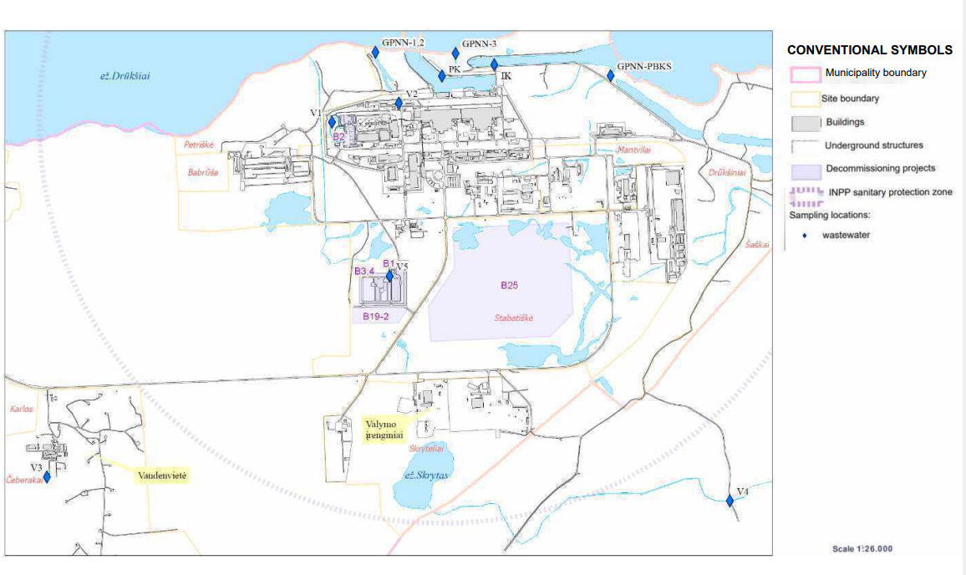

ANNEX 2. LAYOUT DIAGRAM OF PERMANENT MONITORING POINTS
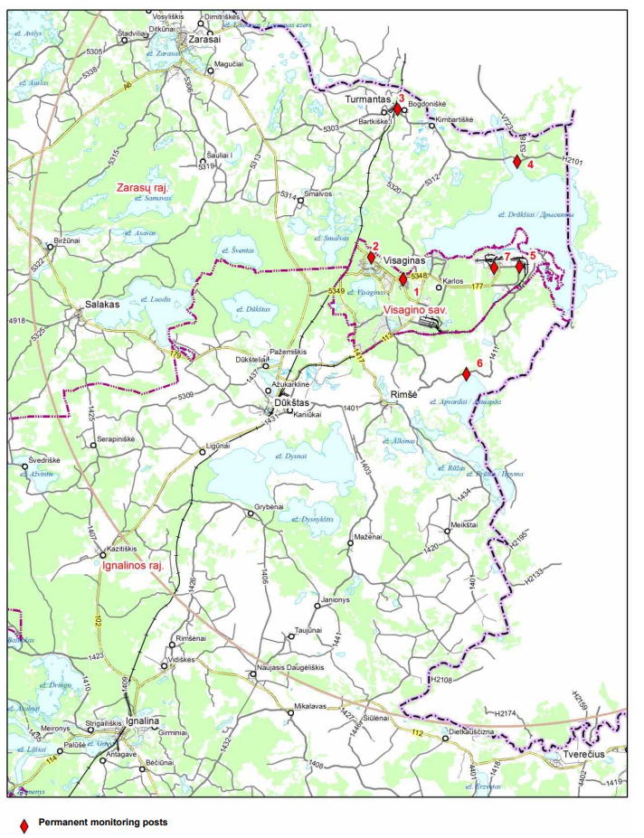
ANNEX 3. LAYOUT DIAGRAM OF ATMOSPHERIC PRECIPITATION AND DRAINAGE WATER SAMPLING LOCATIONS IN THE INPP AND IN THE SPENT FUEL DRY STORAGE FACILITY TERRITORIES
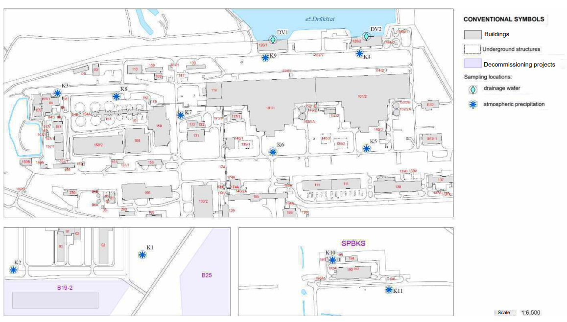

ANNEX 4. LAYOUT DIAGRAM OF “ZERO” BACKGROUND INVESTIGATION LOCATIONS
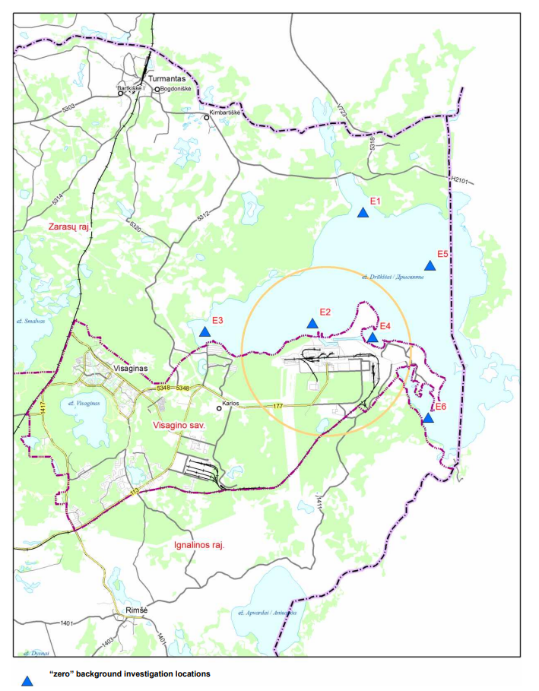

ANNEX 5. MONITORING BOREHOLE NETWORK INTENDED FOR MONITORING THE RADIOACTIVE WASTE STORAGE SITE AND THE SPECIAL SEWER ROUTE LOCATED BETWEEN BUILDINGS 150 AND 130
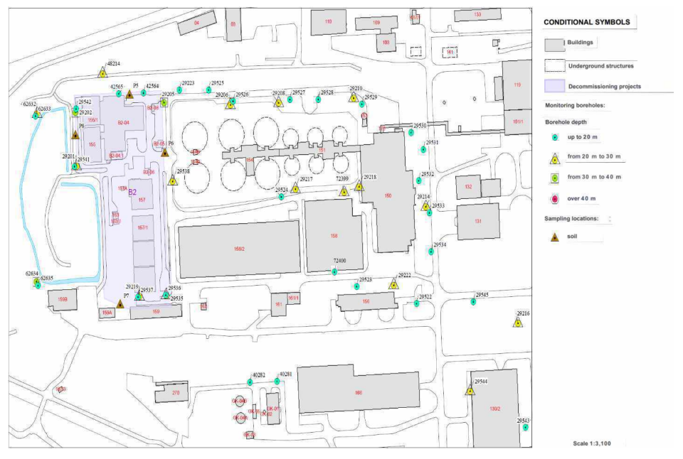

ANNEX 6. MONITORING BOREHOLE NETWORK OF THE TERRITORY OF INPP BUILDINGS 101/1 AND 101/2
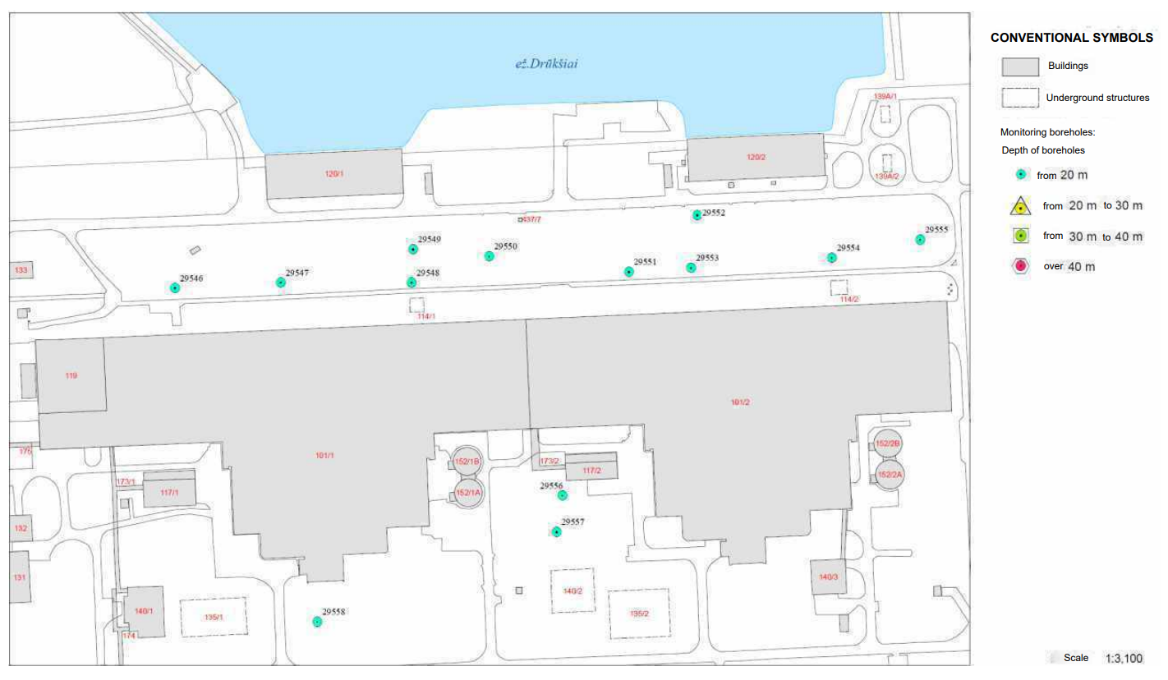

Annex 7. MONITORING BOREHOLE NETWORK OF THE INPP SFDSF SITE
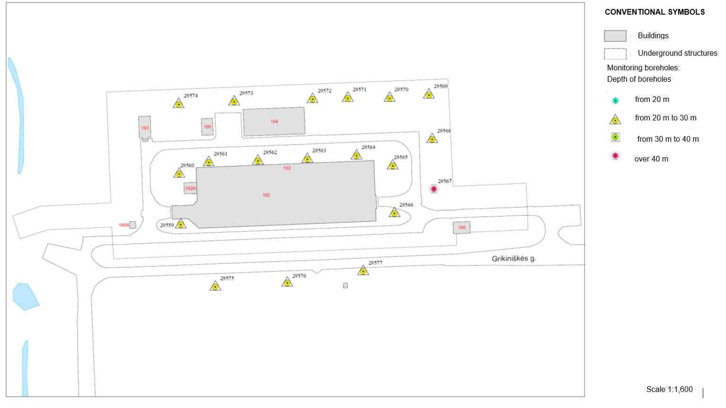

ANNEX 8. MONITORING BOREHOLE NETWORK OF THE SLUDGE STORAGE AREA OF THE TREATMENT FACILITIES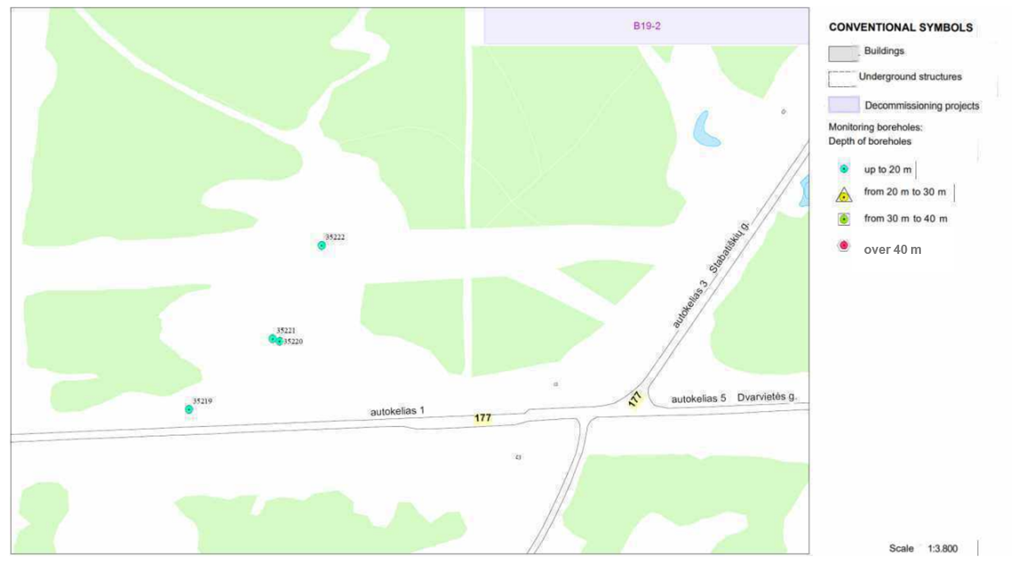

ANNEX 9. MONITORING BOREHOLE NETWORK AND SOIL SAMPLE COLLECTION POINTS AT THE BUFFER STORAGE FACILITY SITE
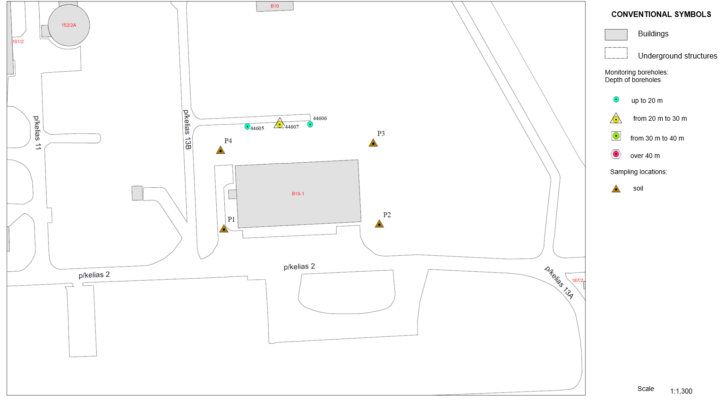

ANNEX 10. MONITORING BOREHOLE NETWORK AND SOIL SAMPLE COLLECTION POINTS AT THE LANDFILL FACILITY FOR SHORT-LIVED VERY LOW LEVEL WASTE AND THE ISFSF-SWTSF SITE
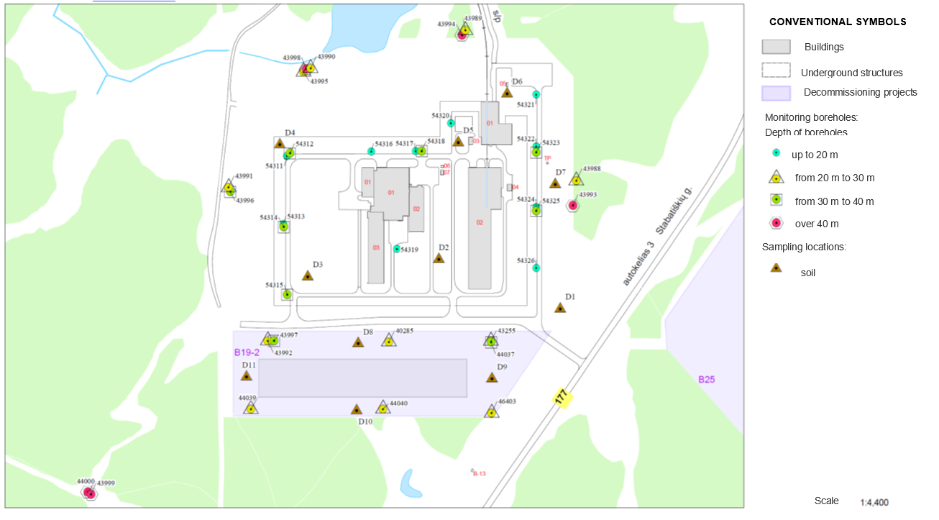

ANNEX 11. COORDINATES OF ENVIRONMENTAL MONITORING SAMPLE COLLECTION LOCATIONS OF THE MAIŠIAGALA RADIOACTIVE WASTE STORAGE FACILITY IN LKS-94
Location name | x-coordinate | y-coordinate
Borehole No. 1 | 6084327.00 | 561605.00
Borehole No. 2 | 6084322.00 | 561591.00
Borehole No. 3 | 6084325.00 | 561580.00
Borehole No. 4 | 6084334.00 | 561590.00
Borehole No. 5 | 6084347.00 | 561598.00
Borehole No. 6 | 6084379.00 | 561571.00
Borehole No. 7 | 6084376.00 | 561541.00
Borehole No. 8 | 6084313.00 | 561551.00
Borehole No. 41 | 6084331.00 | 561595.00
Borehole No. 42 | 6084330.00 | 561587.00
Borehole No. PZ10 | 6084413.20 | 561636.20

