
technical specification
Annex 1 to the Procurement Conditions
"Technical Specification"

Rehabilitation medical equipment

Public Body Central Project Management Agency is carrying out a public procurement procedure for the procurement of Rehabilitation medical equipment for the Zhytomyr Rehabilitation Center (hereinafter referred to as the Beneficiary). The goods offered by the suppliers shall meet the requirements set out in this Technical Specification.
No. | Feature | Technical specification requirement | Documents confirming compliance with the requirement
 | General requirements for the object of procurement
1.1. | Object of procurement | Rehabilitation medical equipment with delivery,  Goods must be manufactured and delivered accordance with the requirements set out below. | The supplier declares compliance with this requirement in section 5 of the Tender form.  Supplier must also provide manufacturer's technical documentation (catalogs, brochures) and/or product manufacturer's declarations (if the manufacturer's technical documentation does not fully reflect the compliance of the offered product with the requirements of the technical specification) or other equivalent documents proving the compliance of the offered product with the technical requirements
1.2. | Quantity | The quantities of rehabilitation medical equipment required are specified in Chapter 2 for each facility. | The supplier declares compliance with this requirement in section 5 of the Tender form.
1.3. | Delivery location | 22 Feshchenko-Chopivskoho St., Zhytomyr, Ukraine. | The supplier declares compliance with this requirement in section 5 of the Tender form.
1.4. | Manufacturing the equipment | The equipment must be new and unused and delivered in the manufacturer's original packaging. Used or used and refurbished items cannot be offered. | The supplier declares compliance with this requirement in section 5 of the Tender form.
1.5. | Warranty | All offered goods must be covered by a warranty of at least 12 months.  The warranty must be provided by the Supplier and/or by the manufacturer and/or its representative in the service location indicated in the territory of beneficiary’s country, and if there are no service stations of the Supplier, manufacturer or its representative in the indicated territory, the equipment shall be transported and returned by the Supplier for warranty service at its own expense from the Beneficiary's places of deployment. | The supplier declares compliance with this requirement in section 5 of the Tender form and also submits the following supporting document.
1.6. | Markings | The offered equipment shall be supplied as a medical device, where applicable, and shall be CE marked and legally placed on the market in accordance with applicable European Union legislation | The supplier declares compliance with this requirement in section 5 of the Tender form and also submits the following supporting documents.
1.7. | Medical purpose | All offered equipment shall be intended for professional rehabilitation use and suitable for repeated clinical operation in healthcare facilities. | The supplier declares compliance with this requirement in section 5 of the Tender form.
1.8. | Documentation to be supplied with the goods | All goods must be supplied with printed maintenance and user manual in English and/or one of the official languages of the beneficiary. | The supplier declares compliance with this requirement in section 5 of the Tender form.
2. | Technical requirements for rehabilitation equipment:
2.1. | Motorized upper and lower limb rehabilitation trainer  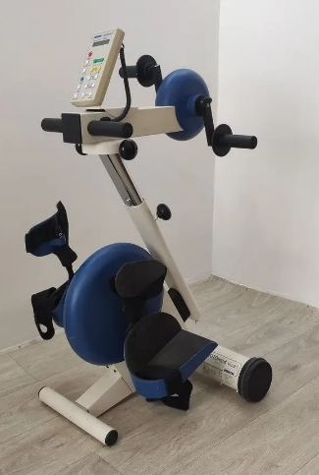 | Quantity – 1 pcs.  Intended use: Rehabilitation and restoration of upper and lower limb motor functions in patients with neurological, orthopedic, geriatric, or other mobility impairments. Main technical parameters not less than:  - The device shall be intended for rehabilitation therapy of both upper and lower limbs.  - The device shall support passive, active, and motor-assisted exercise modes.  - The device shall automatically detect the patient's active participation and provide motor assistance when the patient's muscle force is insufficient.  - The device shall be equipped with a motor drive system enabling therapy for patients with limited or absent voluntary movement.  - The device shall provide adjustable training parameters, including at least speed, resistance level, and therapy duration.  - The device shall include an automatic spasm detection and safety function that stops, reduces resistance, or reverses movement when abnormal resistance is detected.  - The device shall provide visual feedback and display therapy parameters and exercise results.  - The device shall be suitable for use by patients in a seated position, including wheelchair users.  - The device shall be supplied with all accessories required for both arm and leg therapy, including hand grips, foot supports, and fixation elements. | The supplier declares compliance with this requirement in section 5 of the Tender form.  Supplier must also provide manufacturer's technical documentation (catalogs, brochures) and/or product manufacturer's declarations (if the manufacturer's technical documentation does not fully reflect the compliance of the offered product with the requirements of the technical specification) or other equivalent documents, confirming compliance with requirements in paragraphs No.1 through 7.
2.2. | Mobile Body-Weight Support and Gait Training System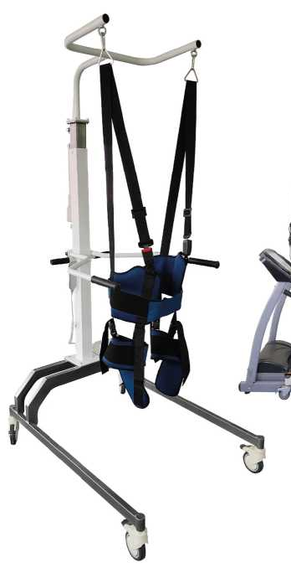 | Quantity – 2 pcs.  Intended for patient verticalization, body-weight supported standing, balance, transfer, and gait training in neurological, orthopedic, geriatric, and post-traumatic rehabilitation. Main technical parameters not less than:  - The device shall be a mobile rehabilitation system intended for patient verticalization, standing, balance, transfer, and gait training.  - The system shall provide adjustable partial body-weight support through a patient harness system.  - The device shall provide dynamic body-weight support during standing, balance, and gait rehabilitation activities.  - The system shall support progressive rehabilitation by allowing adjustment of the body-weight support level according to patient abilities and rehabilitation goals.  - The device shall support patient transfer, standing, balance, and walking exercises while reducing the risk of falls.  - The device shall be equipped with a patient harness or equivalent support system designed for safe and comfortable use during rehabilitation.  - The device shall allow height adjustment to accommodate patients of different heights and rehabilitation needs.  - The device shall be mounted on a mobile frame equipped with lockable wheels for safe transport and positioning.  - The system shall incorporate a fall-prevention mechanism preventing uncontrolled patient descent during therapy.  - The maximum patient weight capacity shall be not less than 150 kg.  - The device shall be suitable for use with patients requiring partial assistance for standing and gait training, including patients with neurological and orthopedic impairments.  - The device shall be supplied with all supports, fixation elements, harnesses, and accessories required for its intended operation. | The same requirement as in point 2.1
2.3. | Continuous Passive Motion (CPM) System for Ankle Joint Rehabilitation  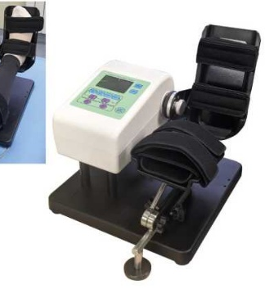 | Quantity – 1 pcs.  Intended for continuous passive mobilization of the ankle joint to support postoperative and post-traumatic rehabilitation, improve joint range of motion, reduce stiffness, and facilitate functional recovery while minimizing patient discomfort. Main technical parameters not less than:  - The device shall be intended for continuous passive motion therapy of the ankle joint.  - The device shall provide motorized passive plantar flexion and dorsiflexion movements of the ankle joint through a programmable range of motion.  - The device shall allow adjustment of therapy parameters, including at least the range of motion and treatment duration.  - The device shall allow adjustment of movement speed during therapy sessions.  - The device shall include patient safety functions, including automatic stop or equivalent protection in the event of excessive resistance during therapy.  - The device shall include adjustable supports and fixation elements to accommodate different patient anatomies and ensure proper limb positioning.  - The device shall be supplied with a handheld controller or integrated control panel for adjustment of therapy parameters. | The same requirement as in point 2.1
2.4. | Orthopedic Standing Frame with Electric Drive  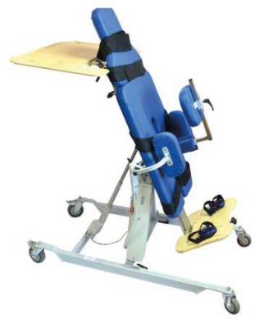 | Quantity – 1 pcs.  Intended for gradual patient verticalization and standing therapy to improve postural control, weight-bearing tolerance, circulation, and functional rehabilitation, while helping to prevent complications associated with prolonged sitting or lying. Main technical parameters not less than:  - The device shall be intended for safe patient verticalization and standing rehabilitation.  - The device shall be equipped with an electrically operated mechanism enabling gradual transition of the patient from a seated or reclined position to a standing position.  - The device shall allow adjustment of the standing angle according to individual patient rehabilitation needs.  - The device shall provide support in standing and semi-recumbent positions and shall include adjustable supports and stabilization elements for safe patient positioning.  - The device shall be equipped with a control system allowing the caregiver and/or patient to operate the verticalization function.  - The device shall incorporate safety features to prevent unintended movement and ensure patient stability during use.  - The device shall support gradual loading of the lower extremities and spine during verticalization therapy.  - The maximum patient weight capacity shall be not less than 100 kg.  - The device should be supplied with a handheld controller or integrated control panel for easy adjustment of therapy parameters.  - The device should be equipped with lockable castors to facilitate movement and positioning within the rehabilitation facility. | The same requirement as in point 2.1
2.5. | Continuous Passive Motion (CPM) System for Knee Joint Rehabilitation  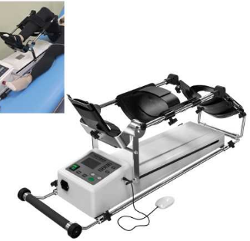 | Quantity – 1 pcs.  Intended for continuous passive mobilization of the knee joint to support postoperative and post-traumatic rehabilitation, improve joint range of motion, reduce stiffness, and facilitate recovery of knee function without active muscular effort by the patient. Main technical parameters not less than:  - The device shall be intended for continuous passive motion therapy of the knee joint.  - The device shall provide motorized passive flexion and extension movements of the knee joint through a programmable range of motion.  - The device shall allow adjustment of therapy parameters, including at least the range of motion and treatment duration.  - The device shall allow adjustment of movement speed during therapy sessions.  - The device shall include adjustable supports and fixation elements to accommodate different patient leg lengths and ensure proper positioning during treatment.  - The device shall incorporate patient safety features, including automatic stop or movement limitation in the event of excessive resistance during therapy.  - The device shall be equipped with a handheld controller or integrated control panel for adjustment of therapy parameters during treatment. | The same requirement as in point 2.1
2.6. | Bedside Active and Passive Lower Limb Rehabilitation Trainer  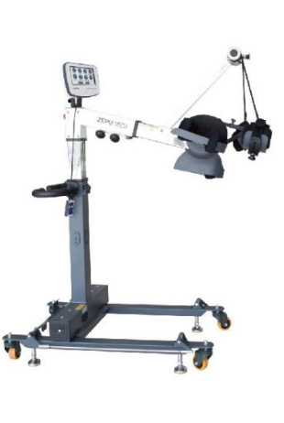 | Quantity – 1 pcs.  Intended for active, passive, and assisted mobilization of the lower limbs in bedridden or mobility-impaired patients to maintain or improve joint mobility, muscle activity, circulation, and functional recovery during rehabilitation. Main technical parameters not less than:  - The device shall be intended for rehabilitation and exercise of the lower limbs in bedridden or seated patients.  - The device shall be suitable for bedside rehabilitation and use by bedridden patients.  - The device shall support passive, active, and motor-assisted training modes.  - The device shall be equipped with a motor-driven system enabling passive exercise for patients with limited or absent voluntary movement.  - The device shall allow adjustment of training parameters, including at least speed, resistance level, and therapy duration.  - The device shall include foot supports or pedals designed to ensure safe and comfortable positioning of the patient's lower limbs during therapy.  - The device shall incorporate automatic spasm detection and safety features that stop or adjust operation in the event of abnormal resistance during therapy.  - The device shall provide visual feedback on training parameters and exercise performance. | The same requirement as in point 2.1
2.7. | Active and Passive Upper Limb Rehabilitation Trainer  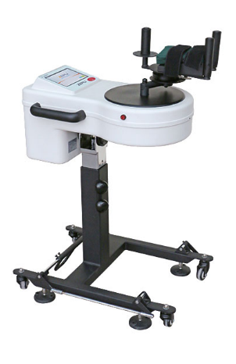 | Quantity – 1 pcs.  Intended for active, passive, and assisted rehabilitation of the upper limbs to improve arm function, joint mobility, muscle activity, coordination, and motor recovery in patients with neurological, orthopedic, or other mobility impairments. Main technical parameters not less than:  - The device shall be intended for rehabilitation and exercise of the upper limbs.  - The device shall support passive, assisted, active, and active-assisted training modes.  - The device shall be equipped with a motor-driven system enabling passive exercise for patients with limited or absent voluntary upper limb movement.  - The device shall provide training involving shoulder, elbow, and wrist movements.  - The device shall allow adjustment of training parameters, including at least speed, resistance level, and therapy duration.  - The device shall include hand grips or equivalent supports designed to ensure safe and comfortable positioning of the patient’s upper limbs during therapy.  - The device shall incorporate safety features that automatically stop or adjust operation in the event of abnormal resistance, including protection against excessive stretching during therapy.  - The device shall provide visual feedback on training parameters and exercise performance. | The same requirement as in point 2.1
2.8. | Mirror Therapy Table  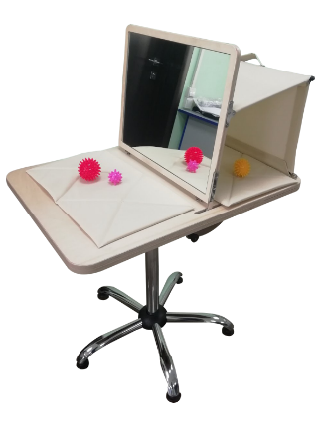 | Quantity – 1 pcs.  Intended for mirror therapy rehabilitation to promote neuroplasticity, improve motor function, reduce pain, and support recovery of upper limb function in patients with neurological, orthopedic, or post-traumatic conditions. Main technical parameters not less than:  - The device shall be intended for mirror therapy of the upper limbs in rehabilitation settings.  - The device shall incorporate a centrally positioned mirror or equivalent reflective surface enabling visual illusion therapy.  - The mirror shall allow the patient to view the reflection of the unaffected limb while obscuring direct view of the affected limb.  - The device shall provide a stable work surface suitable for performing therapeutic exercises of the upper limbs.  - The device shall be designed to accommodate patients in a seated position and allow comfortable access during therapy sessions.  - The device shall have a durable and easy-to-clean construction suitable for healthcare environments.  - The device should allow adjustment of the mirror position and/or table configuration to accommodate different therapeutic exercises and patient needs. | The same requirement as in point 2.1
2.9. | Corrective Rehabilitation Mirror  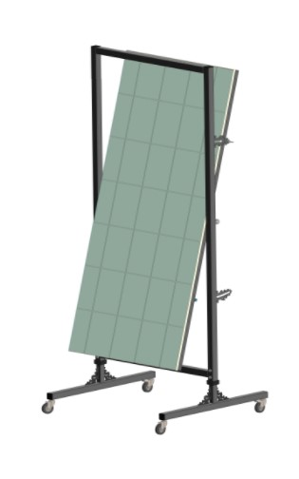 | Quantity – 1 pcs.  Intended for postural correction, movement control training, and rehabilitation exercises through visual feedback, enabling patients to improve body awareness, posture, balance, and motor control during therapeutic activities. Main technical parameters not less than:  - The device shall be intended for rehabilitation, posture correction, and movement control training using visual feedback.  - The device shall incorporate a full-length mirror or equivalent reflective surface enabling the patient to observe the entire body posture, alignment, and movement patterns during rehabilitation activities.  - The mirror shall provide a clear, distortion-free reflection.  - The device shall be designed to allow use by patients in standing and/or seated positions.  - The device shall have a stable construction.  - The device shall be manufactured from durable and easy-to-clean materials suitable for healthcare environments.  - The device should be equipped with a frame, support structure, or mobility solution allowing convenient positioning within a rehabilitation facility. | The same requirement as in point 2.1
2.10. | Vojta-Bobath Therapy Table with Electric Height Adjustment  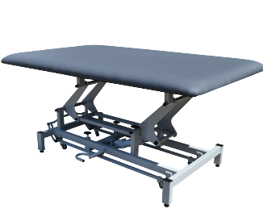 | Quantity – 2 pcs.  Intended for neurological rehabilitation, physiotherapy, and therapeutic interventions based on Vojta, Bobath, or equivalent concepts, providing a stable and spacious treatment surface for patient assessment, positioning, mobilization, and therapeutic exercises. Main technical parameters not less than:  - The device shall be intended for neurological rehabilitation and therapeutic interventions based on Vojta, Bobath, or equivalent concepts.  - The device shall provide electrically operated height adjustment.  - The device shall provide a treatment surface suitable for full-body positioning and therapeutic exercises.  - The device shall ensure ergonomic working conditions for therapists.  - The device shall have a stable construction and safe working load suitable for adult patients.  - The device shall be upholstered with durable and easy-to-clean material suitable for healthcare environments.  - The device shall be equipped with a mobility system and locking mechanism for positioning within the rehabilitation facility. | The same requirement as in point 2.1
2.11. | Computerized Cognitive Rehabilitation System  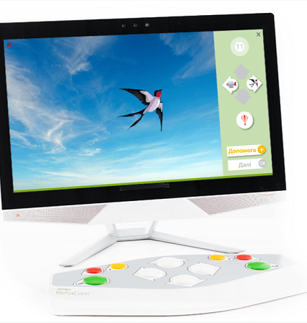 | Quantity – 1 pcs.  Intended for assessment, training, and rehabilitation of cognitive functions in patients with neurological, neuropsychological, or acquired cognitive impairments resulting from disease, injury, or other medical conditions. Main technical parameters not less than:  - The system shall include dedicated software specifically designed for clinical cognitive assessment, training, and rehabilitation.  - The system shall provide cognitive assessment and rehabilitation modules covering at least the following domains: attention, memory, executive functions, and visuospatial abilities.  - The system shall support individualized therapy planning through multiple training modules and adjustable difficulty levels.  - The system shall allow automatic adaptation of task difficulty according to patient performance.  - The system shall provide objective recording, storage, analysis, and reporting of patient assessment and training results.  - The system shall enable creation and management of individual patient profiles and therapy programs.  - The system shall support repeated assessment and monitoring of patient progress over time.  - The system shall include all hardware and software components necessary for its intended operation, including a display suitable for cognitive rehabilitation exercises and review of therapy results.  - The system shall include input and control devices suitable for use by patients with cognitive, neurological, or motor impairments.  - The user interface shall support operation by healthcare professionals and patients during supervised rehabilitation sessions. | The same requirement as in point 2.1
2.12 | Rehabilitation Treadmill  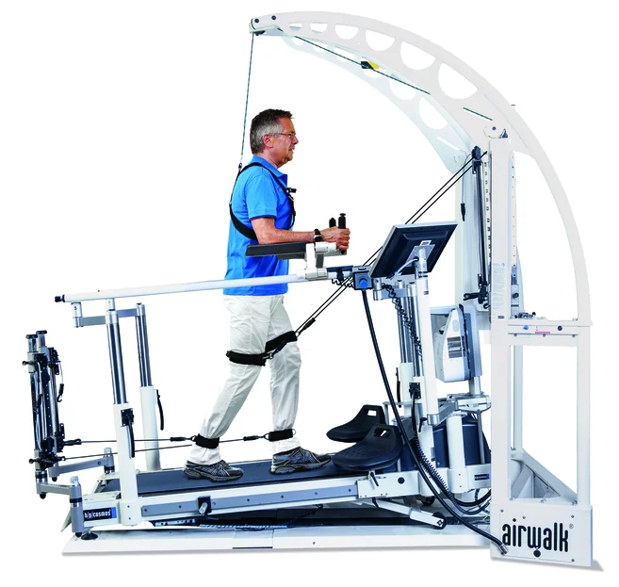 | Quantity – 1 pcs.  Intended for gait training, mobility rehabilitation, and restoration of walking ability in patients with neurological, orthopedic, cardiopulmonary, or other conditions affecting mobility and physical function. Main technical parameters not less than:  - The device shall be intended for medical rehabilitation and therapeutic gait training.  - The device shall allow controlled walking training at adjustable speeds suitable for patients with impaired mobility.  - The device shall allow adjustment of at least speed and training duration during therapy sessions.  - The device shall be equipped with handrails or equivalent support structures to ensure patient safety during training.  - The device shall incorporate an emergency stop function accessible to the patient and therapist.  - The device shall provide low-speed walking training suitable for patients with impaired gait and reduced mobility.  - The device shall provide a walking surface suitable for gait training activities.  - The device shall support progressive rehabilitation by allowing adjustment of training parameters according to patient abilities and rehabilitation goals.  - The device shall include a user interface for setting and monitoring training parameters.  - The device shall be suitable for use in neurological, orthopedic, and general rehabilitation settings.  - The device shall have a stable construction suitable for repeated clinical use.  - The device shall allow safe rehabilitation of patients requiring assistance with standing, balance, and gait training. | The same requirement as in point 2.1
2.13 | Rehabilitation Exercise Bike  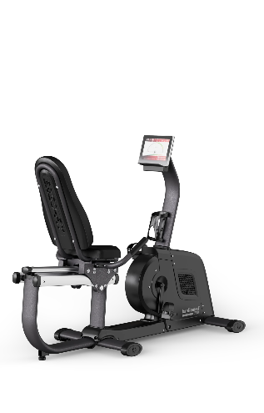 | Quantity – 1 pcs.  Intended for therapeutic exercise, cardiovascular conditioning, and rehabilitation of patients recovering from neurological, orthopedic, cardiopulmonary, or other medical conditions affecting physical function and mobility. Main technical parameters not less than:  - The device shall be specifically designed for medical rehabilitation and therapeutic exercise applications.  - The device shall enable lower-limb cycling exercises with electronically controlled adjustable workload levels suitable for patients with varying physical abilities.  - The device shall allow adjustment of exercise intensity to support individualized and progressive rehabilitation programs.  - The device shall provide real-time display and monitoring of exercise parameters, including at least training time, workload, and pedaling performance.  - The device shall provide a stable, ergonomic, and easily accessible design suitable for patients with reduced mobility.  - The device shall include adjustable seating and/or positioning elements to accommodate different patient anthropometric characteristics.  - The device shall include safety features ensuring safe use during rehabilitation sessions.  - The device shall include a user interface suitable for operation by healthcare professionals and patients during supervised rehabilitation sessions.  - The device shall be suitable for use in neurological, orthopedic, cardiopulmonary, and general rehabilitation settings. | The same requirement as in point 2.1
2.14 | Ceiling-Mounted Patient Lift and Dynamic Rehabilitation System  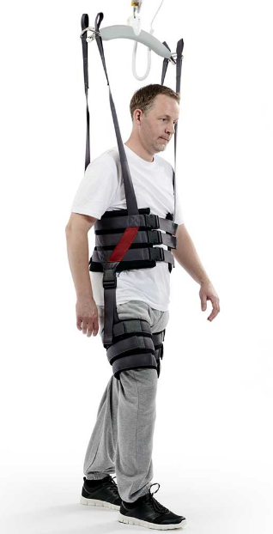 | Quantity – 1 pcs.  Intended for safe patient transfer, verticalization, body-weight supported rehabilitation, and therapeutic mobility training using a permanently installed ceiling-mounted rail system. Main technical parameters not less than:  - The system shall be a permanently installed ceiling-mounted patient lift and rehabilitation system.  - The system shall enable safe patient transfer between bed, wheelchair, therapy equipment, and other rehabilitation areas.  - The system shall provide body-weight support during rehabilitation activities.  - The system shall support patient verticalization and standing training.  - The system shall allow dynamic rehabilitation activities while maintaining continuous body-weight support.  - The system shall include a patient harness system suitable for transfer applications.  - The system shall incorporate fall-prevention functionality preventing uncontrolled patient descent.  - The system shall allow movement of the patient along a ceiling-mounted rail system.  - The system shall include powered lifting and lowering functionality.  - The maximum patient weight capacity shall be not less than 150 kg.  - The system shall be supplied with all rails, suspension components, harnesses, fixation elements, and accessories required for its intended operation. | The same requirement as in point 2.1
2.15 | Dynamic and Static Balance Assessment and Training System  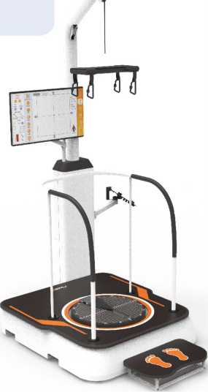 | Quantity – 1 pcs.  Intended for assessment, monitoring, and rehabilitation of balance, postural control, and coordination through static and dynamic balance testing and training in patients with neurological, vestibular, orthopedic, or other conditions affecting mobility and stability. Main technical parameters not less than:  - The system shall provide both static and dynamic balance assessment and training functions.  - The system shall include a force platform or equivalent sensor-based technology capable of measuring balance performance, weight distribution, and shifts in the patient's center of pressure.  - The system shall provide objective assessment of postural stability, balance performance, and weight-bearing asymmetries.  - The system shall provide real-time visual biofeedback, including graphical representation of center of pressure and weight-shift performance during assessment and training activities.  - The system shall include dedicated software for balance assessment, rehabilitation training, patient data management, and individualized therapy planning.  - The system shall support adjustable training difficulty levels and individualized rehabilitation programs.  - The system shall provide recording, storage, analysis, and reporting of patient assessment and training results for clinical evaluation and monitoring of rehabilitation progress.  - The system shall include dedicated assessment protocols and training programs for static and dynamic balance rehabilitation.  - The system shall be suitable for patients with neurological, vestibular, orthopedic, or age-related balance impairments.  - The system shall include a display and all hardware and software components necessary for its intended operation.  - The system shall incorporate patient safety measures suitable for balance assessment and training activities. | The same requirement as in point 2.1
2.16 | Rehabilitation Gait Training System  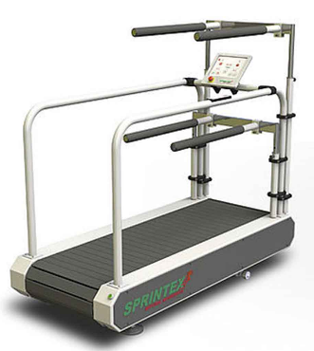 | Quantity – 1 pcs.  Intended for rehabilitation and restoration of physiological gait patterns, improvement of walking ability, balance, and lower limb function in patients with neurological, orthopedic, post-traumatic, or other mobility impairments. Main technical parameters not less than:  - The device shall be specifically designed for medical rehabilitation and gait training applications.  - The device shall enable repetitive gait training in an upright position.  - The device shall be equipped with adjustable support elements for patient stabilization during gait training.  - The device shall allow adjustment to accommodate patients of different body sizes and rehabilitation needs.  - The device shall provide safe gait training for patients with impaired balance or mobility.  - The device shall provide a safe working load of not less than 120 kg.  - The device shall be supplied with all components necessary for its intended operation.  - The device shall include a mechanical or dynamic support system intended to reduce loading on the musculoskeletal system during gait training. | The same requirement as in point 2.1
2.17 | Digital System for Assessment and Occupational Therapy Exercises  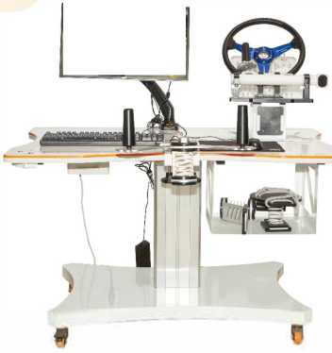 | Quantity – 1 pcs.  Intended for assessment, training, and rehabilitation of upper limb function, coordination, dexterity, and activities of daily living (ADL) in patients with neurological, orthopedic, or other conditions affecting upper extremity function. Main technical parameters not less than:  - The system shall provide digital assessment and rehabilitation training of upper limb functional abilities.  - The system shall include dedicated assessment and rehabilitation modules for upper limb gross motor function, fine motor function, coordination, dexterity, and movement control.  - The system shall support occupational therapy exercises simulating functional tasks and activities of daily living (ADL).  - The system shall include sensor-based technology enabling objective assessment, training, and analysis of upper limb movements.  - The system shall support unilateral and bilateral upper limb assessment and training activities.  - The system shall allow creation and management of individual patient profiles, therapy programs, and rehabilitation progress records.  - The system shall provide adjustable training difficulty levels according to patient performance and rehabilitation goals.  - The system shall provide real-time visual feedback during assessment and training activities.  - The system shall store assessment and training results and generate reports suitable for clinical evaluation and monitoring of rehabilitation progress.  - The system shall include interchangeable training accessories or equivalent solutions enabling different upper limb assessment and training tasks.  - The system shall include all hardware and software components necessary for its intended operation.  - The system shall be supplied with a display suitable for conducting assessment and occupational therapy exercises.  - The system shall be specifically designed and marketed for medical rehabilitation and occupational therapy applications. | The same requirement as in point 2.1
2.18 | Rehabilitation Gait Training System with Body-Weight Support  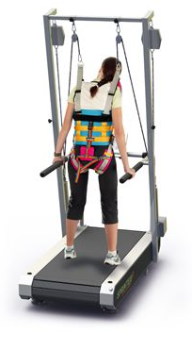 | Quantity – 1 pcs.  Intended for rehabilitation, restoration, and improvement of gait function through partial body-weight support, enabling safe gait training, balance training, and mobility rehabilitation in patients with impaired walking ability. Main technical parameters not less than:  - The device shall be specifically designed for medical rehabilitation and gait training applications.  - The system shall provide adjustable partial body-weight support during rehabilitation activities.  - The system shall enable gait training in an upright position while maintaining patient safety.  - The system shall include a patient harness or equivalent support system suitable for body-weight-supported rehabilitation.  - The system shall enable body-weight-supported gait training in combination with a rehabilitation treadmill.  - The system shall provide continuous patient support and fall prevention during rehabilitation activities.  - The system shall allow adjustment according to patient body size and rehabilitation requirements.  - The system shall support gait, balance, and mobility training for patients with neurological, orthopedic, or other mobility impairments.  - The system shall include a dynamic support mechanism enabling natural movement during rehabilitation activities.  - The system shall have a safe working load of not less than 150 kg.  - The device shall have a stable construction.  - The system shall be supplied with all components necessary for its intended operation. | The same requirement as in point 2.1
2.19 | Integrated Treadmill-Based Gait Rehabilitation System  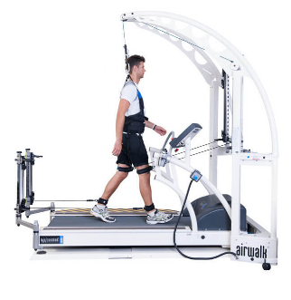 | Quantity – 1 pcs.  Intended for rehabilitation and restoration of walking ability through treadmill-based gait therapy with integrated body-weight support and fall-prevention functions for patients with neurological, orthopedic, post-traumatic, or other mobility impairments. Main technical parameters not less than:  - The system shall be specifically designed for medical rehabilitation and therapeutic gait training applications.  - The system shall integrate a rehabilitation treadmill, body-weight support system, and fall-prevention functionality within a single rehabilitation solution.  - The system shall provide adjustable partial body-weight support during gait rehabilitation.  - The body-weight support system shall include a patient harness or equivalent support mechanism.  - The system shall provide continuous patient support and fall-prevention protection during rehabilitation activities.  - The rehabilitation treadmill shall allow controlled gait training at adjustable walking speeds suitable for patients with impaired mobility.  - The system shall support early-stage rehabilitation of patients requiring body-weight-supported gait training.  - The system shall allow adjustment according to patient body size and rehabilitation requirements.  - The system shall have a safe working load of not less than 150 kg.  - The system shall include a user interface for setting and monitoring rehabilitation parameters.  - The system shall be supplied with all hardware, software, accessories, and components necessary for its intended operation. | The same requirement as in point 2.1
2.20 | Active-Passive Rehabilitation Exercise Bike  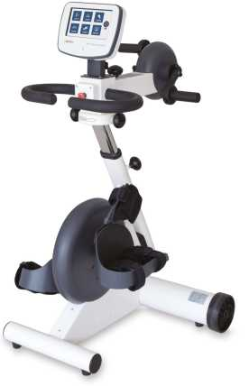 | Quantity – 1 pcs.  Intended for active, passive, and motor-assisted rehabilitation training to improve joint mobility, muscle function, circulation, and functional recovery in patients with neurological, orthopedic, post-traumatic, or other mobility impairments. Main technical parameters not less than:  - The device shall be specifically designed for medical rehabilitation and therapeutic exercise applications.  - The device shall support active, passive, and motor-assisted lower-limb training modes.  - The device shall include a motor-driven system enabling passive exercise for patients with limited or absent voluntary movement.  - The device shall provide automatic adaptation of training mode according to patient performance.  - The device shall allow adjustment of training parameters, including at least exercise speed, resistance level, and therapy duration.  - The device shall automatically detect abnormal resistance or muscle spasticity and provide an appropriate safety response, such as stopping, reducing resistance, or changing movement direction.  - The device shall provide visual display of training parameters and therapy results.  - The device shall include foot supports or pedals suitable for safe lower-limb rehabilitation exercises.  - The device shall allow adjustment to accommodate patients with different body sizes and functional abilities.  - The device shall be suitable for use by patients in a seated position, including patients with reduced mobility.  - The device shall support rehabilitation of patients with neurological, orthopedic, and post-traumatic conditions.  - The device shall be supplied with all hardware and accessories necessary for its intended operation. | The same requirement as in point 2.1
2.21 | Recumbent Rehabilitation Exercise Bike  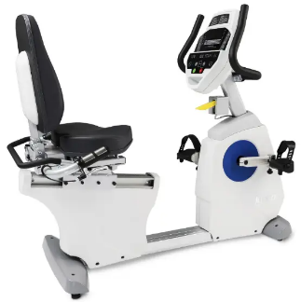 | Quantity – 1 pcs.  Intended for therapeutic exercise, mobility rehabilitation, and cardiovascular conditioning of patients with neurological, orthopedic, post-traumatic, or other conditions affecting physical function and mobility. Main technical parameters not less than:  - The device shall be specifically designed for medical rehabilitation and therapeutic exercise applications.  - The device shall be a recumbent exercise bike providing a stable and ergonomically supported seated position for rehabilitation patients.  - The device shall allow adjustment of exercise resistance according to patient abilities and rehabilitation goals.  - The device shall provide visual display of exercise parameters and training results.  - The device shall allow safe and convenient access for patients with reduced mobility.  - The device shall include adjustable seating and positioning elements to accommodate different patient body sizes. | The same requirement as in point 2.1
2.22 | Ceiling-Mounted Dynamic Body-Weight Support System with Parallel Bars  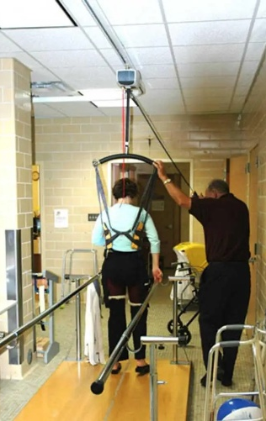 | Quantity – 1 pcs.  Intended for active rehabilitation, gait training, balance training, and restoration of functional mobility through dynamic body-weight support and patient stabilization during therapeutic exercises. Main technical parameters not less than:  - The device shall be specifically designed for active rehabilitation, gait training, balance training, and functional mobility exercises.  - The system shall include a ceiling-mounted body-weight support system enabling dynamic unloading of the patient during rehabilitation activities.  - The body-weight support system shall include a patient harness or equivalent body support mechanism.  - The system shall include parallel bars intended for upper limb support and patient stabilization during gait, balance, and functional mobility training.  - The system shall provide continuous patient support and fall-prevention protection during rehabilitation activities.  - The device shall allow adjustment according to patient body size and rehabilitation requirements.  - The system shall have a safe working load of not less than 150 kg.  - The system shall be supplied with all components necessary for its intended operation. | The same requirement as in point 2.1
2.23 | Positioning Aids (Rollers)  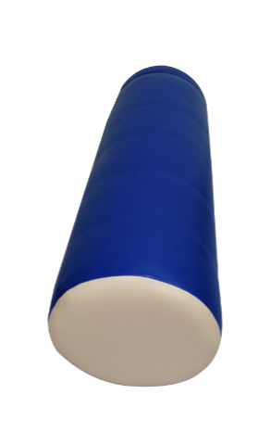 | Quantity – 10 pcs.  Intended for patient positioning, postural support, stabilization, and maintenance of physiologically appropriate body alignment during rehabilitation, therapeutic exercises, and patient care activities. Main technical parameters not less than:  - The positioning aids shall be intended for patient positioning, stabilization, and postural support during rehabilitation and therapeutic activities.  - The positioning aids shall provide support for maintaining physiologically appropriate body alignment.  - The positioning aid shall be of cylindrical shape.  - The positioning aid shall have a length of not less than 60 cm.  - The positioning aid shall have a diameter of not less than 20 cm.  - The positioning aids shall be manufactured from resilient material.  - The positioning aids shall be covered with durable, easy-to-clean, and disinfectant-resistant material.  - The positioning aids shall be suitable for use in rehabilitation, physiotherapy, occupational therapy, and patient care settings. | The same requirement as in point 2.1
2.24 | Rehabilitation Steps – 2-Step Unit  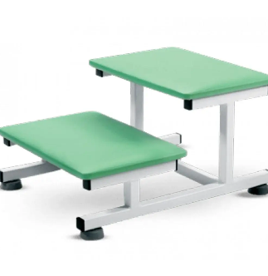 | Quantity – 2 pcs.  Intended for stair-climbing rehabilitation, gait training, and restoration of independent mobility skills in patients with mobility impairments. Main technical parameters not less than:  - The device shall consist of two rehabilitation steps intended for stair-climbing and gait training.  - The steps shall have a non-slip walking surface.  - The overall width of the step unit shall be not less than 60 cm.  - The overall length (depth) of the step unit shall be not less than 45 cm.  - The overall height of the step unit shall be not less than 30 cm.  - The device shall have a stable construction. | The same requirement as in point 2.1
2.25 | Digital Hand Function Rehabilitation Board  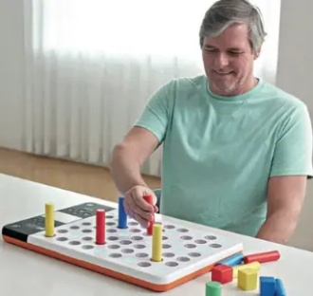 | Quantity – 1 pcs.  Intended for rehabilitation of hand and finger function, fine motor skills, and activities of daily living (ADL) through interactive object manipulation exercises. Main technical parameters not less than:  - The system shall consist of a rehabilitation board with physical objects, pegs, or equivalent manipulatives and integrated digital rehabilitation software.  - The rehabilitation board shall enable patients to perform hand and finger exercises by grasping, inserting, removing, positioning, or transferring physical objects within designated locations on the board.  - The system shall include sensor-based technology capable of detecting and recording the manipulation of objects during rehabilitation exercises.  - The system shall provide interactive task-oriented training activities based on manipulation of physical objects and hand movements.  - The system shall support exercises aimed at improving hand function, finger dexterity, grip control, object manipulation, and hand-eye coordination.  - The system shall provide real-time visual feedback during rehabilitation activities.  - The system shall allow adjustment of exercise difficulty according to patient abilities and rehabilitation goals.  - The system shall include all hardware and software components necessary for its intended operation.  - The offered equipment shall be specifically designed for medical rehabilitation and occupational therapy applications. | The same requirement as in point 2.1
2.26 | Rehabilitation Therapy Putty  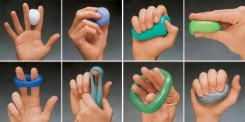 | Quantity – 10 pcs.  Intended for rehabilitation of hand and finger function, grip strength, finger dexterity, range of motion, and fine motor skills in patients with neurological, orthopedic, post-traumatic, or other hand function impairments. Main technical parameters not less than:  - The product shall be a reusable plastic/elastic therapeutic putty intended for hand, palm, wrist, and finger rehabilitation exercises.  - The putty shall allow therapeutic exercises based on squeezing, stretching, pinching, rolling, shaping, and finger-by-finger resistance movements.  - The product shall be available in different resistance levels to allow progressive hand rehabilitation according to patient ability.  - Different resistance levels shall be clearly distinguishable, for example by colour or equivalent marking.  - The putty shall be made of non-toxic material suitable for repeated therapeutic use.  - The product shall be supplied in individual containers or packaging suitable for hygienic storage between therapy sessions. | The same requirement as in point 2.1
2.27 | Patient Transfer and Safety Belt  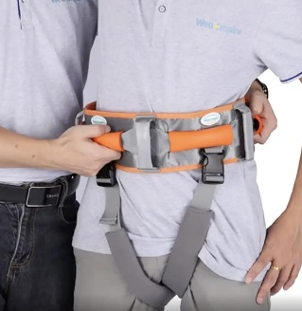 | Quantity – 3 pcs.  Intended for patient stabilization, assisted transfers, gait training, standing exercises, and mobility rehabilitation by providing a secure grip point for healthcare professionals during patient handling. Main technical parameters not less than:  - The product shall be a patient transfer and safety belt intended for assisted patient handling and mobility rehabilitation.  - The belt shall be designed to be secured around the patient's waist or trunk to provide a stable grip point for caregivers or rehabilitation professionals.  - The belt shall include integrated handles or gripping points enabling safe patient support during transfers, standing, and gait training activities.  - The belt shall incorporate an adjustable fastening system allowing adaptation to different patient body sizes.  - The product shall be available in different sizes and/or safe working load capacities suitable for patients of different body weights.  - The belt shall be manufactured from durable, reusable, and easy-to-clean materials.  - The product shall be suitable for use in rehabilitation, physiotherapy, occupational therapy, and patient care settings. | The same requirement as in point 2.1
2.28 | Standing Frame (Static Verticalizer)  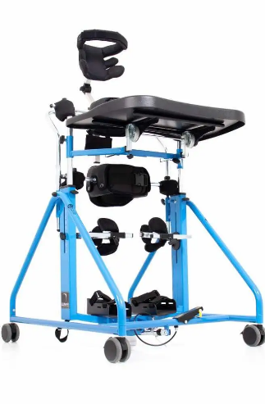 | Quantity – 1 pcs.  Intended for safe positioning and support of patients in an upright standing position for postural control rehabilitation, prevention of complications associated with prolonged immobility, weight-bearing therapy, and functional rehabilitation of patients with limited mobility. Main technical parameters not less than:  - The device shall be a static standing frame intended for positioning and supporting patients in an upright standing position.  - The device shall provide adjustable support elements for stabilization of the trunk, pelvis, and lower limbs during standing therapy.  - The device shall include safety straps, supports, or equivalent positioning systems for secure patient stabilization.  - The device shall allow adjustment according to patient body size and rehabilitation requirements.  - The device shall support weight-bearing therapy and postural control rehabilitation.  - The device shall have a stable construction.  - The device shall have a safe working load suitable for adult patients.  - The device shall be supplied with all components necessary for its intended operation. | The same requirement as in point 2.1
2.29 | Accessible Occupational Therapy Training Kitchen  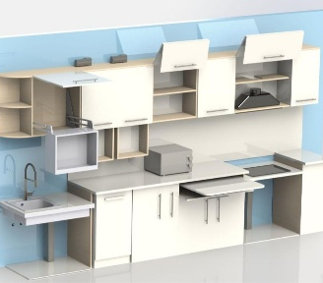 | Quantity – 1 pcs.  Intended for occupational therapy and activities of daily living (ADL) training, enabling patients with mobility limitations to practice food preparation, kitchen activities, and independent living skills in an accessible domestic environment. Main technical parameters not less than:  - The system shall consist of a fully equipped occupational therapy training kitchen designed for rehabilitation and ADL training purposes.  - The kitchen furniture arrangement shall provide a total working length of not less than 4.0 m.  - The system shall include, as a minimum, one sink unit with mixer tap, one food preparation worktop area, one cooking area, wall-mounted storage cabinets, base storage cabinets and/or drawer units, and at least one tall storage cabinet or equivalent full-height storage unit.  - The system shall include at least one dishwasher or equivalent appliance intended for training of dishwashing and kitchen maintenance activities.  - The system shall include not less than two wall-mounted storage cabinets equipped with an electrically operated shelf-lowering mechanism or equivalent accessibility solution enabling access for users with limited reach.  - The system shall include a cooking area with electrically adjustable working height or equivalent accessibility solution suitable for users with reduced mobility.  - The system shall include at least one workstation with free knee clearance suitable for wheelchair users.  - The system shall include not less than three base storage cabinets and/or drawer units intended for training of object handling, organization, and household management activities.  - The system shall include an integrated waste container system or equivalent solution for training of household waste management activities.  - The system shall enable training of reaching, grasping, carrying, handling, food preparation, cleaning, organization, and other activities of daily living.  - The system shall be supplied, installed, connected, and fully commissioned, including all furniture, appliances, fittings, accessories, and ancillary components required for its intended use, with all functions operational and ready for use upon handover. | The same requirement as in point 2.1
2.30 | Rehabilitation Stairs with Inclined Plane  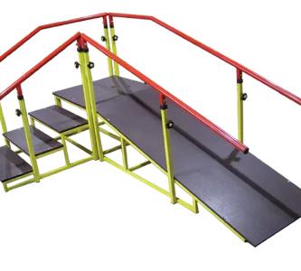 | Quantity – 1 pcs.  Intended for gait rehabilitation, stair-climbing training, ramp walking training, balance rehabilitation, and restoration of functional mobility in patients with neurological, orthopedic, post-traumatic, or other mobility impairments. Main technical parameters not less than:  - The device shall consist of a rehabilitation staircase and an inclined walking plane (ramp) integrated into a single rehabilitation unit.  - The staircase shall include not less than three steps intended for ascent and descent training.  - The inclined plane shall be connected to the staircase and intended for training of walking on inclined surfaces.  - The system shall be equipped with continuous handrails on both sides of the staircase and inclined plane for patient support and stabilization.  - The device shall enable training of stair climbing, stair descent, ramp walking, balance, coordination, and functional mobility skills.  - The walking surfaces of the stairs and inclined plane shall be non-slip and suitable for repeated rehabilitation use.  - The overall width of the walking surface shall be not less than 60 cm.  - The device shall have a stable construction.  - The device shall be supplied with all components necessary for its intended operation. | The same requirement as in point 2.1
2.31 | Rehabilitation Parallel Bars with Obstacles  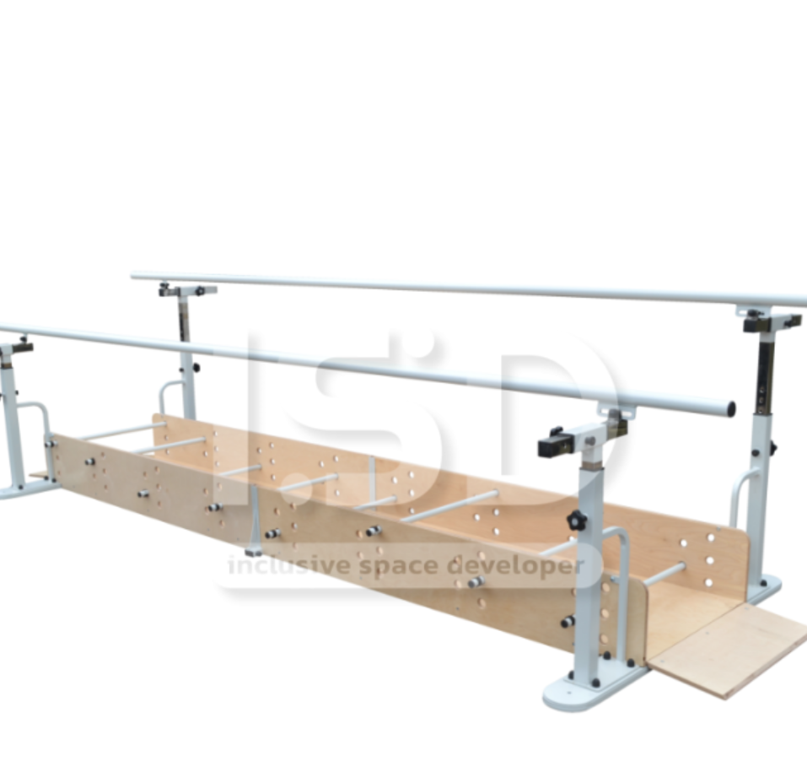 | Quantity – 1 pcs.  Intended for gait rehabilitation, obstacle negotiation training, balance and coordination exercises, and restoration of functional mobility in patients with neurological, orthopedic, post-traumatic, or other mobility impairments. Main technical parameters not less than:  - The device shall consist of rehabilitation parallel bars with integrated obstacle elements forming a single gait training unit.  - The system shall enable training of stepping over obstacles, gait pattern restoration, balance, coordination, and lower-limb motor function.  - The parallel bars shall be adjustable in height to accommodate different patient body sizes and rehabilitation requirements.  - The distance between the parallel bars shall be adjustable.  - The obstacle elements shall be removable, adjustable, or configurable to allow adaptation of training difficulty according to patient abilities and rehabilitation goals.  - The usable training pathway length shall be not less than 2.5 m.  - The system shall include handrails on both sides of the walking pathway for patient support and stabilization during rehabilitation activities.  - The device shall be supplied, installed, and commissioned with all components necessary for its intended operation. | The same requirement as in point 2.1
2.32 | Transfer Board  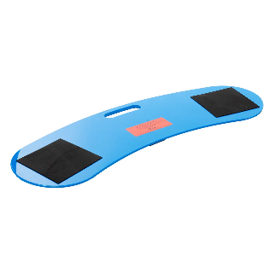 | Quantity – 1 pcs.  Intended to facilitate safe transfer of persons with limited mobility between a wheelchair, bed, chair, toilet chair, bath, or other surfaces of similar height. Main technical parameters not less than:  - The product shall be a rigid transfer board intended for seated patient transfers between adjacent surfaces.  - The board shall have a smooth sliding surface and a curved or semi-circular shape facilitating positioning during transfer.  - The board shall be equipped with a carrying handle and anti-slip elements or equivalent stability solution.  - The effective board length shall be not less than 75 cm.  - The board shall have a safe working load of not less than 130 kg. | The same requirement as in point 2.1
2.33 | Suspension Therapy Cage (UGUL Type)  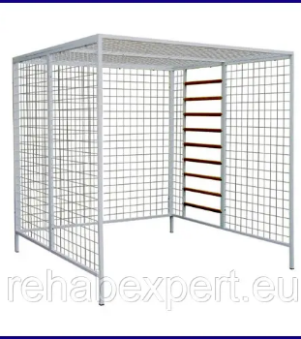 | Quantity – 1 pcs.  Intended for suspension therapy, pulley therapy, muscle strengthening, range of motion exercises, balance training, coordination training, and functional rehabilitation of neurological, orthopedic, and post-traumatic patients. Main technical parameters not less than:  - The device shall be a rehabilitation suspension therapy cage (UGUL type) intended for performance of exercises using suspension and pulley systems.  - The cage dimensions shall be not less than 200 × 200 cm.  - The structure shall provide multiple attachment points on side walls and ceiling for suspension systems, elastic cords, slings, ropes, pulleys, and therapeutic accessories.  - The system shall enable partial or complete unloading of selected body segments during therapeutic exercises.  - The system shall support active, active-assisted, and resisted therapeutic exercises.  - The system shall allow application of pulley-and-weight therapy or equivalent resistance system.  - The cage shall be suitable for performance of suspension therapy, balance training, coordination training, and functional movement exercises.  - The device shall be supplied with suspension and pulley therapy accessories, including slings, straps, ropes, pulleys, and attachment elements necessary for its intended operation.  - The structure shall be manufactured from durable metal profiles.  - The device shall be supplied, installed, and commissioned with all components required for its intended operation. | The same requirement as in point 2.1
2.34 | Suspension Therapy System (Neurac Type)  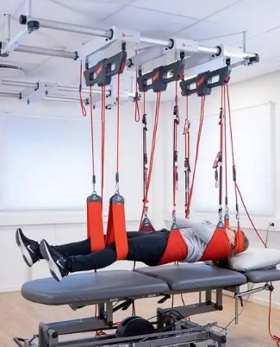 | Quantity – 1 pcs.  Intended for suspension therapy, neuromuscular activation, motor control training, pain reduction, restoration of functional movement patterns, and rehabilitation of neurological, orthopedic, and musculoskeletal disorders. Main technical parameters not less than:  - The system shall be a ceiling-mounted suspension therapy system intended for neuromuscular rehabilitation and therapeutic exercise using body-weight support and suspension techniques.  - The system shall include a ceiling-mounted suspension system with movable suspension points enabling positioning of suspension elements within the therapy area.  - The system shall enable full-body suspension as well as selective unloading of individual body segments during therapeutic exercises.  - The system shall include suspension ropes, slings, straps, handles, and attachment elements necessary for performance of suspension therapy exercises.  - The system shall include elastic resistance elements of different resistance levels suitable for progression of therapeutic exercises.  - The system shall allow rapid adjustment of suspension points, ropes, slings, and resistance elements according to patient needs and therapeutic goals.  - The system shall support exercises aimed at neuromuscular activation, stabilization, balance, coordination, strength development, and restoration of functional movement patterns.  - The system shall allow treatment and exercise performance both with and without a therapy table.  - The system shall be suitable for patients with neurological, orthopedic, post-traumatic, and musculoskeletal conditions.  - The system shall be supplied, installed, and commissioned, including all ceiling mounting components, suspension elements, fixation systems, and accessories required for its intended operation. | The same requirement as in point 2.1
2.35 | Robotic Glove for Hand Rehabilitation  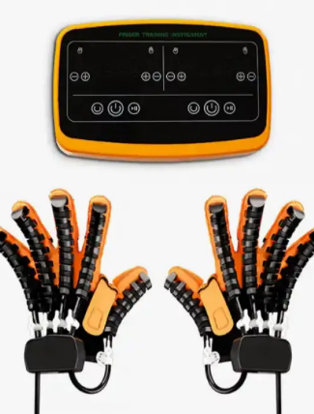 | Quantity – 1 pcs.  Intended for rehabilitation of hand and finger motor function, neuromuscular re-education, restoration of grasping ability, and recovery of upper limb function in patients with neurological, post-stroke, traumatic, or musculoskeletal disorders. Main technical parameters not less than:  - The system shall consist of robotic rehabilitation gloves for both the left and right hand, a control unit, and all accessories necessary for therapy.  - The system shall provide robot-assisted rehabilitation of hand and finger movements through automated flexion and extension of the fingers.  - The system shall allow adjustment of therapy parameters, including movement speed, assistance level, and selection of individual fingers or finger groups.  - The system shall provide bilateral rehabilitation training and mirror therapy functionality, enabling movements performed by one hand to be reproduced by the opposite hand.  - The system shall include a user interface for selection and control of therapy programs.  - The system shall be available in different glove sizes suitable for adaptation to different patient hand dimensions.  - The system shall be suitable for patients after stroke, traumatic brain injury, neurological disorders, hand injuries, or other conditions affecting hand function.  - The device shall be supplied, installed, configured, and commissioned with all functions operational upon handover. | The same requirement as in point 2.1
2.36 | Occupational Therapy Manipulative Training Set   | Quantity – 10 pcs.  Intended for occupational therapy, development and rehabilitation of fine motor skills, hand-eye coordination, cognitive functions, object manipulation skills, and functional independence in activities of daily living. Main technical parameters not less than:  - The set shall consist of not less than 10 different occupational therapy training items intended for manipulation, sorting, matching, assembly, sequencing, or problem-solving activities.  - The set shall include at least:  2 wooden puzzles;  2 stacking or pyramid-type training devices;  2 shape sorting or matching training games;  2 manipulative coordination training devices intended for grasping, placing, rotating, or assembling objects;  2 cognitive training games intended for development of attention, visual perception, sequencing, or problem-solving skills.  - The training items shall support development or rehabilitation of fine motor skills, grasping, finger dexterity, bilateral hand use, and hand-eye coordination.  - The training items shall support training of cognitive functions, including attention, visual perception, spatial orientation, matching, sequencing, planning, and problem solving.  - The set shall include items of different complexity levels suitable for use with patients of different functional abilities and rehabilitation goals.  - The training items shall be manufactured from durable wood or equivalent durable materials suitable for repeated use in rehabilitation settings.  - The set shall be supplied complete with all components necessary for its intended use. | The same requirement as in point 2.1
2.37 | Rehabilitation Stairs for Gait Training  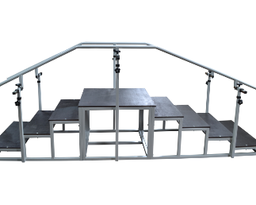 | Quantity – 1 pcs.  Intended for rehabilitation and training of stair ascent and descent, restoration of gait function, balance, coordination, and functional mobility in adult patients with neurological, orthopedic, post-traumatic, or other mobility impairments. Main technical parameters not less than:  - The device shall consist of a rehabilitation staircase with a central platform and stair sections on both sides intended for training of stair ascent and descent.  - The overall length of the staircase shall be not less than 2900 mm.  - The staircase shall be equipped with continuous handrails on both sides of the walking path.  - The handrails shall be adjustable in height and width to accommodate different patient body dimensions and rehabilitation requirements.  - The handrail adjustment range shall be not less than 525–925 mm in height and 450–650 mm in width or equivalent.  - The staircase shall provide at least two different step heights suitable for progressive rehabilitation training.  - The step depth shall be not less than 300 mm.  - The stair and platform surfaces shall be non-slip and suitable for repeated rehabilitation use.  - The device shall support training of gait, balance, coordination, stair negotiation skills, and lower-limb muscle function.  - The device shall have a safe working load of not less than 100 kg.  - The device shall be supplied with all components necessary for its intended operation. | The same requirement as in point 2.1
2.38 | Auxiliary Rehabilitation and Therapeutic Exercise Equipment Set  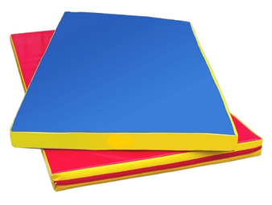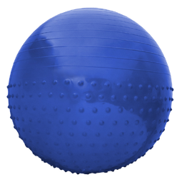  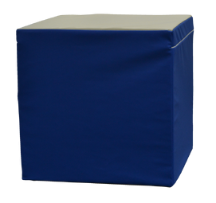 | Quantity – 1 pcs.  Intended for therapeutic exercise, physiotherapy, positioning, balance training, strengthening exercises, motor function recovery, and functional rehabilitation of patients with neurological, orthopedic, post-traumatic, or other movement disorders. Main technical parameters not less than:  - The set shall consist of auxiliary rehabilitation and therapeutic exercise equipment intended for use in physiotherapy, rehabilitation, and therapeutic exercise programs.  - The set shall include not less than one item from each of the following categories:  - gymnastic ball;  - rehabilitation exercise mat;  - ankle weights or equivalent limb-loading device;  - rehabilitation dumbbells with fixation straps or equivalent grip-assist solution;  - positioning cube;  - positioning roller;  - positioning wedge;  - positioning half-roller.  - The positioning aids shall be manufactured from resilient foam or equivalent material suitable for patient support and positioning.  - The exercise equipment shall be suitable for balance training, coordination training, strengthening exercises, flexibility training, positioning, and functional rehabilitation activities.  - The set shall be supplied complete with all components necessary for its intended use. | The same requirement as in point 2.1
2.39 | Bedside Active-Passive Lower Limb Rehabilitation System  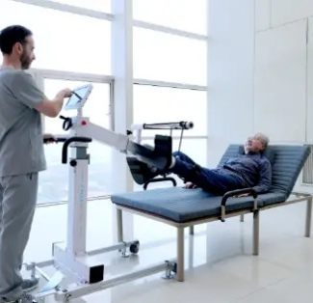 | Quantity – 1 pcs.  Intended for bedside rehabilitation of lower limbs in patients with limited mobility, enabling active, intelligent-assisted, and passive movement training, muscle activation, neuromuscular stimulation, and circulation improvement while the patient remains in a supine position. Main technical parameters not less than:  - The device shall be a motorized bedside rehabilitation system intended for lower-limb training while the patient is in a supine position.  - The system shall provide passive, active, and intelligent-assisted training modes or equivalent functionality.  - The device shall perform cyclic lower-limb movement exercises and include adjustable foot support elements suitable for different patients.  - The system shall include a touch-screen user interface with a screen size of not less than 10 inches.  - The system shall provide real-time training feedback, recording, storage, and quantitative evaluation of training results.  - The system shall include built-in interactive rehabilitation programs or equivalent patient-engagement functionality.  - The device shall perform automatic self-diagnostics at start-up and notify the user of detected faults.  - The device weight shall not exceed 50 kg and shall be suitable for bedside use within a rehabilitation or healthcare facility.  - The device shall be supplied, installed, configured, and commissioned with all accessories required for its intended operation. | The same requirement as in point 2.1
2.40 | Kinesiology Tape  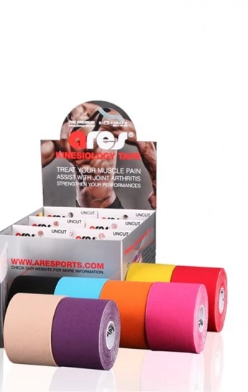 | Quantity – 30 pcs.  Intended for use in physiotherapy, rehabilitation, sports medicine, and therapeutic taping procedures to support muscles and joints, facilitate proprioceptive stimulation, and assist functional rehabilitation without restricting physiological range of motion. Main technical parameters not less than:  - Elastic kinesiology tape intended for rehabilitation and therapeutic taping procedures.  - Breathable, skin-compatible, and water-resistant construction with hypoallergenic adhesive.  - Shall allow unrestricted physiological range of motion during wear.  - Dimensions not less than 5 cm × 5 m per roll. | The same requirement as in point 2.1
3. | Technical requirements for physiotherapy equipment:
3.1. | TECAR Therapy Device  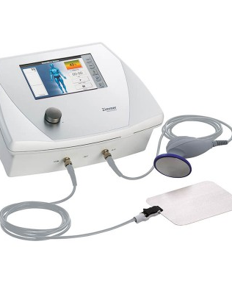 | Quantity – 1 pcs.  Intended for pain management, stimulation of tissue regeneration, improvement of circulation, reduction of muscle tension, and rehabilitation of musculoskeletal, orthopedic, post-traumatic, and neurological conditions. Main technical parameters not less than:  - The device shall utilize capacitive-resistive energy transfer (TECAR / T-CaRe technology) or equivalent radiofrequency diathermy technology for therapeutic treatment of biological tissues.  - The system shall provide both capacitive and resistive treatment modes intended for treatment of superficial and deep tissues.  - The device shall enable treatment of muscles, tendons, ligaments, cartilage, joints, and other soft tissues through controlled deep tissue heating.  - The operating frequency shall be within the radiofrequency range and not less than 300 kHz.  - The output power shall be adjustable and not less than 150 W.  - The system shall provide continuous and pulsed treatment modes or equivalent functionality.  - The device shall include a colour touch-screen user interface for selection and adjustment of treatment parameters.  - The system shall be supplied with capacitive and resistive applicators and all electrodes required for its intended operation.  - The device shall include automatic protection against overheating and system faults or equivalent safety functions.  - The device shall be supplied, installed, configured, and commissioned with all accessories required for its intended operation. | The supplier declares compliance with this requirement in section 5 of the Tender form.  Supplier must also provide manufacturer's technical documentation (catalogs, brochures) and/or product manufacturer's declarations (if the manufacturer's technical documentation does not fully reflect the compliance of the offered product with the requirements of the technical specification) or other equivalent documents, confirming compliance with requirements in paragraphs No.1 through 7.
3.2 | Electrophoresis and Galvanization Device  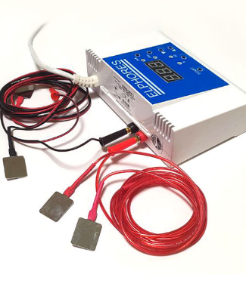 | Quantity – 1 pcs.  Intended for galvanization and medicinal electrophoresis procedures, enabling transdermal delivery of medicinal substances using controlled direct current in physiotherapy and rehabilitation practice. Main technical parameters not less than:  - The device shall provide both galvanization and medicinal electrophoresis treatment modes.  - The system shall generate electronically controlled and stabilized direct current with treatment current not less than 50 mA.  - The device shall allow adjustment of treatment duration and treatment current parameters and provide digital display of active treatment settings.  - The system shall include automatic patient safety functions, including controlled current reduction at the end of treatment and protection against interruption of electrode contact or equivalent functionality.  - The device shall be supplied with reusable electrodes, patient leads, and all accessories required for galvanization and medicinal electrophoresis procedures.  - The device shall be supplied, installed, configured, and commissioned with all functions operational upon handover. | The same requirement as in point 3.1
3.3 | Ultrasound Therapy Device  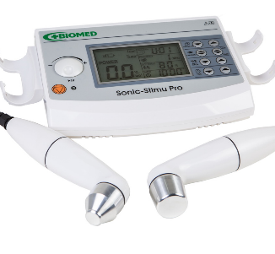 | Quantity – 2 pcs.  Intended for therapeutic ultrasound treatment, pain reduction, stimulation of tissue healing and regeneration, and rehabilitation of musculoskeletal, orthopedic, neurological, and post-traumatic conditions. Main technical parameters not less than:  - The device shall provide therapeutic ultrasound treatment in continuous and pulsed modes.  - The system shall operate at two ultrasound frequencies suitable for treatment of superficial and deep tissues.  - The device shall be supplied with at least two ultrasound applicators of different effective treatment areas suitable for treatment of small and large anatomical regions.  - The system shall allow adjustment of treatment intensity and treatment parameters and shall include pre-programmed and user-configurable therapy protocols.  - The device shall provide applicator contact monitoring and automatic protection against ineffective ultrasound delivery or overheating.  - The applicators shall be suitable for contact and underwater ultrasound therapy.  - The device shall be supplied with all applicators, accessories, and components required for its intended operation. | The same requirement as in point 3.1
3.4 | Shockwave Therapy Device  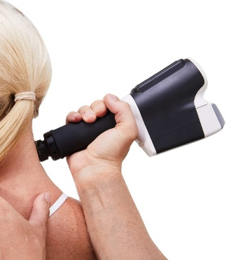 | Quantity – 1 pcs.  Intended for non-invasive radial shockwave therapy for treatment of musculoskeletal disorders, pain reduction, stimulation of tissue regeneration, and rehabilitation of orthopedic, sports-related, and post-traumatic conditions. Main technical parameters not less than:  - The device shall provide radial shockwave therapy using high-energy acoustic waves.  - The system shall provide adjustable treatment energy within a range not less than 1–4 bar (or equivalent energy output) and adjustable pulse frequency of not less than 1–20 Hz.  - The device shall include pre-programmed treatment protocols and the possibility to create or modify user-defined treatment parameters.  - The system shall be supplied with at least one treatment handpiece and interchangeable applicators suitable for treatment of different anatomical regions and clinical indications.  - The device shall include an integrated display for setting and monitoring treatment parameters during therapy sessions.  - The system shall be portable and suitable for use in different treatment rooms or mobile rehabilitation services.  - The device shall be supplied with all applicators, accessories, cables, and components required for its intended operation. | The same requirement as in point 3.1
3.5 | Low-Frequency Magnetotherapy Device  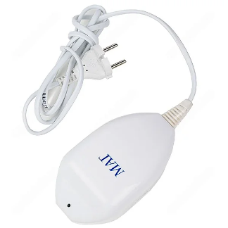 | Quantity – 2 pcs.  Intended for low-frequency magnetotherapy procedures using an alternating magnetic field for therapeutic treatment and rehabilitation of musculoskeletal, neurological, vascular, and post-traumatic conditions. Main technical parameters not less than:  - The device shall generate a low-frequency alternating non-uniform magnetic field intended for therapeutic application to biological tissues.  - The magnetic field induction at the treatment surface shall be not less than 30 mT.  - The device shall be intended for local magnetotherapy treatment of different anatomical regions.  - The system shall include an integrated treatment timer with automatic termination of the procedure.  - The device shall be portable and suitable for use in rehabilitation, physiotherapy, and healthcare settings.  - The device shall be supplied with all components required for its intended operation. | The same requirement as in point 3.1
3.6 | Combined Magnetotherapy Device  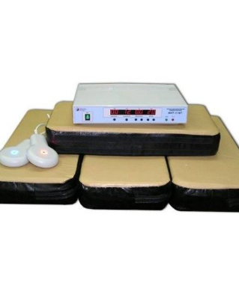 | Quantity – 1 pcs.  Intended for physiotherapy and rehabilitation procedures using combined magnetic field and light therapy for treatment of musculoskeletal, neurological, vascular, post-traumatic, and chronic conditions. Main technical parameters not less than:  - The device shall provide treatment using a low-frequency pulsed magnetic field.  - The system shall provide combined magnetic field and light therapy and shall allow both simultaneous and independent application of these treatment modalities.  - The device shall include pre-programmed treatment protocols and allow selection of therapy parameters according to clinical indications.  - The system shall be suitable for treatment of different anatomical regions through local application of therapy.  - The device shall include visual indication of operating mode and treatment parameters.  - The system shall be supplied with all applicators, emitters, accessories, and components required for its intended operation.  - The device shall be supplied, installed, configured, and commissioned with all functions operational upon handover. | The same requirement as in point 3.1
3.7 | Darsonval and Ultratone Therapy Device  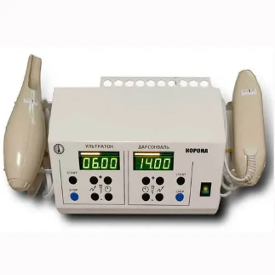 | Quantity – 1 pcs.  Intended for physiotherapy procedures aimed at improving microcirculation, stimulating tissue regeneration, reducing pain, and supporting rehabilitation of neurological, musculoskeletal, vascular, and dermatological conditions. Main technical parameters not less than:  - The device shall provide darsonvalization and ultratone therapy procedures using high-frequency electrical currents.  - The system shall include not less than two independent treatment channels allowing simultaneous treatment of two anatomical regions or two patients.  - The device shall allow independent adjustment of treatment intensity for each treatment channel.  - The system shall include integrated treatment timers with automatic procedure completion indication.  - The device shall be supplied with not less than 12 interchangeable glass electrodes suitable for treatment of different anatomical regions and clinical applications.  - The system shall be suitable for local physiotherapy applications in rehabilitation, neurology, sports medicine, vascular therapy, dermatology, and related fields.  - The device shall be supplied with all electrodes, accessories, and components required for its intended operation.  - The device shall be supplied, installed, configured, and commissioned with all functions operational upon handover. | The same requirement as in point 3.1
3.8 | Electrotherapy Device  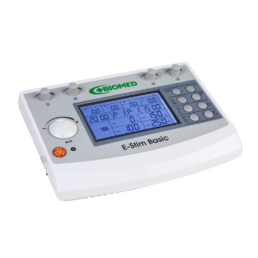 | Quantity – 1 pcs.  Intended for electrotherapy procedures using low- and medium-frequency electrical currents for pain management, neuromuscular stimulation, muscle rehabilitation, circulation improvement, and functional recovery. Main technical parameters not less than:  - The device shall be a professional electrotherapy system providing low- and medium-frequency electrical stimulation.  - The system shall include not less than four independent treatment channels and shall allow simultaneous treatment of two patients or two treatment areas.  - The device shall provide at least the following therapy modalities or equivalent:  - transcutaneous electrical nerve stimulation (TENS);  - neuromuscular electrical stimulation (NMES/EMS);  - interferential current therapy;  - medium-frequency muscle stimulation.  - The system shall allow adjustment of treatment intensity, frequency, pulse duration, and treatment time according to clinical requirements.  - The device shall include pre-programmed treatment protocols and the possibility to create user-defined treatment programs.  - The system shall be intended for pain therapy, muscle strengthening, muscle re-education, prevention of disuse atrophy, circulation improvement, and functional rehabilitation.  - The device shall be supplied with patient cables, electrodes, fixation accessories, and all components required for its intended operation.  - The device shall be supplied, installed, configured, and commissioned with all functions operational upon handover. | The same requirement as in point 3.1
3.9 | Phototherapy Device  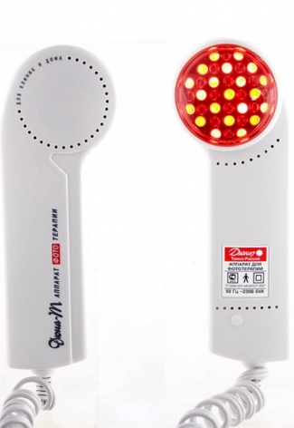 | Quantity – 1 pcs.  Intended for phototherapy procedures using visible red light and infrared radiation for pain reduction, stimulation of tissue regeneration, improvement of microcirculation, reduction of inflammation and edema, and rehabilitation of musculoskeletal, neurological, post-traumatic, and soft tissue conditions. Main technical parameters not less than:  - The device shall provide phototherapy using simultaneous visible red light and infrared radiation.  - The system shall utilize LED light sources for generation of therapeutic optical radiation.  - The device shall be intended for local application to soft tissues, joints, muscles, skin, and other anatomical regions.  - The system shall provide non-invasive therapy intended to improve microcirculation, stimulate tissue repair processes, and reduce pain and inflammation.  - The device shall be portable and suitable for use in rehabilitation, physiotherapy, and healthcare settings.  - The device shall be supplied with all accessories and components required for its intended operation. | The same requirement as in point 3.1
3.10 | Two-Channel Electrotherapy Device  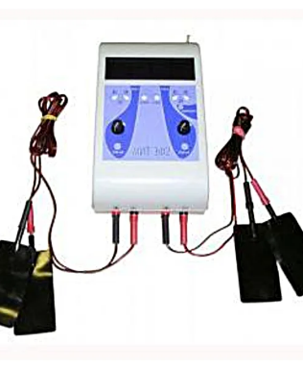 | Quantity – 2 pcs.  Intended for electrotherapy procedures using direct and pulsed electrical currents for medicinal electrophoresis, pain management, and rehabilitation of neurological and musculoskeletal disorders. Main technical parameters not less than:  - The device shall provide medicinal electrophoresis, electroanalgesia, and interferential electrotherapy modes or equivalent.  - The system shall include not less than two independent treatment channels with separate adjustment of treatment parameters for each channel.  - The electrophoresis current intensity shall be adjustable independently for each channel within a therapeutic range.  - The system shall allow adjustment of stimulation frequency and treatment duration according to clinical requirements.  - The device shall be supplied with electrodes, patient leads, fixation accessories, and all components required for electrotherapy and electrophoresis procedures.  - The device shall be supplied, installed, configured, and commissioned with all functions operational upon handover. | The same requirement as in point 3.1
3.11 | Low-Level Laser Therapy Device for Nasal and Ear Treatment  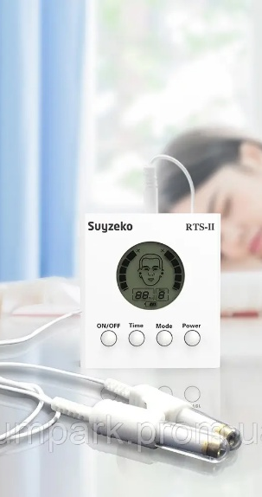 | Quantity – 2 pcs.  Intended for low-level laser therapy (LLLT) of nasal and ear conditions, aimed at reducing inflammation, improving local microcirculation, stimulating tissue regeneration, and supporting rehabilitation of ENT disorders. Main technical parameters not less than:  - The device shall provide low-level laser therapy using optical radiation with a wavelength of 650 nm ±10 nm or equivalent therapeutic red-light / low-level laser wavelength suitable for ENT applications.  - The system shall be intended for therapeutic application in the nasal cavity and external auditory canal.  - The device shall provide non-invasive local photobiomodulation therapy for ENT applications.  - The system shall allow adjustment or selection of treatment duration within a therapeutic range.  - The device shall be suitable for treatment of acute and chronic inflammatory conditions of the upper respiratory tract and ear or equivalent ENT indications.  - The device shall be supplied with all applicators, accessories, and components required for nasal and ear laser therapy.  - The device shall be supplied, installed, configured, and commissioned with all functions operational upon handover. | The same requirement as in point 3.1
3.12 | Compressor Nebulizer Inhaler  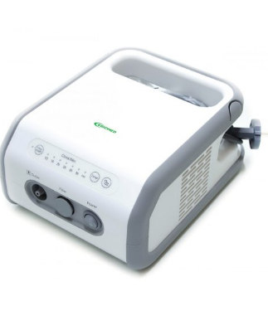 | Quantity – 2 pcs.  Intended for aerosol inhalation therapy through conversion of liquid medicinal solutions into fine aerosol particles for delivery of medication to the upper and lower respiratory tract. Main technical parameters not less than:  - The device shall be a compressor-type nebulizer intended for clinical and rehabilitation inhalation therapy.  - The nebulizer shall generate aerosol particles with a mean particle size not greater than 4 μm and at least 70% of particles smaller than 5 μm.  - The medication reservoir capacity shall be not less than 6 ml.  - The compressor air flow rate shall be not less than 10 l/min and the maximum compression pressure shall be not less than 0.15 MPa.  - The system shall be suitable for delivery of medications to both upper and lower respiratory tract regions.  - The device shall be supplied with adult and pediatric masks, nebulizer chamber, air tubing, replacement air filters, and all accessories required for its intended operation.  - The device shall be supplied ready for immediate clinical use upon handover. | The same requirement as in point 3.1
3.13 | Pulsed Low-Frequency Magnetotherapy Device  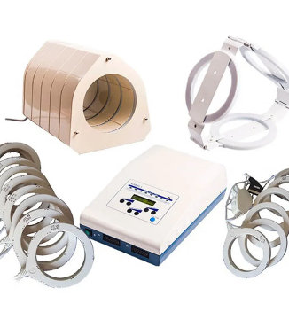 | Quantity – 2 pcs.  Intended for physiotherapy and rehabilitation procedures using pulsed low-frequency magnetic fields for treatment of musculoskeletal, neurological, vascular, gynecological, and post-traumatic conditions. Main technical parameters not less than:  - The device shall provide pulsed low-frequency magnetotherapy with magnetic field induction not less than 5 mT.  - The system shall include not less than four independent channels for connection and operation of magnetic applicators.  - The device shall allow adjustment of magnetic field intensity, pulse frequency, and treatment duration according to clinical requirements.  - The system shall be supplied with solenoid-type applicators of different sizes and configurations suitable for treatment of extremities and larger anatomical regions.  - The applicator set shall include circular and/or polygonal solenoid applicators with diameters not less than 105 mm and 185 mm or equivalent treatment coverage.  - The device shall be intended for treatment of joints, spine, extremities, vascular, neurological, and post-traumatic conditions.  - The system shall be supplied with all applicators, cables, accessories, and components required for its intended operation.  - The device shall be supplied, installed, configured, and commissioned with all functions operational upon handover. | The same requirement as in point 3.1
3.14 | Combined Physiotherapy System  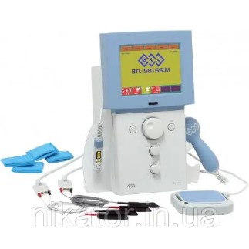 | Quantity – 1 pcs.  Intended for physiotherapy and rehabilitation procedures combining electrotherapy, ultrasound therapy, laser therapy, and magnetotherapy within a single system for treatment of musculoskeletal, neurological, post-traumatic, sports medicine, and pain-related conditions. Main technical parameters not less than:  - The system shall integrate electrotherapy, ultrasound therapy, laser therapy, and magnetotherapy within a single device.  - The system shall allow simultaneous treatment of not less than two patients or two treatment areas using independent therapy channels.  - The electrotherapy module shall provide low- and medium-frequency electrotherapy, including interferential therapy or equivalent functionality.  - The ultrasound therapy module shall support continuous and pulsed operation modes and shall include multi-frequency applicators operating at 1 MHz and 3 MHz.  - The laser therapy module shall support interchangeable treatment applicators suitable for different clinical applications.  - The system shall include pre-programmed treatment protocols, user-defined treatment protocols, and patient database functionality.  - The device shall include a touchscreen user interface and automatic recognition of connected accessories.  - The system shall be supplied with all electrodes, applicators, probes, accessories, and components required for its intended operation. | The same requirement as in point 3.1
3.15 | Electrotherapy System  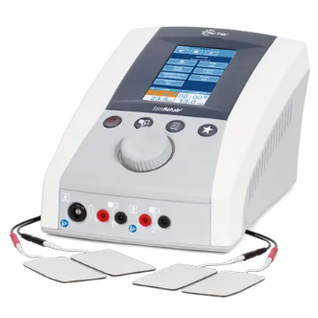 | Quantity – 1 pcs.  Intended for electrotherapy procedures using low- and medium-frequency electrical currents for pain management, neuromuscular stimulation, muscle rehabilitation, circulation improvement, and functional recovery. Main technical parameters not less than:  - The system shall include not less than two independent electrotherapy channels with separate adjustment of treatment parameters.  - The device shall provide interferential therapy, TENS therapy, neuromuscular electrical stimulation (NMS/NMES), galvanic therapy, microcurrent therapy, and medium-frequency muscle stimulation modes or equivalent.  - The maximum therapy current output shall be not less than 100 mA for interferential therapy modes.  - The system shall include not less than 40 pre-programmed clinical treatment protocols with graphical electrode placement guidance.  - The device shall allow creation, storage, and recall of user-defined treatment protocols.  - The system shall include a color touchscreen display not smaller than 5 inches and multilingual user interface.  - The device shall include a patient safety stop function allowing immediate interruption of therapy by the patient.  - The system shall be supplied with patient cables, electrodes, fixation accessories, and all components required for its intended operation.  - The device shall be supplied, installed, configured, and commissioned with all functions operational upon handover. | The same requirement as in point 3.1
3.16 | Combined Physiotherapy System  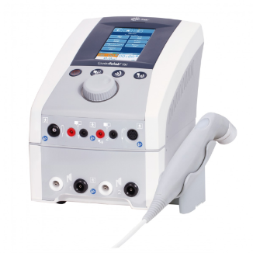 | Quantity – 1 pcs.  Intended for physiotherapy and rehabilitation procedures combining electrotherapy, ultrasound therapy, and vacuum therapy for treatment of musculoskeletal, neurological, vascular, and post-traumatic conditions. Main technical parameters not less than:  - The system shall integrate electrotherapy, ultrasound therapy, and vacuum therapy within a single device.  - The electrotherapy module shall include not less than two independent treatment channels and provide interferential therapy, TENS, neuromuscular stimulation, microcurrent therapy, galvanic therapy, and medium-frequency muscle stimulation modes or equivalent.  - The ultrasound therapy module shall support continuous and pulsed operation modes and shall provide treatment frequencies of 1 MHz and 3 MHz.  - The ultrasound module shall be supplied with a waterproof ultrasound applicator with an effective radiating area of not less than 5 cm² and contact monitoring functionality.  - The vacuum therapy module shall provide adjustable therapeutic vacuum and support combined electro-vacuum therapy procedures.  - The system shall include a color touchscreen user interface and patient safety stop function.  - The device shall be supplied with ultrasound applicators, vacuum electrodes and cups, patient cables, electrodes, fixation accessories, and all components required for its intended operation.  - The device shall be supplied, installed, configured, and commissioned with all functions operational upon handover. | The same requirement as in point 3.1
3.17 | Sequential Compression System  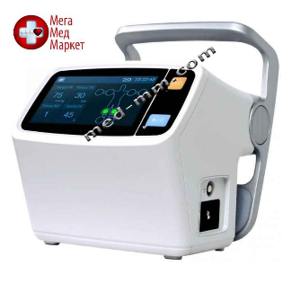 | Quantity – 1 pcs.  Intended for intermittent pneumatic compression therapy for prevention of deep vein thrombosis (DVT), reduction of venous stasis and edema, and improvement of venous and lymphatic circulation in patients with limited mobility. Main technical parameters not less than:  - The system shall provide intermittent pneumatic compression therapy with gradient and uniform compression modes.  - The device shall include not less than two independent treatment channels, each controlling not less than four compression chambers.  - The system shall provide not less than 12 pre-programmed treatment protocols and at least one user-configurable treatment mode.  - The therapeutic pressure shall be adjustable within a range covering at least 0–280 mmHg.  - The device shall allow adjustment of treatment duration, venous refill time, and inflation speed.  - The system shall include a color touchscreen display not smaller than 4.3 inches for monitoring and control of therapy parameters.  - The device shall include an integrated rechargeable battery providing not less than 4 hours of operation without mains power.  - The system shall be supplied with reusable multi-chamber compression garments for lower limbs and upper limbs, together with all accessories required for its intended operation.  - The device shall be supplied with a mobile stand or equivalent transport solution.  - The system shall be supplied, installed, configured, and commissioned with all functions operational upon handover. | The same requirement as in point 3.1
NOTES:
Where the technical specification indicates a specific model or source of supply, a specific process specific to the goods or services supplied by a particular supplier, or a trademark, patent, types, specific origin or manufacture, it shall be understood that these characteristics are indicative only and that the suppliers are free to offer an equivalent option. The supplier must demonstrate the equivalence referred to in this paragraph.
In the event that the technical specification specifies values/parameters for a particular technical characteristic, suppliers may offer goods whose values/parameters are not inferior to those specified (goods with no inferior characteristics may be offered).
All images included in this specification are for illustrative purposes only and do not define the required manufacturer, model, design, dimensions, appearance, or technical solution. Equivalent products meeting the functional and technical requirements shall be accepted.

