Dear Supplier,

The Public Institution Central Project Management Agency is conducting a market consultation in preparation for an upcoming public procurement procedure for a rehabilitation medical equipment for the Zhytomyr Rehabilitation Center.

The purpose of the consultation is to obtain comments, suggestions, and recommendations from market participants regarding the draft Technical Specification and other procurement requirements.

Market participants are invited to review the draft Technical Specification (Annex 1) and submit any comments, questions, suggestions, or recommendations by completing the Market Consultation Questionnaire (Annex 2). Responses should be submitted via the Central Public Procurement Information System (CVP IS) https://viesiejipirkimai.lt/ or by email to publicprocurement@cpva.lt no later than 20 July 2026, 10:00 (Lithuanian time).

We appreciate your time and contribution to the preparation of a well-designed and competitive procurement procedure.

Best regards,
Public Procurement Commission

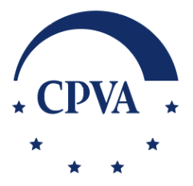 | Central Project Management Agency Branch – Lithuanian International Partnership Center  S. Konarskio g. 13, LT-03109 Vilnius  Tel. +370 64912635  publicprocurement@cpva.lt | www.cpva.lt | LinkedIn | Facebook | X


