REQUIREMENTS FOR THE OBJECT OF TENDER

Services for creating an ESPBI IS service-oriented architecture based on the FHIR5 standard and testing the parallel operation of two versions of the ESPBI IS (the old FHIR0.8 and the new FHIR5) as a proof of concept (PoC)

Table of Contents

1. POC OF MULTIPLE FHIR VERSIONS MAINTENANCE 4
1.1. Project description and primary objectives 4
1.2. Terms and abbreviations 4
1.3. Assumptions and verification needs 5
1.4. AS-IS description 6
1.4.1. Technologies 8
1.5. Limitations and challenges 8
1.5.1. Centralized monolithic architecture 8
1.5.2. Proprietary data model 8
1.5.3. Data exchange mechanisms 8
1.6. PoC objectives 9
2. Full-scale architecture 9
3. PoC objectives 11
3.1. General aspects of PoC objectives 11
3.1.1. Set-up for PoC 12
3.1.2. Medical documents to validate 12
3.1.3. Mapped resources to validate 12
3.1.4. Unmapped resources to validate 13
3.1.5. Validations (controls) to check 13
3.1.6. Possible currently identified concerns 14
3.2. Objective 1. Implement FHIR v5.0.0 16
3.3. Objective 2. Implement FHIR DSTU1 (v0.0.82) and FHIR v5.0.0 synchronization mechanism with a full mapping scenario. 19
3.4. Objective 3. Ensure that unmapped data between FHIR DSTU1 (v0.0.82) and FHIR v5.0.0 is identified and visualized for end-user in HTML or other recommended formats 23
3.5. Objective 4. Enhance ESPBIS authentication and authorization technology 31
3.6. Objective 5. Implement integration for regular client usage (mob. application, specialist portal, HIS) & ensure iframe or equivalent solution for data presentation 33
3.7. Objective 6. Implement integration with ULSVIS 38
4. Long-term ESPBI architecture 41
4.1. General Requirements: 41
4.2. Specific Requirements: 41
5. PoC implementation stages & results 42
6. Requirements for service provision 45
6.1. Requirements for documentation and its coordination 45
6.1.1. Requirements for analysis and design 46
6.1.2. Deployment requirements 46
6.1.3. Testing requirements 47
6.1.4. Requirements for project management 48
6.1.5. Requirements for change management 48
6.1.6. Licensing requirements 49
6.1.7. Warranty requirements 49

POC OF MULTIPLE FHIR VERSIONS MAINTENANCE

Project description and primary objectives
Proof of Concept (PoC) of multiple FHIR versions maintenance in Lithuania's Electronic Health Services and Cooperation Infrastructure Information System (lit. Elektroninė sveikatos paslaugų ir bendradarbiavimo infrastruktūros informacinė sistema) (ESPBI IS) project goal is to ensure seamless transition to a newer version of FHIR.
ESPBI IS currently operates on the outdated FHIR DSTU1 (v0.0.82) standard version. Transitioning to a newer version of FHIR is a necessary step to improve interoperability, align with modern healthcare data standards and ensure scalability to meet future requirements. However, this migration presents challenges, that should be taken into consideration:
- The system's proprietary data model is heavily tied to FHIR DSTU1. Migrating to newer versions poses challenges, mainly:
  - Many data fields are not directly compatible with structures in newer FHIR versions.
  - Some resource types in DSTU1 lack direct equivalents in newer versions, increasing the risk of data loss or misrepresentation during the transition.
- Updating data exchange protocols to comply with newer FHIR standards requires:
  - Redevelopment of APIs and integration layers.
  - Investment from both internal teams and external partners who must adapt their systems to the new standards.
- Ongoing initiatives within ESPBI IS, such as patient registration component upgrades, telemedicine and disease prevention programs may influence the system’s roadmap. These interconnected projects could impact priorities, design and functionality during the migration process.
Given these challenges, conducting a PoC is crucial to identifying and mitigating potential risks and ensure a smooth transition. The primary objectives of the PoC are to:
- Validate the feasibility of migrating FHIR version while preserving data integrity.
- Assess the technical and resource implications of updating APIs and integration layers.
- Ensure interoperability with existing and future system components.
- Ensure that the migration process would be acceptable by system's clients and their end-users and would not identify major usability challenges.

Terms and abbreviations
Terms and abbreviations used are presented in table 1 “Terms and abbreviations used “.
Table 1. Terms and abbreviations used
Term/abbreviation | Description
API | Application programing interface
Client | State Enterprise Centre of Registers or RC
ESPBI IS | Lithuania's Electronic Health Services and Cooperation Infrastructure Information System (lit. Elektroninė sveikatos paslaugų ir bendradarbiavimo infrastruktūros informacinė sistema)
eLAB | Laboratory diagnostics subsystem of ESPBI (Laboratorinių tyrimų posistemė ESPBI)
EMR | Electronic medical record
FHIR | Fast Healthcare Interoperability Resources
HIS | Hospital information system
IS | Information system
JSON | JavaScript Object Notation
Keycloak | An open source identity and access management solution.
PoC | Proof of Concept
RC | State Enterprise Centre of Registers (lit. Registrų centras)
SAM | Ministry of Health (lit. Sveikatos apsaugos ministerija)
Service provider | The company that is providing software development services for the implementation of the project.
ULSVIS | State information systems for infectious diseases and their agents
XML | eXtensible Markup Language

Assumptions and verification needs
- As this Proof of Concept (PoC) is conducted with the underlying assumption that direct data mapping between FHIR DSTU1 and FHIR v5.0.0 is currently not feasible, it is important to acknowledge that this conclusion has not yet been independently validated and it will be checked during other projects.
  - Due to time and resource constraints, this PoC will operate under the stated assumption of non-interoperability without attempting direct mapping.
  - It is anticipated that separate, future projects will undertake the verification of this assumption by attempting to establish whether direct mapping is feasible. Findings from these initiatives will be critical in shaping long-term strategic decisions on standard migration and interoperability solutions.
- Therefore, PoC TO-BE architecture does not aim to ensure full mapping of all resources, though achieving such coverage would be ideal. Instead, the focus will be on mapping key FHIR resources.

AS-IS description
- ESPBI IS as is situation is described in publicly available documentation.

Technologies

- Technological stack of Portals, ESPBI and related components:
  - Portal API and ESPBI core– spring: 3.2.2 (Java 1.8)
  - DB: oracle (ojdbc8): 19.18.0.0.
  - Portal web:
  - Angular.js - 1.5.11
  - Angular: 16.1.8

Limitations and challenges

Centralized monolithic architecture
- ESPBI IS portals (patient, specialist, pharmacist) are directly tied to the business logic and data exchange layers.
- Update or maintenance activity risks downtime for all portals, disrupting end-user access and system operations. Update or maintenance activity risks downtime across multiple components, disrupting end-user access and system operations. Portals are connected through a load balancer, but the current architecture involves a tight integration with the Core system, which leads to changes affecting all connected components and portals.

Proprietary data model
- ESPBI IS for data management and storage currently uses a proprietary data model with unique data structure, heavily tied to FHIR DSTU1 (v0.0.82) in its centralized database.
- DSTU1 is an early beta version, designed for experimentation rather than production use.
- The data model is less expressive and structured, limiting its ability to represent complex healthcare scenarios to extract, normalize, and analyze data for insights or clinical research.
- Changes to data structures require significant development effort due to the lack of flexibility in the proprietary data model.
- The system lacks robust mechanisms for ensuring data quality and consistency, which are addressed in newer FHIR standards.

Data exchange mechanisms
- Communication between portals and the business logic layer is conducted via RESTful services based on FHIR DSTU1.
- The system lacks mechanisms to handle requests and data in different FHIR versions simultaneously. At this moment such objective was not identified as only FHIR DSTU1 was used.
- Using DSTU1 creates compatibility issues to integrate to the broader healthcare IT ecosystem and APIs, where tools, technologies, and frameworks built on open standards for example using newer FHIR versions. This requires custom integration layers and increase development and maintenance costs.

PoC objectives
- The PoC project is divided into specific objectives to define and manage its scope and goals. Each of these objectives is defined more in detail further in the document.
Table 2. PoC objectives
No. | Objective | Main tasks
 | Implement FHIR v5.0.0 core | Develop the ESPBI Core V2 stand-alone system leveraging the FHIR v5.0.0 standard. More details are provided in other section (see Objective 1. Implement FHIR v5.0.0).
 | Implement FHIR DSTU1 (v0.0.82) and FHIR v5.0.0 synchronization with a full mapping scenario | Develop FHIR DSTU1 (v0.0.82) and FHIR v5.0.0 synchronization mechanism and required components enabling both forward and backward interoperability with a full mapping scenario of resources:  1.1. Patient,  1.2. Organization,  1.3. Practitioner,  1.4. Encounter,  1.5. Condition,  1.6. Allergyintolerance,  1.7. Medication,  1.8. Substance.  More details are provided in other section (see Objective 2. Implement FHIR DSTU1 (v0.0.82) and FHIR v5.0.0 synchronization mechanism with a full mapping scenario.
 | Ensure that unmapped data between FHIR DSTU1 (v0.0.82) and FHIR v5.0.0 is identified and visualized for end-user in HTML or other recommended formats | This task involves covering and testing scenarios where data between FHIR DSTU1 (v0.0.82) and FHIR v5.0.0 is not mapped, focusing on visualizing data in other ways. The visualization will be implemented in HTML or other recommended formats to ensure the end-user can read the data even from different FHIR version information system. More details are provided in other section (see Objective 3. ).
 | Enhance ESPBIS authentication and authorization technology | Develop authentication and authorization processes to be based on Keycloak IAM solution. More details are provided in other section see (Objective 4. Enhance ESPBIS authentication and authorization technology).
 | Implement integration for regular client usage (mob. application, specialist portal, HIS) & ensure iframe or equivalent solution for data presentation | Develop required interfaces to enable regular clients (specialist portal, mobile application and HIS) to access ESPBI IS PoC. More details are provided in other section see (Objective 5. Implement integration for regular client usage (mob. application, specialist portal, HIS) & ensure iframe or equivalent solution for data presentation ).
 | Implement integration with ULSVIS | Develop required interfaces and components to enable integration with ULSVIS. More details are provided in other section (see Objective 6. Implement integration with ).

Full-scale architecture
- Full-scale architecture is presented and later in the document separated into smaller parts based on each of the objectives. Components and integrations marked in green presents parts that are not currently in place and should be developed during the project.
- The legacy systems test versions will be provided by the Client during the project, however the integrations or adjustments should be conducted by the Service Provider (presented more in detail on other section see Set-up for PoC).
- Service Provider is eligible to suggest alternative architectural principles to achieve project objectives, however they should be aligned with the Client and project purposes.

Figure 2: Full-scale architecture
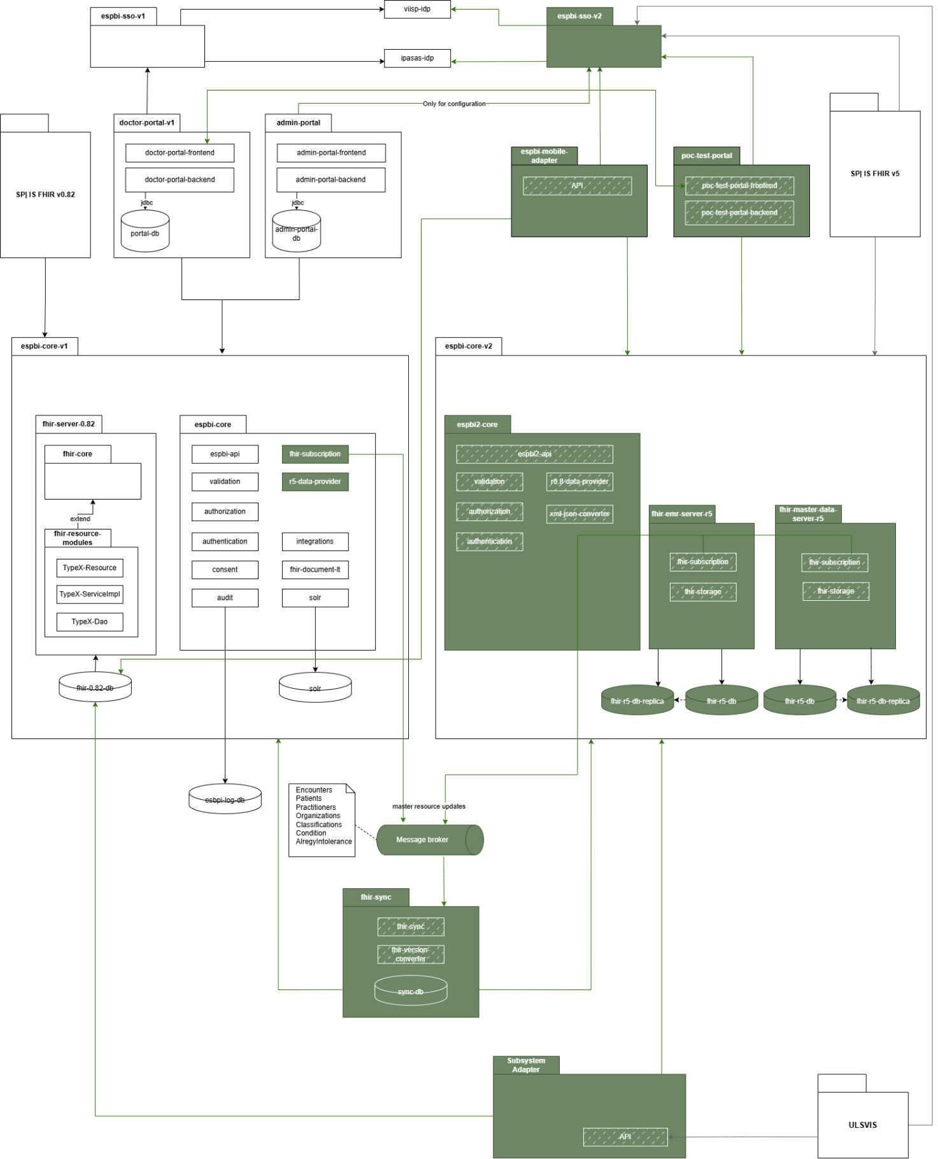

PoC objectives

General aspects of PoC objectives
- This section provides a detailed description of each project objective. For each objective, the component architecture is presented along with explanation. Where applicable, sequence diagrams are included to illustrate data flow within the objective (these diagrams serve as examples and may be adjusted based on recommendations from the Service Provider). Additionally, test scenarios or validation criteria are outlined to guide the evaluation of each objective, with insights and recommendations expected from the Service Provider. The Service Provider may propose additional or revised testing scenarios or components, provided if they are agreed with the Client.

Set-up for PoC
- Service provider is responsible to ensure all applications, data integrations or infrastructure required to perform PoC, unless it is indicated differently in the technical specification. The components that are not marked as changed in the architecture (the FHIR DSTU1 components) would be provided by the Client together with TEST environment, however these components might need modification to ensure PoC objectives are met. Service provider is responsible not only for ensuring additional components, but also for modifying existing ESPBI components in TEST environment to achieve these goals.
- The service provider must ensure that all provided components are compatible with the existing ESPBI infrastructure and can integrate with the Client's systems without significant changes.
- The service provider must ensure that all provided components are deployable onto OpenShift platform provided by the client and can integrate with the existing components without significant changes.
- The service provider must document the installation, configuration, and setup procedures for all components provided for the PoC. Documentation more in detail is provided in other sections.

Medical documents to validate
- The PoC scenarios should be conducted using selected medical documents. Each scenario (where applicable) should be tested against all mentioned documents. The following documents have been identified for testing purposes:
  - E027: Medical document summary / referral (form 027/a).
  - E027-ats: Response to referral.
  - EREC01: prescription

Mapped resources to validate
- At least these resources are projected to be mapped. Service Provider shall conduct mapping of these resources and ensure the possibility to assure interoperability of these resources:
  - Patient,
  - Organization,
  - Practitioner,
  - Encounter,
  - Condition,
  - Allergyintolerance,
  - Medication,
  - Substance.

Unmapped resources to validate
- For scenarios where unmapped resources need to be tested, these resources should be taken into account:
  - ImmunizationRecommendation - records of planned vaccination schedules.
  - Observation. Different type of observations:
    - risk factors
    - work capacity level
    - disability level
    - special needs.
  - Device (medical devices / implants) - (currently unavailable but expected to be introduced with other tender. Structure is already defined and the Device endpoint exists but is not yet in use).
  - Procedure - surgical procedures.
  - AdverseReaction - suspected adverse reactions.

Validations (controls) to check
- During the PoC, testing will focus on the following two validations, unless critical additional validations are identified that require testing. Any such additional validations will be addressed separately and agreed upon with the Client. These validations aim to determine whether two different FHIR standard information systems can operate together effectively and ensure data interoperability in alignment with the provided PoC objectives:
    - Validation #1 - RMPR_0024 Message Text: Medication with this ATC code level 5 has already been prescribed, and the treatment course has not yet ended.
    - The system checks if a medication with the specified ATC code level 5 is already prescribed to the patient:
    - If the prescription status is "Active," the system verifies whether [the date of the already prescribed medication] + [duration of use in days] <= the date of the newly prescribed medication.
  - Validation #2 - ERMPR_3005 message text: If the medication is an LTI, it must be prescribed with a specific active ingredient unless it is the first time it is being prescribed. Applies to both reimbursable and non-reimbursable medications.
    - If active active ingredient has no prior prescriptions in the patient’s history, no specific one is required.
    - If the active ingredient has been prescribed before, the new prescription must include a specific medication with such active ingredient.

Possible currently identified concerns
- This section outlines the currently identified concerns for the Service Provider to consider. The Service Provider should take these concerns into account, address them, and provide insights for each one of them in the analysis documentation. These concerns are not exhaustive and may evolve or be disproven during the project:
  - Differences in specialist resource types between FHIR versions may lead to mismapped data fields during retrieval. This can cause inconsistencies in how specialist information is accessed and represented across systems.
  - When using filters to query specialists across DSTU1 and v5.0, variations in resource definitions and query parameters may result in incomplete or mismatched data retrieval outcomes.
  - If organization identifiers are generated or structured differently across databases or FHIR versions, inconsistent mapping may affect access to patient data across encounters, potentially hindering data integration.
  - Discrepancies in how active Encounters are represented or mapped between different databases could make it challenging to verify them, impacting access control and data accuracy despite full mapping efforts.
  - Without a clear, standardized approach to setting access permissions, data requests may be inconsistently applied across systems or services. This can lead to unauthorized access or denial of legitimate access due to varying interpretations of permission settings.
  - During the transition period, systems may need to handle different result delivery formats—such as AtomFeed in DSTU1 versus Bundle in v5.0—and varying ID structures. This coexistence can cause data compatibility issues for consumers interacting with both FHIR versions simultaneously.
  - Incompatibilities in handling existing diagnoses between FHIR versions—for example, differences in resource structures or coding systems—may disrupt treatment continuity. Essential diagnostic information might be misrepresented or lost, and this concern is highlighted in test scenarios involving diagnosis data migration.
  - Updating data across different FHIR versions could lead to versioning conflicts or errors due to differences in resource schemas, validation rules, or update mechanisms, potentially affecting data integrity.
  - Inconsistent structuring of XML/JSON data for signed PDFs across different FHIR versions may cause issues in storage, retrieval, and validation. This inconsistency can affect the integrity and accessibility of legally significant documents.
  - Ensuring compatibility when handling various orders and results is crucial to prevent incomplete processes and ensure continuity of care (the whole process should be finished and does not stop due to FHIR version differences).
  - Data inconsistency between old and new standards during the transition period may cause data fragmentation or loss. Implementing careful data mapping and synchronization strategies is essential to maintain data integrity throughout the transition.

Objective 1. Implement FHIR v5.0.0

- The objective will be considered achieved when the following conditions are met:
  - ESPBI Core V2 stand-alone system meets the requirements provided in the Table 3: Objective 1 Implementation requirements and component description.
  - ESPBI Core V2 stand-alone system consists of components and data integrations provided in the Figure 3: Objective 1. Components diagram.
  - Testing scenarios are checked and achieved required result listed in the table below Table 4: Objective 1. Testing scenarios
Table 3: Objective 1 Implementation requirements and component description
Nr. | Requirement | Notation in components diagram
 | ESPBI Core V2 must perform validations of process and data from FHIR servers fhir-emr-server-r5 and fhir-master-data-server-r5 and reject invalid or non-compliant inputs. | validation
 | ESPBI Core V2 should transform data between XML and JSON formats. | xml-json-converter
 | ESPBI Core V2 should contain a server to manage current data (which is equally written and read). | fhir-emr-server-r5
 | ESPBI Core V2 should contain a server to manage demographic data (which is less frequently overwritten). | fhir-master-data-server-r5
 | ESPBI Core V2 should have a database, which is required to store FHIR resources. | fhir-r5-db
 | ESPBI Core V2 should have a database replica to offload read-heavy operations from the primary database, improving system performance. | fhir-r5-db-replica
 | ESPBI Core V2 should be able to send and receive data or requests. | espbi2-api

Figure 3: Objective 1. Components diagram
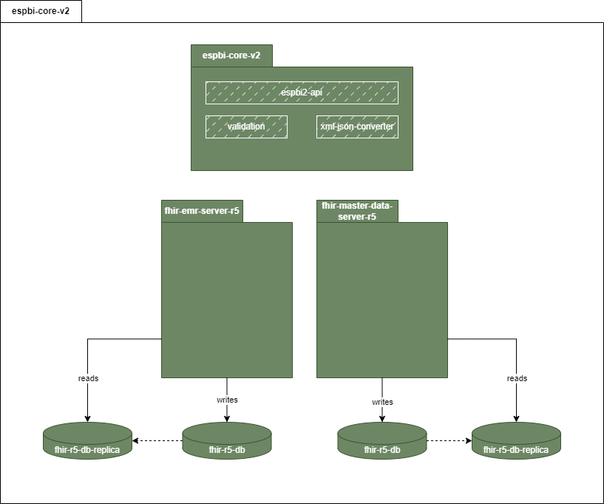
Table 4: Objective 1. Testing scenarios
Nr. | Scenario | Description | Expected result
 | New resource created | New resource (e.g. Patient resource) is created based on FHIR r5 version | New resource is created based on FHIR r5 standard.
 | New document is read consisting of newly created resource | New document out of the list (see Medical documents to validate) is viewed consisting of newly created resource. | Document is created and viewed.
 | Resource conversion | Newly created resource is converted from XML to JSON format. | Resources are converted to other format.
 | New resource created for respective FHIR server | 2 resources are created and based on their type are written to the appropriate FHIR data server. | 2 resources have been created - one for demographic data server (Patient resource) and another for non-demographic (FHIR emr data server).

Objective 2. Implement FHIR DSTU1 (v0.0.82) and FHIR v5.0.0 synchronization mechanism with a full mapping scenario.
- The objective will be considered achieved when the following conditions are met:
  - The synchronization mechanism meets the requirements provided in the Table 5: Objective 2. Implementation requirements and component description.
  - The synchronization mechanism consists of components and processes provided below.
  - The synchronization mechanism must enable forward and backward interoperability with a full mapping scenario of resources:
    - Patient,
    - Organization,
    - Practitioner,
    - Encounter,
    - Condition,
    - Allergyintolerance,
    - Medication,
    - Substance.
  - Testing scenarios are performed and achieved the required result listed in the Table 6: Objective 2. Testing scenarios.

Table 5: Objective 2. Implementation requirements and component description
Nr. | Requirement | Notation in components diagram
 | The new Core V2 architecture must support operations using the servers fhir-emr-server-r5 and fhir-master-data-server-r5 while ensuring data compatibility and synchronization with the legacy Core V1 architecture. | fhir-emr-server-r5  fhir-master-data-server-r5
 | The legacy system (ESPBI Core V1) must support operations using the fhir-server-0.82 while ensuring data compatibility and synchronization with the new Core V2 architecture. | the fhir-server-0.82
 | Synchronization mechanism must include components for event (create, delete, update) subscriptions monitoring, management and notifying about updates to resources in both ESPBI core components v1 and v2. | fhir-subscription
 | Ensure persistent storage for FHIR resources with support for versioning, validation, and efficient querying in the EPBI core V2 FHIR servers. | fhir-storage
 | Synchronization mechanism must include central message broker for publishing and distributing resource updates. | Message broker
 | Synchronization mechanism must include components dedicated to facilitating synchronization of FHIR resources between FHIR 0.82 to FHIR R5 and ensures backward and forward compatibility. | fhir-sync
 | Synchronization mechanism must include components, which converts FHIR resources between FHIR 0.82 to FHIR R5 and ensures backward and forward compatibility. | fhir-version-converter
 | Synchronization mechanism must include components, which stores metadata and logs related to synchronization operations (e.g. relations between resource representations across different systems). | sync-db

Figure 4: Objective 2. Components diagram
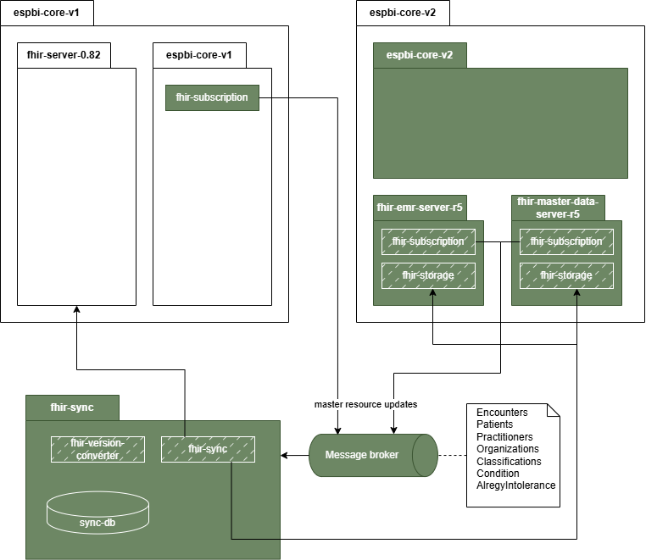

Figure 5: Objective 2. Sequence diagram
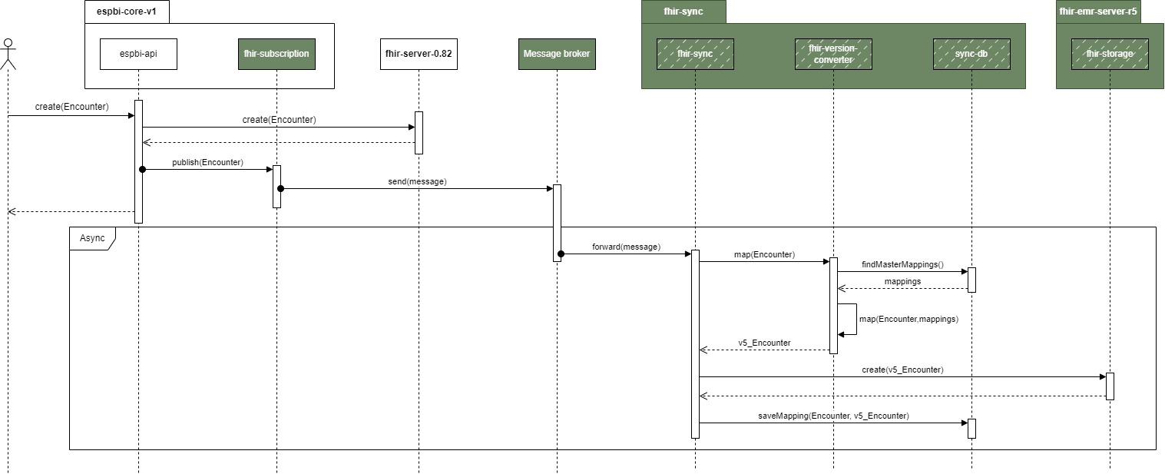

Table 6: Objective 2. Testing scenarios
Nr. | Scenario | Description | Expected result
 | Resource created, updated, deleted in new (R5) and read in old (DSTU1) version | Resource is created, updated, deleted in FHIR R5 and must be read in FHIR DSTU1, with all resources synchronized (mapped) between versions. Testing should be conducted with the mentioned mapped resources (see 34.3). | Resource is presented with all the mapped data points.
 | Resource created, updated, deleted in old (DSTU1) and read in new (R5) version | The resource is created, updated, deleted in FHIR DSTU1 and must be read in FHIR R5, with all resources synchronized (mapped) between versions. Testing should be conducted with the mentioned mapped resources (see 34.3). | Resource is presented with all the mapped data points.
 | Reference ID of resources mapped | When a new resource is created its reference ID is mapped to the reference ID of the corresponding core system in FHIR sync component. | List of resources with mapped reference IDs.
 | Encounter synchronization fail | New encounter is registered in the core v1 (FHIR DSTU1) but fails to synchronize with the new system. As a result, when attempting to access this encounter in the new system, it will not be available due to the lack of synchronization between the two systems. | It should not be possible to manage data without outstanding encounter. Service Provider shall additionally include (not only for this scenario) insights on how the risk could be managed.

Objective 3. Ensure that unmapped data between FHIR DSTU1 (v0.0.82) and FHIR v5.0.0 is identified and visualized for end-user in HTML or other recommended formats
- Service provider must develop mechanism and required components for handling data from FHIR DSTU1 (v0.0.82) and FHIR v5.0.0 without implementing any direct mapping or synchronization. Instead, the focus will be on visualizing the unmapped data in HTML or an equivalent format. This approach is based on the assumption that direct data mapping between FHIR DSTU1 and FHIR v5.0.0 is currently not feasible (please refer to Assumptions and verification needs).
- The objective will be considered achieved when the following conditions are met:
  - Data handling mechanism meets the requirements provided in the Table 7: Objective 3. Implementation requirements and component description.
  - Data handling mechanism consists of components and processes provided in other section, Figure 7: Objective 3. Sequence diagram and Figure 8: Objective 3. Sequence diagram (partial mapping scenario).
  - Testing scenarios are performed and achieved required result listed in the Table 8: Objective 3. Testing scenarios .

Table 7: Objective 3. Implementation requirements and component description
Nr. | Requirement | Notation in components diagram
 | Data handling mechanism should involve FHIR DSTU1 (v0.0.82) version r0.8-data-provider in ESBI Core V2, which by interacting with fhir-server-0.82 in ESPBI core V1 extracts data and transforms it into HTML (or similar) format, so ESBI Core V2 can read and display result. | r0.8-data-provider
 | Data handling mechanism should involve FHIR v5.0.0 version r5-data-provider in ESBI Core V1, which by interacting fhir-emr-server-r5 and fhir-master-data-server-r5 in ESPBI core V2 extracts data and transforms it into HTML (or similar) format, so ESBI Core V1 can read and display result. | r5-data-provider

Figure 6: Objective 3. Components diagram
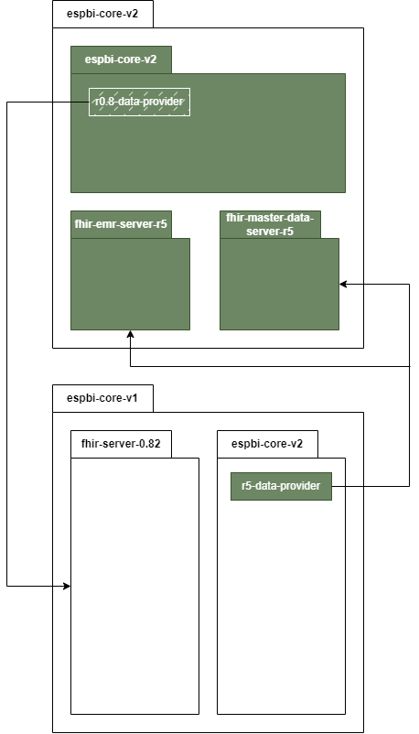

Figure 7: Objective 3. Sequence diagram
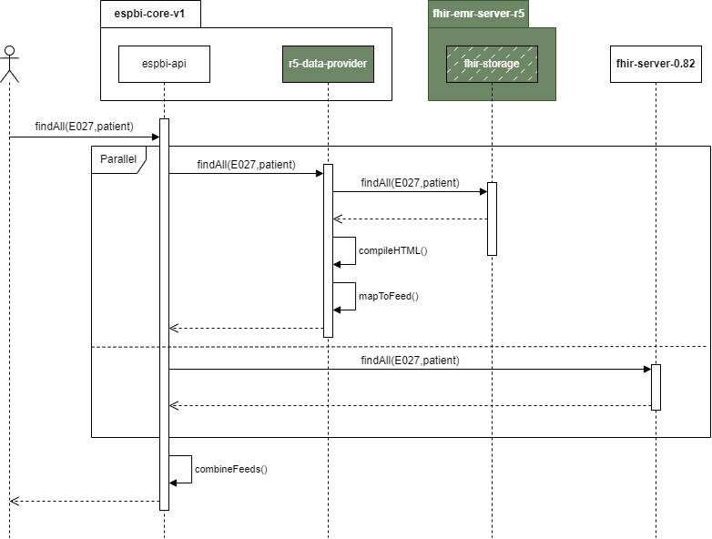

Figure 8: Objective 3. Sequence diagram (partial mapping scenario)
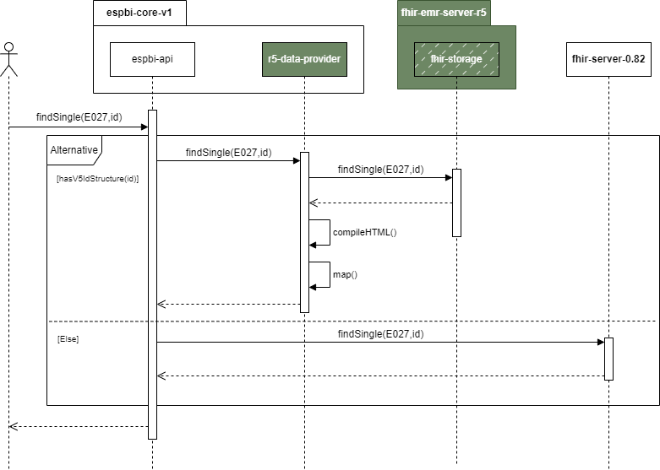

Figure 9: Objective 3. Sequence diagram (partial mapping scenario)
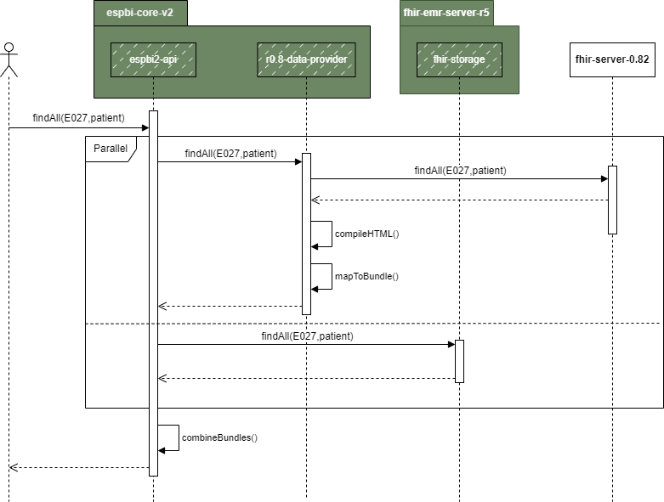

Table 8: Objective 3. Testing scenarios
Nr. | Scenario | Description | Expected result
 | Document created, updated, deleted in new (R5) and read in old (DSTU1) version | Document (list of documents is provided in other section see medical documents to validate) is created, updated, deleted in FHIR r5 and needs to be read in FHIR DSTU1. Mapped document data should be properly synchronized, while unmapped data should be displayed in HTML or an equivalent format proposed by the Service Provider. | Document is presented with all the mapped data points. If the data points are not mapped, then HTML is presented in addition. Document that should be tested with is provided in other section (see medical documents to validate).
 | Document created, updated, deleted in old (DSTU1) and read in new (R5) version | Document (list of documents is provided in other section is created, updated, deleted in FHIR DSTU1 and needs to be read in FHIR R5. Mapped document data should be properly synchronized, while unmapped data should be displayed in HTML or an equivalent format proposed by the Service Provider. | Document is presented with all the mapped data points. If the data points are not mapped, then HTML is presented in addition.
 | Resource created, updated, deleted in new (R5) and read in old (DSTU1) version | Resource is created, updated, deleted in FHIR R5 and must be read in FHIR DSTU1. However, the resource is not mapped, and it should be presented as HTML format similar. The test should be presented with at least 5 resources that should be decided during the project. | Resource is presented with all mapped data, while unmapped data should be presented as HTML or similar format.
 | Resource created, updated, deleted in old (DSTU1) and read in new (R5) version | The resource is created, updated, deleted in FHIR DSTU1 and must be read in FHIR R5. However, the resource is not mapped, and it should be presented as HTML format similar. The test should be presented with at least 5 resources that should be decided during the project. | Resource is presented with all mapped data, while unmapped data should be presented as HTML or similar format.
 | Document search | Documents of a specific type are searched across both the old and new FHIR version databases. The resulting document lists from both versions are combined and displayed together. However, documents are only presented in the structured manner if their format version matches the one that is currently in use. Documents from the other version must first be converted to HTML format before being opened. Paging risks should be managed to ensure the search results are unified, and the system should determine which results to display. It should also be possible to sort or filter results. | List of all selected type of documents from both versions.
 | Resource data list view | FHIR R5 specialist submits a request to retrieve a list of all specific resource that has not been mapped. Testing should include scenarios where there is no direct one-to-one correspondence between resource types in both versions, such as a single resource in FHIR DSTU1 being divided into separate resources in FHIR R5. | List of resources is presented.
 | Data retrieval from previous FHIR version | Specialist is creating a new document and needs to select an existing diagnosis for the patient, as it continues previously initiated treatment. The system retrieves the patient’s diagnosis history, including active Encounters, ensuring that Encounter representations are accurately mapped between FHIR versions. | The system retrieves the patient’s diagnosis history. The selected diagnosis is then linked to the new document.
 | Query branching avoidance | To avoid multiple requests (branching), the system must determine which database to query to maintain high performance. This scenario should be tested in at least 3 instances. | Query is executed only in a specific database.

Objective 4. Enhance ESPBIS authentication and authorization technology
- The objective will be considered achieved when the following conditions are met:
  - The authentication and authorization processes meet the requirements provided in the Table 9: Objective 4. Implementation requirements and component description.
  - Authentication and authorization processes consists of components and processes provided in the Figure 10: Objective 4. Components diagram.
- Testing scenarios are performed and achieved the required result listed in the Table 10: Objective 4. Testing scenarios.

Table 9: Objective 4. Implementation requirements and component description
Nr. | Requirement | Notation in components diagram
 | The developed authentication and authorization processes should provide a middleware component in Core V2 API, which handles token validation and role enforcement. The permission policy must be configured, and users with the appropriate role are created. | espbi2-api

Figure 10: Objective 4. Components diagram
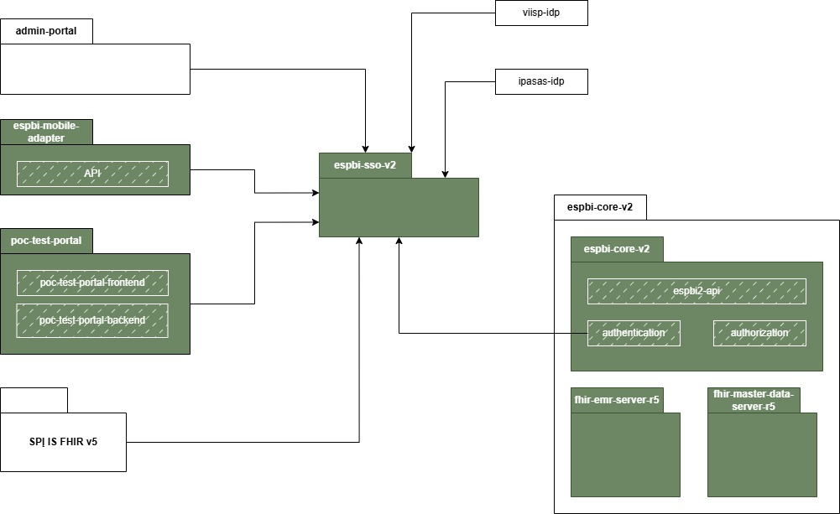

Table 10: Objective 4. Testing scenarios
Nr. | Scenario | Description | Expected result
 | User authorization | Keycloak permission policy is configured, and a new user with the appropriate role is created. The user attempts to log in and access data for which they have the necessary permissions. Subsequently, they attempt to access data for which they do not have permission, and access should be denied. | User authorization allow / disallows user to access data based on role information.
 | External system authorization (SPĮ IS FHIR v5) | SPĮ IS FHIR v5 performs authorization and requests data. Data for which SPĮ IS FHIR v5 has the necessary permissions is provided, while access to unauthorized data is denied. | Authorization mechanism allows / disallows external system to access data.

Objective 5. Implement integration for regular client usage (mob. application, specialist portal, HIS) & ensure iframe or equivalent solution for data presentation
- The objective will be considered achieved when the following conditions are met:
  - The developed interfaces meet the requirements provided in the Table 11: Objective 5. Implementation requirements and component description.
  - The developed interfaces consist of components and processes provided in the Figure 11: Objective 5. Components diagram.
  - Testing scenarios are performed and achieved the required result listed in the Table 12: Objective 5. Testing scenarios.

Table 11: Objective 5. Implementation requirements and component description
Nr. | Requirement | Notation in components diagram
 | It is planned that the newly developed test portal should access data from the old system (v1) and enable users to view it directly within the new test portal. While the old system (v1) will support data viewing via an iframe, the new system may not offer this functionality due to potential challenges with token exchange. Therefore, it is not mandatory to implement iframe functionality for the new system, but the Service Provider must define how the functionality should work and describe possible scenarios and alternatives to solve it. | poc-test-portal  poc-test-portal-frontend
 | The improved specialist’s portal should access data from the new (v2) system, and it should be viewable directly on the specialist portal. In addition to converting the data to HTML format or opening the document via different portal, the data should be accessible through an iframe or a similar functionality suggested by the Service provider. | doctor-portal-v1  doctor-portal-frontend
 | The developed v2 API must provide mapped data seamlessly while unmapped data should be presented in HTML or a similar format to the SPĮ IS FHIR v5 system. | espbi2-api
 | The developed v2 API should receive data requests and parameters such as UserID, PatientID, DocumentTypeCode, EncounterOrganizationID, DateFrom, and DateTill from the ESPBI Mobile throughout the adapter. The adapter should receive and handle data from both systems (V1 and V2) unified, and returned in a single response. The response includes documents and visit details as shared in Table 12: Objective 5. Testing scenarios. | espbi-mobile-adapter  espbi2-api  espbi-api

Figure 11: Objective 5. Components diagram
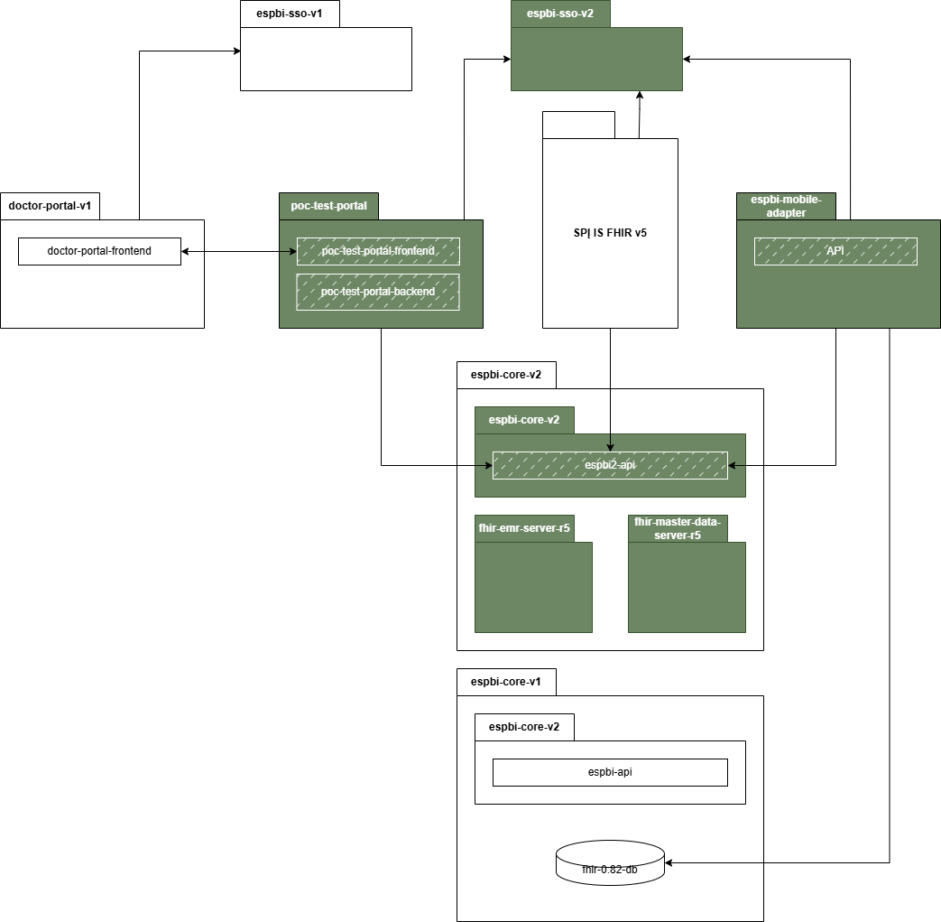
Table 12: Objective 5. Testing scenarios
Nr. | Scenario | Description | Expected result
 | Document created in new (R5) and read in old (DSTU1) version (Iframe or equivalent functionality) | Document linked to a sequence, such as a referral and its response, is managed within a single system. When a specialist opens the document in the old version of the system and seeks to review data from the new system, the data should be viewable directly within the old system. For viewing purpose, the data should be presented in HTML or similar format. For user functions, instead of converting the data to HTML format or requiring the document to be opened in the other system, the data should be accessible through an iframe or a similar functionality suggested by the Service provider. | Data is presented directly in the system using iframe or similar functionality.
 | Document created in old (DSTU1) and read in new (R5) version (SPĮ IS FHIR v5) | A document is opened in the new version portal (FHIR v5 system), and the user seeks to review data from the old Core v1 system. Data should be presented in HTML or a similar format. In another instance, the specialist closes the FHIR v5 system, accesses the Core v1 portal, and opens the same document to review it. Iframe functionality should be described (ideally provided) but it is not necessary as there might be challenges with token exchange. Service provider should define possibilities and alternatives how iframe or similar approach could be used for this purpose. | HIS specialist checks the document through HTML presentation possibility and with possibility to access old version of the (core1) portal and provide insights and recommendations regarding iframe or similar functionality.
 | Token exchange functionality | The Core v1 system provides possibility to submit data using an iframe or a similar functionality. Since Core v1 utilizes SSO v1 and the new Core v2 uses SSO v2, there should be no additional authorization requests for the user, and the token should be accepted. This scenario should be tested in one direction - opening the old system and displaying data from the new system. Vice-versa scenario should only be described identifying risks and providing possible solutions and suggestions. | Tokens are exchanged and iframe is displayed for data submission. No additional authorization is required.
 | Patient visit list view | ESPBI mobile adapter submits a request to retrieve a list of patient visits across two parallel ESPBI systems (FHIR DSTU1 and FHIR R5 cores). The application sends the request to get visit data for a specific patient, including parameters such as UserID, PatientID, DocumentTypeCode, EncounterOrganizationID, DateFrom, and DateTill. The data is received from both systems, unified, and returned in a single response. The response includes detailed visit information such as visit ID, status, class, type, associated patient and organization details, register information, and visit periods. The scenario is tested to ensure that the data is retrieved accurately from both systems, regardless of the differences in database structure or FHIR versions. | Patient list data is provided to mobile application.
 | Patient document list | ESPBI mobile adapter submits a request to retrieve a list of documents for a specific patient across the two ESPBI systems (FHIR DSTU1 and FHIR R5 cores). The request includes parameters like UserID, PatientID, DocumentTypeCode, DocumentOrganizationID, DocumentEncounterID, DateFrom, and DateTill. The system receive document data from both systems, consolidates it, and returns a unified list. The response contains document details such as document ID, type, name, associated patient and organization information, encounter ID, document creation date, author details, and additional document-specific information. The scenario is tested to verify that the unified document data is correctly received and returned, while ensuring that the system can handle large data volumes efficiently during the transitional period. | Patient document data is provided to mobile application.

Objective 6. Implement integration with ULSVIS
- The objective will be considered achieved when the following conditions are met:
  - The integration meets the requirements provided in the Table 13: Objective 6. Implementation requirements and component description.
  - The developed interfaces consist of components and processes provided in the Figure 12: Objective 6. Components diagram .
  - Testing scenarios are performed and achieved the required result listed in the Table 14: Objective 6. Testing scenarios.

Table 13: Objective 6. Implementation requirements and component description
Nr. | Requirement | Notation in components diagram
 | The integration must enable ULSVIS to request data via newly developed subsystem adapter component, where data should be aggregated and provided to ULSVIS. | subsystem-adapter
 | The integration must include authentication and authorization processes, which handles token validation and role enforcement, and the permission policy must be configured. | subsystem-adapter

Figure 12: Objective 6. Components diagram
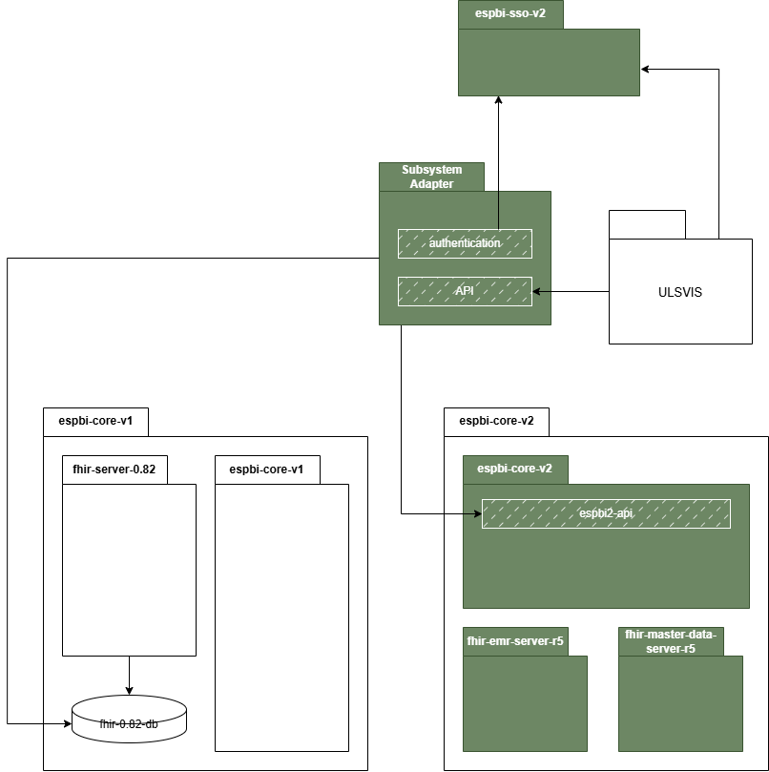

Table 14: Objective 6. Testing scenarios
Nr. | Scenario | Description | Expected result
 | External system authorization (ULSVIS) | ULSVIS authenticates via KeyCloak (espbi-sso-v2) and receives access token allowing the system to fetch E027-ats documents. The service provider must configure necessary authorization policies in KeyCloak for the generated token be valid for the use case. | Request via Subsystem Adapter using such token is authorized. Request via Subsystem Adapter using any other client's token is rejected.
 | ULSVIS data integration | ULSVIS system accesses the Subsystem Adapter component and requests for E027-ats documents. Subsystem Adapter collects the data from both espbi-core-v1 (utilizing existing integration mechanisms ULSVIS is requesting the documents today) as well as the newly introduced espbi-core-v2 (via espbi2-api), maps it into a representation that is suitable for ULSVIS and combines the results into a single collection. Performance testing should be conducted with large data volumes to identify potential risks and bottlenecks and provide recommendations for optimizing data integration processes with ULSVIS as well as other future clients of similar nature. | Combined collection of E027-ats documents is returned to ULSVIS. Performance measurements are collected and presented to the client with recommendations on how the mechanism can be improved.

Long-term ESPBI architecture

During the project, the Service Provider may be tasked, upon a separate additional request, to develop a long-term ESPBI architecture. This architecture should cover all ESPBI components, including their internal and external integrations. It must be prepared across multiple dimensions: business, data (including integrations), security, technology and application architecture. The Service Provider will present these architectural frameworks to the client's architecture board for review and approval.

General Requirements:
- Service provider shall prepare full future (TO-BE) architecture documentation including architecture diagrams and detailed descriptions of it.
- Architecture document shall describe the existing ESPBI architecture and provide insights into current issues and challenges that the long-term architecture should address.
- Architecture shall include ongoing projects that are not yet in the production environment (PROD).
- Architecture shall include additional functional components that are not currently part of the ESPBI system but are recommended by Service provider for future implementation.
- Architecture diagrams shall be prepared using the Achimate (preferred) or Draw.io tool.
- Architecture shall include detailed descriptions of each component, process, and data flow.
- Where necessary, architecture shall be elaborated with additional diagrams and additional descriptions to ensure clarity.

Specific Requirements:
- Business architecture
  - Business architecture shall identify different types of system users and their interactions with ESPBI.
  - Business architecture shall detail the supported business processes and their alignment with organizational goals.
- Data architecture
  - Data architecture shall describe internal and external data flows, including interactions with organizational data warehouse solutions.
  - Data architecture shall provide insights into data quality management practices and recommendations for improvement.
- Security architecture
  - Security architecture shall define access control mechanisms, security measures, and roles to ensure data protection and compliance.
  - Security architecture shall identify potential vulnerabilities and recommend mitigation strategies.
- Application architecture
  - Application architecture shall outline the lifecycle of existing applications, including updates, maintenance, and decommissioning plans.
  - Application architecture shall explore possibilities for integrating or adopting new applications to meet future needs.
- By adhering to these requirements, the Service Provider will ensure that the long-term ESPBI architecture is forward-looking and aligned with the client's strategic objectives and industry trends.

PoC implementation stages & results
Table 3. PoC implementation stages

Stage | Responsibilities | Result | Results / Requirements | Deadline
Initiation | Service provider:  - Prepares the Service Provision Regulation and other project planning documents.  - Coordinates with the Client on project objectives related to the PoC.  Client:  - Provides necessary information regarding the current system architecture and requirements for the PoC. | R-1 – Project initiation documentation | - Prepared Service Provision Regulation, detailing:  - project goals & priorities,  - results (deliveries) description,  - stakeholders,  - project team & responsibilities (detailing organizational structure of decision-making process)  - work schedule,  - risks and their management methods,  - communication principles,  - criteria for interim and results acceptance,  - change management procedures. | Delivery must be presented and coordinated with the Client no later than 15 business days from the effective date of the Service Provision Contract.
Initiation |  | R-2 – Interim reports | - Interim activity reports, if specified in the Service Provision Regulation, detailing:  - A project schedule with percentage completion metrics of each stage.  - A list of active risks with status updates, mitigative actions and impact on the project.  - A list of key decisions and / or strategic questions required to progress the project.  - Any additional recommendations for project continuation. | Provided monthly (depending on the Contract signature date (if less than 10 calendar days are left for the month, interim report for 1st or last month is not necessary.
Analysis & design | Service provider:  - Conducts assessment of the AS-IS and TO-BE situation.  - Prepares detailed analysis documentation and updates the architecture provided if new insights are gathered.  Client:  - Provides necessary information.  - Provides comments and recommendations.  - Approves the Service provider's stage results. | R-3.1. – PoC requirement analysis and design report | - Analysis documentation should consist of:  - Proposed full-scale architecture review and recommendations provision.  - Review describe proposed PoC objectives. Service Provider shall provide insights of what additional objectives could be tested, which components will be developed and what additional testing scenarios should be included.  - Provided detailed description of PoC solution:  - Provide description of each proposed architecture component  - Identify and describe what products or custom-made solutions will be used  - Describe each data flows and what should be prepared by the Client owned components  - Describe how each of the scenarios provided will be tested and provide additional scenarios if necessary.  - The document should be detailed design document of the PoC solution. | All services shall be provided in 9 months since contract signature, but not later than 2026 April 30th.
Analysis & design |  | R-3.2. – PoC document mapping report | - Mapping results of identified documents or resources that are mapped.
Development | Service provider:  - Develops PoC solution.  - Ensures internal testing.  Client:  Approves the Service provider's stage results. | R-4. – Internal testing report. | - PoC solution is developed and internally tested.  - Internal testing report is provided consisting of each PoC scenario and description of the internal testing results. Service provider shall include additional testing scenarios based on proposed solution.
PoC demonstration and alignment | Service provider:  - Demonstrates the PoC to the Client, showcasing functionality and user experience of the testing scenarios.  - Collects feedback and comments from the Client.  - Provides accompanying documentation with the demonstration.  Client:  - Reviews the PoC demonstration.  - Provides feedback and recommendations for improvements. | R-4 – PoC scenarios feedback | - PoC demonstrated to the Client. The possibility should be ensured for the Client to test scenarios themselves or include 3rd party representatives (HIS representatives (specialists)) to test.  - Feedback collected and documented.  - Necessary adjustments should be conducted on the provided feedback.
PoC final report | Service provider:  - Prepares the final report for the PoC, including risks, alternatives, and recommendations for future steps.  - Updates all relevant project documentation.  Client:  - Reviews and approves the final report. | R-5 – Final PoC report | - PoC final report prepared, encompassing:  - Summary of activities and outcomes during PoC.  - Description of each PoC scenario and comments on how it proceeded.  - PoC architecture diagrams must be provided for all necessary aspects (data architecture, logical architecture, etc.).  - Alternatives considered and their evaluations (both high level strategic alternatives and scenario level alternatives).  - Identified risks and mitigation strategies (both technical and business organizational).  - Prepared risk list, which includes risks that could not fully be mitigated during the PoC with explanation of why these risks remain.  - An assessment of whether the proposed FHIR version deployment principle is optimal and recommend any necessary architectural changes.  - Include a section on lessons learned and best practices identified during the PoC.  - Suggest potential future enhancements or optimizations based on PoC findings (not only related to FHIR version upgrade, but all that were discussed during the project).  - Other recommendations for future implementation.

Requirements for service provision

Requirements for documentation and its coordination

- All project documentation prepared by the Service provider must be prepared in Lithuanian and English language in accordance with the rules of the respective language grammar and formatting rules illustrated with diagrams, tables, graphs and other visual means, the presented material is arranged clearly, consistently and in detail.
- Amended documents provided by the Service provider must visibly display changes using the track changes feature to clearly indicate modifications.
- The documents agreed with the Client must be amended during subsequent stages, if changes are made to the modified System, considering the results of the acceptance testing and pilot operation, other project activities and circumstances that are related to the content of the submitted documentation. The project documentation must be actualized (updated) and the final versions submitted within the deadlines agreed with the Client, but no later than by the date of submission of the final delivery-acceptance transfer act.
- Preliminary (design) versions must be submitted in electronic format by electronic means of communication. Documentation must be managed in Client’s owned Confluence environment.
- All documents prepared by the Service provider must be agreed upon with both the Client and the Service provider.
- The final versions of the documents must be submitted in two formats: electronically (.doc, .docx, .pdf, or another agreed format suitable for editing) and in a signed format by the responsible person of the Service provider (either electronic or physical). Intermediate versions of documents are to be submitted only in electronic format.
- The Client and other interested parties must submit comments on the evaluated documentation:
  - within no more than 10 days for documents up to 100 pages.
  - Within a time agreed with the Service provider, not less than 10 days, for documents exceeding 100 pages.
- After receiving comments, the Service provider must make the required corrections according to the following timelines:
  - for documents up to 100 pages, corrections must be made within 5 working days.
  - for documents over 100 pages, corrections must be completed within a maximum of 10 working days.
- The Client’s GitLab repository must be used to store the system source codes.
- For processes ensuring and installing system quality, the Client’s GitLab repository must be used.
- During the system development, the Client intends to conduct both automatic and manual software source code analysis review procedures on the GitLab platform. The Service provider must consider these reviews and make changes in accordance with the Client's comments.
- During the system development, static code analysis tools must be coordinated and utilized with the Client to ensure code compliance with good practices, correct syntax formation, and security vulnerability checks.
- For the development of the system and its components, frameworks such as Spring, Spring Boot, Symfony, or equivalents must be used for the creation of web and/or microservices.
- The system and its components must be capable of operating with a common data layer (Persistent Storage).
- The systems must be able to operate with a common memory layer (RAM).
- Integration must be conducted in accordance with good practices based on 'Dependency Management' principles, where integration packages are developed as separate software libraries and implemented using tools like Maven, Composer, or equivalents.

Requirements for analysis and design
- During the implementation of the analysis and design stages, the Service provider must carry out a detailed analysis and design of project needs.
- The detailed requirements analysis document must include use cases prepared according to the functional and non-functional requirements of the Technical Specification and the needs expressed by the Client. These use cases should include usage case diagrams and detailed descriptions, specifying steps (main course, alternative course, exceptional progress), and other constraints using Unified Modeling Language (UML) notation. All functional and non-functional requirements of the Technical Specification must be linked to the content of the detailed analysis document (chapters, appendices, diagrams, etc.). This linking must be clear in illustrating how each requirement of the RPO is designed and realized.
- During the analysis and design stages, the Service provider shall conduct meetings with operational specialists appointed by the Client and specialists from other relevant institutions to ensure all stakeholder inputs are considered.
- During the detailed analysis and design stages, the Service provider shall refine the functional and non-functional requirements of the RPO to develop a System that fully meets the expressed needs of the Client.

Deployment requirements
- For the installation of versions of the system into the Client's environments, the Service provider shall prepare a detailed Installation Plan.
- The installation of versions of the system must be carried out in stages, with each service station using the System separately to ensure system integrity and minimal disruption.
- The installation of versions of the system must follow the prescribed order:
- A new version of the System is installed in the DEV environment.
  - tests are performed on the installed version of the System.
    - if testing is unsuccessful, necessary changes are made to the System, and the installation process is repeated.
    - after successful completion of the tests, the installation process advances to the next stage.
  - A new version of the System, successfully tested in the DEV environment, is installed in the TEST environment.
    - tests are performed on the installed version of the System.
    - if testing is unsuccessful, necessary changes are made to the System, and the installation process is repeated.
    - after successful completion of the tests, the installation process is deemed complete.
- During the installation of the version, the server where the installation work is being carried out will be inaccessible to users to prevent interference and maintain security.

Testing requirements
- Each scenario (provided under each PoC objective) should be detailed and broken down into sub-scenarios based on the solution provided by the Service Provider. Service provider shall conduct this analysis and align sub-scenarios with Client. For each testing scenario outlined under each objective (unless it is not relevant) the Service Provider shall evaluate the following.:
  - User-experience (UX/UI). Assess whether the system actions are user-friendly, and provide examples, recommendations, and insights for improvement. Service Provider shall conduct analysis how 2 FHIR versions could impact end-user actions in the system.
  - Performance. Where applicable evaluate and measure the system's performance, considering potential increases in data volumes and offering recommendations for improvement. The evaluation must include:
    - Unmapped data extraction via v2. Analyse the impact of data volume on latency when extracting unmapped data from both systems.
    - Unmapped data extraction via v1. Assess the effect of data volume on latency when extracting unmapped data from both systems.
    - Mapped data synchronization. Evaluate the impact of data volume on latency during mapped data synchronization.
  - Data integrity. Verify that no data is lost during system operations, identify potential risks of data loss and propose mitigation strategies.
  - Security. Identify any additional security risks introduced by the solution describe these risks and provide recommendations to mitigate them.
- Client will provide existing ESPBI components test version in test environment with populated test data.

Requirements for project management
- The Service provider must ensure that all communication during the Project is conducted in Lithuanian or English language. If experts from foreign countries are involved, the Service provider must provide translation services into Lithuanian at its own expense.
- The Service provider must cooperate directly with the Client, Project partners, and other interested parties involved in the Project. This includes maintaining open lines of communication and collaboration throughout the project duration.
- The Service provider shall regularly inform the Client about the progress of the Services and, upon the Client's request, prepare and present results at various stages of service provision.
- The Service provider must submit and agree with the Client on the Regulation of Service Provision, which should detail the stages of the provision of services and their results (presentations), a calendar schedule for the execution of phases corresponding to the detailed deadlines specified by the Client, describe communication and risk management measures and the procedure for combining documents.
- The Service provider shall prepare and submit to the Client monthly interim reports on the provision of services, which shall include:
  - Updates on the progress of the Service Agreement.
  - Information about the risks and problems recorded during the reporting month.
  - Updates on any agreed changes in the change register.
- Interim reports on the provision of Services must be submitted to the Client within 5 working days from the end of the reporting period.
- Upon completion of all works, the Service provider shall prepare a final report on the provision of services. This final report must be submitted to the Client within 10 business days from the end of the last stage of Service Provision.
- The Service provider must continue to cooperate directly with the Client, the Project partners, and other interested parties throughout the project, ensuring all stakeholders are engaged and informed.

Requirements for change management
- Amendments to the requirements set out in the RPO, the Technical Specification, or other annexes to the Service Agreement may be initiated by either the Service provider or the Client.
- Changes may arise due to circumstances that were unforeseeable and uncontrollable at the time of the tender submission or the conclusion of the purchase agreement. These include situations that could not have been reasonably foreseen and controlled, as well as the risks associated with such occurrences.
- Any amendment must be implemented after both the Service provider and the Client have approved the change in writing, formalizing the agreement as an annex to the contract. Implementation must comply with the terms of the Service Agreement and this technical specification, adhering to the principles of public procurement. The following activities should be applied, considering the nature of the change:
  - Document the effect of the change, assess its criticality level (minor, medium, critical), and describe the consequences.
  - Ensure the change is not critical and does not affect the functionality of the entire solution.
  - If the change is functional, ensure it is marked on the test plan and will be additionally tested.
  - Document changes made to technical documentation and business processes related to the change in functionality.
  - Ensure the change is authorized and signed by a person authorized by the Client.
  - Ensure the change is duly notified to all parties involved in the provision of the Services.
  - Ensure the change does not complicate the achievement of the procurement goals.
  - Ensure any changes related to functionality are entered in the change log.
- If the change in functionality is carried out without following the procedures set out above, such a change is considered invalid.
- The Service provider shall provide up to 1,000 (one thousand) man-hours dedicated to implementing changes requested by the Client during the project execution and after its completion. These hours are intended for any modifications, enhancements, or adjustments to the delivered solution as per the Client's needs. All such changes must be managed in accordance with the change management procedures outlined in points 88 to 91.

Licensing requirements
- No specific licenses are anticipated to be required for this project. However, if any licenses are necessary it will be the responsibility of the Service Provider to procure and ensure their availability for whole project time and 24 months after the project is completed (during warranty period).

Warranty requirements
- 6 months warranty is applied for all results provided during the project by the Service Provider. Whole PoC architecture should be available for Client during 24 month period after project closure (Client should be able to check it, present it to relevant stakeholders).

https://www.esveikata.lt/espbi-specifikacija
Mapped resources means where FHIR DSTU1 and FHIR v5 resources are mapped between different versions.
Unmapped resources means where FHIR DSTU1 and FHIR v5 resources are not fully mapped between different versions.
Low therapeutic index (lit.: mažo terapinio indekso).
Information about patients, related persons (specialists and their groupings).

